State Diagram

Class Diagram

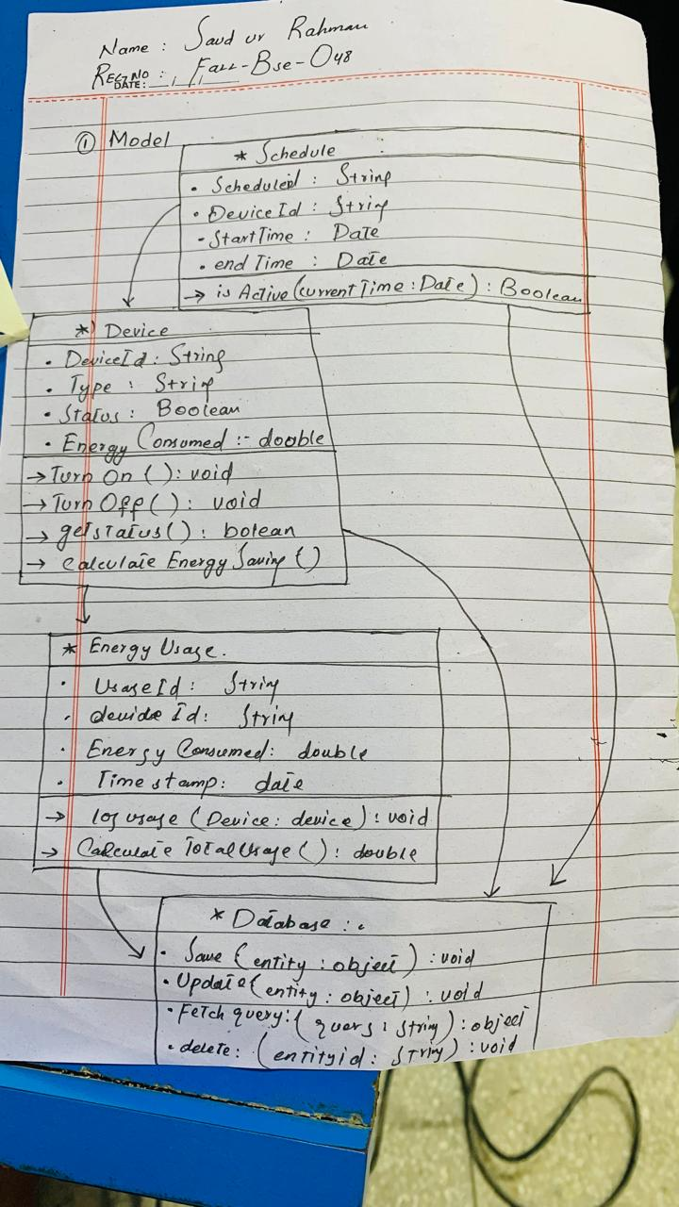

Architecture Diagram

