A Project Report
Submitted in Partial fulfillment of Major Project for the award of
Bachelor of Computer Application

Submitted to
ITM UNIVERSITY
GWALIOR (M.P.)



MAJOR PROJECT REPORT
Submitted by

Shahrukh Khan [BCAN1CA14040]
Milan Sikarwar [BCAN1CA14054]
Asif Khan [BCAN1CA140XX]

Under the supervision of
Mrs. Kirti Shrivastava

Dept. of Computer Science & Applications
ITM UNIVERSITY
GWALIOR (M.P.)
SESSION-Jan-June- 2017

Dept. of Computer Science & Applications
ITM UNIVERSITY, Gwalior (M.P)

CERTIFICATE

This is to Certify that Shahrukh Khan, Milan Sikarwar, Asif Khan, student of BCA Final Semester , January 2017– June 2017 session of this school has completed his final semester project entitled “IOT Based Home Automation”

He/She has submitted a satisfactory project report for the award of degree of Bachelor of Computer Applications (BCA) of ITM University, Gwalior.

Dr. Pallavi Khatri Mrs. Kirti Shrivastava
Associate Professor & Head, Assistant Professor
Dept. of Computer Science & Applications Dept. of Computer Science & Applications
ITM University, Gwalior ITM University, Gwalior

Acknowledgment

The satisfaction that accompanies the successful completion of any task would be incomplete without mentioning of the people where ceaseless cooperation made it possible, whose constant guidance and encouragement crown all the efforts with success.
We shall always be grateful to our parent whose moral support at every step of our life is the reason to us of using our self. Their encouragement in every joy and believe of life laid the real foundation for our personality.
We sincerely thank to our project guide Mrs. Kirti Shrivastava for their great help, guidance, support and ideas towards our project. We are highly grateful to –
Dr.Pallavi Khatri (HOD, Dept. of Computer Science & Applications, ITM UNIVERSITY)
for providing us their valuable guidance, suggestions, encouragement & ideas during whole project work.
We are also thankful to staff members for providing us the technical support to carry out the project work and guidance at each & every step during the project work.
We are also very thankful to lab assistants for their co-operation. It was their careful evaluation, keen interest, timely guidance and valuable suggestions that steered us out of difficulties at every stage of the project. It was great pleasure and good learning experience to have worked under their guidance during tenure of the project.
We also convey our sincere thanks to all our friends who ardently encouraged us through their precious advices and helping attitude in all the fields.

Shahrukh Khan
Milan Sikarwar
Asif Khan

Dept. of Computer Science & Applications
ITM UNIVERSITY, Gwalior (M.P)

DECLARATION

Shahrukh Khan, Milan Sikarwar, Asif Khan student of Bachelor of computer application, Dept. of Computer Science & Applications ,ITM UNIVERSITY, Gwalior(M.P.) hereby declare that the work presented in this Major project is outcome of our own work, is bonafide, correct to the best of our knowledge and this work has been carried out taking care of Engineering Ethics. The work presented does not infringe any patented work and has not been submitted to any University for the award of any degree or professional diploma.

Shahrukh Khan (BCAN1CA14040)
Milan Sikarwar (BCAN1CA14054)
Asif Khan (BCAN1CA140 )

INDEX

Sr. No. | Chapter Name | Page No. | Remarks
1. | Preface | 6-7
2. | Analysis of Proposed System and System requirements | 8-10
3. | Logical and Physical design of system | 11-13
4. | Proposed Model | 14
5. | Security | 15
6. | System Testing and Implementation | 16-18
7. | Conclusion | 19

Preface

Home automation is a topic that has been around for many years. It includes everything that you can imagine to control and automate your home. The most widely spread example is the Control of appliances. Alarm system of your home, Motion sensors, contact sensors, and the central device that orchestrates your alarm system are generally the main components of any home automation system.
There are countless devices that are available for home automation. You can buy complete home automation devices from a lot of stores, and even get them installed in your home.
However, many of these systems are very expensive, impossible to be customized for your own needs, and have outdated user interfaces.
On the other hand, we have the Arduino platform. Arduino is a platform that you can use to quickly prototype electronic systems. It is now used by millions of people around the world to build more complex systems. It is actually the perfect platform to build home automation systems. Because of the flexibility of the Arduino platform, we are going to see that it is easy to interface with various sensors and actuators that are usually found in many home automation systems. It can also be interfaced with many wireless systems, such as Wi-Fi, Bluetooth.
In this Project, we are going to see how to build home automation systems with Arduino.

This Project is for all those who are willing to build their own home automation systems based on Arduino. You actually don’t need to know anything about the Arduino platform beforehand, since all the projects will be explained step-by-step with clear instructions. The only thing you need in order to follow the projects found in this book is basic knowledge of electronics and programming.

Analysis of Proposed System and System requirements
- System Analysis
Let’s first see what components are needed for this project.
This board has just the bare minimum of components to be usable. This way, no power is wasted on components that are not necessary when the system is operating, such as LEDs, a USB interface, and so on. This board can then be used in very low-power applications such as Bluetooth Module.

The most important component in this project will be the microcontroller itself. The microcontroller is at the heart of all Arduino boards. It is the component that we program every time we write a new sketch.

I based my design on the Arduino Uno board design, so I used the same controller as the Arduino Uno board. For this project, you will need one of these microcontrollers, which are sold separately. Please make sure that you are buying one with the Arduino boot loader so that you can directly upload the Arduino code to the microcontroller.

You will also need several smaller components to make the microcontroller work.

To program the microcontroller, you will need an external programmer because the project does not integrate a programmer. Instead of using a dedicated programmer, I simply used an Arduino Uno board for this task.

Finally, you will need a Relay Board and some jumper cables to make the connections between the different components of the project.

On the software side, you will need to download the Arduino IDE.

- S/W Analysis

ARDUINO IDE
The open-source Arduino Software (IDE) makes it easy to write code and upload it to the board. It runs on Windows, Mac OS X, and Linux. The environment is written in Java and based on Processing and other open-source software.
This software can be used with any Arduino board.
The Arduino Software (IDE) allows you to write programs and upload them to your board.

A program written with the IDE for Arduino is called a sketch. Sketches are saved on the development computer as text files with the file extension .ino. Arduino Software (IDE) pre-1.0 saved sketches with the extension .pde.

The Arduino IDE supports the languages C and C++ using special rules of code structuring. The Arduino IDE supplies a software library from the Wiring project, which provides many common input and output procedures. User-written code only requires two basic functions, for starting the sketch and the main program loop, that are compiled and linked with a program stub main() into an executable cyclic executive program with the GNU toolchain, also included with the IDE distribution. The Arduino IDE employs the program avrdude to convert the executable code into a text file in hexadecimal encoding that is loaded into the Arduino board by a loader program in the board's firmware

A minimal Arduino C/C++ sketch, as seen by the Arduino IDE programmer, consists of only two functions:
- Setup: This function is called once when a sketch starts after power-up or reset. It is used to initialize variables, input and output pin modes, and other libraries needed in the sketch.
- Loop: After setup has been called, function loop is executed repeatedly in the main program. It controls the board until the board is powered off or is reset.

Logical and Physical design of system

- Arduino
Arduino is an open-source programmable microcontroller board. The programming Language used to program the microcontroller board is C and C++.
Arduino board designs use a variety of microprocessors and controllers. The boards are equipped with sets of digital and analog input/output (I/O) pins that may be interfaced to various expansion boards (shields) and other circuits. The boards feature serial communications interfaces, including Universal Serial Bus (USB) on some models, which are also used for loading programs from personal computers. The microcontrollers are typically programmed using a dialect of features from the programming languages C and C++. In addition to using traditional compiler tool chains, the Arduino project provides an integrated development environment (IDE) based on the Processing language project

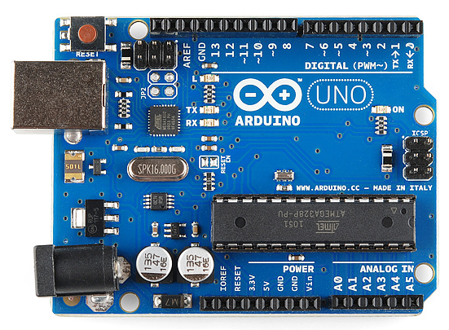

- Relay Board

The Single Relay Board can be used to turn lights, fans and other devices on/off while keeping them isolated from your microcontroller.
A relay is an electrically operated switch. Many relays use an electromagnet to mechanically operate a switch, but other operating principles are also used, such as solid-state relays. Relays are used where it is necessary to control a circuit by a separate low-power signal, or where several circuits must be controlled by one signal. The first relays were used in long distance telegraph circuits as amplifiers: they repeated the signal coming in from one circuit and re-transmitted it on another circuit. Relays were used extensively in telephone exchanges and early computers to perform logical operations.

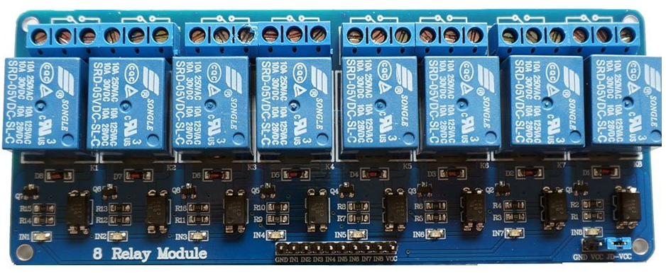
- HC-05 Bluetooth Module

Bluetooth is a wireless technology standard for exchanging data over Bluetooth connectivity.
HC‐05 module is an easy to use Bluetooth SPP (Serial Port Protocol) module, designed for transparent wireless serial connection setup. The HC-05 Bluetooth Module can be used in a Master or Slave configuration, making it a great solution for wireless communication. This serial port Bluetooth module is fully qualified Bluetooth V2.0+EDR (Enhanced Data Rate) 3Mbps Modulation with complete 2.4GHz radio transceiver and baseband

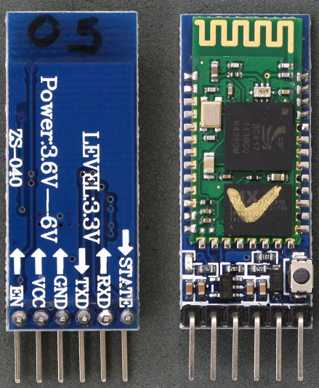

Proposed Model
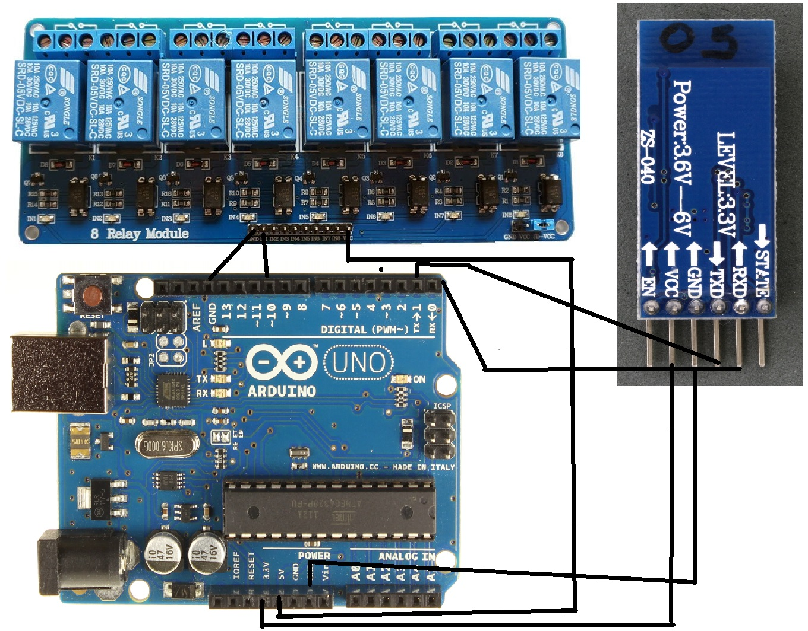

Security
As the Internet of Things has gained popularity and buzzword status, a number of large efforts to create standards consortiums and offer cloud services for storage and processing the data collected. Unfortunately, the weakest link, the device actually gathering data has not really been considered or has been marked in the “too difficult” bucket in regards to security a problem for someone to solve.

With the introduction of micro controllers like the Arduino – it has become very easy (for almost anyone) to connect sensors and the appropriate network connections to gather information as part of the IoT ecosystem either in a hobby project or even the future development of a commercial product. Can such solutions be secured?
Here we are not using public Networking, We are using a local connection.

System Testing and Implementation
Testing the Microcontoller
As the hardware Requirements are complete.
We should check the working of Arduino microcontroller board is working or not.
So, we’ll first write a simple sketch to test the blinking of led. Go over to your Arduino IDE and you can start writing some code. The code will be detailed below:

// the setup function runs once when you press reset or power the board
void setup() {
// initialize digital pin LED_BUILTIN as an output.
pinMode(LED_BUILTIN, OUTPUT);
}
// the loop function runs over and over again forever
void loop() {
digitalWrite(LED_BUILTIN, HIGH); // turn the LED on (HIGH is the voltage level)
delay(1000); // wait for a second
digitalWrite(LED_BUILTIN, LOW); // turn the LED off by making the voltage LOW
delay(1000); // wait for a second
}

The Above code will blink the led on the microcontroller.
The led will be turned on and off alternatively every second.

Testing The Bluetooth Module:

It can be tested by connecting any bluetooth enable device to our bluetooth module, led of module will blink as soon as it gets power supply.

Testing the relays and Bluetooth connection
Relay and Bluetooth connection can be tested after all the wiring and setup of the project.

(i)Test Cases
(a) Black Box Testing
All the Codes and both the functions i.e. setup() and loop() are to be tested before the execution.

(b) White Box Testing
All the Modules are to be checked before connection.
And the Connection on proposed model has to be checked before implementation.

Conclusion

The home automation using Internet of Things has been experimentally proven to work by connecting simple appliances to it and the appliances were successfully controlled remotely. The programmed controller processes according to the requirement, for example switching on the light when the on button is clicked on the phone. This will help the user to control the appliances without going near to the appliance.

