Results Summary for Power BI Project 3 for Udacity Nanodegree

- What is the correlation between sales and income?

The correlation between Sales and Income is 0.78.
The scatterplot below presents linear regression between the variables and the corresponding card with correlation value calculated.

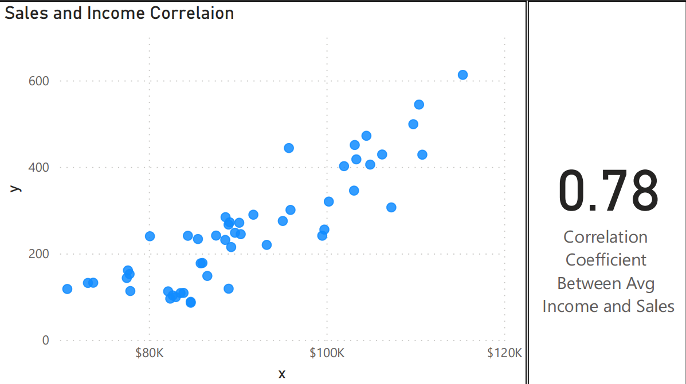

- What is the correlation (R2 value) between customer ratings and product return rate?

The correlation between Customer Ratings and product return rate is -0.83, which means that the return rate is less with highest ratings products.
The lineplot below presents linear regression between the variables and the corresponding card with correlation value calculated.

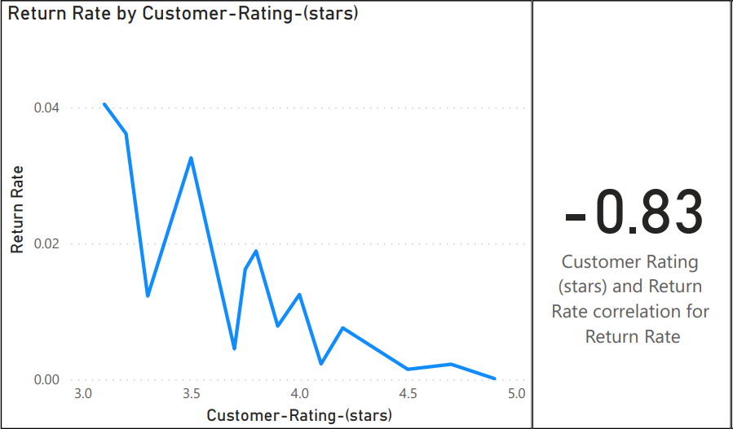

- What is the top recommended item?

The donut chart below demonstrates the recommended item percentages, the top product we have is ‘Sweater’ with 66% of the score.

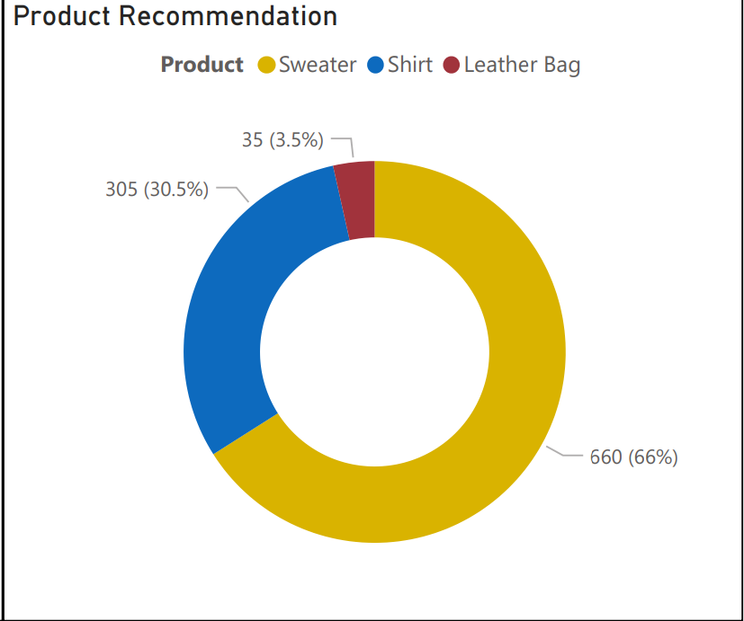

- What are the top products by price in stock?

The bar charts visualize for us the top 10 products we have on stock by their prices.

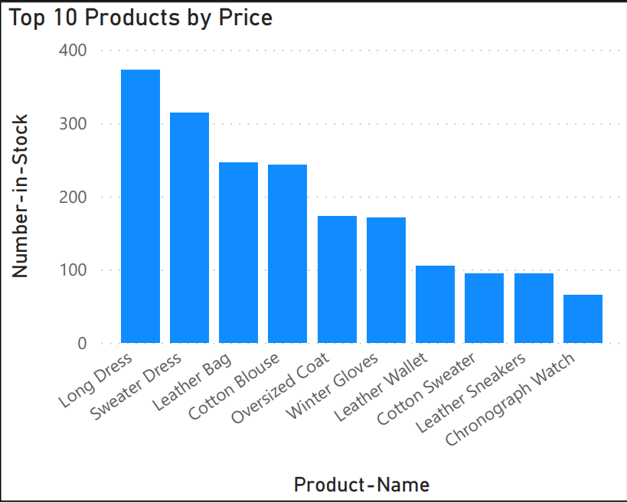

- What are the best and worst performing products?

These two cards represent the best and worst performing products with respect to return rate and customer ratings

