**SOFTWARE DESIGN DOCUMENT**

Conference Management and Reservation Online Portal

Supervisor:

Dr.Patrick Then

Client:

Ms. Lesley Lu

Team Members:

Rayner Paun 4308875

Ch’ng Chuan Way 100061188

Samu Pillai Sadeiyen 4323696

Samuel Hii Tuan Ong 4307100

Contents

1.0 Introduction 4

1.1 Purpose 4

1.2 Scope 4

2.0 UML Class Diagram 4

2.1 UML Class Diagram for Website 4

3.0 Sequence Diagram for Website 5

3.1 Event Manager 6

3.1.1Login 6

3.1.2 Logout 7

3.1.3 Add Conference 8

3.1.4 Edit Conference 9

3.1.5 Remove Conference 10

3.1.6 Add Sponsor 11

3.1.7 Delete Sponsor 12

3.1.8 Modify Sponsors 13

3.1.9 View Schedule 14

3.1.10 View Session Details 15

3.1.11 Add Session 16

3.1.12 Delete Session 17

3.1.13 Modify Session 18

3.1.14 Add Venue 19

3.1.15 Delete Venue 20

3.1.16 Modify venue 21

3.1.17 View Room 22

3.1.18 Add Room 23

3.1.19 Delete Room 24

3.1.20 Modify Room 25

3.1.21 Add Speaker 26

3.1.22 Delete Speaker 27

3.1.23 Modify Speaker 28

3.1.24 Add Caterer 29

3.1.25 Delete Caterer 30

3.1.26 Modify Caterer 31

3.1.27 View Conference 32

3.1.28 Generate Conference Registration Summary 33

3.1.29 User Management 34

3.1.30 Generate Participants Checklist 35

3.1.31 Generate Guest List 36

3.1.32 Generate Sponsors List 37

3.1.33 Generate Speakers List 38

3.1.34 Generate Feedback Report 39

3.2 Conference Participant 40

3.2.1 Login 40

3.2.2 Logout 41

3.2.3 Registration 42

3.2.4 View Schedule 43

3.2.5 View session details 44

3.2.6 View Speaker 45

3.2.7 Make Conference Booking 46

3.2.8 Transfer Conference Booking 47

3.2.9 Cancel Conference Booking 48

3.2.10 Book Hotel 49

3.2.11 Book Tour 50

3.2.12 Modify Hotel Booking 51

3.2.13 Cancel Hotel Booking 52

3.2.14 Provide Feedback 53

3.2.15 Enquire about conference 54

4.0 Functional Requirements 55

4.1 Use Cases 55

4.1.1 Event Manager 57

4.1.2 Conference Participant 91

5.0 Entity-Relationship Diagram 109

# Introduction

## Purpose

The purpose of this Software Design Document is to provide all the essential written description of a software, Conference System. In general, this documentation serves as a guidelines for the project team to the architecture of software, conference system. In addition, software design diagram, storage of persistent data and global flow control. It also emphasizes the use of component and UML to deal with solution domain complexity

## Scope

The document focuses on the design principle that would be adhered to while programming and articulating the software. In this document, the team has documented several process of designing the software using UML class diagram, Sequence diagram and Entity-Relationship Diagram.

# UML Class Diagram

## 2.1 UML Class Diagram for Website

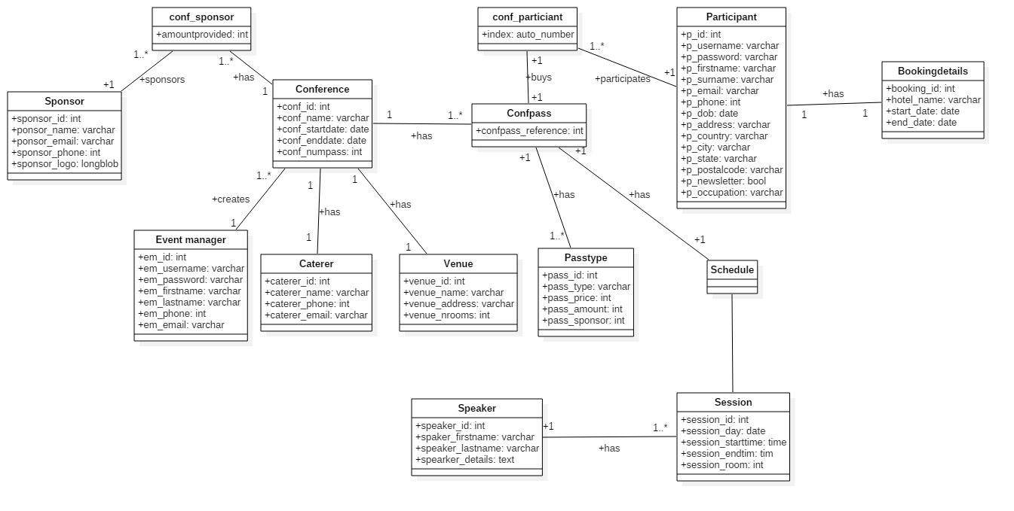

# Sequence Diagram for Website

## 3.1 Event Manager

### 3.1.1Login

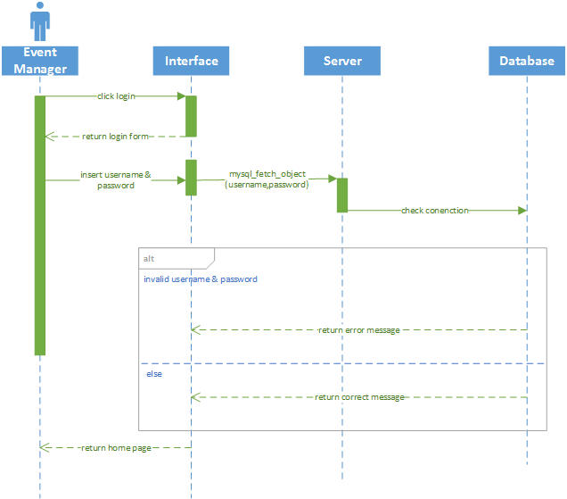

### 3.1.2 Logout

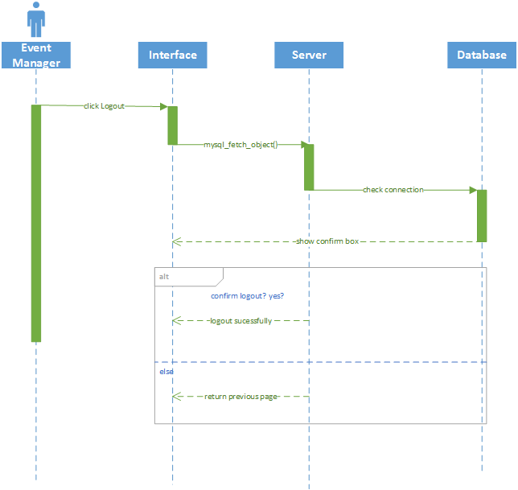

### 3.1.3 Add Conference

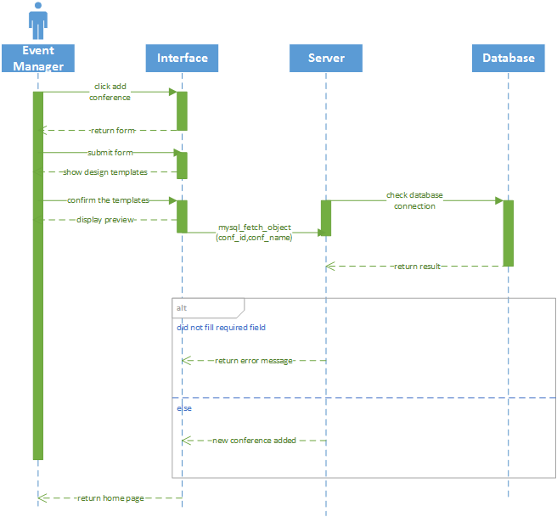

### 3.1.4 Edit Conference

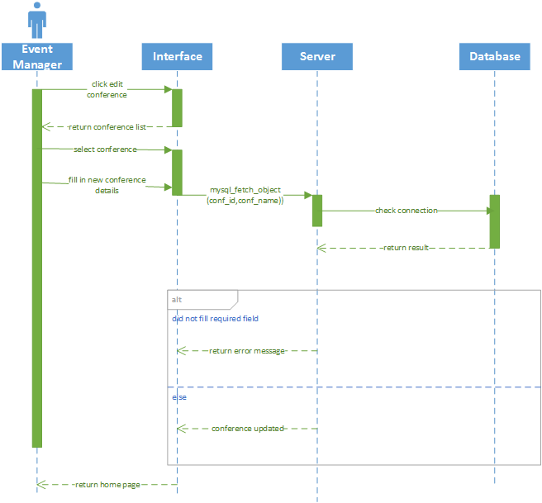

### 3.1.5 Remove Conference

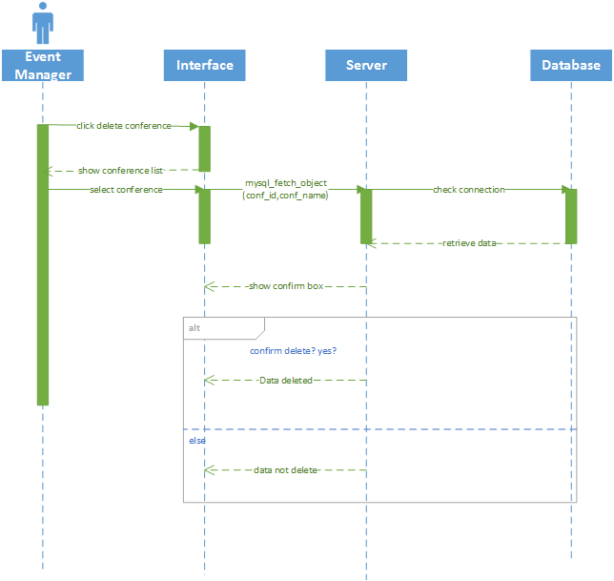

### 3.1.6 Add Sponsor

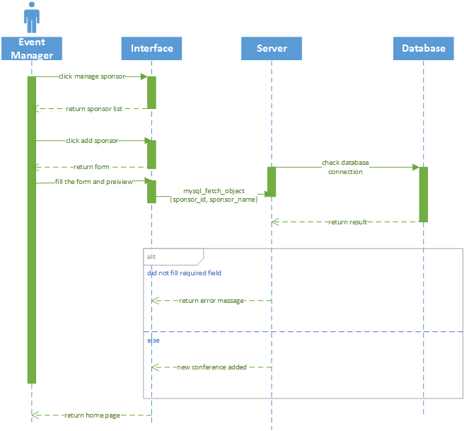

### 3.1.7 Delete Sponsor

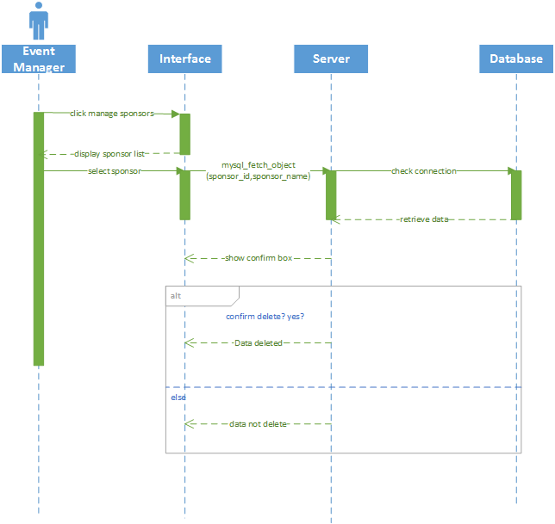

### 3.1.8 Modify Sponsors

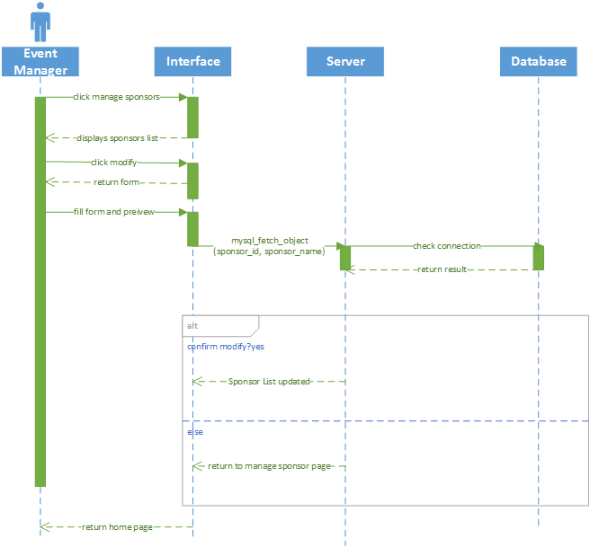

### 3.1.9 View Schedule

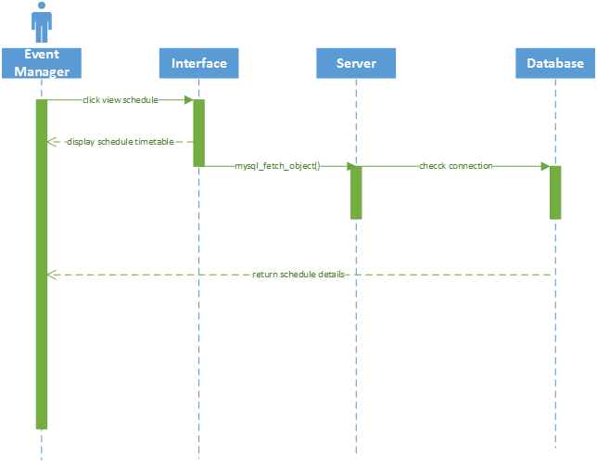

### 3.1.10 View Session Details

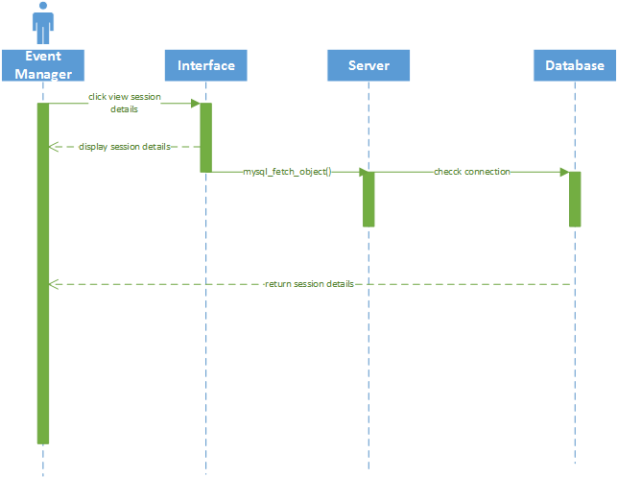

### 3.1.11 Add Session

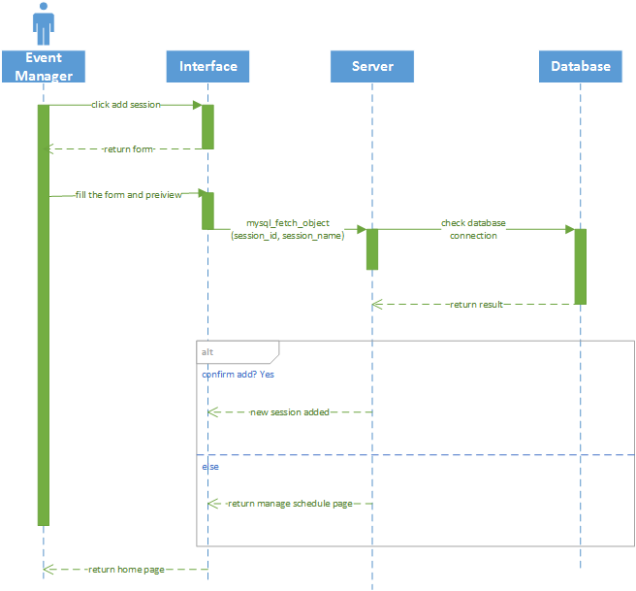

### 3.1.12 Delete Session

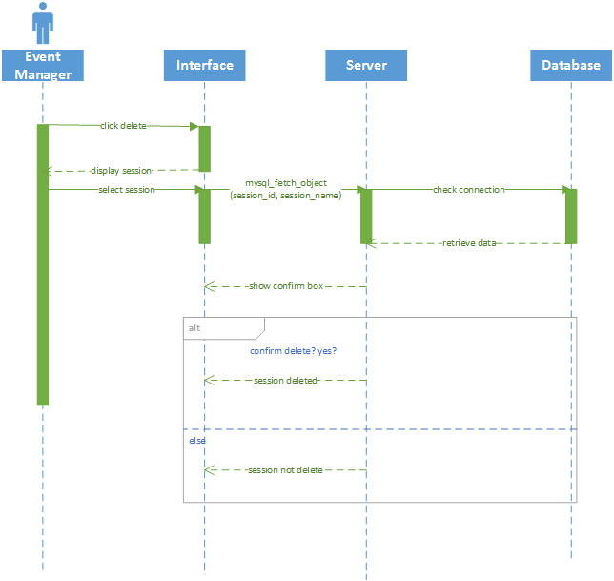

### 3.1.13 Modify Session

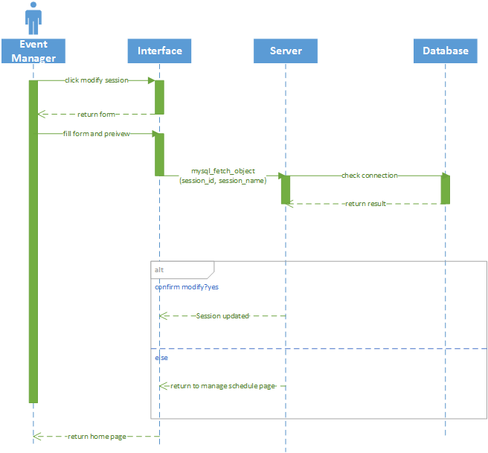

### 3.1.14 Add Venue

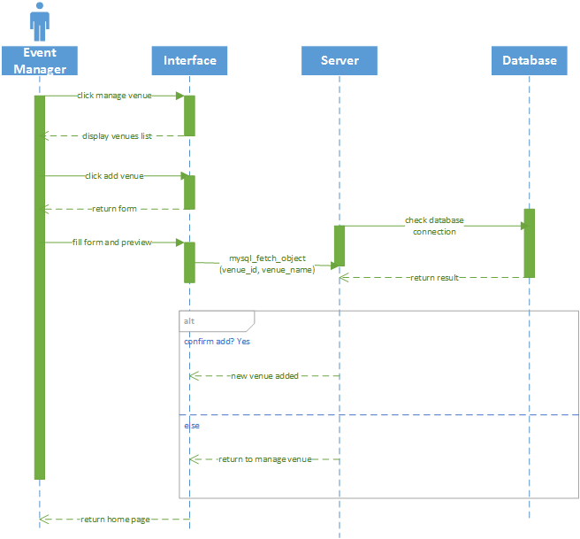

### 3.1.15 Delete Venue

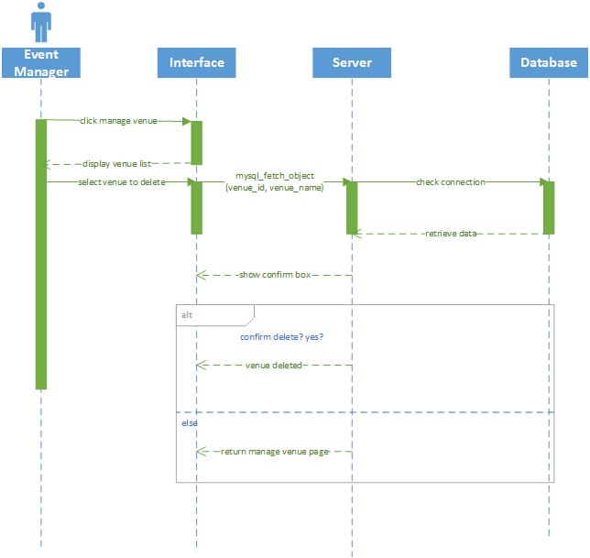

### 3.1.16 Modify venue

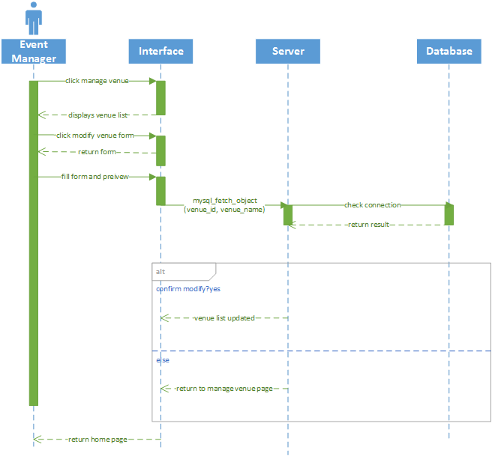

### 3.1.17 View Room

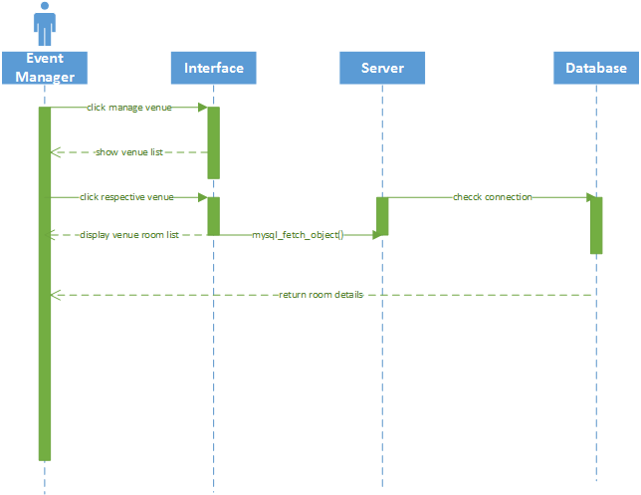

### 3.1.18 Add Room

### 

### 3.1.19 Delete Room

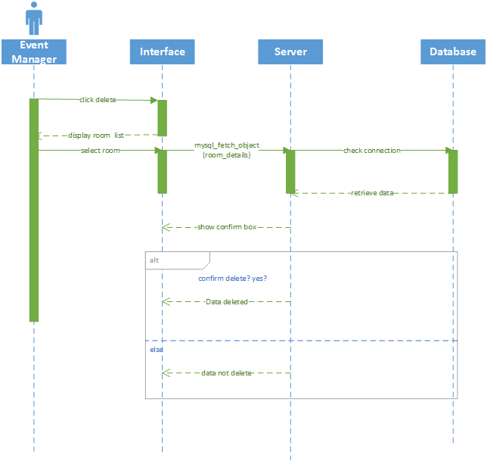

### 3.1.20 Modify Room

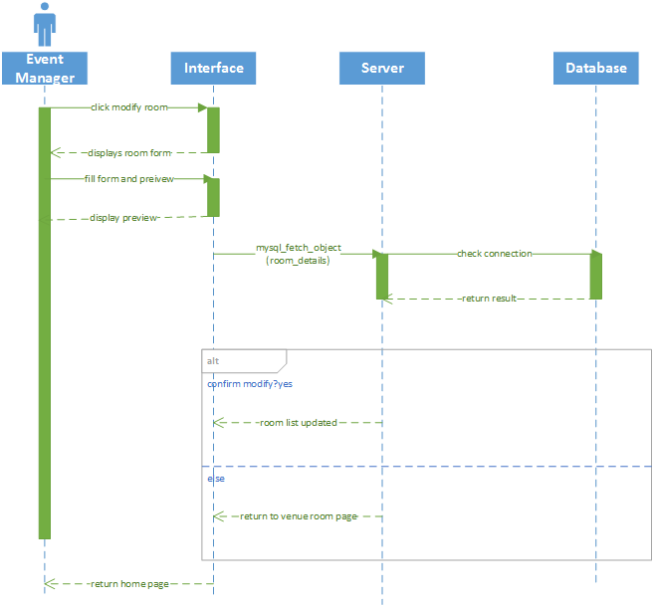

### 3.1.21 Add Speaker

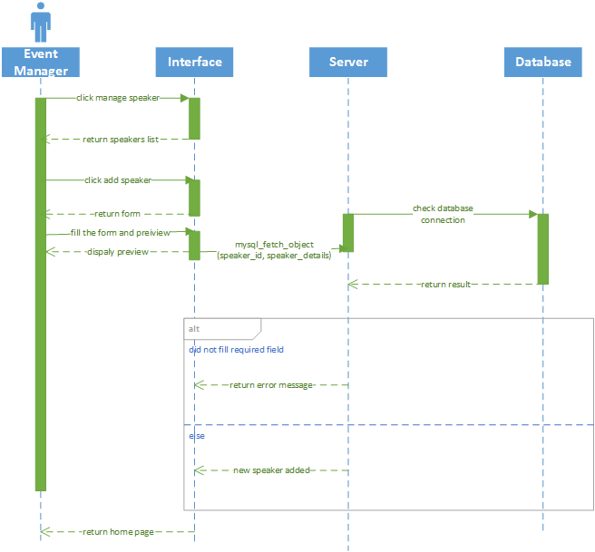

### 3.1.22 Delete Speaker

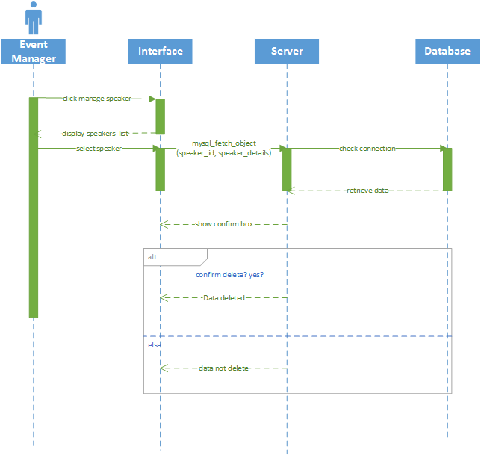

### 3.1.23 Modify Speaker

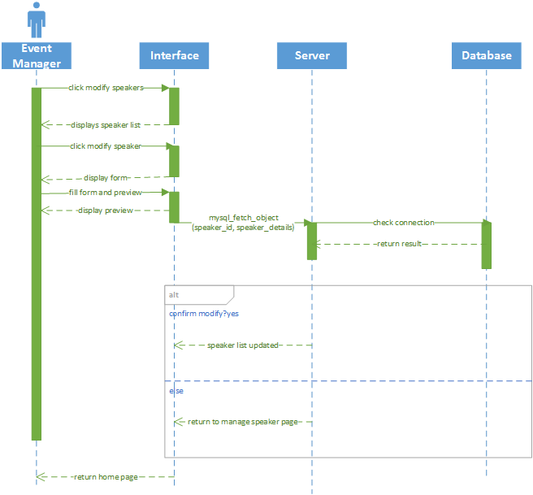

### 3.1.24 Add Caterer

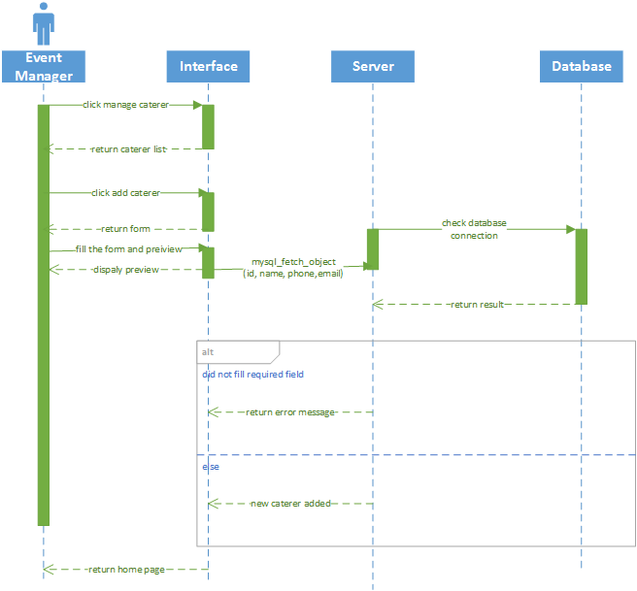

### 3.1.25 Delete Caterer

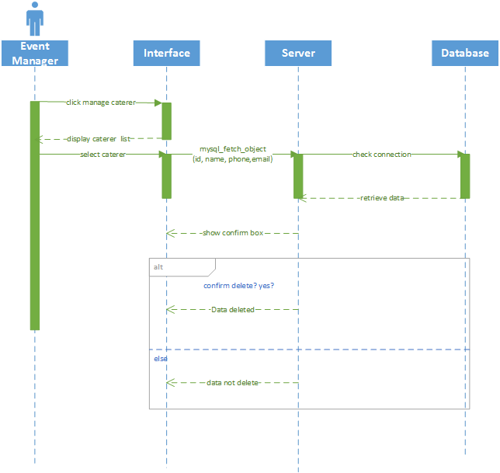

### 3.1.26 Modify Caterer

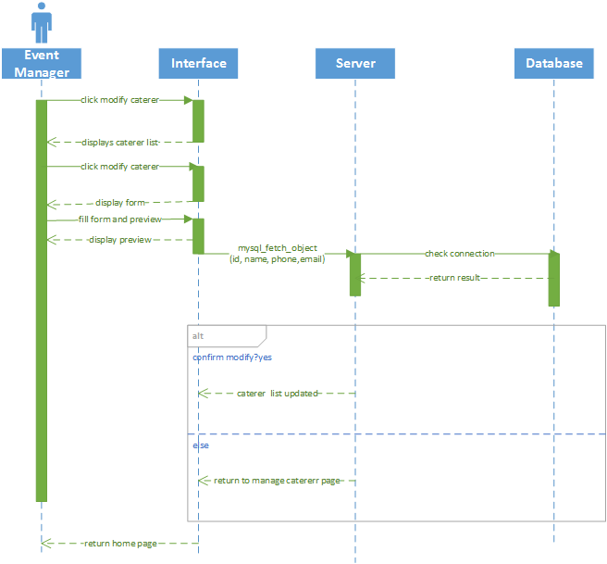

### 3.1.27 View Conference

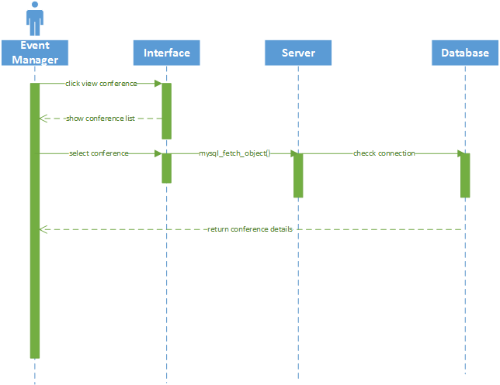

### 3.1.28 Generate Conference Registration Summary

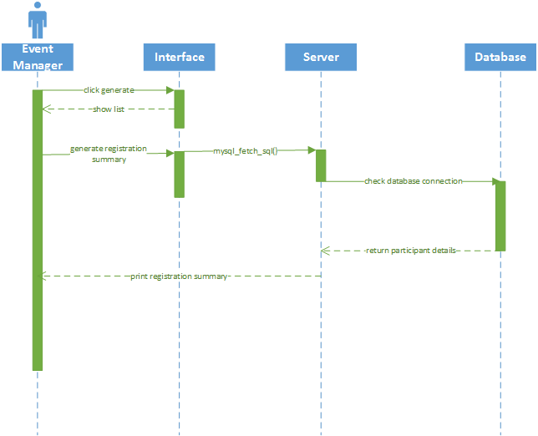

### 3.1.29 User Management

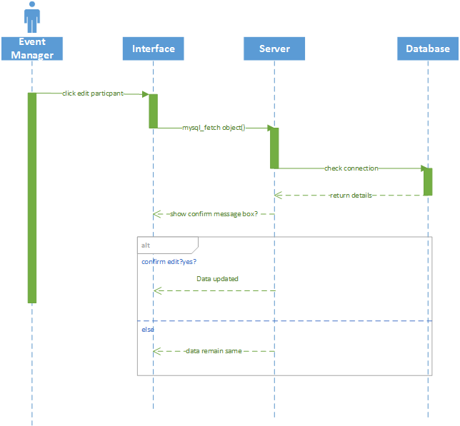

### 3.1.30 Generate Participants Checklist

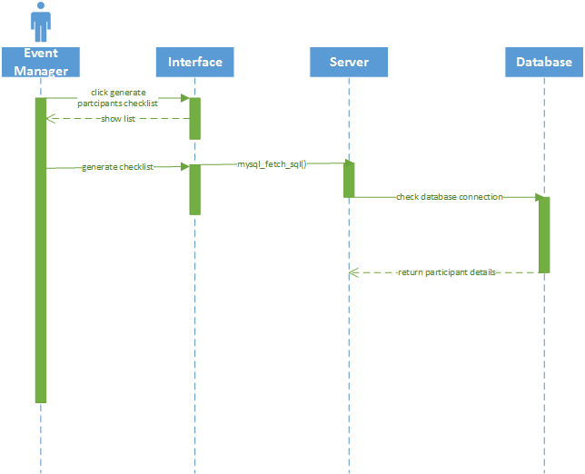

### 3.1.31 Generate Guest List

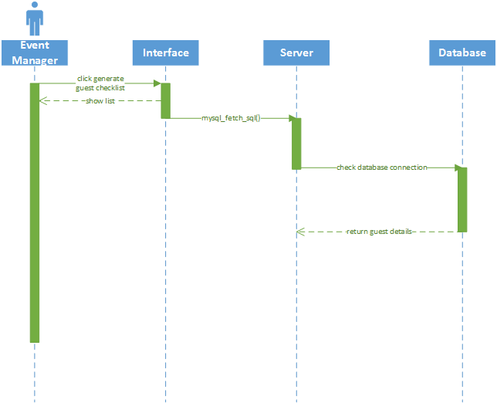

### 3.1.32 Generate Sponsors List

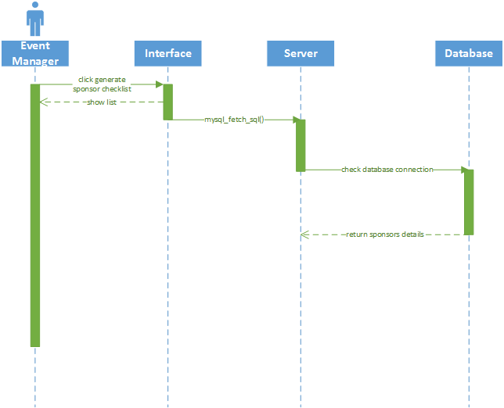

### 3.1.33 Generate Speakers List

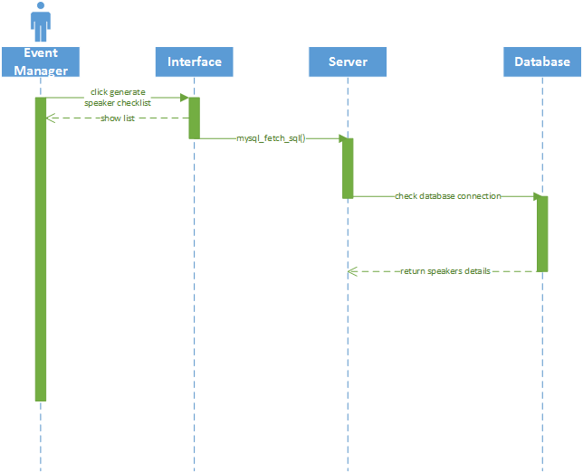

### 3.1.34 Generate Feedback Report

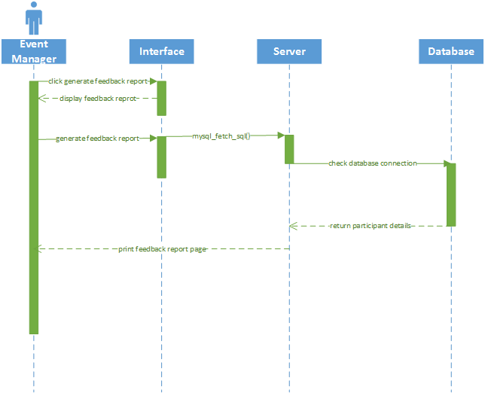

## 3.2 Conference Participant

### 3.2.1 Login

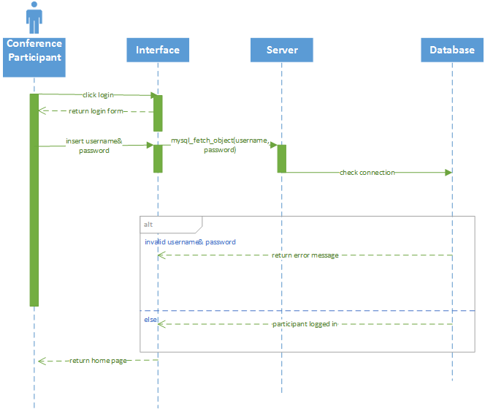

### 3.2.2 Logout

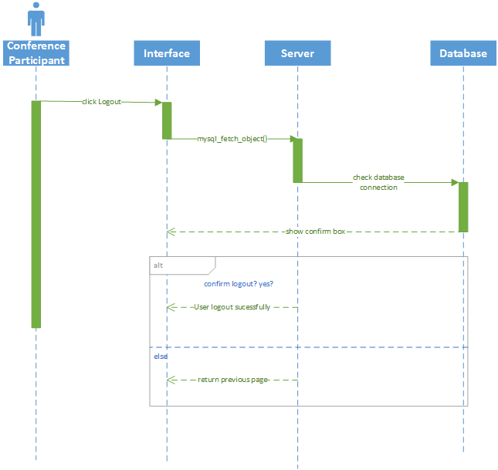

### 3.2.3 Registration

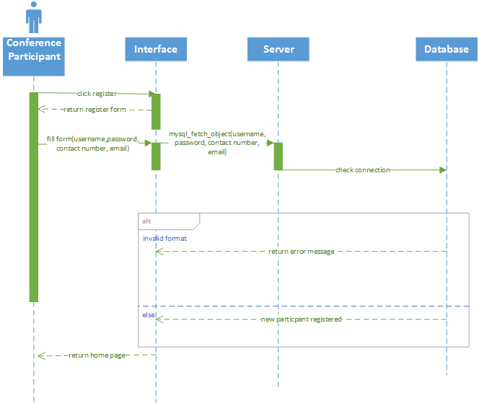

### 3.2.4 View Schedule

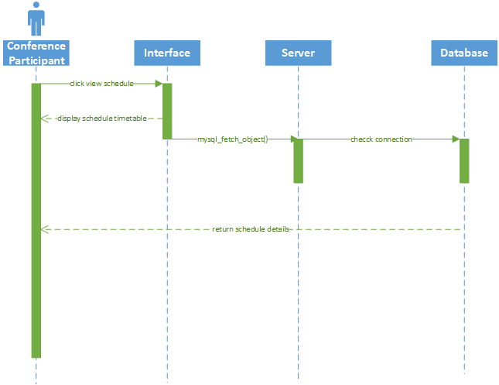

### 3.2.5 View session details

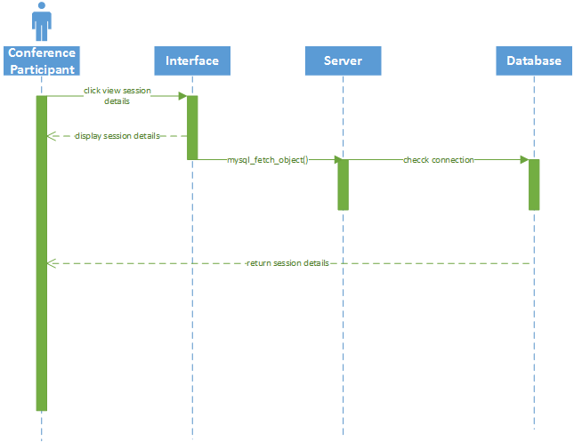

### 3.2.6 View Speaker

### 

### 3.2.7 Make Conference Booking

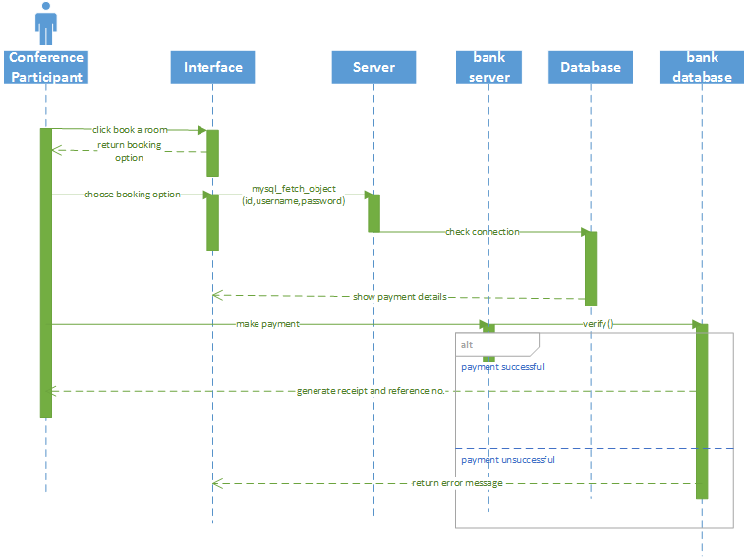

### 3.2.8 Transfer Conference Booking

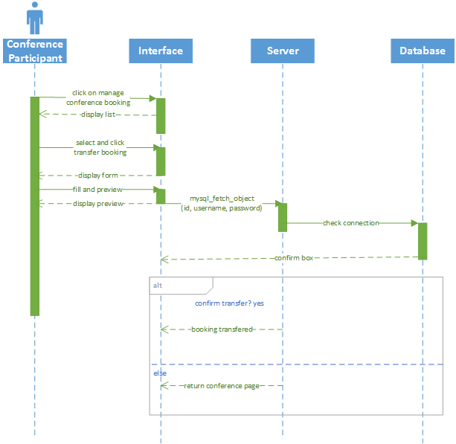

### 3.2.9 Cancel Conference Booking

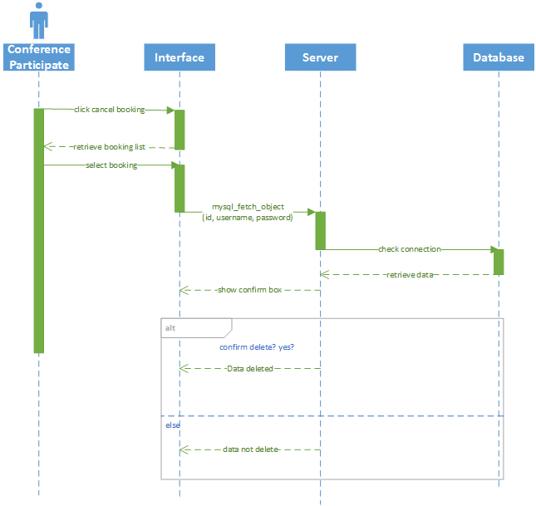

### 3.2.10 Book Hotel

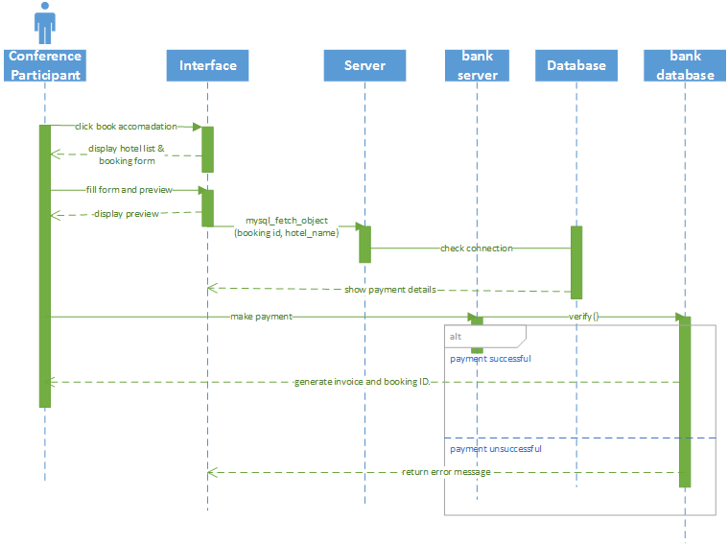

### 3.2.11 Book Tour

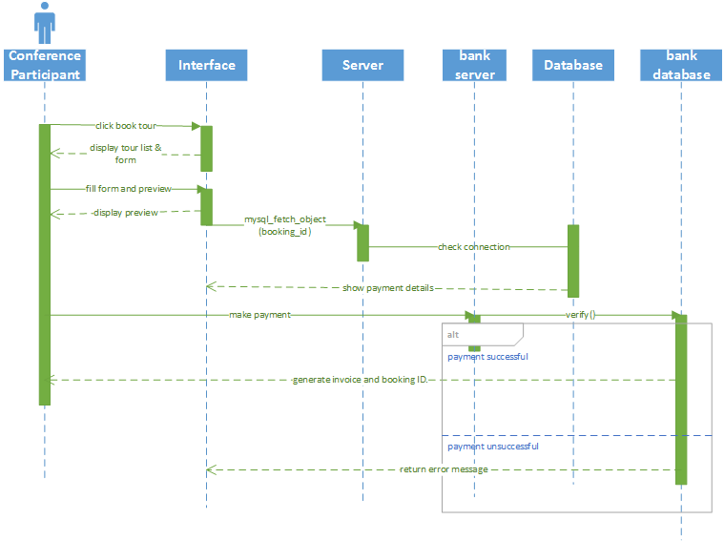

### 3.2.12 Modify Hotel Booking

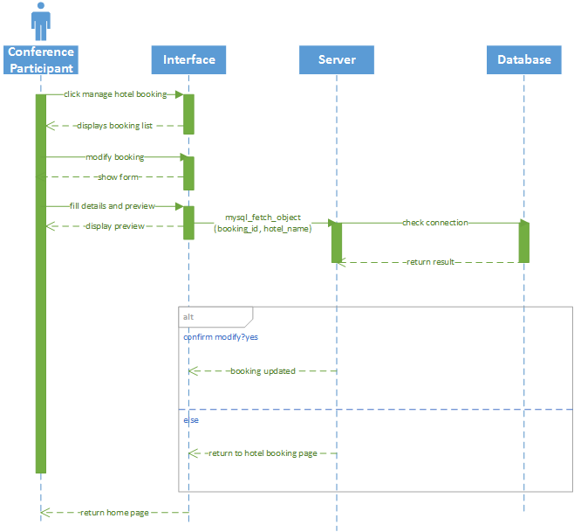

### 3.2.13 Cancel Hotel Booking

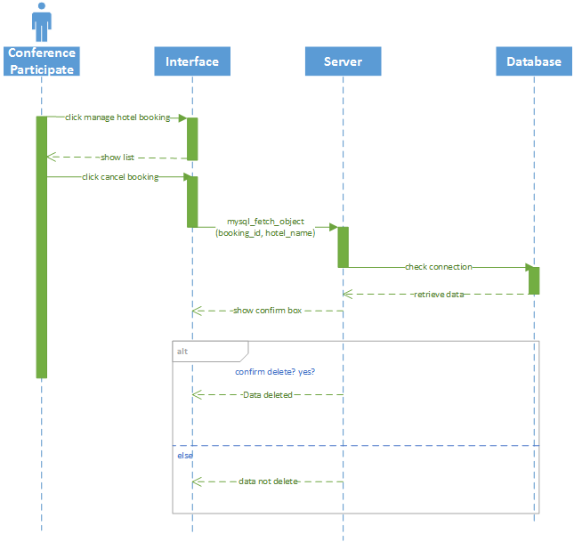

### 3.2.14 Provide Feedback

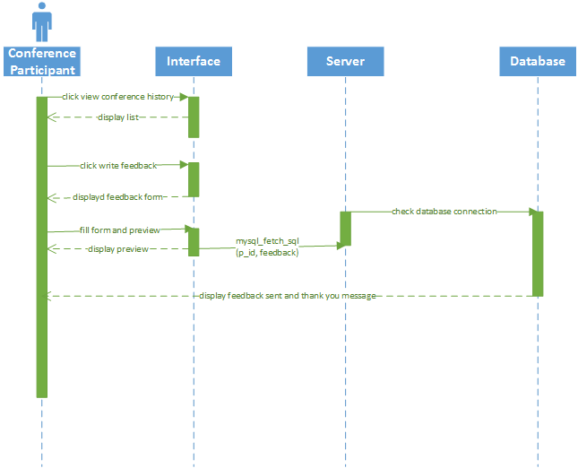

### 3.2.15 Enquire about conference

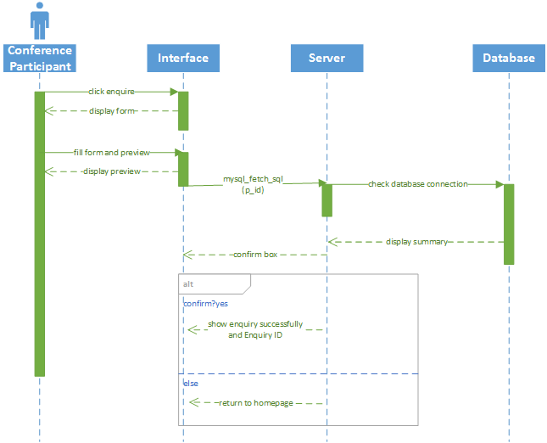

# 4.0 Functional Requirements

## 4.1 Use Cases

List of use cases:

Event manager

1. Login
2. Logout
3. Add conference
4. Delete conference
5. Modify conference
6. Add sponsors
7. Delete sponsors
8. Modify sponsors
9. Add session
10. Delete session
11. Modify session
12. Add venue
13. Delete venue
14. Modify venue
15. Add speaker
16. Delete speaker
17. Modify speaker
18. Add caterer
19. Delete caterer
20. Modify caterer
21. View schedule
22. View session details
23. View conference
24. Generate conference registration summary
25. Generate participant list
26. Generate sponsors list
27. Generate speaker list
28. Generate feedback report
29. User management

User (participant)

1. Login
2. Logout
3. View schedule
4. View session details
5. View speaker
6. Register
7. Make conference booking
8. Transfer conference booking
9. Cancel conference booking
10. Book hotel
11. Book tour
12. Modify hotel booking
13. Cancel hotel booking
14. View hotel booking
15. Provide feedback
16. Enquire about conference

## 4.1.1 Event Manager

Use Case: Login

|  |  |
| --- | --- |
| Use Case Name | Login |
| Actor | Project Event Manager |
| Precondition | - |
| Post Condition / Success Guarantee | Project Event Manager successfully logs in to the account |
| Success Scenario | 1. Project Event Manager opens the login page of the portal. 2. Web page shows login form. 3. Project Event Manager keys in username and password and clicks Submit. 4. Web page logs into Project Event Manager account. |
| Extension | 4a) Project Event Manager entered invalid user name or password  4a1) Web page displays “Incorrect username or password” |

Use Case: Logout

|  |  |
| --- | --- |
| Use Case Name | Logout |
| Actor | Project Event Manager |
| Precondition | Project Event manager is logged in to the portal |
| Post Condition / Success Guarantee | Project Event manager successfully logs out from the portal |
| Success Scenario | 1. Project Event Manager clicks the Logout button. 2. Web page displays confirmation message for logout. 3. Project Event Manager clicks Confirm. 4. Web page logs out from Project Event Manager account. |
| Extension | 3a) Project Event Manager clicks Cancel  3a1) Web page returns to the previous page |

Use Case: Add Conference

|  |  |
| --- | --- |
| Use Case Name | Add Conference |
| Actor | Project Event Manager |
| Precondition | Project Event Manager has logged into his account |
| Post Condition / Success Guarantee | Project Event Manager successfully adds a conference event |
| Success Scenario | 1. Project Event Manager clicks on Add Conference. 2. Web page shows Add New Conference form. 3. Project Event Manager fills in conference details and clicks Submit. 4. Web page shows a selection of design templates for the conference. 5. Project Event Manager chooses from the template or uploads a custom picture and clicks Confirm. 6. Web page displays the preview page. 7. Project Event Manager clicks Confirm to add the conference event. |
| Extension | 4a) Project Event Manager did not enter all required fields.  4a1) Web page displays “Please fill in required fields”.  4b) Project Event Manager enters wrong format in the field.  4b1) Web page displays “Invalid format”.  7a) Project Event Manager clicks Modify  7a1) Web page returns to step 2.  7b) Project Event Manager clicks Cancel  7b1) Web page returns to User Account page. |

Use Case: Edit Conference

|  |  |
| --- | --- |
| Use Case Name | Edit Conference |
| Actor | Project Event Manager |
| Precondition | Project Event Manager has logged into his account  Project Event Manager is viewing the conference page |
| Post Condition / Success Guarantee | Project Event Manager successfully edits the conference event |
| Success Scenario | 1. Project Event Manager clicks on Edit Conference. 2. Web page shows Edit Existing Conference form. 3. Project Event Manager fills in new conference details and clicks Submit. 4. Web page shows a selection of design templates for the conference. 5. Project Event Manager chooses from the template or uploads a custom picture and clicks Confirm. 6. Web page displays the preview page. 7. Project Event Manager clicks Confirm to apply the changes to the conference event. |
| Extension | 4a) Project Event Manager did not enter all required fields.  4a1) Web page displays “Please fill in required fields”.  4b) Project Event Manager enters wrong format in the field.  4b1) Web page displays “Invalid format”.  7a) Project Event Manager clicks Modify.  7a1) Web page returns to step 2.  7b) Project Event Manager clicks Cancel  7b1) Web page returns to User Account page. |

Use Case: Remove Conference

|  |  |
| --- | --- |
| Use Case Name | Remove Conference |
| Actor | Project Event Manager |
| Precondition | Project Event Manager has logged into his account  Project Event Manager is viewing the conference page |
| Post Condition / Success Guarantee | Project Event Manager successfully removes the conference event |
| Success Scenario | 1. Project Event Manager clicks on Remove Conference. 2. Web page displays confirmation message for event removal. 3. Project Event Manager clicks Confirm. |
| Extension | 3a) Project Event Manager clicks Cancel.  3a1) Web page returns to View Conference page. |

Use Case: Add Sponsor

|  |  |
| --- | --- |
| Use Case Name | Add Sponsor |
| Actor | Project Event Manager |
| Precondition | Project Event Manager has logged into his account  Project Event Manager is viewing the conference page |
| Post Condition / Success Guarantee | Project Event Manager successfully adds sponsors to the conference event |
| Success Scenario | 1. Project Event Manager clicks on Manage Sponsors. 2. Web page displays sponsors list. 3. Project Event Manager clicks on Add Sponsors. 4. Web page displays Add New Sponsors form. 5. Project Event Manager fills in the form and clicks Preview. 6. Web page displays sponsor details preview. 7. Project Event Manager clicks Confirm. 8. Web page displays New Sponsors Added. |
| Extension | 5a) Project Event Manager clicks Cancel.  5a1) Web page returns to Manage Sponsors page.  5b) Project Event Manager clicks Clear.  5b1) All fields in the form are cleared.  5c) Mandatory fields are not filled.  5c1) Web page displays Please fill in mandatory fields.  5d) Invalid format typed in the field.  5d1) Web page displays Please use the correct format.  7a) Project Event Manager clicks Back.  7a1) Return to Step 2.  7b) Project Event Manager clicks Cancel.  7b2) Web page returns to Manage Sponsors page. |

Use Case: Delete Sponsor

|  |  |
| --- | --- |
| Use Case Name | Delete Sponsor |
| Actor | Project Event Manager |
| Precondition | Project Event Manager has logged into his account  Project Event Manager is viewing the conference page |
| Post Condition / Success Guarantee | Project Event Manager successfully deletes sponsor from the conference event |
| Success Scenario | 1. Project Event Manager clicks on Manage Sponsors. 2. Web page displays sponsor list. 3. Project Event Manager selects the sponsor and clicks Delete. 4. Web page displays confirmation for deletion of selected sponsors. 5. Project Event Manager clicks Confirm. 6. Web page displays Sponsors Deleted. |
| Extension | 4a) No sponsors selected  4a1) Web page displays Please select at least 1 sponsor  5a) Project Event Manager clicks Cancel.  5b2) Web page returns to Manage Sponsors page. |

Use Case: Modify Sponsors

|  |  |
| --- | --- |
| Use Case Name | Modify Sponsors |
| Actor | Project Event Manager |
| Precondition | Project Event Manager has logged into his account  Project Event Manager is viewing the conference page |
| Post Condition / Success Guarantee | Project Event Manager successfully modifies sponsor for the conference event |
| Success Scenario | 1. Project Event Manager clicks on Manage Sponsors. 2. Web page displays sponsors list. 3. Project Event Manager clicks on Modify Sponsor. 4. Web page displays Modify Sponsor form. 5. Project Event Manager fills in the form and clicks Preview. 6. Web page displays sponsor details preview. 7. Project Event Manager clicks Confirm. 8. Web page displays Sponsor Modified. |
| Extension | 5a) Project Event Manager clicks Cancel.  5a1) Web page returns to Manage Sponsors page.  5b) Project Event Manager clicks Clear.  5b1) All fields in the form are cleared.  5c) Mandatory fields are not filled.  5c1) Web page displays Please fill in mandatory fields.  5d) Invalid format typed in the field.  5d1) Web page displays Please use the correct format.  7a) Project Event Manager clicks Back.  7a1) Return to Step 2.  7b) Project Event Manager clicks Cancel.  7b2) Web page returns to Manage Sponsors page. |

Use Case: View Schedule

|  |  |
| --- | --- |
| Use Case Name | View Schedule |
| Actor | Project Event Manager |
| Precondition | Project Event Manager has logged into his account  Project Event Manager is viewing the conference page |
| Post Condition / Success Guarantee | Project Event Manager successfully view schedule for the conference event |
| Success Scenario | 1. Project Event Manager clicks on View Schedule. 2. Web page displays schedule timetable. |
| Extension | 2a) No session in the schedule  2a1) Web page displays No Sessions Available |

Use Case: View session details

|  |  |
| --- | --- |
| Use Case Name | View Session Details |
| Actor | Project Event Manager |
| Precondition | Project Event Manager has logged into his account  Project Event Manager is viewing the schedule page |
| Post Condition / Success Guarantee | Project Event Manager successfully views session of the conference event |
| Success Scenario | 1. Project Event Manager clicks on View Details for a session in the schedule. 2. Web page displays Session Details. |
| Extension | - |

Use Case: Add session

|  |  |
| --- | --- |
| Use Case Name | Add Session |
| Actor | Project Event Manager |
| Precondition | Project Event Manager has logged into his account  Project Event Manager is viewing the schedule page |
| Post Condition / Success Guarantee | Project Event Manager successfully adds session to the conference event |
| Success Scenario | 1. Project Event Manager clicks on Add Session. 2. Web page displays Add Session form. 3. Project Event Manager fills in the form and clicks Preview. 4. Web page displays session details preview. 5. Project Event Manager clicks Confirm. 6. Web page displays New Session Added. |
| Extension | 3a) Project Event Manager clicks Cancel.  3a1) Web page returns to Manage Schedule page.  3b) Project Event Manager clicks Clear.  3b1) All fields in the form are cleared.  3c) Mandatory fields are not filled.  3c1) Web page displays Please fill in mandatory fields.  3d) Invalid format typed in the field.  3d1) Web page displays Please use the correct format.  5a) Project Event Manager clicks Back.  5a1) Return to Step 2.  5b) Project Event Manager clicks Cancel.  5b2) Web page returns to Manage Schedule page. |

 Use Case: Delete session

|  |  |
| --- | --- |
| Use Case Name | Delete Session |
| Actor | Project Event Manager |
| Precondition | Project Event Manager has logged into his account  Project Event Manager is viewing the schedule page |
| Post Condition / Success Guarantee | Project Event Manager successfully deletes session from the conference event |
| Success Scenario | 1. Project Event Manager selects the sessions and clicks Delete. 2. Web page displays confirmation for deletion of selected sessions. 3. Project Event Manager clicks Confirm. 4. Web page displays Sessions Deleted. |
| Extension | 2a) No sessions selected  2a1) Web page displays Please select at least 1 session  3a) Project Event Manager clicks Cancel.  3b2) Web page returns to Manage Schedule page. |

Use Case: Modify session

|  |  |
| --- | --- |
| Use Case Name | Modify Session |
| Actor | Project Event Manager |
| Precondition | Project Event Manager has logged into his account  Project Event Manager is viewing the schedule page |
| Post Condition / Success Guarantee | Project Event Manager successfully modifies session for the conference event |
| Success Scenario | 1. Project Event Manager clicks on Modify Session. 2. Web page displays Modify Session form. 3. Project Event Manager fills in the form and clicks Preview. 4. Web page displays session details preview. 5. Project Event Manager clicks Confirm. 6. Web page displays Session Modified. |
| Extension | 3a) Project Event Manager clicks Cancel.  3a1) Web page returns to Manage Schedule page.  3b) Project Event Manager clicks Clear.  3b1) All fields in the form are cleared.  3c) Mandatory fields are not filled.  3c1) Web page displays Please fill in mandatory fields.  3d) Invalid format typed in the field.  3d1) Web page displays Please use the correct format.  5a) Project Event Manager clicks Back.  5a1) Return to Step 2.  5b) Project Event Manager clicks Cancel.  5b2) Web page returns to Manage Schedule page. |

 Use Case: Add venue

|  |  |
| --- | --- |
| Use Case Name | Add Venue |
| Actor | Project Event Manager |
| Precondition | Project Event Manager has logged into his account  Project Event Manager is viewing the conference page |
| Post Condition / Success Guarantee | Project Event Manager successfully adds venue to the conference event |
| Success Scenario | 1. Project Event Manager clicks on Manage Venue. 2. Web page displays list of venues. 3. Project Event Manager clicks on Add Venue. 4. Web page displays Add Venue form. 5. Project Event Manager fills in the form and clicks Preview. 6. Web page displays venue details preview. 7. Project Event Manager clicks Confirm. 8. Web page displays New Venue Added. |
| Extension | 5a) Project Event Manager clicks Cancel.  5a1) Web page returns to Manage Venue page.  5b) Project Event Manager clicks Clear.  5b1) All fields in the form are cleared.  5c) Mandatory fields are not filled.  5c1) Web page displays Please fill in mandatory fields.  5d) Invalid format typed in the field.  5d1) Web page displays Please use the correct format.  7a) Project Event Manager clicks Back.  7a1) Return to Step 2.  7b) Project Event Manager clicks Cancel.  7b2) Web page returns to Manage Schedule page. |

 Use Case: Delete venue

|  |  |
| --- | --- |
| Use Case Name | Delete Venue |
| Actor | Project Event Manager |
| Precondition | Project Event Manager has logged into his account  Project Event Manager is viewing the conference page |
| Post Condition / Success Guarantee | Project Event Manager successfully deletes venue from the conference event |
| Success Scenario | 1. Project Event Manager clicks on Manage Venue. 2. Web page displays list of venues. 3. Project Event Manager selects the venues and clicks Delete. 4. Web page displays confirmation for deletion of selected venues. 5. Project Event Manager clicks Confirm. 6. Web page displays Venues Deleted. |
| Extension | 4a) No sessions selected  4a1) Web page displays Please select at least 1 session  5a) Project Event Manager clicks Cancel.  5b2) Web page returns to Manage Venue page. |

Use Case: Modify venue

|  |  |
| --- | --- |
| Use Case Name | Modify Venue |
| Actor | Project Event Manager |
| Precondition | Project Event Manager has logged into his account  Project Event Manager is viewing the conference page |
| Post Condition / Success Guarantee | Project Event Manager successfully modifies session for the conference event |
| Success Scenario | 1. Project Event Manager clicks on Manage Venues. 2. Web page displays list of venues. 3. Project Event Manager clicks on Modify Venue. 4. Web page displays Modify Venue form. 5. Project Event Manager fills in the form and clicks Preview. 6. Web page displays venue details preview. 7. Project Event Manager clicks Confirm. 8. Web page displays Venue Modified. |
| Extension | 5a) Project Event Manager clicks Cancel.  5a1) Web page returns to Manage Venue page.  5b) Project Event Manager clicks Clear.  5b1) All fields in the form are cleared.  5c) Mandatory fields are not filled.  5c1) Web page displays Please fill in mandatory fields.  5d) Invalid format typed in the field.  5d1) Web page displays Please use the correct format.  7a) Project Event Manager clicks Back.  7a1) Return to Step 2.  7b) Project Event Manager clicks Cancel.  7b2) Web page returns to Manage Venue page. |

Use Case: View room

|  |  |
| --- | --- |
| Use Case Name | View Room |
| Actor | Project Event Manager |
| Precondition | Project Event Manager has logged into his account  Project Event Manager is viewing the conference page |
| Post Condition / Success Guarantee | Project Event Manager successfully views the room of a venue |
| Success Scenario | 1. Project Event Manager clicks on Manage Venue. 2. Web page displays list of venues. 3. Project Event Manager clicks on the respective venue. 4. Web page displays a list of venue rooms. |
| Extension | 2a) No venues created  2a1) Web page displays No Venues Available  4a) No rooms created  4a1) Web page displays No Rooms Available |

Use Case: Add room

|  |  |
| --- | --- |
| Use Case Name | Add Room |
| Actor | Project Event Manager |
| Precondition | Project Event Manager has logged into his account  Project Event Manager is viewing the venue rooms page |
| Post Condition / Success Guarantee | Project Event Manager successfully adds room to the venue of conference event |
| Success Scenario | 1. Project Event Manager clicks on Add Room. 2. Web page displays Add Room form. 3. Project Event Manager fills in the form and clicks Preview. 4. Web page displays room details preview. 5. Project Event Manager clicks Confirm. 6. Web page displays New Room Added. |
| Extension | 3a) Project Event Manager clicks Cancel.  3a1) Web page returns to Venue Rooms page.  3b) Project Event Manager clicks Clear.  3b1) All fields in the form are cleared.  3c) Mandatory fields are not filled.  3c1) Web page displays Please fill in mandatory fields.  3d) Invalid format typed in the field.  3d1) Web page displays Please use the correct format.  5a) Project Event Manager clicks Back.  5a1) Return to Step 2.  5b) Project Event Manager clicks Cancel.  5b2) Web page returns to Venue Rooms page. |

 Use Case: Delete room

|  |  |
| --- | --- |
| Use Case Name | Delete Room |
| Actor | Project Event Manager |
| Precondition | Project Event Manager has logged into his account  Project Event Manager is viewing the venue rooms page |
| Post Condition / Success Guarantee | Project Event Manager successfully deletes room from the venue |
| Success Scenario | 1. Project Event Manager selects the rooms and clicks Delete. 2. Web page displays confirmation for deletion of selected venues. 3. Project Event Manager clicks Confirm. 4. Web page displays Rooms Deleted. |
| Extension | 2a) No sessions selected  2a1) Web page displays Please select at least 1 session  3a) Project Event Manager clicks Cancel.  3b2) Web page returns to Venue Rooms page. |

Use Case: Modify room

|  |  |
| --- | --- |
| Use Case Name | Modify Room |
| Actor | Project Event Manager |
| Precondition | Project Event Manager has logged into his account  Project Event Manager is viewing the venue rooms page |
| Post Condition / Success Guarantee | Project Event Manager successfully modifies room from the venue |
| Success Scenario | 1. Project Event Manager clicks on Modify Room. 2. Web page displays Modify Room form. 3. Project Event Manager fills in the form and clicks Preview. 4. Web page displays room details preview. 5. Project Event Manager clicks Confirm. 6. Web page displays Room Modified. |
| Extension | 3a) Project Event Manager clicks Cancel.  3a1) Web page returns to Venue Rooms page.  3b) Project Event Manager clicks Clear.  3b1) All fields in the form are cleared.  3c) Mandatory fields are not filled.  3c1) Web page displays Please fill in mandatory fields.  3d) Invalid format typed in the field.  3d1) Web page displays Please use the correct format.  5a) Project Event Manager clicks Back.  5a1) Return to Step 2.  5b) Project Event Manager clicks Cancel.  5b2) Web page returns to Venue Rooms page. |

Use Case: Add speaker

|  |  |
| --- | --- |
| Use Case Name | Add Speaker |
| Actor | Project Event Manager |
| Precondition | Project Event Manager has logged into his account  Project Event Manager is viewing the session details page |
| Post Condition / Success Guarantee | Project Event Manager successfully adds speaker to session |
| Success Scenario | 1. Project Event Manager clicks on Manage Speakers. 2. Web page displays speakers list. 3. Project Event Manager clicks on Add Speaker. 4. Web page displays Add New Speaker form. 5. Project Event Manager fills in the form and clicks Preview. 6. Web page displays speaker details preview. 7. Project Event Manager clicks Confirm. 8. Web page displays New Speaker Added. |
| Extension | 5a) Project Event Manager clicks Cancel.  5a1) Web page returns to Manage Speakers page.  5b) Project Event Manager clicks Clear.  5b1) All fields in the form are cleared.  5c) Mandatory fields are not filled.  5c1) Web page displays Please fill in mandatory fields.  5d) Invalid format typed in the field.  5d1) Web page displays Please use the correct format.  7a) Project Event Manager clicks Back.  7a1) Return to Step 2.  7b) Project Event Manager clicks Cancel.  7b2) Web page returns to Manage Speakers page. |

Use Case: Delete speaker

|  |  |
| --- | --- |
| Use Case Name | Delete Speaker |
| Actor | Project Event Manager |
| Precondition | Project Event Manager has logged into his account  Project Event Manager is viewing the session details page |
| Post Condition / Success Guarantee | Project Event Manager successfully deletes speaker from the session |
| Success Scenario | 1. Project Event Manager clicks on Manage Speakers. 2. Web page displays speakers list. 3. Project Event Manager selects the speakers and clicks Delete. 4. Web page displays confirmation for deletion of selected speakers. 5. Project Event Manager clicks Confirm. 6. Web page displays Speakers Deleted. |
| Extension | 4a) No speakers selected  4a1) Web page displays Please select at least 1 speaker  5a) Project Event Manager clicks Cancel.  5b2) Web page returns to Manage Speakers page. |

Use Case: Modify Speaker

|  |  |
| --- | --- |
| Use Case Name | Modify Speaker |
| Actor | Project Event Manager |
| Precondition | Project Event Manager has logged into his account  Project Event Manager is viewing the session details page |
| Post Condition / Success Guarantee | Project Event Manager successfully modifies speaker for the session |
| Success Scenario | 1. Project Event Manager clicks on Manage Speakers. 2. Web page displays speakers list. 3. Project Event Manager clicks on Modify Speaker. 4. Web page displays Modify Speaker form. 5. Project Event Manager fills in the form and clicks Preview. 6. Web page displays speaker details preview. 7. Project Event Manager clicks Confirm. 8. Web page displays Speaker Modified. |
| Extension | 5a) Project Event Manager clicks Cancel.  5a1) Web page returns to Manage Speakers page.  5b) Project Event Manager clicks Clear.  5b1) All fields in the form are cleared.  5c) Mandatory fields are not filled.  5c1) Web page displays Please fill in mandatory fields.  5d) Invalid format typed in the field.  5d1) Web page displays Please use the correct format.  7a) Project Event Manager clicks Back.  7a1) Return to Step 2.  7b) Project Event Manager clicks Cancel.  7b2) Web page returns to Manage Speakers page. |

Use Case: Add Caterer

|  |  |
| --- | --- |
| Use Case Name | Add Caterer |
| Actor | Project Event Manager |
| Precondition | Project Event Manager has logged into his account  Project Event Manager is viewing the conference page |
| Post Condition / Success Guarantee | Project Event Manager successfully adds caterer to the conference event |
| Success Scenario | 1. Project Event Manager clicks on Manage Caterers. 2. Web page displays caterers list. 3. Project Event Manager clicks on Add Caterer. 4. Web page displays Add New Caterer form. 5. Project Event Manager fills in the form and clicks Preview. 6. Web page displays caterer details preview. 7. Project Event Manager clicks Confirm. 8. Web page displays New Caterer Added. |
| Extension | 5a) Project Event Manager clicks Cancel.  5a1) Web page returns to Manage Caterer page.  5b) Project Event Manager clicks Clear.  5b1) All fields in the form are cleared.  5c) Mandatory fields are not filled.  5c1) Web page displays Please fill in mandatory fields.  5d) Invalid format typed in the field.  5d1) Web page displays Please use the correct format.  7a) Project Event Manager clicks Back.  7a1) Return to Step 2.  7b) Project Event Manager clicks Cancel.  7b2) Web page returns to Manage Caterer page. |

Use Case: Delete Caterer

|  |  |
| --- | --- |
| Use Case Name | Delete Caterer |
| Actor | Project Event Manager |
| Precondition | Project Event Manager has logged into his account  Project Event Manager is viewing the conference page |
| Post Condition / Success Guarantee | Project Event Manager successfully deletes caterer from the conference event |
| Success Scenario | 1. Project Event Manager clicks on Manage Caterer. 2. Web page displays caterers list. 3. Project Event Manager selects the caterers and clicks Delete. 4. Web page displays confirmation for deletion of selected caterers. 5. Project Event Manager clicks Confirm. 6. Web page displays Caterer Deleted. |
| Extension | 4a) No caterers selected  4a1) Web page displays Please select at least 1 caterer  5a) Project Event Manager clicks Cancel.  5b2) Web page returns to Manage Caterers page. |

Use Case: Modify Caterer

|  |  |
| --- | --- |
| Use Case Name | Modify Caterer |
| Actor | Project Event Manager |
| Precondition | Project Event Manager has logged into his account  Project Event Manager is viewing the conference page |
| Post Condition / Success Guarantee | Project Event Manager successfully modifies caterer for the conference event |
| Success Scenario | 1. Project Event Manager clicks on Manage Caterer. 2. Web page displays caterer list. 3. Project Event Manager clicks on Modify Caterer. 4. Web page displays Modify Caterer form. 5. Project Event Manager fills in the form and clicks Preview. 6. Web page displays caterer details preview. 7. Project Event Manager clicks Confirm. 8. Web page displays Caterer Modified. |
| Extension | 5a) Project Event Manager clicks Cancel.  5a1) Web page returns to Manage Caterer page.  5b) Project Event Manager clicks Clear.  5b1) All fields in the form are cleared.  5c) Mandatory fields are not filled.  5c1) Web page displays Please fill in mandatory fields.  5d) Invalid format typed in the field.  5d1) Web page displays Please use the correct format.  7a) Project Event Manager clicks Back.  7a1) Return to Step 2.  7b) Project Event Manager clicks Cancel.  7b2) Web page returns to Manage Caterer page. |

Use Case: View Conference

|  |  |
| --- | --- |
| Use Case Name | View Conference |
| Actor | Project Event Manager |
| Precondition | Project Event Manager has logged into his account |
| Post Condition / Success Guarantee | Project Event Manager successfully views the conference event |
| Success Scenario | 1. Project Event Manager clicks on View Conference. 2. Web page displays the View Conference page. |
| Extension | 2a) No conference events available  2a1)Web page displays No Conference Event available |

Use Case: Generate Conference Registration Summary

|  |  |
| --- | --- |
| Use Case Name | Generate Conference Registration Summary |
| Actor | Project Event Manager |
| Precondition | Project Event Manager has logged into his account  Project Event Manager is viewing the conference page |
| Post Condition / Success Guarantee | Project Event Manager successfully view the conference registration summary |
| Success Scenario | 1. Project Event Manager clicks on Generate Conference Registration Summary. 2. Web page displays the Registration Summary page. |
| Extension | 2a) No participants available in the conference  2a1) Web page displays No Participants Available |

Use Case: User Management

|  |  |
| --- | --- |
| Use Case Name | User Management |
| Actor | Project Event Manager |
| Precondition | Project Event Manager has logged into his account  Project Event Manager is viewing the registration summary |
| Post Condition / Success Guarantee | Project Event Manager successfully modified the participant details |
| Success Scenario | 1. Project Event Manager clicks on Edit for the respective participant. 2. Web page displays the User Management page. 3. Project Event Manager makes changes for desired participant details and clicks Save Changes. 4. Web page displays preview page for participant details. 5. Project Event Manager clicks confirm. 6. Web page returns to Registration Summary page and displays Changes Saved. |
| Extension | 3a) Project Event Manager clicks Cancel Changes  3a1) Web page returns to Registration Summary.  3b) Project Event Manager clicks Remove Participant  3b1) Web page displays confirmation for removal of participant.  3b1i) Project Event Manager clicks Confirm.  3b1i1) Web page returns to Registration Summary page and displays Participant Removed.  3b1ii) Project Event Manager clicks Cancel.  3b1i2) Web page returns to Registration Summary page  5a) Project Event Manager clicks Modify  5a1) Web page returns to step 2.  5b) Project Event Manager clicks Cancel  5b1) Web page returns to Registration Summary page. |

Use Case: Generate Participants Checklist

|  |  |
| --- | --- |
| Use Case Name | Generate Participants Checklist |
| Actor | Project Event Manager |
| Precondition | Project Event Manager has logged into his account  Project Event Manager is viewing the conference page |
| Post Condition / Success Guarantee | Project Event Manager successfully generate the participant checklist |
| Success Scenario | 1. Project Event Manager clicks on Generate Participants Checklist. 2. Web page displays the Participants Checklist page. |
| Extension | 2a) No participants  2a1) Web page shows No Participants |

Use Case: Generate Guests List

|  |  |
| --- | --- |
| Use Case Name | Generate Guest List |
| Actor | Project Event Manager |
| Precondition | Project Event Manager has logged into his account  Project Event Manager is viewing the conference page |
| Post Condition / Success Guarantee | Project Event Manager successfully generate the Guest List |
| Success Scenario | 1. Project Event Manager clicks on Generate Guest List. 2. Web page displays the Guest List page. |
| Extension | 2a) No guests  2a1) Web page shows No Guests |

Use Case: Generate Sponsors List

|  |  |
| --- | --- |
| Use Case Name | Generate Sponsors List |
| Actor | Project Event Manager |
| Precondition | Project Event Manager has logged into his account  Project Event Manager is viewing the conference page |
| Post Condition / Success Guarantee | Project Event Manager successfully generate the Sponsors List |
| Success Scenario | 1. Project Event Manager clicks on Generate Sponsors List. 2. Web page displays the Sponsors List page. |
| Extension | 2a) No sponsors  2a1) Web page shows No Sponsors |

Use Case: Generate Speakers List

|  |  |
| --- | --- |
| Use Case Name | Generate Speakers List |
| Actor | Project Event Manager |
| Precondition | Project Event Manager has logged into his account  Project Event Manager is viewing the conference page |
| Post Condition / Success Guarantee | Project Event Manager successfully view the Speakers List |
| Success Scenario | 1. Project Event Manager clicks on Generate Speakers List. 2. Web page displays the Speakers List page. |
| Extension | 2a) No speakers  2a1) Web page shows No Speakers |

Use case: Generate Feedback Report

|  |  |
| --- | --- |
| Use Case Name | Generate Feedback Report |
| Actor | Project Event Manager |
| Precondition | Project Event Manager has logged into his account  Project Event Manager is viewing the conference page |
| Post Condition / Success Guarantee | Project Event Manager successfully view the Feedback Report |
| Success Scenario | 1. Project Event Manager clicks on Generate Feedback Report. 2. Web page displays the Feedback Report page. |
| Extension | 2a) No feedback  2a1) Web page shows No Feedback |

## 4.1.2 Conference Participant

Use case: Login

|  |  |
| --- | --- |
| Use case name | Login |
| Actor | Conference Participant |
| Pre – condition | Conference Participant is registered and at the login page |
| Goal | To log into the system |
| Success Guarantee / Post Condition | The Conference Participant logged into the system successfully |
| Main Success Scenario | 1. Conference Participant entered his/her username and password and clicks login button 2. System will display a message that the actor had successfully logged into the system |
| Extension | 1a) Conference Participant clicks Cancel  1a1)System goes back to the home page  2a) Conference Participant entered invalid username or password  2a1) Web page displays Invalid Username/Password and returns to login page |

Use case: Logout

|  |  |
| --- | --- |
| Use case name | Logout |
| Actor | Conference Participant |
| Pre – condition | Conference Participant is logged in to the account |
| Goal | To log out of the system |
| Success Guarantee / Post Condition | The actor logged out of the system successfully |
| Main Success Scenario | 1. Conference Participant clicks the Logout button. 2. Web page displays confirmation message for logout. 3. Conference Participant clicks Confirm. 4. Web page logs out from Project Event Manager account. |
| Extension | 3a) Conference Participant clicks Cancel  3a1) Web page returns to the previous page |

Use case: Registration

|  |  |
| --- | --- |
| Use case name | Registration |
| Actor | Conference Participant |
| Pre – condition | Conference Participant is viewing the home page |
| Goal | To register as a conference participant |
| Success Guarantee / Post Condition | Conference Participant registered as a conference participant successfully |
| Main Success Scenario | 1. Conference Participant clicks Register button 2. Web page displays registration form 3. Conference Participant fills in the Registration form and clicks confirm 4. Web page displays the registration details summary. 5. Conference Participant clicks Confirm. 6. Web page displays User Successfully Registered. |
| Extension | 3a) Conference Participant clicks Cancel  3a1) Web page returns to the home page  3b) Conference Participant clicks Clear  3b1) Registration form is cleared  4a) Required details are not filled  4a1) Web page displays Please fill in required details  4b) Wrong format filled as input  4b1) Web page displays Invalid Format  5a) Conference Participant clicks Cancel  5a1) Return to home page  5b) Conference Participant clicks Modify  5b1) Return to step 2 |

Use Case: View schedule

|  |  |
| --- | --- |
| Use Case Name | View Schedule |
| Actor | Conference Participant |
| Precondition | Conference Participant has logged into his account |
| Post Condition / Success Guarantee | Conference Participant successfully views the schedule of his/her participated conference event |
| Success Scenario | 1. Conference Participant clicks on View Schedule. 2. Web page displays schedule timetable. |
| Extension | 2a) No participated conference session  2a1) Display no participated sessions |

Use Case: View session details

|  |  |
| --- | --- |
| Use Case Name | View Schedule Details |
| Actor | Conference Participant |
| Precondition | Conference Participant has logged into his account  Conference Participant is viewing his/her schedule of his/her participated conference event |
| Post Condition / Success Guarantee | Conference Participant successfully views the session details of his/her participated conference event |
| Success Scenario | 1. Conference Participant clicks on view session details. 2. Web page displays session details. |
| Extension | - |

Use Case: View speaker

|  |  |
| --- | --- |
| Use Case Name | View Schedule |
| Actor | Conference Participant |
| Precondition | Conference Participant has logged into his account  Project Event Manager is viewing the session details |
| Post Condition / Success Guarantee | Conference Participant successfully views the speaker for the session of his/her participated conference event |
| Success Scenario | 1. Conference Participant clicks on View Speaker. 2. Web page displays speaker details. |
| Extension | - |

Use case: Make Conference Booking

|  |  |
| --- | --- |
| Use case name | Make Conference Booking |
| Actor | Conference Participant |
| Pre – condition | Conference Participant is logged into his/her account  Conference Participant is viewing the home page |
| Goal | To make a conference booking |
| Success Guarantee / Post Condition | The Conference Participant successfully make a conference booking |
| Main Success Scenario | 1. Conference Participant clicks on Book Now button for the respective conference event 2. Web page displays conference event details and schedule 3. Conference Participant selects available conference event session and clicks Make a Booking 4. Web page displays Conference Booking form 5. Conference Participant fills in the Conference Booking form and clicks Preview 6. Web page shows the Conference Booking Summary. 7. Conference Participant clicks Confirm. 8. Web page shows Payment Details page. 9. Conference Participant chooses a payment method, fills in the details and clicks Make Transaction. 10. Web page shows Transaction Successful and generates invoice and booking ID. |
| Extension | 5a) Conference Participant clicks Clear.  5a1) Conference Booking form is cleared.  5b) Conference Participant clicks Cancel.  5b1) Web page returns to home page.  7a) Conference Participant clicks Back.  7a1) Web page returns to Conference Booking form.  7b) Conference Participant clicks Cancel.  7b1) Web page returns to home page.  9a) Conference Participant clicks Cancel.  9a1) Web page returns to home page.  10a) Payment not successful.  10a1) Web page displays Payment Not Successful and returns to Payment Details page. |

Use case: Transfer conference booking

|  |  |
| --- | --- |
| Use case name | Transfer Conference Booking |
| Actor | Conference Participant |
| Pre – condition | Conference Participant has logged into his/her account |
| Goal | To transfer a conference booking |
| Success Guarantee / Post Condition | The Conference Participant transfer a conference booking |
| Main Success Scenario | 1. Conference Participant clicks on Manage Conference Booking. 2. Web page displays a list of conference events and sessions. 3. Conference Participant selects the conference event session and clicks Transfer Booking. 4. Web page displays Transfer Booking Details Form. 5. Conference Participant fills in the Transfer Booking Details form and clicks preview. 6. Web page displays Transfer Booking Details Summary. 7. Conference Participant clicks Confirm. 8. Web page displays Conference Booking Transferred. |
| Extension | 2a) No participated conference sessions  2a1) Web page displays No Participated Conference Sessions.  5a) Conference Participant clicks Clear  6a1) Form is cleared.  5b) Conference Participant clicks Cancel.  6b1) Web page returns to Manage Conference Booking page.  6a) Required fields not filled  6a1) Web page displays Please fill in required fields.  6b) Invalid format input in the field  6b1) Web page displays Invalid Format.  7a) Conference Participant clicks Back  7a1) Web page returns to Transfer Booking Details Form.  7b) Conference Participant clicks Cancel  7b1) Web page returns to Manage Conference Booking page. |

Use case: Cancel Conference Booking

|  |  |
| --- | --- |
| Use case name | Cancel Conference Booking |
| Actor | Conference Participant |
| Pre – condition | Conference Participant is logged into his account |
| Goal | To cancel a confirmed participation of a conference |
| Success Guarantee / Post Condition | The Conference Participant successfully cancelled his/her conference booking |
| Main Success Scenario | 1. Conference Participant clicks on Manage Conference Booking. 2. Web page displays a list of conference events and sessions. 3. Conference Participant selects the conference event session and clicks Cancel Booking. 4. Web page displays confirmation message 5. Conference Participant clicks Confirm. 6. Web page display Conference Booking is successfully cancelled |
| Extension | 4a) Conference Participant clicks no  4a1) Web page returns to Manage Conference Booking page. |

Use case: Book Hotel

|  |  |
| --- | --- |
| Use case name | Book Hotel |
| Actor | Conference Participant |
| Pre – condition | Conference Participant is logged into his/her account  Conference Participant is viewing the home page  Conference Participant has made a conference booking |
| Goal | To make a hotel booking |
| Success Guarantee / Post Condition | The Conference Participant successfully make a hotel booking |
| Main Success Scenario | 1. Conference Participant clicks on Book Accommodation button for the respective conference event 2. Web page displays the list of nearby available accommodations and the respective details 3. Web page displays Hotel Booking form 4. Conference Participant fills in the Hotel Booking form and clicks Preview 5. Web page shows the Hotel Booking Summary. 6. Conference Participant clicks Confirm. 7. Web page shows Payment Details page. 8. Conference Participant chooses a payment method, fills in the details and clicks Make Transaction. 9. Web page shows Transaction Successful and generates invoice and hotel booking ID. |
| Extension | 4a) Conference Participant clicks Clear.  4a1) Hotel Booking form is cleared.  4b) Conference Participant clicks Cancel.  4b1) Web page returns to home page.  6a) Conference Participant clicks Back.  6a1) Web page returns to Hotel Booking form.  6b) Conference Participant clicks Cancel.  6b1) Web page returns to home page.  8a) Conference Participant clicks Cancel.  8a1) Web page returns to home page.  9a) Payment not successful.  9a1) Web page displays Payment Not Successful and returns to Payment Details page. |

Use case: Book Tour

|  |  |
| --- | --- |
| Use case name | Book Tour |
| Actor | Conference Participant |
| Pre – condition | Conference Participant is logged into his/her account  Conference Participant is viewing the home page  Conference Participant has made a conference booking |
| Goal | To make a tour booking |
| Success Guarantee / Post Condition | The Conference Participant successfully make a tour booking |
| Main Success Scenario | 1. Conference Participant clicks on Book Tour button for the respective conference event 2. Web page displays the list of available tours and the respective details 3. Web page displays Tour Booking form 4. Conference Participant fills in the Tour Booking form and clicks Preview 5. Web page shows the Tour Booking Summary. 6. Conference Participant clicks Confirm. 7. Web page shows Payment Details page. 8. Conference Participant chooses a payment method, fills in the details and clicks Make Transaction. 9. Web page shows Transaction Successful and generates invoice and tour booking ID. |
| Extension | 4a) Conference Participant clicks Clear.  4a1) Tour Booking form is cleared.  4b) Conference Participant clicks Cancel.  4b1) Web page returns to home page.  6a) Conference Participant clicks Back.  6a1) Web page returns to Tour Booking form.  6b) Conference Participant clicks Cancel.  6b1) Web page returns to home page.  8a) Conference Participant clicks Cancel.  8a1) Web page returns to home page.  9a) Payment not successful.  9a1) Web page displays Payment Not Successful and returns to Payment Details page. |

Use Case: Modify Hotel Booking

|  |  |
| --- | --- |
| Use Case Name | Modify Hotel Booking |
| Actor | Conference Participant |
| Precondition | Conference Participant has logged into his account |
| Post Condition / Success Guarantee | Conference Participant successfully modifies the hotel booking |
| Success Scenario | 1. Conference Participant clicks on Manage Hotel Bookings. 2. Web page shows list of Hotel Bookings. 3. Conference Participant clicks on Modify Booking for the respective hotel booking. 4. Web page shows Modify Hotel Booking form. 5. Conference Participant fills in new hotel booking details and clicks Submit. 6. Web page displays the preview page. 7. Conference Participant clicks Confirm. 8. Web page displays Hotel Booking Modified. |
| Extension | 5a) Conference Participant clicks Clear  5a1) Hotel Booking form is cleared.  5b) Conference Participant clicks Cancel  5b1) Web page returns to Manage Hotel Bookings page.  6a) Conference Participant did not enter all required fields.  6a1) Web page displays “Please fill in required fields”.  6b) Conference Participant enters wrong format in the field.  6b1) Web page displays “Invalid format”.  7a) Conference Participant clicks Modify.  7a1)Web page returns to step 2.  7b) Conference Participant clicks Cancel  7b1) Web page returns to Manage Hotel Bookings page. |

Use Case: Cancel Hotel Booking

|  |  |
| --- | --- |
| Use Case Name | Cancel Hotel Booking |
| Actor | Conference Participant |
| Precondition | Conference Participant has logged into his account |
| Post Condition / Success Guarantee | Conference Participant successfully cancel the hotel booking |
| Success Scenario | 1. Conference Participant clicks on Manage Hotel Bookings. 2. Web page shows list of Hotel Bookings. 3. Project Event Manager clicks on Cancel Booking for the respective hotel booking. 4. Web page displays confirmation message for hotel booking cancellation. 5. Project Event Manager clicks Confirm. |
| Extension | 5a) Project Event Manager clicks Cancel.  5a1) Web page returns to Manage Hotel Bookings page. |

Use case: Provide Feedback

|  |  |
| --- | --- |
| Use case name | Provide Feedback |
| Actor | Conference Participant |
| Pre – condition | Conference Participant is logged into his/her account  Conference Participant is viewing the home page |
| Goal | To provide feedback for a conference event |
| Success Guarantee / Post Condition | The Conference Participant successfully provide feedback for a conference event |
| Main Success Scenario | 1. Conference Participant clicks on View Conference History 2. Web page displays list of participated conference 3. Conference Participant clicks on Write Feedback for particular conference event 4. Web page displays Write Feedback form 5. Conference Participant fills in the Write Feedback form and clicks Preview 6. Web page shows the Feedback Summary. 7. Conference Participant clicks Confirm. 8. Web page shows Feedback Sent and Thank You message. |
| Extension | 6a) Conference Participant clicks Clear.  6a1) Write Feedback form is cleared.  6b) Conference Participant clicks Cancel.  6b1) Web page returns to home page.  7a) Conference Participant clicks Back.  7a1) Web page returns to Write Feedback form.  7b) Conference Participant clicks Cancel.  7b1) Web page returns to home page. |

Use case: Enquire about conference

|  |  |
| --- | --- |
| Use case name | Enquire about conference |
| Actor | Conference Participant |
| Pre – condition | Conference Participant is logged into his/her account |
| Goal | To enquire about a conference |
| Success Guarantee / Post Condition | The Conference Participant successfully makes enquiry about conference |
| Main Success Scenario | 1. Conference Participant clicks on Enquire button for the respective conference event 2. Web page displays Conference Enquiry form 3. Conference Participant fills in the Conference Enquiry form and clicks Preview 4. Web page shows the Conference Enquiry Summary. 5. Conference Participant clicks Confirm. 6. Web page shows Enquiry Successful and Enquiry ID. |
| Extension | 3a) Conference Participant clicks Clear.  3a1) Conference Enquiry form is cleared.  3b) Conference Participant clicks Cancel.  3b1) Web page returns to home page.  5a) Conference Participant clicks Back.  5a1) Web page returns to Conference Enquiry form.  5b) Conference Participant clicks Cancel.  5b1) Web page returns to home page. |

# 5.0 Entity-Relationship Diagram

The diagram below shows the Extended Entity Relationship Diagram for the data that is going to be stored in the system’s database

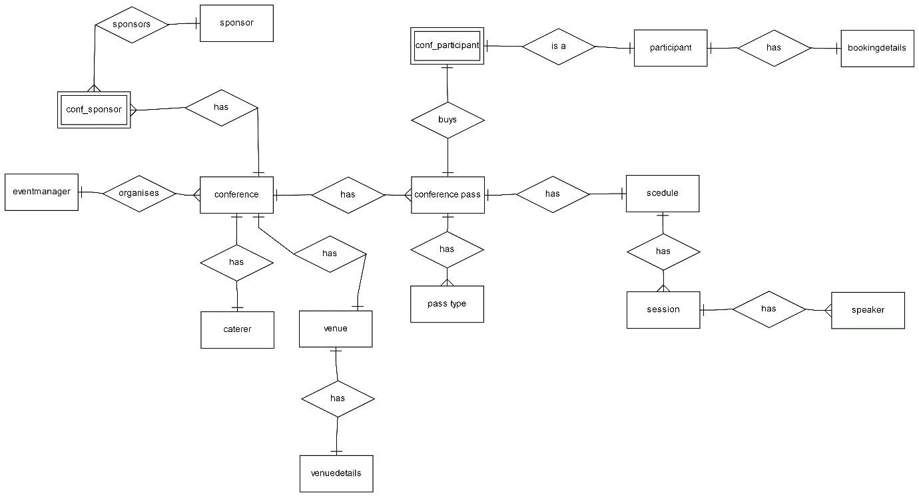

Relational schema

tbleventmanager (em_id,em_username,em_password,em_firstname,em_lastname,em_phone,em_email)

PK: em_id

FK: NONE

tblcaterer(caterer_id,caterer_name,caterer_phone,caterer_email)

PK: caterer_id

FK: NONE

tblparticipant(p_id,p_username,p_password,p_firstname,p_surname,p_email,p_phone,p_dob,p_address,p_country,p_city,p_state,p_postalcode,p_newsletter,p_occupation)

PK: p_id

FK: NONE

tblspeaker(speaker_id,speaker_firstname,speaker_lastname,speaker_details,speaker_image)

PK: speaker_id

FK: NONE

tblsponsor(sponsor_id,sponsor_name,sponsor_email,sponsor_phone,sponsor_logo)

PK: sponsor_id

FK: NONE

tblvenue(venue_id, venue_name, venue_address, venue_nrooms)

PK: venue_id

FK: NONE

tblpasstype(pass_id,pass_type,pass_desc,pass_price,pass_amount,conf_id)

PK: pass_id

FK: NONE

tblconference (conf_id,conf_name,conf_startdate,conf_enddate,conf_numpass,caterer_id, venue_id, em_id, conf_desc)

PK: conf_id

FK: (em_id) REFERENCES tbleventmanager(em_id)

FK: (caterer_id) REFERENCES tblcaterer(caterer_id)

FK: (venue_id) REFERENCES tblvenue(venue_id)

tblconf_sponsor(cs_index, sponsor_id, conf_id, amount_provided)

PK: cs_index

FK: (conf_id) REFERENCES tblconference(conf_id)

FK: (sponsor_id) REFERENCES tblsponsor(sponsor_id)

tblconf_participant(conf_id, p_id, confpass_reference, pass_id, purchase_date)

PK: confpass_reference

FK: (conf_id) REFERENCES tblconference(conf_id)

FK: (p_id) REFERENCES tblparticipant(p_id)

tblscession(session_id, conf_id, speaker_id, session_day, session_starttime, session_endtime, session_room, session_name)

PK: session_id

FK: (conf_id) REFERENCES tblconference(conf_id),

FK: (speaker_id) REFERENCES tblspeaker(speaker_id)

tblbookingdetails(booking_id, p_id, p_firstname, p_surname, confpass_reference, hotel_name, start_date, end_date, amount_paid, booking_date);

PK: booking_id

FK: (p_id) REFERENCES tblparticipant(p_id)

FK: (confpass_reference) REFERENCES tblconf_participant(confpass_reference)

tbltour(tour_id, tour_name, tour_location, tour_price, tour_duration, tour_starttime)

PK: tour_id

FK: NONE

tbltourbookingdetails(tourbooking_id, p_id, p_firstname, p_surname, confpass_reference, tour_name, tour_location, tour_price, tour_duration, tour_starttime, booking_date)

PK: tourbooking_id

FK: (p_id) REFERENCES tblparticipant(p_id)

FK: (confpass_reference) REFERENCES tblconf_participant(confpass_reference)

Table definition

tbleventmanager

|  |  |  |
| --- | --- | --- |
| **Attribute name** | **Data type** | **NULL value allowed** |
| em_id | Integer | 6 |
| em_username | Varchar | 15 |
| em_password | Varchar | 15 |
| em_firstname | Varchar | 15 |
| em_lastname | Varchar | 25 |
| em_phone | Integer | 15 |
| em_email | Varchar | 50 |

tblcaterer

|  |  |  |
| --- | --- | --- |
| **Attribute name** | **Data type** | **NULL value allowed** |
| caterer_id | Integer | 6 |
| caterer_name | Varchar | 40 |
| caterer_phone | Integer | 14 |
| caterer_email | Varchar | 50 |

tblparticipant

|  |  |  |
| --- | --- | --- |
| **Attribute name** | **Data type** | **NULL value allowed** |
| p_id | Integer | 6 |
| p_username | Varchar | 20 |
| p_password | Varchar | 15 |
| p_firstname | Varchar | 20 |
| p_surname | Varchar | 30 |
| p_email | Varchar | 50 |
| p_phone | Integer | 15 |
| p_dob | Date | Not NULL |
| P_address | Varchar | 50 |
| p_country | Varchar | 30 |
| p_city | Varchar | 30 |
| p_state | Varchar | 30 |
| p_postalcode | Varchar | 10 |
| p_newsletter | Boolean | Not NULL |
| p_occupation | Varchar | 30 |

tblspeaker

|  |  |  |
| --- | --- | --- |
| **Attribute name** | **Data type** | **NULL value allowed** |
| speaker_id | Integer | 6 |
| speaker_firstname | Varchar | 30 |
| spearker_lastname | Varchar | 40 |
| speaker_details | Text | Not NULL |
| speaker_image | LongBlob | Not NULL |

tblsponsor

|  |  |  |
| --- | --- | --- |
| **Attribute name** | **Data type** | **NULL value allowed** |
| sponsor_id | Integer | 6 |
| sponsor_name | Varchar | 50 |
| sponsor_email | Varchar | 50 |
| sponsor_phone | Integer | 15 |
| sponsor_logo | Longlob | Not NULL |

tblvenue

|  |  |  |
| --- | --- | --- |
| **Attribute name** | **Data type** | **NULL value allowed** |
| venue_id | Integer | 6 |
| venue_name | Varchar | 50 |
| venue_address | Varchar | 80 |
| venue_nrooms | Integer | 2 |

tblpasstype

|  |  |  |
| --- | --- | --- |
| **Attribute name** | **Data type** | **NULL value allowed** |
| pass_id | Integer | 6 |
| pass_type | Varchar | 25 |
| pass_desc | Text | Not NULL |
| pass_price | Integer | 5 |
| pass_amount | Integer | 4 |

tblconference

|  |  |  |
| --- | --- | --- |
| **Attribute name** | **Data type** | **NULL value allowed** |
| conf_id | Integer | 6 |
| conf_name | Varchar | 50 |
| conf_startdate | Date | Not NULL |
| conf_enddate | Date | Not NULL |
| conf_numpass | Integer | 4 |
| caterer_id | Integer | 6 |
| venue_id | Integer | 6 |
| em_id | Integer | 6 |
| conf_desc | Text | Not NULL |

tblconf_sponsor

|  |  |  |
| --- | --- | --- |
| **Attribute name** | **Data type** | **NULL value allowed** |
| cs_index | Integer | 6 |
| sponsor_id | Integer | 6 |
| conf_id | Integer | 6 |
| amount_provided | Integer | 5 |

tblconf_participant

|  |  |  |
| --- | --- | --- |
| **Attribute name** | **Data type** | **NULL value allowed** |
| conf_id | Integer | 6 |
| p_id | Integer | 6 |
| confpass_reference | Integer | 6 |
| pass_id | Integer | 11 |
| purchase_date | Date | NOT NULL |

tblsessions

|  |  |  |
| --- | --- | --- |
| **Attribute name** | **Data type** | **NULL value allowed** |
| session_id | Integer | 6 |
| conf_id | Integer | 6 |
| speaker_id | Integer | 6 |
| session_day | Date | Not NULL |
| session_starttime | Time | Not NULL |
| session_endtime | Time | Not NULL |
| session_room | Integer | 2 |
| session_name | Varchar | 100 |

tblbookingdetails

|  |  |  |
| --- | --- | --- |
| **Attribute name** | **Data type** | **NULL value allowed** |
| booking_id | Integer | 6 |
| p_id | Integer | 6 |
| p_firstname | Varchar | 20 |
| p_surname | Varchar | 30 |
| confpass_reference | Integer | 6 |
| hotel_name | Varchar | 40 |
| start_date | Date | NOT NULL |
| end_date | Date | NOT NULL |
| amount_paid | Float | 6 |
| booking_date | Date | Not NULL |

tbltour

|  |  |  |
| --- | --- | --- |
| **Attribute name** | **Data type** | **NULL value allowed** |
| tour_id | Integer | 6 |
| tour_name | Varchar | 50 |
| tour_location | Varchar | 50 |
| tour_price | Integer | 5 |
| tour_duration | Varchar | 40 |
| tour_starttime | Varchar | 50 |

|  |  |  |
| --- | --- | --- |
| **Attribute name** | **Data type** | **NULL value allowed** |
| tourbooking_id | Integer | 6 |
| p_id | Integer | 6 |
| p_firstname | Varchar | 20 |
| p_surname | Varchar | 30 |
| confpass_reference | Integer | 6 |
| tour_name | Varchar | 50 |
| tour_location | Varchar | 50 |
| tour_price | Integer | 5 |
| tour_duration | Varchar | 40 |
| tour_starttime | Varchar | 50 |
| booking_date | Date | NOT NULL |

tbltourbookingdetails