**SOFTWARE DESIGN DOCUMENT**

Conference Management and Reservation Online Portal

Supervisor:

Dr.Patrick Then

Client:

Ms. Lesley Lu

Team Members:

Rayner Paun 4308875

Ch’ng Chuan Way 100061188

Samu Pillai Sadeiyen 4323696

Samuel Hii Tuan Ong 4307100

Contents

1.0 Introduction 4

1.1 Purpose 4

1.2 Scope 4

2.0 UML Class Diagram 4

2.1 UML Class Diagram for Website 4

3.0 Sequence Diagram for Website 5

3.1 Event Manager 6

3.1.1Login 6

3.1.2 Logout 7

3.1.3 Add Conference 8

3.1.4 Edit Conference 9

3.1.5 Remove Conference 10

3.1.6 Add Sponsor 11

3.1.7 Delete Sponsor 12

3.1.8 Modify Sponsors 13

3.1.9 View Schedule 14

3.1.10 View Session Details 15

3.1.11 Add Session 16

3.1.12 Delete Session 17

3.1.13 Modify Session 18

3.1.14 Add Venue 19

3.1.15 Delete Venue 20

3.1.16 Modify venue 21

3.1.17 View Room 22

3.1.18 Add Room 23

3.1.19 Delete Room 24

3.1.20 Modify Room 25

3.1.21 Add Speaker 26

3.1.22 Delete Speaker 27

3.1.23 Modify Speaker 28

3.1.24 Add Caterer 29

3.1.25 Delete Caterer 30

3.1.26 Modify Caterer 31

3.1.27 View Conference 32

3.1.28 Generate Conference Registration Summary 33

3.1.29 User Management 34

3.1.30 Generate Participants Checklist 35

3.1.31 Generate Guest List 36

3.1.32 Generate Sponsors List 37

3.1.33 Generate Speakers List 38

3.1.34 Generate Feedback Report 39

3.2 Conference Participant 40

3.2.1 Login 40

3.2.2 Logout 41

3.2.3 Registration 42

3.2.4 View Schedule 43

3.2.5 View session details 44

3.2.6 View Speaker 45

3.2.7 Make Conference Booking 46

3.2.8 Transfer Conference Booking 47

3.2.9 Cancel Conference Booking 48

3.2.10 Book Hotel 49

3.2.11 Book Tour 50

3.2.12 Modify Hotel Booking 51

3.2.13 Cancel Hotel Booking 52

3.2.14 Provide Feedback 53

3.2.15 Enquire about conference 54

4.0 Entity-Relationship Diagram 55

# Introduction

## Purpose

The purpose of this Software Design Document is to provide all the essential written description of a software, Conference System. In general, this documentation serves as a guidelines for the project team to the architecture of software, conference system. In addition, software design diagram, storage of persistent data and global flow control. It also emphasizes the use of component and UML to deal with solution domain complexity

## Scope

The document focuses on the design principle that would be adhered to while programming and articulating the software. In this document, the team has documented several process of designing the software using UML class diagram, Sequence diagram and Entity-Relationship Diagram.

# UML Class Diagram

## 2.1 UML Class Diagram for Website

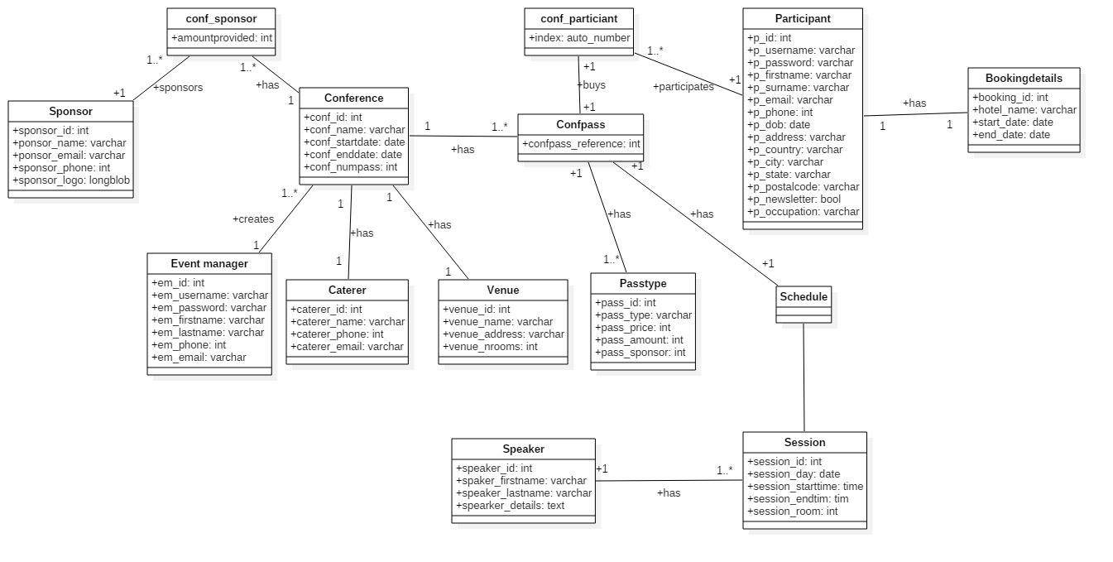

# Sequence Diagram for Website

## 3.1 Event Manager

### 3.1.1Login

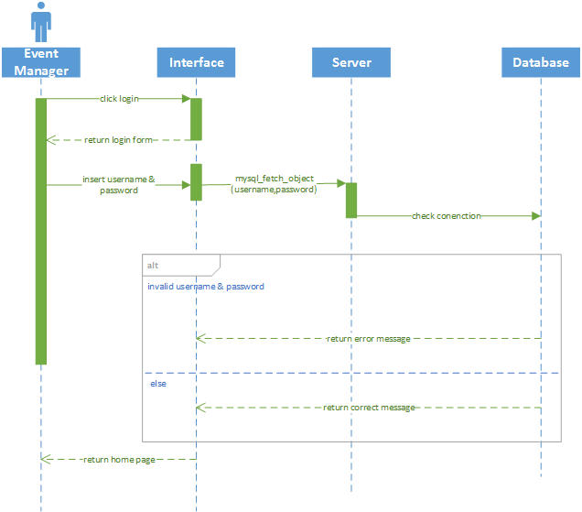

### 3.1.2 Logout

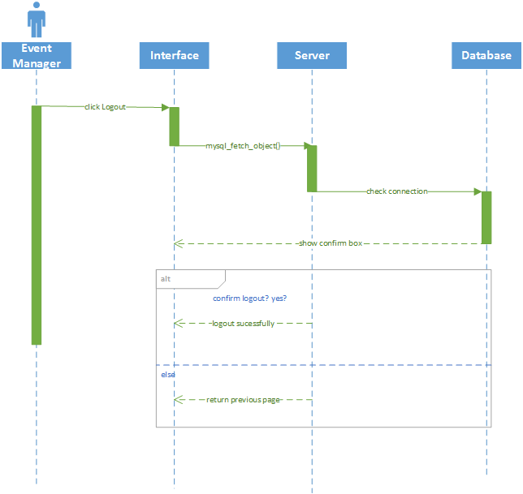

### 3.1.3 Add Conference

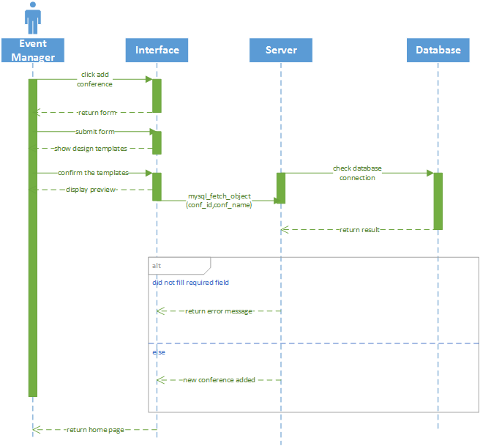

### 3.1.4 Edit Conference

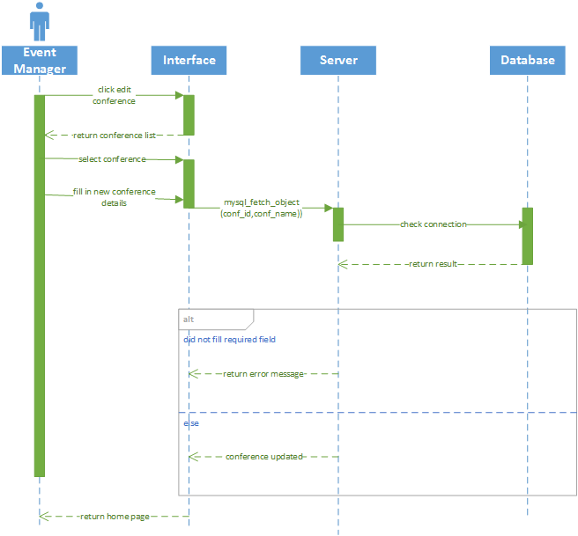

### 3.1.5 Remove Conference

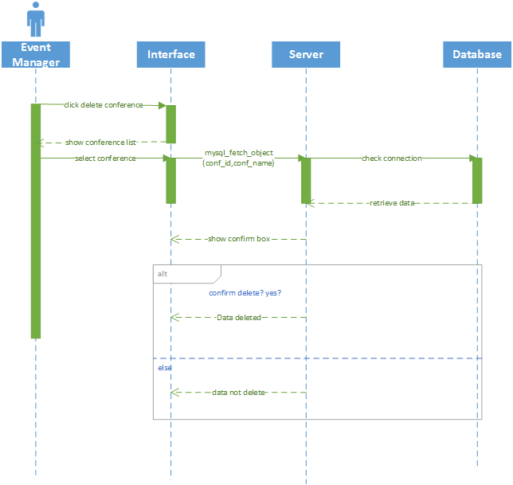

### 3.1.6 Add Sponsor

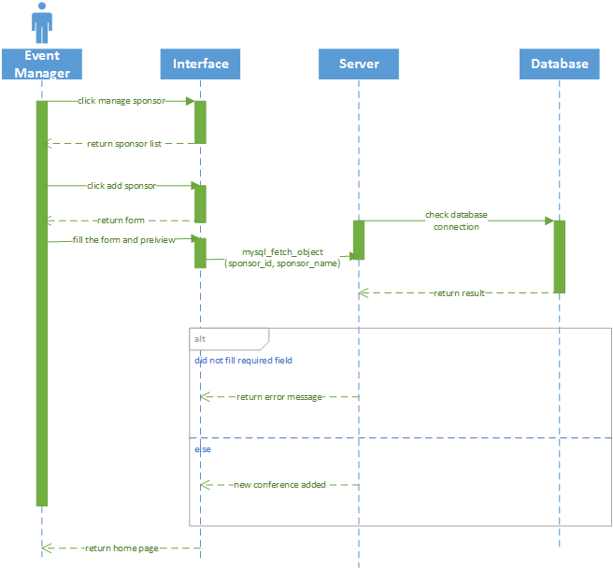

### 3.1.7 Delete Sponsor

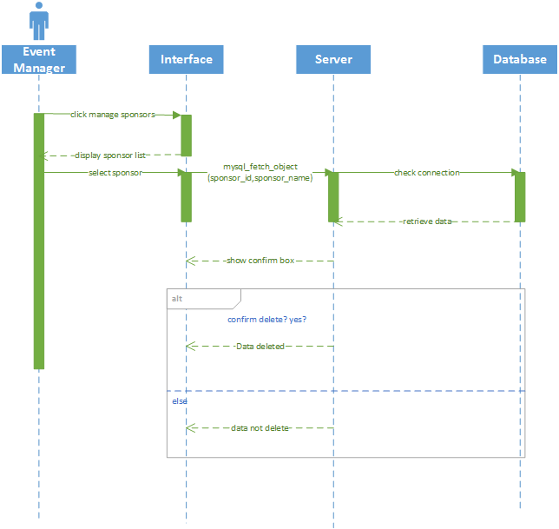

### 3.1.8 Modify Sponsors

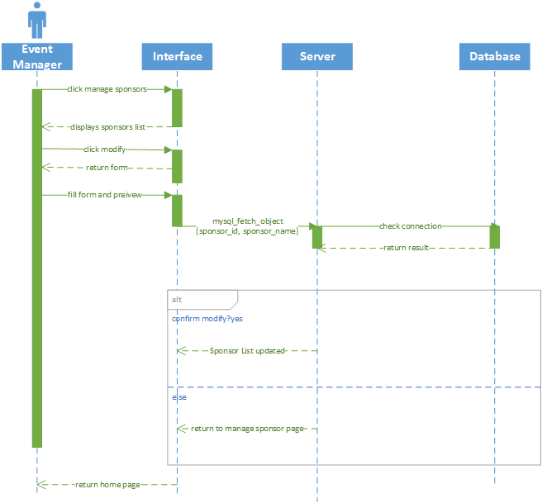

### 3.1.9 View Schedule

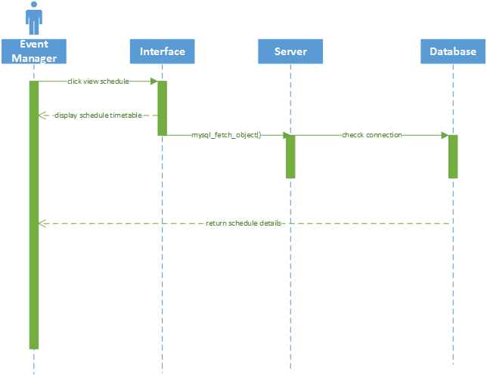

### 3.1.10 View Session Details

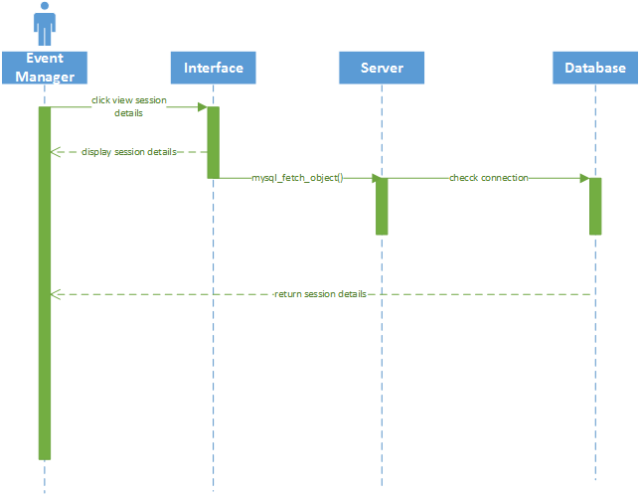

### 3.1.11 Add Session

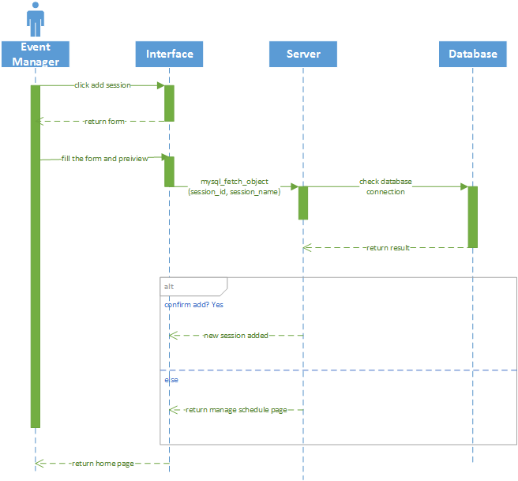

### 3.1.12 Delete Session

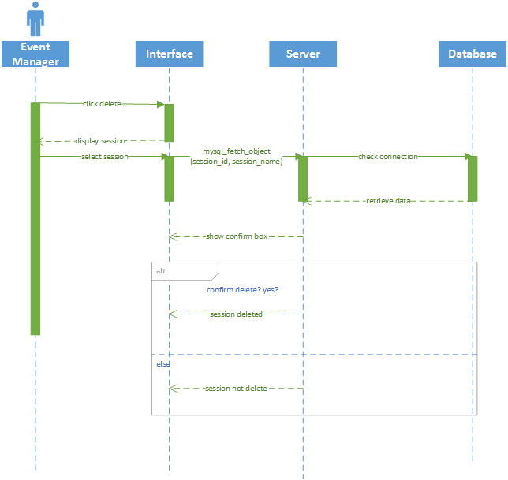

### 3.1.13 Modify Session

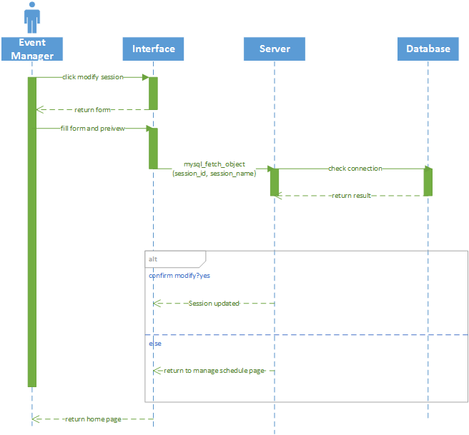

### 3.1.14 Add Venue

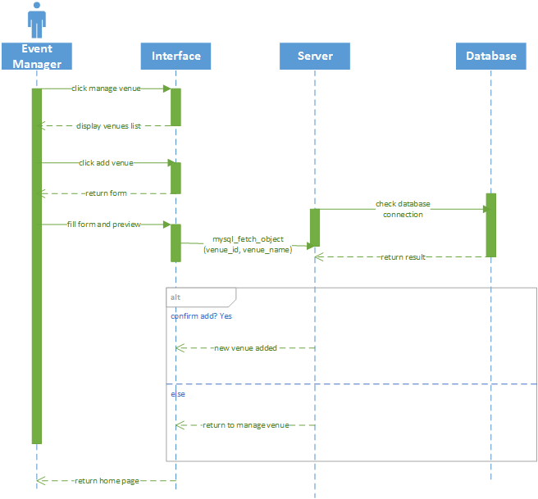

### 3.1.15 Delete Venue

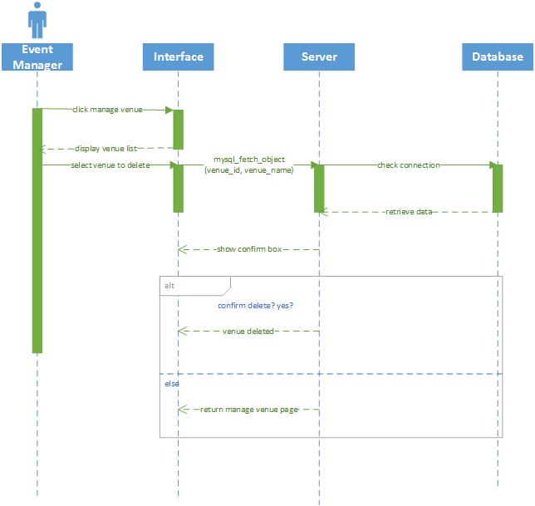

### 3.1.16 Modify venue

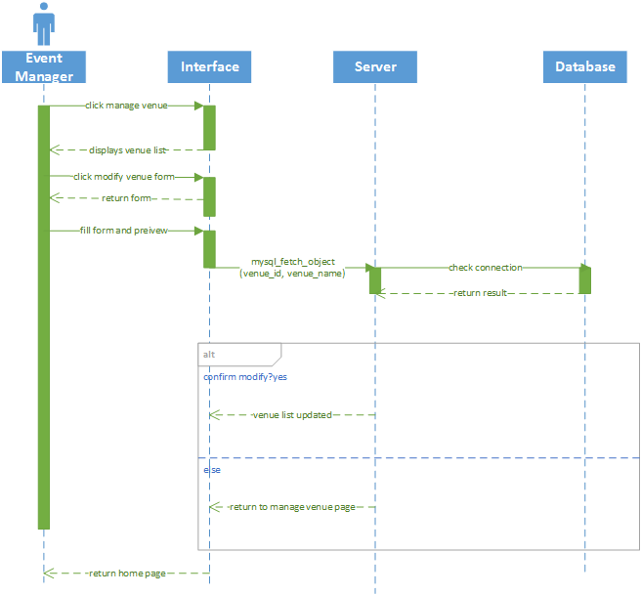

### 3.1.17 View Room

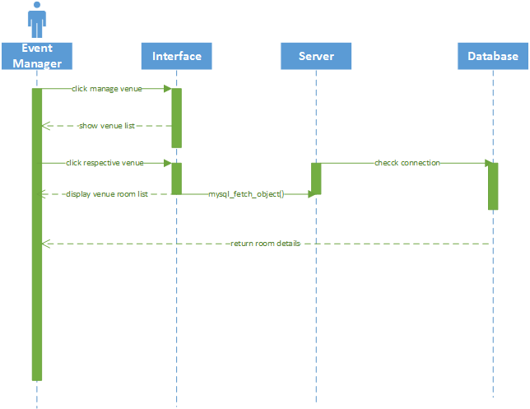

### 3.1.18 Add Room

### 

### 3.1.19 Delete Room

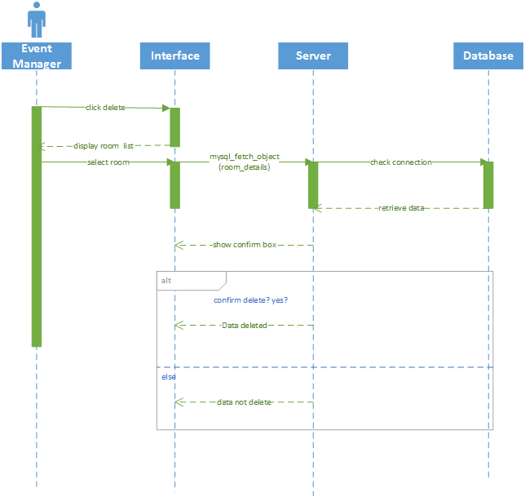

### 3.1.20 Modify Room

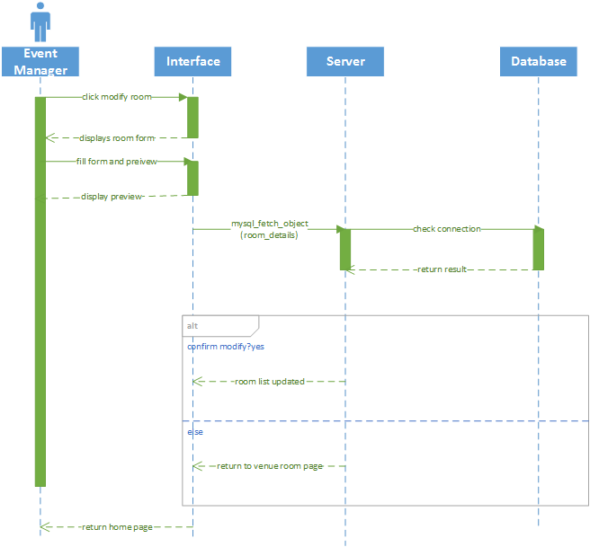

### 3.1.21 Add Speaker

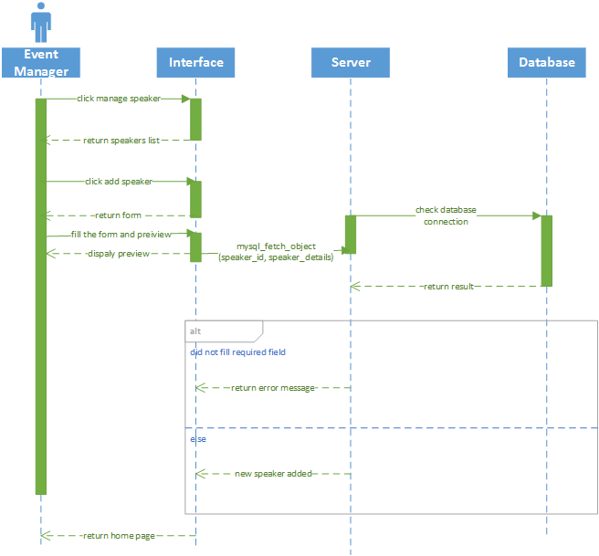

### 3.1.22 Delete Speaker

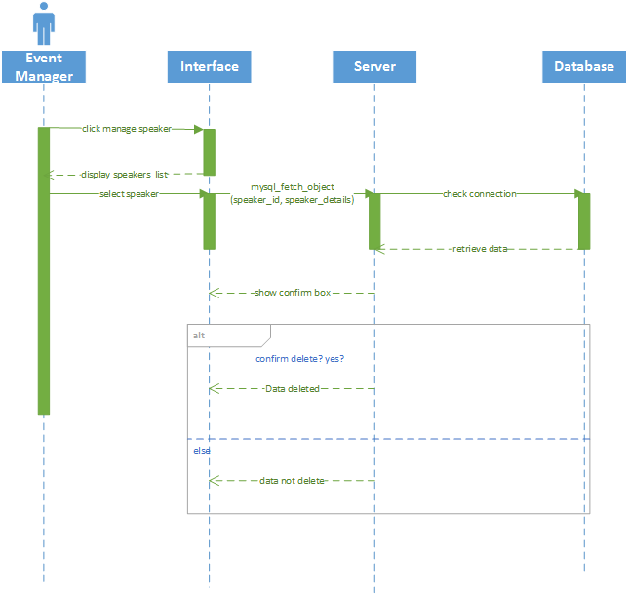

### 3.1.23 Modify Speaker

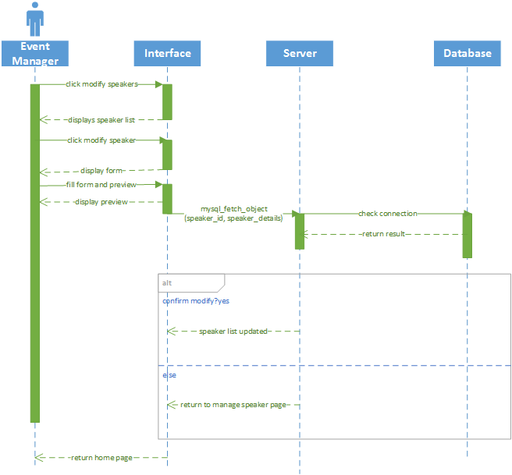

### 3.1.24 Add Caterer

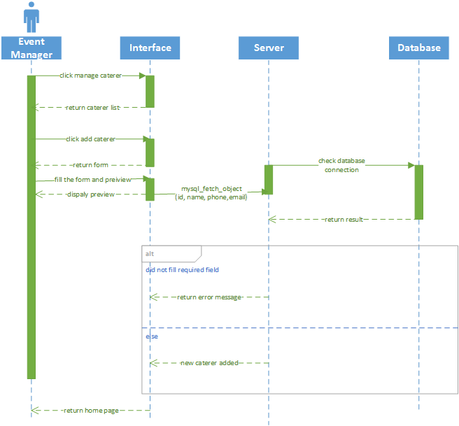

### 3.1.25 Delete Caterer

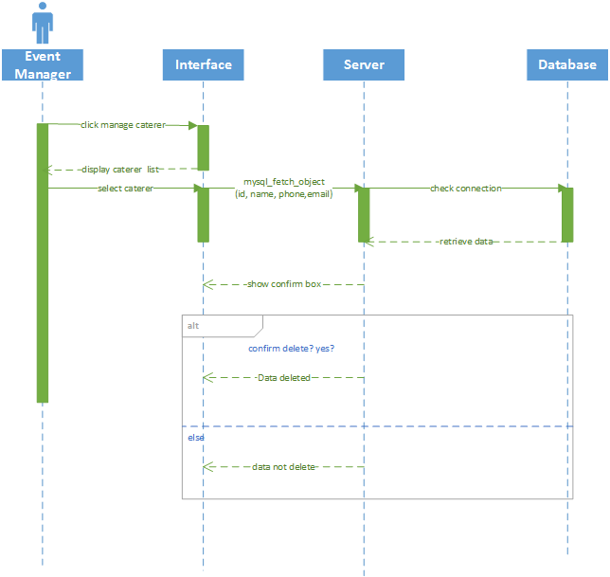

### 3.1.26 Modify Caterer

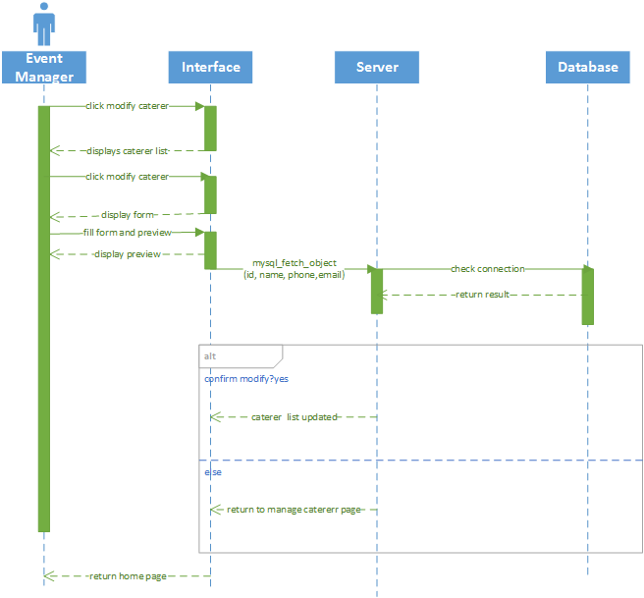

### 3.1.27 View Conference

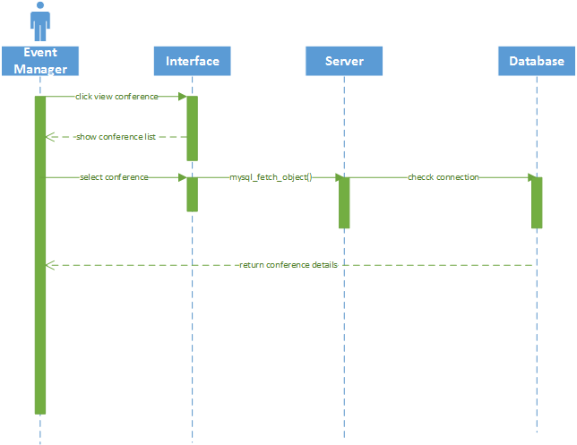

### 3.1.28 Generate Conference Registration Summary

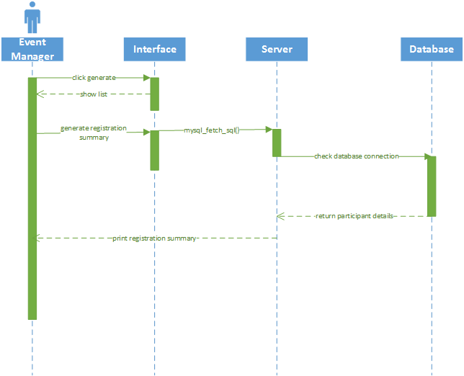

### 3.1.29 User Management

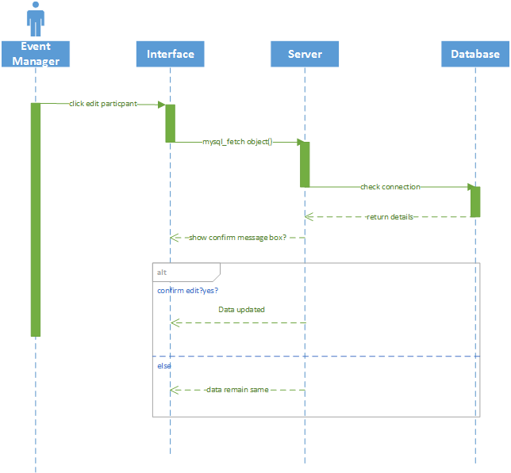

### 3.1.30 Generate Participants Checklist

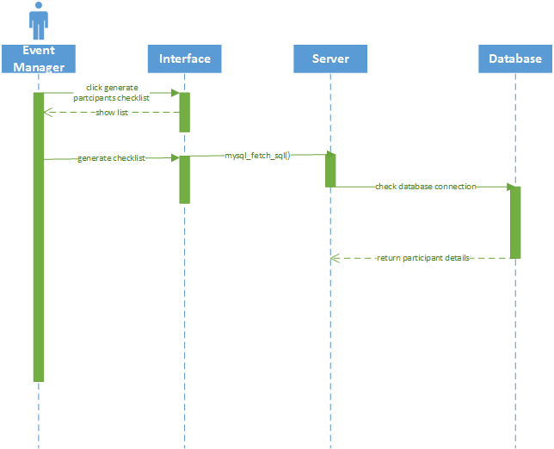

### 3.1.31 Generate Guest List

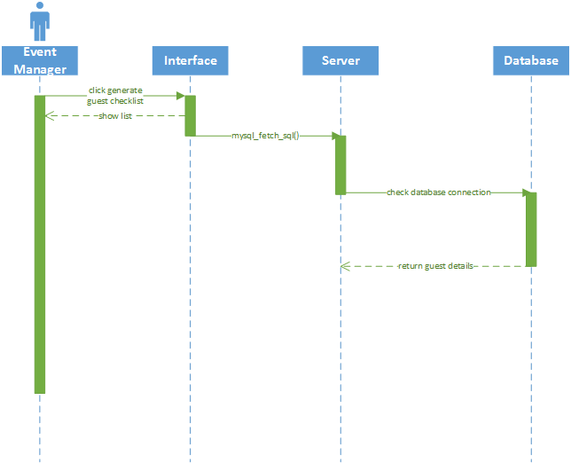

### 3.1.32 Generate Sponsors List

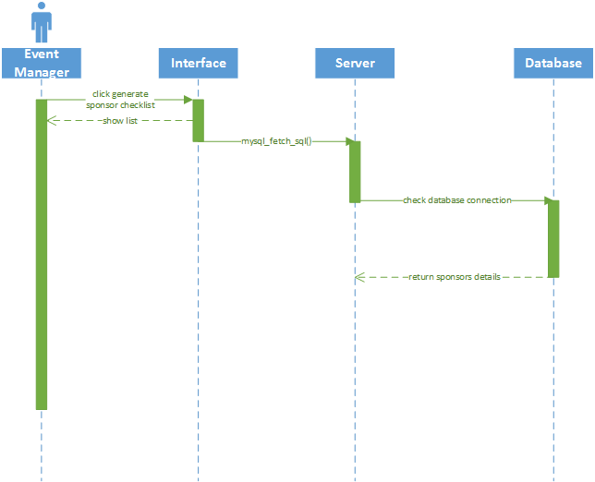

### 3.1.33 Generate Speakers List

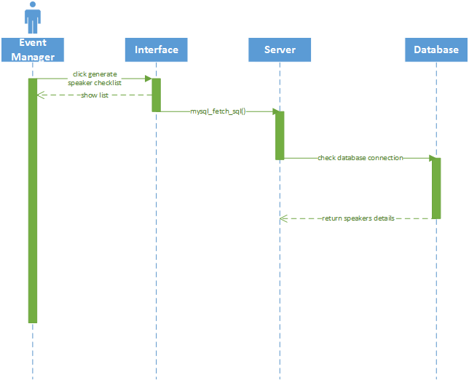

### 3.1.34 Generate Feedback Report

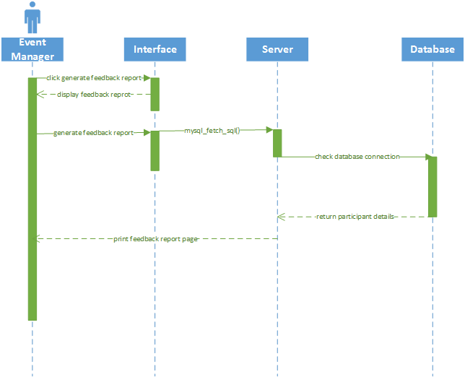

## 3.2 Conference Participant

### 3.2.1 Login

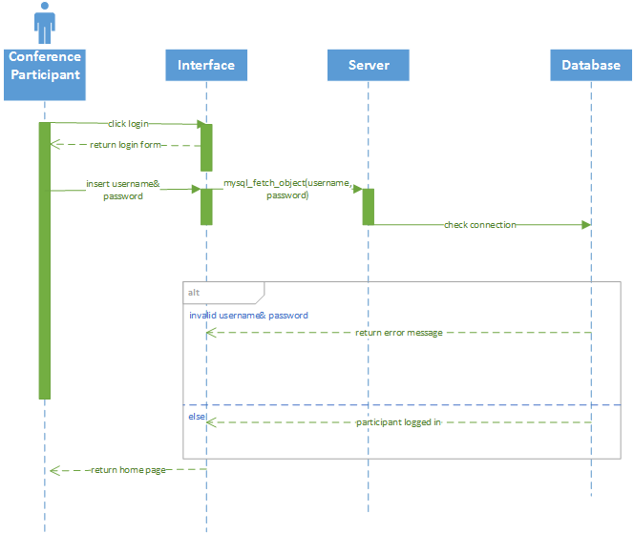

### 3.2.2 Logout

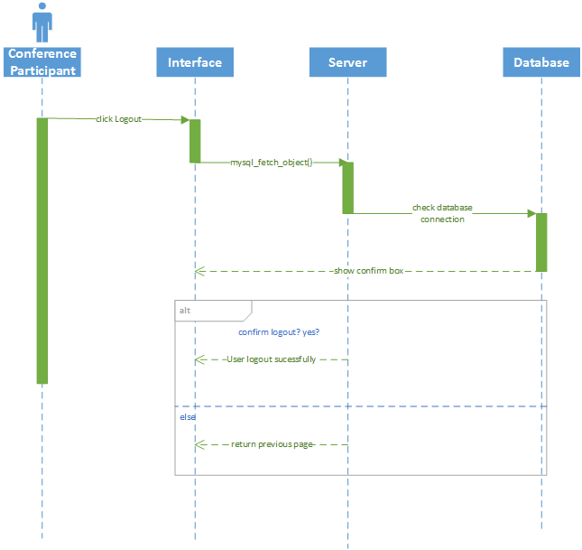

### 3.2.3 Registration

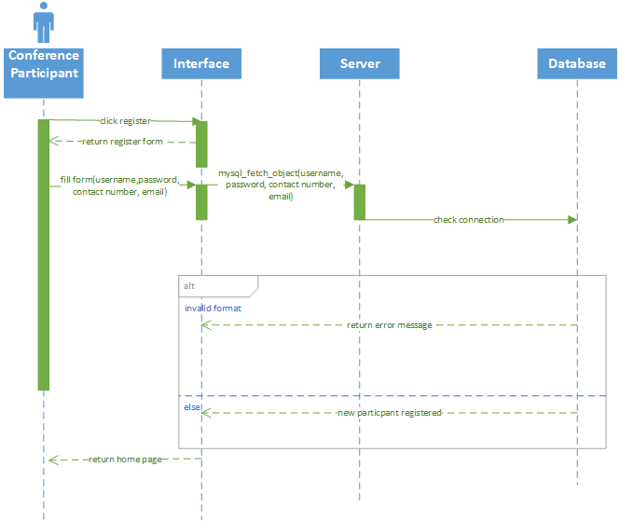

### 3.2.4 View Schedule

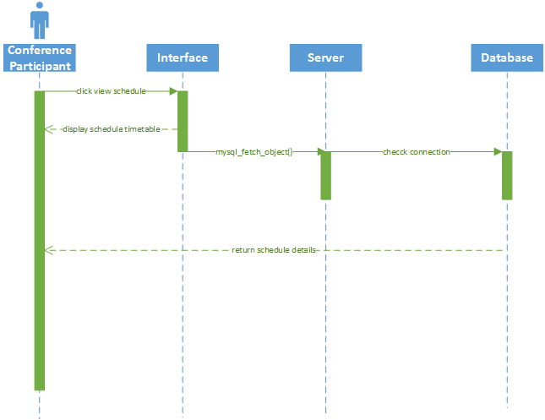

### 3.2.5 View session details

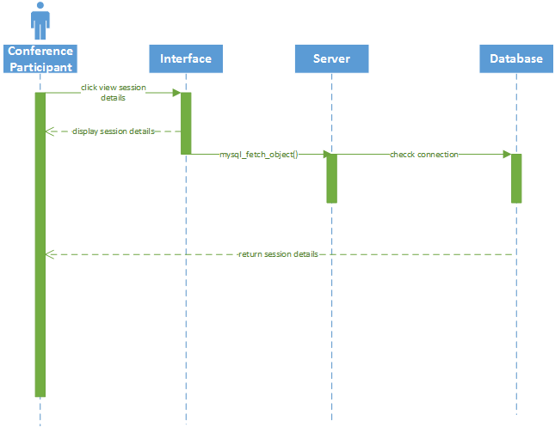

### 3.2.6 View Speaker

### 

### 3.2.7 Make Conference Booking

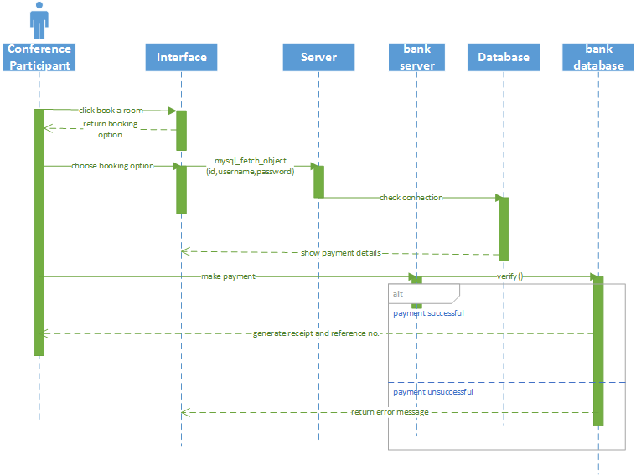

### 3.2.8 Transfer Conference Booking

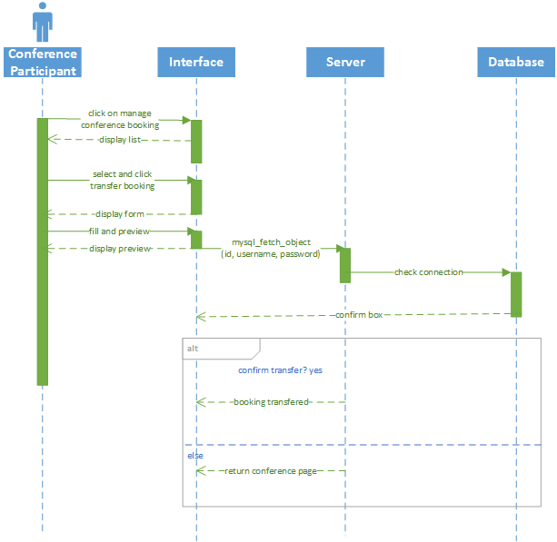

### 3.2.9 Cancel Conference Booking

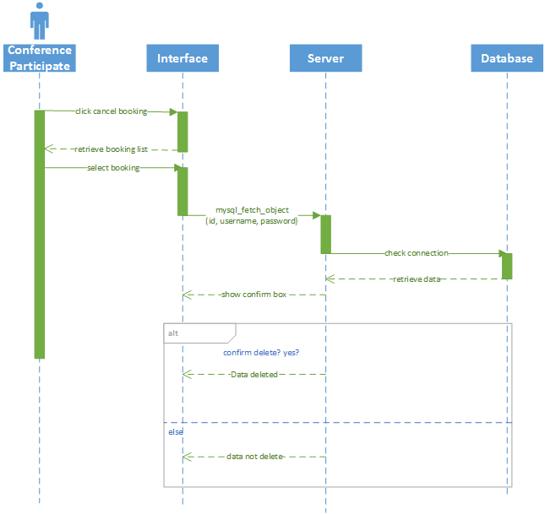

### 3.2.10 Book Hotel

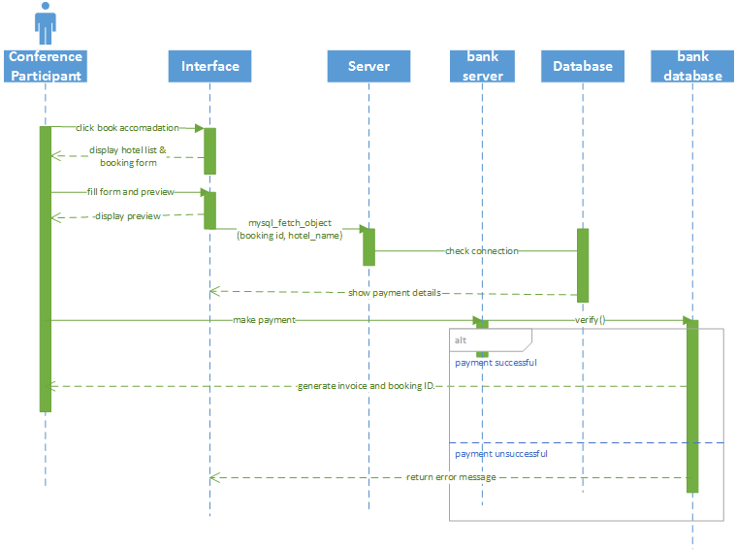

### 3.2.11 Book Tour

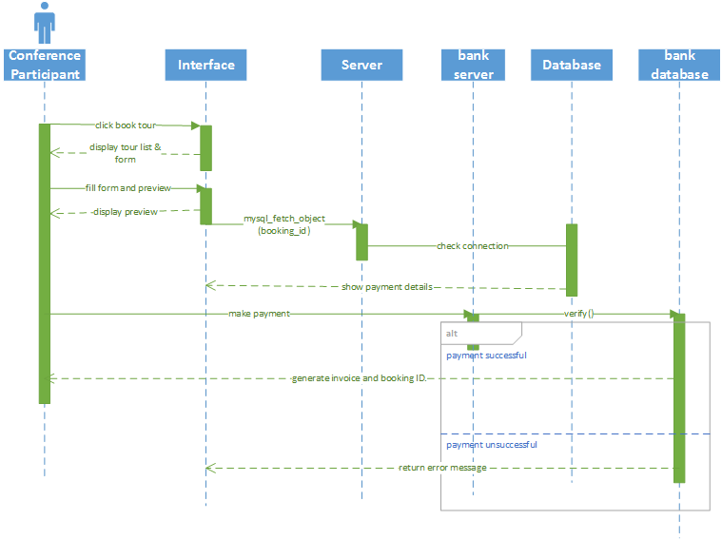

### 3.2.12 Modify Hotel Booking

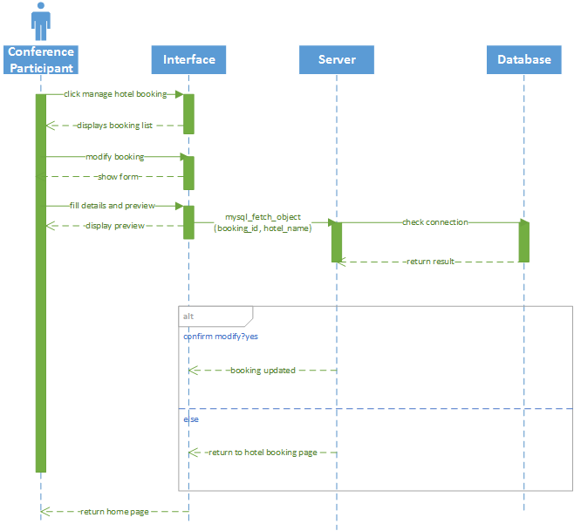

### 3.2.13 Cancel Hotel Booking

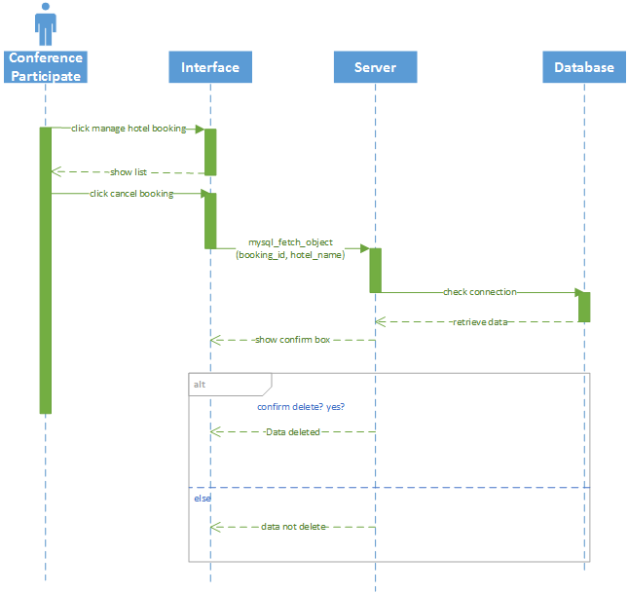

### 3.2.14 Provide Feedback

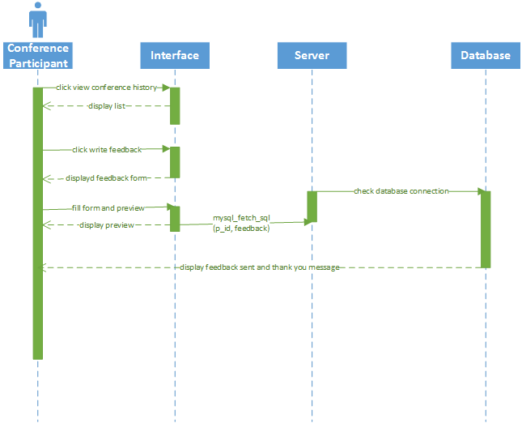

### 3.2.15 Enquire about conference

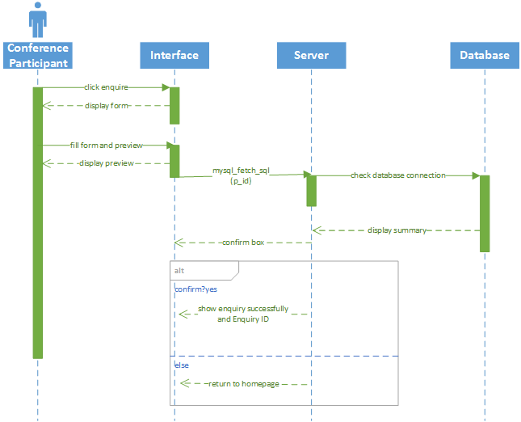

# 4.0 Entity-Relationship Diagram

The diagram below shows the Extended Entity Relationship Diagram for the data that is going to be stored in the system’s database

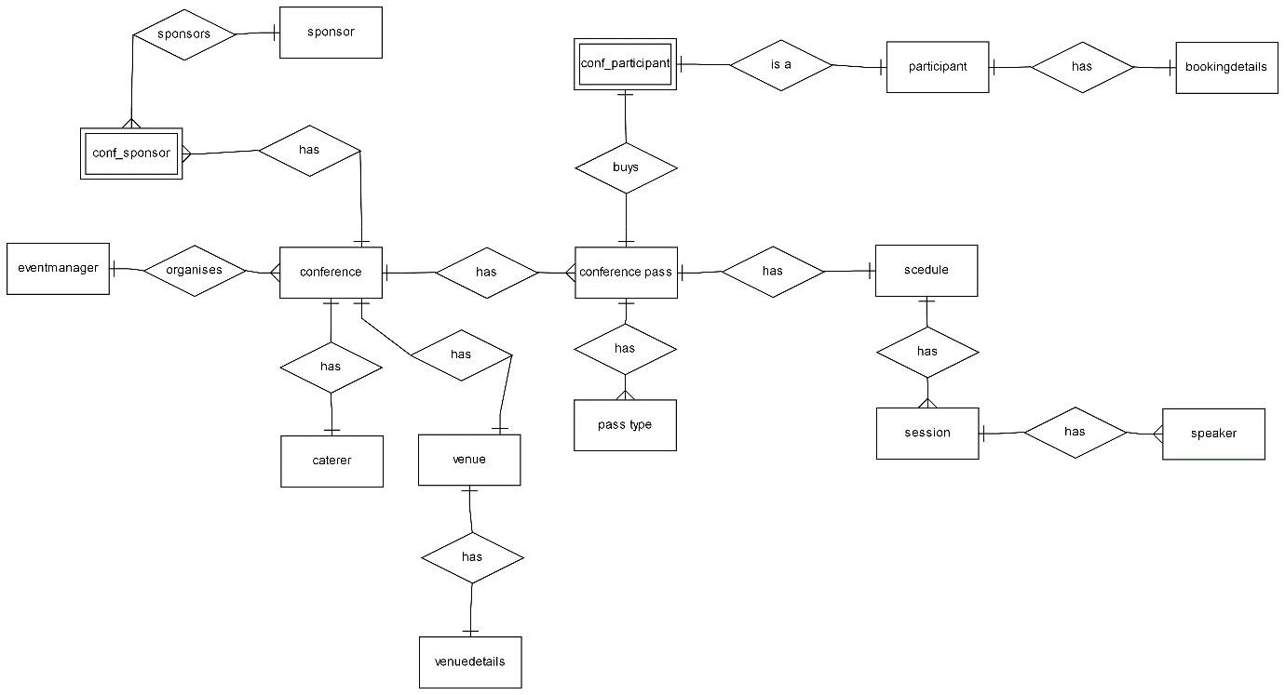

Relational schema

tbleventmanager (em_id,em_username,em_password,em_firstname,em_lastname,em_phone,em_email)

PK: em_id

FK: NONE

tblcaterer(caterer_id,caterer_name,caterer_phone,caterer_email)

PK: caterer_id

FK: NONE

tblparticipant(p_id,p_username,p_password,p_firstname,p_surname,p_email,p_phone,p_dob,p_address,p_country,p_city,p_state,p_postalcode,p_newsletter,p_occupation)

PK: p_id

FK: NONE

tblspeaker(speaker_id,speaker_firstname,speaker_lastname,speaker_details,speaker_image)

PK: speaker_id

FK: NONE

tblsponsor(sponsor_id,sponsor_name,sponsor_email,sponsor_phone,sponsor_logo)

PK: sponsor_id

FK: NONE

tblvenue(venue_id, venue_name, venue_address, venue_nrooms)

PK: venue_id

FK: NONE

tblpasstype(pass_id,pass_type,pass_desc,pass_price,pass_amount,conf_id)

PK: pass_id

FK: NONE

tblconference (conf_id,conf_name,conf_startdate,conf_enddate,conf_numpass,caterer_id, venue_id, em_id, conf_desc)

PK: conf_id

FK: (em_id) REFERENCES tbleventmanager(em_id)

FK: (caterer_id) REFERENCES tblcaterer(caterer_id)

FK: (venue_id) REFERENCES tblvenue(venue_id)

tblconf_sponsor(cs_index, sponsor_id, conf_id, amount_provided)

PK: cs_index

FK: (conf_id) REFERENCES tblconference(conf_id)

FK: (sponsor_id) REFERENCES tblsponsor(sponsor_id)

tblconf_participant(conf_id, p_id, confpass_reference)

PK: confpass_reference

FK: (conf_id) REFERENCES tblconference(conf_id)

FK: (p_id) REFERENCES tblparticipant(p_id)

tblscession(session_id, conf_id, speaker_id, session_day, session_starttime, session_endtime, session_room, session_name)

PK: session_id

FK: (conf_id) REFERENCES tblconference(conf_id),

FK: (speaker_id) REFERENCES tblspeaker(speaker_id)

tblbookingdetails(booking_id, p_id, p_firstname, p_surname, confpass_reference, hotel_name, start_date, end_date, amount_paid);

PK: booking_id

FK: (p_id) REFERENCES tblparticipant(p_id)

FK: (confpass_reference) REFERENCES tblconf_participant(confpass_reference)

Table definition

tbleventmanager

|  |  |  |
| --- | --- | --- |
| **Attribute name** | **Data type** | **NULL value allowed** |
| em_id | Integer | 6 |
| em_username | Varchar | 15 |
| em_password | Varchar | 15 |
| em_firstname | Varchar | 15 |
| em_lastname | Varchar | 25 |
| em_phone | Integer | 15 |
| em_email | Varchar | 50 |

tblcaterer

|  |  |  |
| --- | --- | --- |
| **Attribute name** | **Data type** | **NULL value allowed** |
| caterer_id | Integer | 6 |
| caterer_name | Varchar | 40 |
| caterer_phone | Integer | 14 |
| caterer_email | Varchar | 50 |

tblparticipant

|  |  |  |
| --- | --- | --- |
| **Attribute name** | **Data type** | **NULL value allowed** |
| p_id | Integer | 6 |
| p_username | Varchar | 20 |
| p_password | Varchar | 15 |
| p_firstname | Varchar | 20 |
| p_surname | Varchar | 30 |
| p_email | Varchar | 50 |
| p_phone | Integer | 15 |
| p_dob | Date | Not NULL |
| P_address | Varchar | 50 |
| p_country | Varchar | 30 |
| p_city | Varchar | 30 |
| p_state | Varchar | 30 |
| p_postalcode | Varchar | 10 |
| p_newsletter | Boolean | Not NULL |
| p_occupation | Varchar | 30 |

tblspeaker

|  |  |  |
| --- | --- | --- |
| **Attribute name** | **Data type** | **NULL value allowed** |
| speaker_id | Integer | 6 |
| speaker_firstname | Varchar | 30 |
| spearker_lastname | Varchar | 40 |
| speaker_details | Text | Not NULL |
| speaker_image | LongBlob | Not NULL |

tblsponsor

|  |  |  |
| --- | --- | --- |
| **Attribute name** | **Data type** | **NULL value allowed** |
| sponsor_id | Integer | 6 |
| sponsor_name | Varchar | 50 |
| sponsor_email | Varchar | 50 |
| sponsor_phone | Integer | 15 |
| sponsor_logo | Longlob | Not NULL |

tblvenue

|  |  |  |
| --- | --- | --- |
| **Attribute name** | **Data type** | **NULL value allowed** |
| venue_id | Integer | 6 |
| venue_name | Varchar | 50 |
| venue_address | Varchar | 80 |
| venue_nrooms | Integer | 2 |

tblpasstype

|  |  |  |
| --- | --- | --- |
| **Attribute name** | **Data type** | **NULL value allowed** |
| pass_id | Integer | 6 |
| pass_type | Varchar | 25 |
| pass_desc | Text | Not NULL |
| pass_price | Integer | 5 |
| pass_amount | Integer | 4 |

tblconference

|  |  |  |
| --- | --- | --- |
| **Attribute name** | **Data type** | **NULL value allowed** |
| conf_id | Integer | 6 |
| conf_name | Varchar | 50 |
| conf_startdate | Date | Not NULL |
| conf_enddate | Date | Not NULL |
| conf_numpass | Integer | 4 |
| caterer_id | Integer | 6 |
| venue_id | Integer | 6 |
| em_id | Integer | 6 |
| conf_desc | Text | Not NULL |

tblconf_sponsor

|  |  |  |
| --- | --- | --- |
| **Attribute name** | **Data type** | **NULL value allowed** |
| cs_index | Integer | 6 |
| sponsor_id | Integer | 6 |
| conf_id | Integer | 6 |
| amount_provided | Integer | 5 |

tblconf_participant

|  |  |  |
| --- | --- | --- |
| **Attribute name** | **Data type** | **NULL value allowed** |
| conf_id | Integer | 6 |
| p_id | Integer | 6 |
| confpass_reference | Integer | 6 |

tblsessions

|  |  |  |
| --- | --- | --- |
| **Attribute name** | **Data type** | **NULL value allowed** |
| session_id | Integer | 6 |
| conf_id | Integer | 6 |
| speaker_id | Integer | 6 |
| session_day | Date | Not NULL |
| session_starttime | Time | Not NULL |
| session_endtime | Time | Not NULL |
| session_room | Integer | 2 |
| session_name | Varchar | 100 |

tblbookingdetails

|  |  |  |
| --- | --- | --- |
| **Attribute name** | **Data type** | **NULL value allowed** |
| booking_id | Integer | 6 |
| p_id | Integer | 6 |
| p_firstname | Varchar | 20 |
| p_surname | Varchar | 30 |
| confpass_reference | Integer | 6 |
| hotel_name | Varchar | 40 |
| start_date | Date | Not NULL |
| end_date | Date | Not NULL |
| amount_paid | Float | 6 |