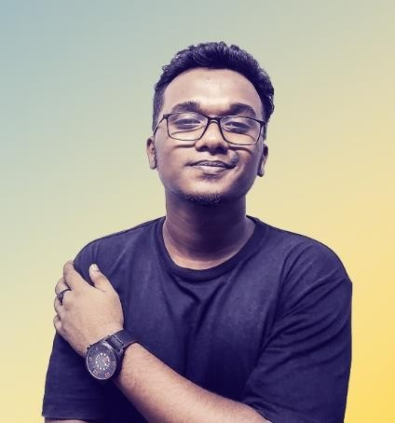Mushphyqur Rahman

Chashara, Narayanganj, Bangladesh | +8801674608620 [mushphyqur@pm.me](mailto:mushphyqur@pm.me)

# Objective

I’m a Computer Programmer and IT Specialist. Tinkering with various technologies for 5 years in several open source and personal projects. Learning new technologies on the fly. I have decided to become a professional. Here I’m offering you my expertise and best effort. Thank you.

# Education

* University of London, London, United Kingdom
* BSc. Computer Science | 2022 - Enrolled
* Artificial Intelligence
* Narayanganj University College, Narayanganj, Bangladesh
* Higher School Certificate | 2017 – 2020
* Science
* Adarsha School Narayanganj, Narayanganj, Bangladesh
* Secondary School Certificate | 2015 – 2017
* Science

# Experience

2021 – Present

Computer Programmer | Freelancer.com | Global

“Computer Programmer” can describe a large number of work styles. From Automation to Web Scrapping Even Cyber Security. I wanted my knowledge to be wide and resourceful.

**Skills:** Bash/Shell Automation, Python Web Scrapping, Python Text Based Games, Network Security and many more.

2020 – Present

Web Developer | Freelancer.com | Global

As a freelance developer I used various programming language and skills in many projects.

**Skills:** JavaScript, React, Python, PHP, C, Django etc.

2019

Graphics Designer | Freelancer.com | Global

As a Graphics Designer I created posters, websites, logos, brochures, magazines and many other materials to communicate ideas and information visually.

# Awards & Acknowledgments

* Arctic Code Vault Contributor
* Creator of “Searchit” Software
* 2020 Xpousure International Photography Award Winner

# Language Proficiency

* Bengali : Native
* English : Fluent, W/R in American & British

# Biographical Information

Father’s name : Md. Habibur Rahman Mother’s name : Mrs. Maksuda Akter Date of birth : 08 Feb 2002

Citizenship : Bangladeshi (by birth)

Gender : Male

Religion : Islam

Marital status : Single

Blood Group : O+

Permanent Address : Jajira, Shariatpur-8010 Height : 5’.7’’

# Social and Links

* Github : [www.github.com/xSomoy](http://www.github.com/xSomoy)
* Linkedin : [www.linkedin.com/xSomoy](http://www.linkedin.com/xSomoy)
* Facebook : [www.facebook.com/xSomoy](http://www.facebook.com/xSomoy)

# Declaration

The information stated in this resume is true and complete with the best of my knowledge. I authorized you to verify the information provided in this resume.

# Reference

# Ivy Rahman

# Executive, E-commerce

# Vivo Headquarter.

# Contact no. 01818896674

# Email: ivyrahman.vivo@gmail.com