Mushphyqur Rahm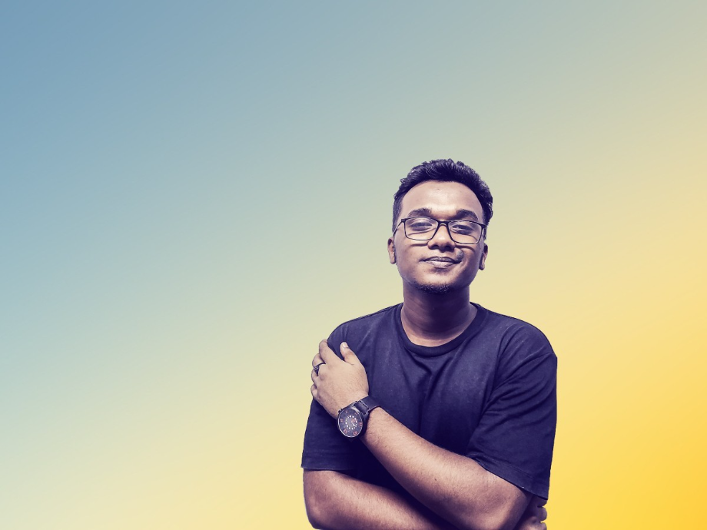an Tanveer

Shankar, Dhanmondi, Dhaka, Bangladesh | +8801674608620

Email: mushphyqur@pm.me

# Objective

Dedicated and hardworking professional with a strong commitment to discipline and loyalty. Seeking to contribute my reliability, integrity, and unwavering dedication to company, while supporting its goals with a focus on long-term success and team collaboration. Thank You.

# Education

* University of Development Alternative, Dhaka, Bangladesh
* BSc. Computer Science and Engineering | 2024 – Semester 2
* Artificial Intelligence
* Narayanganj University College, Narayanganj, Bangladesh
* Higher School Certificate | 2017 – 2020
* Science
* Adarsha School Narayanganj, Narayanganj, Bangladesh
* Secondary School Certificate | 2015 – 2017
* Science

# Experience

## 2020 – 2023

### Programmer | Freelancer.com | Global

As a freelance developer I used various programming language and skills in many projects. JavaScript, Python, PHP, C, Django etc.

## 2019 - 2020

### Graphics Designer | Freelancer.com | Global

As a Graphics Designer I created posters, websites, logos, brochures, magazines and many other materials to communicate ideas and information visually.

# Professional Certification

* Google IT Support Professional Certificate | Google | Running
* Google IT Automation with Python Professional Certificate | Google | Running
* Machine Learning | Stanford University | Running
* Areal Robotics | University of Pennsylvania | Running
* Python (Basic) | HackerRank | 2021
* The Bits and Bytes of Computer Networking | Google | 2021
* Technical Support Fundamentals | Google | 2021
* Build a Full Website using WordPress | Coursera | 2021
* Operating Systems and You: Becoming a Power User | Google | 2021
* Introduction to Cybersecurity Tools & Cyber Attacks | IBM | 2020
* Responsive Web Design | Creative IT Institute | 2020
* Crash Course on Python | Google | 2020
* Introduction to Psychology | Yale University | 2020
* Design Thinking for Innovation | University of Virginia | 2020
* HTML, CSS, and JavaScript for Web Developers | Johns Hopkins University | 2020
* What is Data Science? | IBM | 2020
* Introduction to Artificial Intelligence (AI) | IBM | 2020
* Seeing Through Photographs | The Museum of Modern Art | 2020

# Awards & Acknowledgments

* Arctic Code Vault Contributor
* Creator of “Searchit” Software
* 2020 Xpousure International Photography Award Winner

# Language Proficiency

* Bengali : Native
* English : Fluent, W/R in American & British

# Biographical Information

Father’s name **:**  Md. Habibur Rahman

Mother’s name **:** Mrs. Maksuda Akter

Date of birth **:** 08 Feb 2002

Citizenship **:** Bangladeshi (by birth)

Gender **:** Male

Religion **:** Islam

Marital status **:** Single

Blood Group **:** O+

Permanent Address **:** Jajira, Shariatpur-8010

Height **:** 5’.7’’

# Social and Links

* Github : [www.github.com/xSomoy](http://www.github.com/xSomoy)
* LinkedIn : www.linkedin.com/xSomoy
* Facebook : [www.facebook.com/xSomoy](http://www.facebook.com/xSomoy)

# Reference:

Ivy Rahman

Executive – Branding

Vivo Headquarter

Phone: +8801818896674

# Declaration

# The information stated in this resume is true and complete with the best of Knowledge. I authorized you to verify the information provided in this resume.



-------------------------------------------

# Mushphyqur Rahman Tanveer