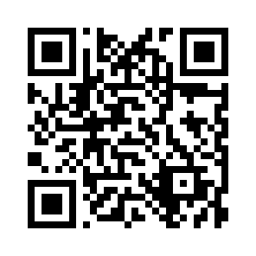

**Tell the world about your tour!**

Search for **Dubai City Urban Adventures** on [www.tripadvisor.com](http://www.tripadvisor.com/) or scan QR code.

**Where are you going next?**

London · Sydney · Cairo · Istanbul · Kuala Lumpur

Plus many other destinations worldwide

**Grab a 10% discount off your next tour!**

**Promo:**

**UADUB**



[**www.urbanadventures.com**](http://www.urbanadventures.com/)