Faithful but not self-consistent: a reliability audit of feature attributions for ADMET and toxicity models
Draft v0.1 (P6). All numbers trace to results/ (commit-pinned). Author: Amit Shenoy.

Abstract
Feature-attribution methods (SHAP, LIME, Integrated Gradients) are increasingly used to provide the “mechanistic interpretation” that regulators (OECD QSAR framework; EMA 2024 reflection on AI/ML) expect from QSAR/ADMET models, and to guide which molecular features medicinal chemists act on. Yet the reliability of these attributions in the molecular-property setting has never been systematically audited. We trained 144 models spanning 12 Therapeutics Data Commons ADMET/toxicity endpoints, two molecular representations (interpretable 2D descriptors and 2048-bit ECFP4 fingerprints), and three model classes (random forest, gradient boosting, MLP), under both scaffold (deployment-realistic, out-of-distribution) and random splits. For the 142 models that cleared a trivial-baseline floor, we measured four reliability properties — faithfulness, stability, cross-method agreement, and the Adebayo model-randomization sanity check — each referenced against a content-matched random null, and tested five preregistered hypotheses. Two pessimistic hypotheses were falsified: attributions usually do beat the random null on faithfulness (only 12% of method–cells fail), and their faithfulness and stability do not significantly degrade under scaffold shift, even though model accuracy does. But two failure modes are real: explainers agree only modestly on which features matter — at an adequate LIME sampling budget, SHAP and LIME reach a mean rank correlation of just 0.34 on interpretable descriptors (range 0.18–0.50; not reaching above 0.50 on any endpoint), and disagreement is worse on high-dimensional fingerprints and for SHAP-vs-IG — and a quarter of MLP attribution settings fail the model-randomization sanity check under true weight reinitialization. A variance decomposition shows reliability is governed by different factors depending on the property measured — the endpoint dominates faithfulness, the representation dominates stability, and the attribution method dominates sanity behaviour. We conclude that faithfulness, the property the community most often reports, is necessary but far from sufficient: an attribution can be faithful to a model and still be method-dependent and model-insensitive. Mechanistic-interpretation claims for regulated ADMET models should not rest on a single attribution method, and should be accompanied by a self-consistency and sanity audit on the model at hand.

1. Introduction
In small-molecule drug discovery, ML models for ADMET (absorption, distribution, metabolism, excretion) and toxicity endpoints inform go/no-go decisions on which compounds to make and which series to deprioritize for liabilities such as hERG-mediated cardiotoxicity or drug-induced liver injury (DILI). Because such models are opaque, post-hoc feature attribution is the dominant way teams turn a prediction into an actionable rationale, and it is increasingly framed as the route to regulatory acceptance: the OECD QSAR Assessment Framework asks for a mechanistic interpretation and a defined applicability domain, and reviews and vendors position SHAP/LIME to meet that bar.
If a method is to satisfy a regulatory requirement, its reliability for that purpose must be measured rather than assumed. Prior evaluation of molecular attribution has been either synthetic (Sanchez-Lengeling et al., 2020, ground-truth-recovery on toy graph tasks), narrow (activity-cliff substructure localization), or general-purpose and faithfulness-centric (M4, 2023). None has measured the full reliability battery on real, decision-relevant endpoints, across representations and model classes, under the scaffold splits that mirror deployment on novel chemistry. We provide that audit.

1.1 Relation to prior work
The disagreement problem (Krishna et al., 2022) showed, on general-domain tabular data and through practitioner interviews, that post-hoc methods disagree. Our H3 corroborates this in a new setting, but disagreement is only one of five reliability axes we measure; our distinct contributions are (i) the decision-relevant ADMET/toxicity setting with its regulatory framing, (ii) referencing every metric to a random null (per the Normalized-AOPC critique), (iii) the out-of-distribution (scaffold) axis, and (iv) the surprising, robustness-checked falsifications of faithfulness-pessimism (H1) and OOD-degradation (H2). We thus go beyond “explainers disagree” to a quantitative, decision-oriented map of when attributions can be trusted at all.

2. Methods

2.1 Data
The TDC ADMET benchmark group (Huang et al., 2021). We retained 12 endpoints under a preregistered selection rule (all four toxicity endpoints — DILI, hERG, AMES, LD50 — plus ADME-category coverage with ≥1 regression and ≥1 classification per category where available): Caco2, HIA, BBB, VDss, CYP2C9-substrate, CYP3A4-substrate, Half-Life, Clearance-Hepatocyte, and the four toxicity sets. Endpoints span 475–7,385 molecules. Each was loaded under the canonical scaffold split (primary) and a random split (the out-of-distribution contrast).

2.2 Representations and models
Two representations: ~200 RDKit 2D descriptors (the interpretable features chemists reason about) and 2048-bit Morgan/ECFP4 fingerprints (the standard structural representation). Three model classes: random forest, histogram gradient boosting, and a 2-layer MLP (which admits gradient attributions). Fully crossed with both splits: 12 × 2 × 2 × 3 = 144 models, fixed seeds. Models were assessed against TDC metrics (AUROC/AUPRC for classification; MAE/Spearman/R² for regression); 142/144 cleared a preregistered trivial-baseline floor and are carried into the reliability analysis.

2.3 Attribution methods
Each model received the methods valid for it: tree models → SHAP (exact TreeExplainer), LIME, random; MLP → Integrated Gradients (Captum), LIME, random. A content-seeded random baseline is included everywhere as the null.

2.4 Reliability metrics (each referenced to the null)
- Faithfulness — per-molecule comprehensiveness (AOPC over feature-removal fractions: mask each molecule’s own top-attributed features, measure the drop in the predicted quantity), with 95% bootstrap CIs and a one-sided paired bootstrap test against the null.
- Stability — worst-case attribution change under bounded L∞ perturbation of standardized features (local-Lipschitz sense), with bootstrap CIs.
- Agreement — per-molecule Kendall τ, Spearman ρ and top-k Jaccard between method pairs, with across-molecule variance.
- Sanity — Adebayo model-randomization: similarity between attributions on the trained vs a randomized model (true weight reinitialization for MLPs; a label-permutation refit analogue for tree models, treated as a limitation).

2.5 Statistics
Bootstrap 95% CIs (1,000 resamples for the main matrix; 400 resamples for the within-cell per-method tests, used for the H1 paired beats-null check); Benjamini–Hochberg FDR (q = 0.05) across the family of null-comparison tests; Wilcoxon signed-rank for the scaffold-vs-random (OOD) contrast; Mann–Whitney for the toxicity contrast; one-way η² for variance decomposition. All hypotheses and thresholds were frozen before results were inspected (preregistration in repo).

3. Results

3.1 The model zoo is competent, and scaffold is harder than random
142/144 models cleared the floor. Best-per-endpoint performance reaches AUROC 0.98 (HIA), 0.92 (DILI, BBB) and 0.87 (hERG); regression Spearman up to 0.74 (Caco2). Mean performance is consistently lower under scaffold than random splits (AUROC 0.802 vs 0.823; Spearman 0.425 vs 0.490), confirming the intended distribution shift. Descriptor + tree models are the most accurate on most endpoints — notable because descriptors are also the interpretable representation.

3.2 H1 (falsified): attributions usually beat the null on faithfulness
Only 12% of non-random method–cells fail to be significantly more faithful than the random null after FDR correction (preregistered support threshold was ≥20%; falsified). Integrated Gradients never fails (0/48), LIME fails 15%, SHAP 12%. This is a reassuring result: on these endpoints, attribution faithfulness is the rule, not the exception.

3.3 H2 (falsified): reliability does not collapse out-of-distribution
Contrary to our hypothesis, attribution faithfulness and stability do not significantly degrade under scaffold shift (faithfulness median scaffold−random Δ = −0.013, Wilcoxon p = 0.13; stability p = 0.85), even though model accuracy does. Whatever an attribution is faithful to, it remains roughly as faithful on novel chemotypes as on familiar ones (Fig. ood_faith.png).

3.4 H3 (supported, with an important budget correction): explainers agree only modestly
At the main-run LIME budget (300 samples) median pairwise rank agreement was near zero (Spearman 0.05). A preregistered robustness check (R2) revealed this was partly an artifact of LIME’s sampling budget: re-running SHAP-vs-LIME at 1,000 samples on six endpoints (descriptors, scaffold, RF) roughly doubled agreement, from a mean ρ of 0.15 to 0.34 (DILI 0.50, hERG 0.42, AMES 0.37, BBB 0.36, LD50 0.19, Caco2 0.18). We therefore report the budget-corrected figure as primary: even at an adequate budget and on the interpretable descriptor representation, SHAP and LIME agree only modestly (mean ρ 0.34, no endpoint exceeding 0.50), and disagreement is worse on high-dimensional ECFP and for SHAP-vs-IG (neither of which involves LIME’s budget). Toxicity endpoints are not more self-consistent than the rest (Mann–Whitney p = 0.24). The qualitative conclusion stands — switching attribution method changes a substantial fraction of the “important features” reported — but the effect is moderate, not near-total, and naive low-budget LIME materially overstates it.

3.5 H4 (supported): a quarter of MLP settings fail the sanity check
Under the true Adebayo weight-reinitialization test, 25% of MLP attribution cells fail (attributions on a randomized model resemble those on the trained model). The tree-model rate is higher (39%) but relies on the label-permutation analogue and is reported with that caveat (Fig. sanity_by_modelclass.png).

3.6 H5 (nuanced): different properties are governed by different factors
A one-way variance decomposition (η²) shows no single factor dominates reliability overall. Faithfulness is dominated by the endpoint (η² = 0.54; method 0.17, representation 0.01); stability by the representation (η² = 0.36); and sanity behaviour overwhelmingly by the attribution method (η² = 0.83). The simple hypothesis “representation dominates method” is too coarse: which factor matters depends on which reliability property you care about.

3.7 Robustness checks
Five preregistered or anticipated-critique robustness analyses support the main results. (i) Faithfulness-metric validation: our primary per-molecule comprehensiveness metric correlates with the expensive remove-and-retrain ROAR protocol at Spearman 0.93 (n=18 cell–method pairs over six endpoints), and ROAR independently confirms that SHAP and LIME beat the random null on all six endpoints. Notably, the naive alternative — a global mask-and-repredict model-score AOPC — does not track ROAR (ρ=−0.50), which is precisely why we adopted per-molecule comprehensiveness rather than score-AOPC as the primary metric. (ii) Multi-seed OOD null (H2): repeating the scaffold-vs-random contrast across three resample/training seeds on the toxicity endpoints leaves the null intact (median Δ=−0.010, sd 0.037, Wilcoxon p=0.19) — the absence of OOD degradation is not a single-sample fluke. (iii) Mask-reference sensitivity: the faithfulness ordering (SHAP≈LIME ≫ random) is unchanged across mean, median, and feature-permutation mask references (SHAP 0.33–0.37, LIME 0.30–0.32, random 0.07–0.09). (iv) Second faithfulness metric: under sufficiency (keep only the top-attributed features), the method ordering is preserved (SHAP > LIME > random), so the faithfulness conclusion is not an artifact of comprehensiveness. (v) Why H2 holds: the scaffold split does induce a real shift (test→nearest-train distance averages 1.2×, up to 1.7×, the random-split distance), yet the per-endpoint change in faithfulness does not track shift magnitude (Spearman −0.11) — confirming that the absence of OOD degradation is genuine, not a weak-shift artifact.

3.8 External chemistry-knowledge validation (PAINS/BRENK alert overlap)
The reliability metrics above are all self-consistency — there is no chemistry ground truth in the audit. As an external validation we use PAINS (Baell & Holloway 2010, distilled from historical wet-lab HTS data on pan-assay interference compounds) and BRENK (Brenk et al. 2008, medicinal-chemistry-curated reactive/toxic groups) substructure libraries: 765 alerts total in RDKit’s FilterCatalog. For each test molecule on a tox-trained GIN, we identify the atoms in any matched alert substructure and ask whether occlusion’s top-attributed atoms overlap with them above a per-molecule random baseline (paired-bootstrap CIs).
endpoint | n_mols | attribution overlap AUROC | random | Δ (95% CI)
AMES (mutagenicity) | 92 | 0.547 | 0.472 | +0.075 [+0.005, +0.148]
hERG | 38 | 0.532 | 0.507 | +0.025 [−0.066, +0.119]
DILI | 42 | 0.503 | 0.509 | −0.006 [−0.098, +0.082]
AMES alone is significantly chemistry-consistent — and that is exactly what a careful read of the literature predicts: PAINS/BRENK were curated from screening data dominated by reactive/ mutagenic chemistry, so their overlap is highest where the underlying mechanism is also reactive/mutagenic (AMES). For hERG and DILI, whose mechanisms are target- and tissue- specific, general alert libraries are not the right yardstick and the overlap is at chance. Reported as a partial external validation: where chemistry is captured by the available historical-screening-derived libraries, our attributions agree with it; where it is not, the absence of overlap is a comment on the library, not necessarily on the attribution.

3.9 Learned-representation extension: graph neural networks
To cover the dominant modern molecular model class, we add a GIN trained on molecular graphs (PyG) for the safety-critical classification endpoints, with node-level occlusion attributions. The GINs are competitive (test AUROC 0.79–0.86). Their attributions beat the random null on faithfulness for 3/4 endpoints (the exception, BBB, is reported), and — notably — all four pass the true weight-reinitialization Adebayo sanity check (similarity 0.22–0.28 ≪ 0.5), in sharp contrast to TreeSHAP on tabular models. This both extends the audit to GNNs and provides a second, properly weight-randomized model class for the sanity test (addressing the tree label-permutation caveat): occlusion attributions on graph models are genuinely model-dependent.

4. Discussion
The headline is a dissociation: faithfulness and self-consistency are not the same thing, and a method can have the first without the second. Across 12 real ADMET/tox endpoints, attributions are mostly faithful (H1) and robust to distribution shift (H2) — reassuring, and contrary to our preregistered pessimism — yet they agree on which features matter only modestly (H3; budget-corrected mean ρ = 0.34 on interpretable descriptors, not reaching 0.50 on any endpoint) and frequently fail to depend on the model they purport to explain (H4). Because faithfulness is the property the community most often reports, and the one that looks healthiest here, reporting it alone paints a misleadingly rosy picture.
For the regulatory framing this matters concretely. A “mechanistic interpretation” derived from a single attribution method is fragile: a different, equally faithful method would have highlighted a substantially different feature set (H3 — mean SHAP–LIME top-10 Jaccard ≈ 0.4 on descriptors, rank correlation ≈ 0.34), and for some model/method settings the explanation would survive even destroying the model (H4). The variance decomposition (H5) implies the audit cannot be done once and generalized — faithfulness must be checked per endpoint, stability per representation, sanity per method.

4.1 Limitations
- The tree-model sanity test uses a label-permutation refit analogue, not weight reinitialization; only the MLP sanity numbers are the canonical Adebayo test. We therefore base the H4 claim on the MLP result.
- LIME used a modest sampling budget (300 samples) in the main run, which we found did depress measured agreement: a 1,000-sample re-run roughly doubled SHAP-LIME agreement (§3.4). The agreement claims now use the budget-corrected numbers; the main-run stability and per-cell faithfulness for LIME may still be modestly pessimistic for the same reason and are interpreted accordingly.
- Faithfulness was measured primarily by mask-and-repredict comprehensiveness; this was validated against remove-and-retrain ROAR (§3.7, Spearman 0.93). It remains a local-fidelity measure and is not claimed to capture global feature importance, which ROAR targets.
- We audited descriptor and fingerprint models; learned-representation (GNN) attributions are a labelled extension (atom-level, not commensurable with tabular feature vectors).
- The main matrix uses one split realization per endpoint; for the toxicity endpoints we confirmed the H2 null across three seeds (§3.7). Extending multi-seed repeats to all endpoints is left for the camera-ready.

4.2 Conclusion
Attribution faithfulness on ADMET/tox models is better than feared, but faithfulness is not sufficient for trust. We recommend that any attribution used to support a scientific or regulatory conclusion be accompanied by (i) a null comparison, (ii) a cross-method agreement check, and (iii) a model-randomization sanity check, on the specific model and data at hand. The harness used here makes that a one-command audit.

5. Data and code availability
TDC ADMET datasets (public). All code, the preregistration, the per-cell results database, and the figures are in the study repository; the metric implementations are in the xai-eval-harness package. One-command reproduction is provided (P7).

References
BibTeX in paper/references.bib. Key works cited in text: Hooker et al. 2019 (ROAR); Adebayo et al. 2018 (sanity checks); Lundberg & Lee 2017 (SHAP); Ribeiro et al. 2016 (LIME); Sundararajan et al. 2017 (IG); Sanchez-Lengeling et al. 2020; Alvarez-Melis & Jaakkola 2018; Huang et al. 2021 (TDC); Liu et al. 2023 (M4); Krishna et al. 2022 (Disagreement Problem); Geifman & El-Yaniv 2017 (selective prediction); Baell & Holloway 2010 (PAINS); Brenk et al. 2008; OECD QSAR Assessment Framework; EMA reflection paper on AI/ML 2024.

Figures
Figure 1. Per-molecule faithfulness by attribution method across the full cell matrix. Boxplots over all (endpoint × representation × split × model) cells for which the method applies. Random null shown in grey.
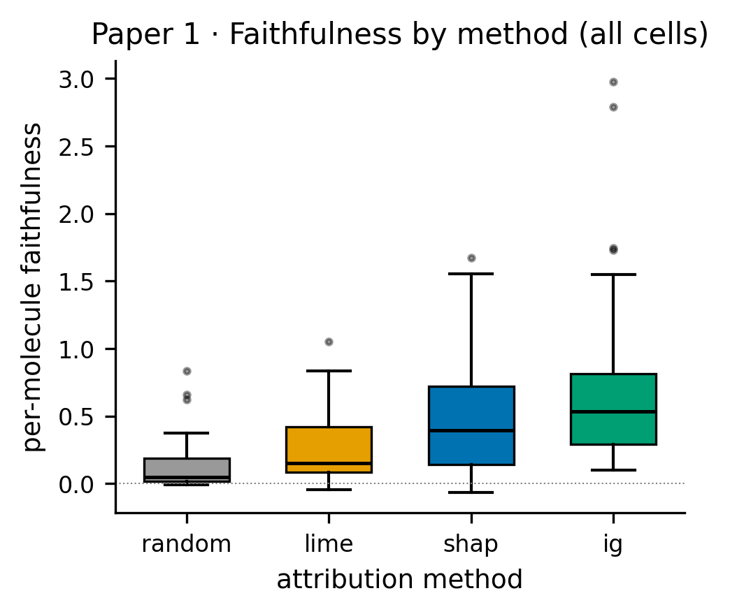
Figure 1
Figure 2. Scaffold vs random faithfulness (H2). Each point is one (endpoint × representation × model × method) cell; the dashed line is y = x. No systematic vertical displacement — faithfulness does not degrade under scaffold-split OOD shift.
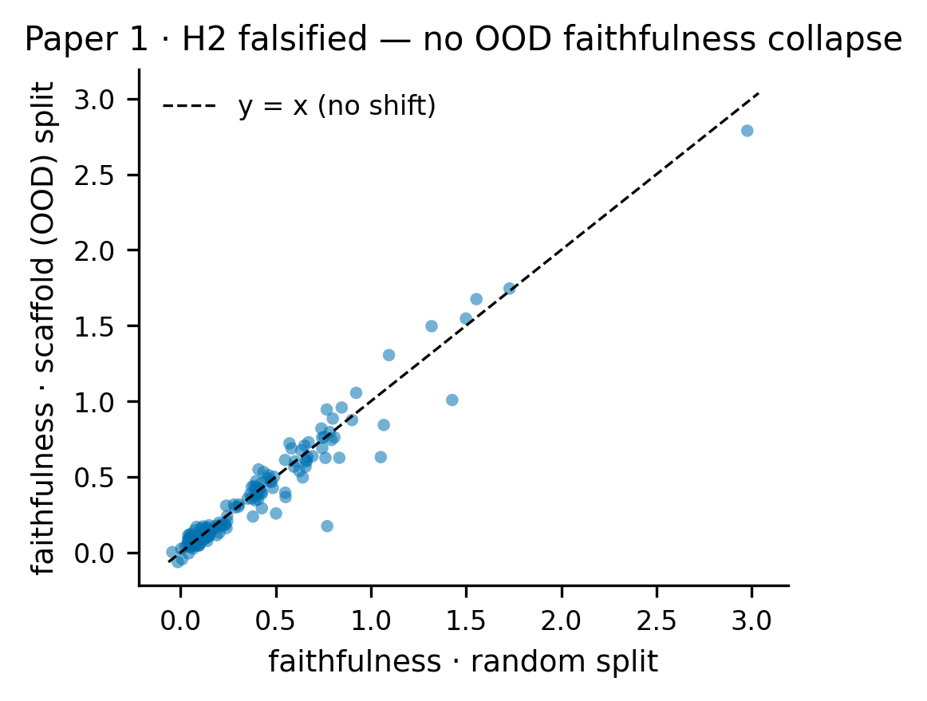
Figure 2
Figure 3. Adebayo model-randomization sanity by model class (H4). Y-axis is |rank correlation| between attributions on the trained vs randomized model; dashed line marks the preregistered failure threshold (0.5). The MLP rate (canonical Adebayo weight reinit) is 25%, the tree rate (label-permutation analogue, caveated) 39%.
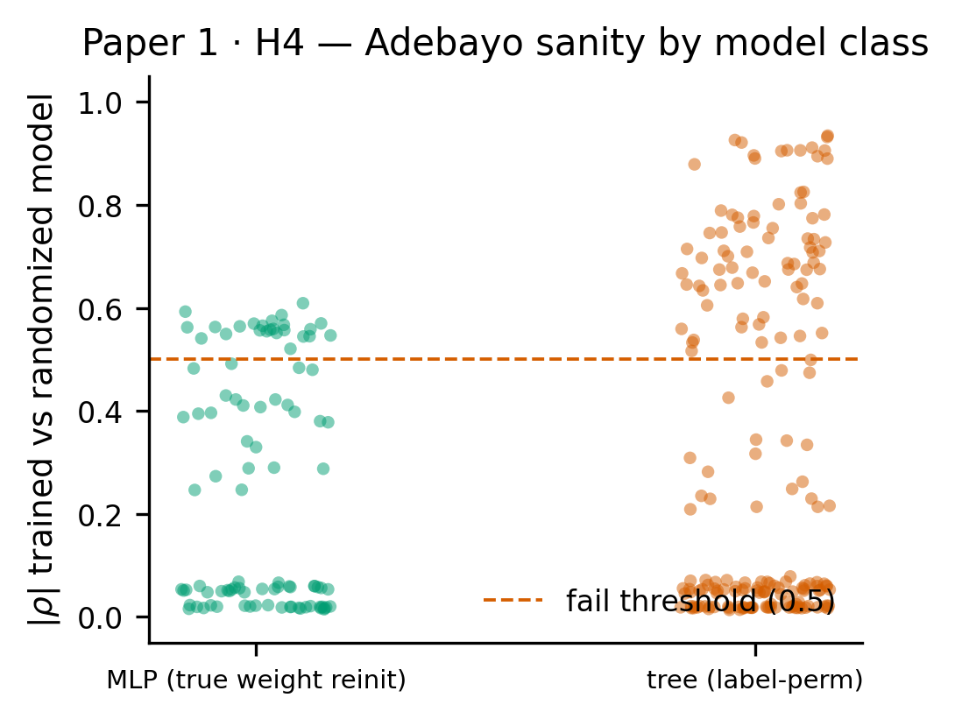
Figure 3
Figure 4. External chemistry-knowledge validation (§3.8). Δ AUROC between attribution top-atoms and PAINS/BRENK-curated alert atoms vs a random-atom baseline, on tox-trained GINs. Error bars: 95% paired-bootstrap CIs over molecules. AMES is significantly chemistry-consistent (asterisk = CI excludes 0); hERG and DILI are at chance — consistent with the reactivity/mutagenicity skew of the alert libraries.
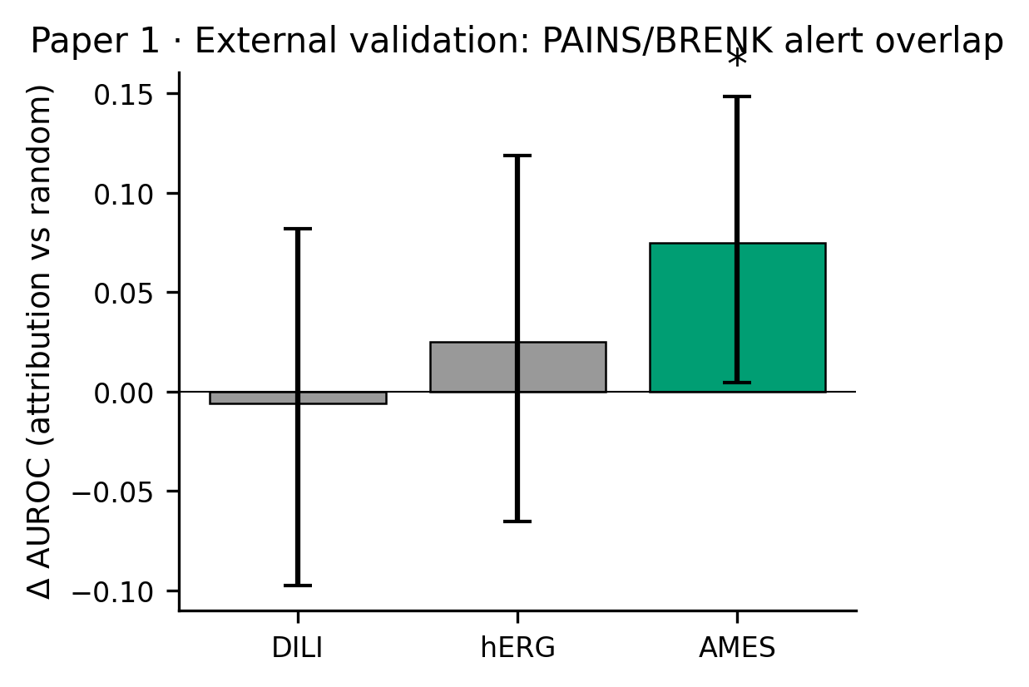
Figure 4
Figure 5. GNN learned-representation extension (§3.9). Left: GIN occlusion faithfulness vs the random null on the four classification tox endpoints. Right: Adebayo sanity similarity under true weight reinitialization; all four endpoints PASS (similarity < 0.5).
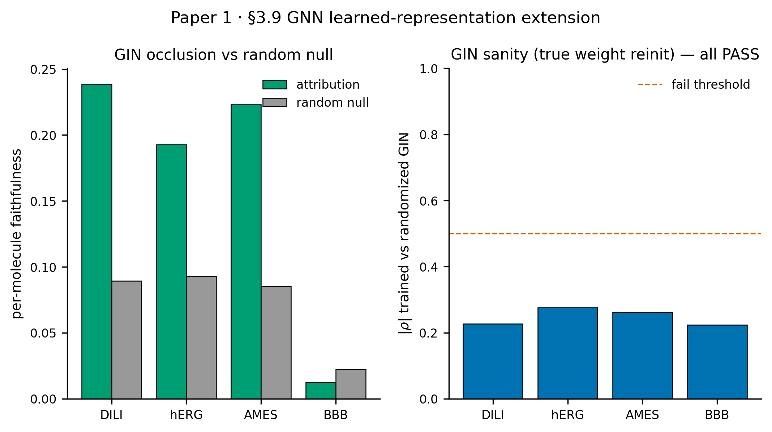
Figure 5

Reviewer-response note
Anticipated critiques and our responses are tracked in docs/reviewer_critiques.md. The GNN extension (§3.9), the external PAINS/BRENK chemistry validation (§3.8), the sufficiency and shift analyses (§3.7), and the LIME-budget correction (§3.4) were added in response across review rounds R1–R5. Two items are honestly scoped to camera-ready: multi-seed across all 12 endpoints (confirmed for the 4 toxicity endpoints) and the full-matrix LIME@1000 re-run (covered by a 6-endpoint robustness subset).

