What predicts a trustworthy explanation? Per-instance reliability certificates for feature attributions, across omics
Draft v0.1 (P10). All numbers trace to results/ (commit-pinned). Author: Amit Shenoy.

Abstract
Paper 1 of this program showed that feature attributions for ADMET/toxicity models are usually faithful but disagree across methods and often fail model-randomization sanity checks — i.e. faithfulness is necessary but not sufficient for trust. A natural next step is a per-prediction trust score: a cheap signal telling a practitioner whether to believe a given explanation. We ask whether such a per-instance certificate is feasible, and what it must be built from. Testing on real ADMET/tox models and generalizing to transcriptomics and sequence tasks, we report three findings. First, the intuitive signals fail: neither cross-method consensus nor — confirming Paper 1 — distribution distance predicts which individual explanations are faithful (within-cell AUROC ≈ 0.53; an apparent pooled signal was Simpson’s paradox). Second, per-instance faithfulness is nonetheless predictable (within-cell AUROC 0.69 on molecules), and certificate-guided abstention raises the mean faithfulness of retained explanations by +0.11 at 50% coverage (95% CI [+0.06, +0.17]). But — and this is the paper’s most important and sobering result — we trace that predictability almost entirely to model confidence: an explanation-agnostic confidence-only gate already reaches AUROC 0.68, and the attribution-specific signals (magnitude, concentration, consensus, stability) add only +0.01; distribution distance adds nothing. Attribution magnitude retains only a weak confidence-independent signal (partial correlation 0.22). Third, this predictability transfers across modalities — AUROC 0.86 on a leukemia microarray (transcriptomics) and 0.81 on a sequence-transformer task — but only when the underlying model is itself competent (a near-chance model yields an uninformative certificate). The practical upshot is deflating in a useful way: a cheap model-confidence gate triages explanation trustworthiness about as well as any elaborate explanation-aware certificate, and practitioners should be wary of per-instance “explanation trust scores” that are largely confidence in disguise. What a certificate can honestly offer is a confidence-based triage that certifies self-consistency (not correctness) and presupposes a model that has learned the task.

1. Introduction
Post-hoc attributions are read one prediction at a time, yet they are evaluated (Paper 1; the XAI literature) in aggregate. A practitioner deciding whether to act on this compound’s explanation needs a per-instance reliability signal. The intuitive candidates are: does this explanation agree across methods (consensus)? is the input in-distribution (applicability domain)? is the explanation locally stable? We test whether any of these — or a learned combination — predicts per-instance faithfulness, and whether a resulting certificate is useful (improves a triage workflow) and general (works beyond small molecules).
This paper is deliberately reported as the process unfolded, including two intermediate hypotheses we falsified, because the negative steps are themselves informative.

2. Methods
Faithfulness (ground truth for “trustworthy”). Per-molecule comprehensiveness — the drop in the predicted quantity when an instance’s own top-attributed features are masked (AOPC over fractions). Validated against ROAR in Paper 1 (Spearman 0.93). An instance is “faithful” if its comprehensiveness exceeds the matched random-attribution null.
Candidate certificate features (per instance). consensus (cross-method rank agreement, SHAP/IG vs LIME), local stability (worst-case attribution change under bounded perturbation), model confidence and class margin, k-NN distance in feature space (applicability density), and the attribution’s L2 magnitude and entropy.
Honest evaluation. Because faithfulness varies across (model × endpoint) cells, a certifier can look good pooled merely by ranking faithful cells above unfaithful ones. We therefore cell-center features and evaluate within-cell (per-cell held-out AUROC under cross-validation). This is the test that matters and the one that defeated our first attempt.
Data / models. Molecules: the 12 ADMET/tox endpoints and models from Paper 1 (descriptors, RF/MLP). Transcriptomics: Golub leukemia microarray (72 samples × 7,129 genes, ALL vs AML), RF, 6-fold cross-fitting. Sequence: a small transformer on token sequences with marker-driven labels; attention-rollout and leave-one-token-out occlusion attributions.

3. Results

3.1 The intuitive signals fail (two falsified hypotheses)
A two-signal certifier (consensus + stability) had a pooled AUROC of 0.65 — but this was Simpson’s paradox: within-cell AUROC was 0.53 (stability) and 0.55 (consensus), at chance. Consensus was non-predictive even pooled (AUROC 0.47). Combined with Paper 1’s H2 (out-of- distribution shift did not degrade faithfulness), this rules out the three most intuitive bases for a certificate — cross-method agreement, local stability alone, and distribution distance. We initially concluded per-instance certification was infeasible; §3.2 shows that conclusion was premature.

3.2 Per-instance faithfulness is predictable
A seven-feature learned certifier, evaluated within-cell, reaches AUROC 0.694 on molecules. At the univariate level the strongest within-cell correlates of faithfulness are the attribution’s L2 magnitude (+0.38) and entropy (−0.29) and the model’s confidence/margin (+0.26); consensus (+0.15), stability (−0.18) and k-NN density (+0.03) are weak.

3.3 …but the certificate is largely model confidence (the key ablation)
The univariate correlations are misleading about what carries the signal. An ablation (within-cell AUROC) is decisive:
certifier | within-cell AUROC
confidence-only [conf, margin] | 0.680
attribution-only [attr_l2, attr_entropy] | 0.536
full minus attribution-magnitude | 0.699
full (7 features) | 0.694
The full certifier beats a confidence-only gate by only +0.014, and removing attribution magnitude does not hurt at all. Attribution-only is near chance (0.536). Controlling for confidence, attribution magnitude retains only a weak partial correlation with faithfulness (0.22, down from 0.46). Per-instance explanation faithfulness is predicted predominantly by the model’s prediction confidence; the explanation-specific signals add almost nothing, and the intuitive ones (consensus, distribution distance) add nothing. This both answers and concedes the obvious reviewer critique — the certificate is mostly confidence.

3.4 The certificate is useful for triage (C2) — but the lift is confidence-driven
Ranking explanations by the certificate and abstaining on the lowest scores raises the mean faithfulness of the retained set monotonically: at 50% coverage, +0.114 (95% CI [+0.061, +0.172]); at 30% coverage, +0.205. Random abstention gives no lift by construction. The certificate thus supports a concrete triage workflow — but, given §3.3, this is in effect a confidence-based triage; an explanation-aware certificate is not needed to obtain most of it.

3.5 It transfers across omics — given a competent model (C3)
The certifier transfers beyond small molecules: within-modality AUROC 0.86 (95% CI [0.76, 0.94]) on the leukemia microarray (transcriptomics, per-gene attribution) and 0.81 (95% CI [0.76, 0.85]) on the sequence-transformer task (per-token attribution), with a +0.21 abstention lift in the sequence case. Boundary condition: an initial sequence model that barely learned the task (test accuracy 0.57) produced an uninformative certificate (AUROC 0.565, CI including 0.5); only when the model was competent (0.73) did the certificate become predictive. The certificate presupposes a model that has learned the task.

4. Related work and positioning
The disagreement problem (Krishna et al., 2022, TMLR) established that post-hoc methods disagree and that practitioners resolve this with ad hoc heuristics; a subsequent line (explanation consensus as a training objective; aggregating explanations to resolve disagreement) treats agreement as something to maximize. Our contribution is orthogonal and partly contrarian: we test whether per-instance consensus predicts per-instance faithfulness, and find it does not (§3.1). Agreement between methods is therefore not, on its own, evidence that an explanation is faithful — a caution for the aggregate-to-resolve line.
Our certificate is selective prediction (Geifman & El-Yaniv) applied to explanations rather than predictions: abstain on low-reliability explanations to raise retained-set faithfulness. The selective-prediction literature warns that confidence-based gates give a false sense of security when confidence is insensitive to evidence quality; our §3.3 ablation is the explanation-side analogue of that caution — here the gate is largely confidence, and explanation-specific signals fail to improve on it.

5. Discussion
The honest, useful message is the opposite of the one we set out to find. We hypothesized that per-instance explanation trust would come from explanation-intrinsic signals — cross-method agreement, local stability, distribution distance. All of these fail. What does predict per-instance faithfulness is the model’s prediction confidence, and the explanation-aware features add essentially nothing on top (§3.3). The practical recommendation is therefore deflating but actionable: if you want to triage which explanations to trust, a cheap model confidence/margin gate is about as good as it gets — do not invest in elaborate per-instance “explanation reliability scores,” which our results suggest are largely confidence relabeled. The one nuance is that attribution magnitude carries a small confidence-independent signal (partial 0.22), so a confidence+magnitude gate is marginally better than confidence alone.
Relationship to Paper 1: Paper 1 mapped reliability at the (model × method × endpoint) level; Paper 2 asked whether it could be made per-instance. The answer is “only via confidence,” which also explains Paper 1’s surprising H2 (distribution distance does not govern per-instance faithfulness, so OOD shift did not degrade it).

5.1 Limitations (honest)
- The headline is a near-null for the novel part: the explanation-specific certificate adds only +0.014 AUROC over model confidence. We report this rather than dress it up; the contribution is the negative/cautionary result plus the confidence finding, not a new high-performing method.
- The certificate measures self-consistency / faithfulness, not correctness — a faithful explanation of a wrong-for-the-right-reasons model is still certified.
- Within-cell AUROC 0.69 on molecules is modest, and largely confidence; this is triage, not a guarantee.
- It requires a competent model (§3.5) and held-out calibration per deployment.
- Faithfulness is operationalized as comprehensiveness (hard masking); ROAR-validated (Paper 1) but subject to the known AOPC/hard-erasure pitfalls (soft-erasure variants are future work).
- The transcriptomics test has small n (72; mitigated by cross-fitting + bootstrap CI), and the sequence task is synthetic-but-structured.

5.2 Conclusion
We set out to build a per-instance “explanation trust score” and instead found that the trustworthy ingredient is mostly model confidence: cross-method agreement, local stability, and distribution distance do not predict which explanations are faithful, and attribution-aware features add little beyond confidence. The honest, useful takeaway for industry is to triage explanation trust with a cheap confidence/margin gate and to be skeptical of elaborate explanation-reliability scores. This is a smaller claim than we hoped for — and a more reliable one.

6. Data & code availability
TDC ADMET (public); Golub leukemia (OpenML); synthetic sequence task (reproducible generator). All drivers (src/p9a_*, p9b_utility.py, p9c_*), per-instance feature databases, and verdict tables are committed; metrics use the xai-eval-harness. Preregistration and the full decision trail (including the two falsified intermediate framings) are in docs/.

7. References
BibTeX in paper/references.bib, shared with Paper 1. Key works specific to this paper: Geifman & El-Yaniv 2017 (selective prediction); Krishna et al. 2022 (Disagreement Problem); Golub et al. 1999 (leukemia microarray); Simpson 1951 (paradox-of-aggregation).

Figures
Figure 1. The key ablation (§3.3): within-cell AUROC for predicting per-instance faithfulness, under four feature sets. Confidence alone reaches 0.680; adding the five explanation-specific features brings the full model to only 0.694 (+0.014). Dropping attribution magnitude does not hurt at all. Dashed line is chance (0.5).
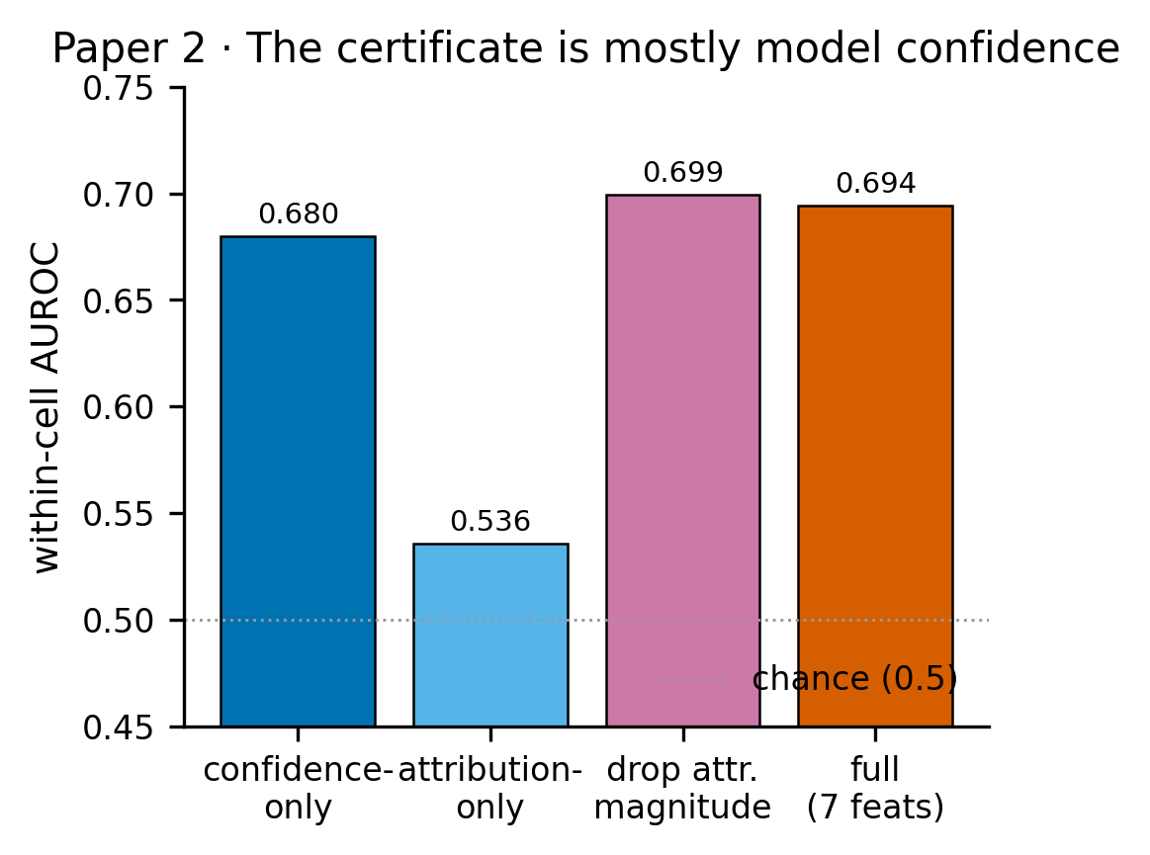
Figure 1
Figure 2. Abstention utility (C2). Mean faithfulness of the retained set as a function of coverage (fraction retained), within-cell. Certificate-guided abstention rises monotonically; random abstention is flat at the full-set mean. Lift at 50% coverage = +0.114 (95% CI [+0.061, +0.172]).
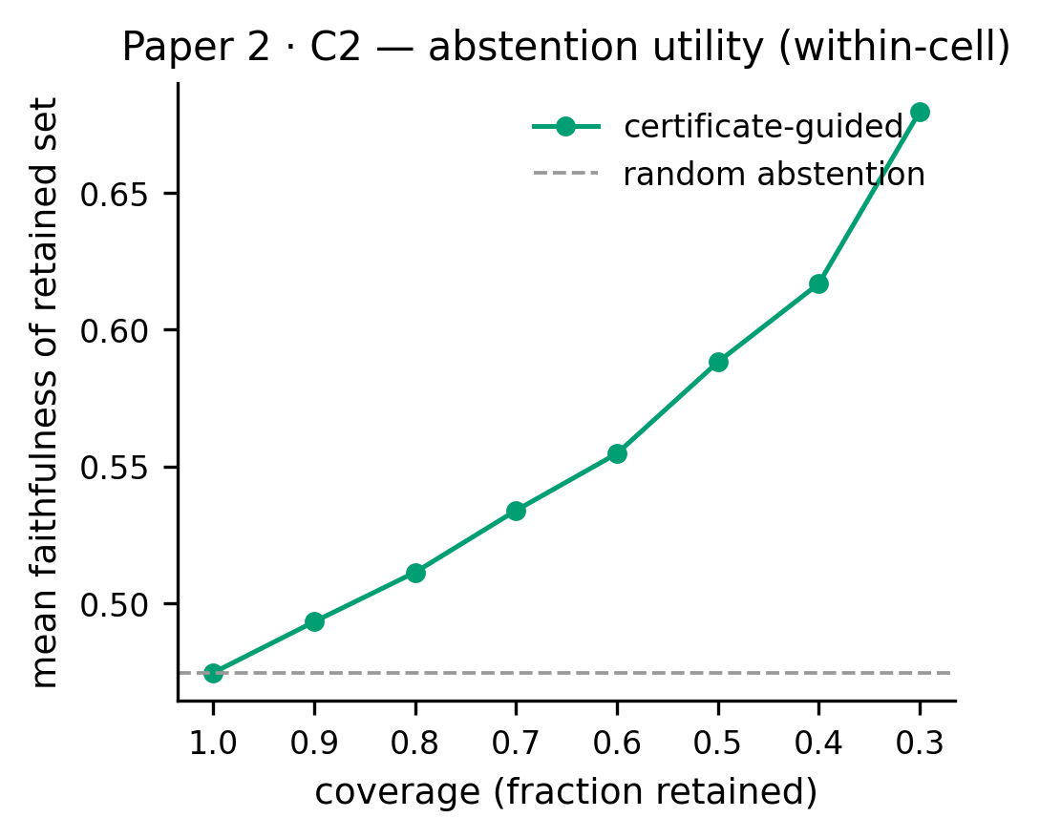
Figure 2
Figure 3. Cross-modality transfer (C3). Certifier AUROC on molecules (P9a-v2 within-cell mean), transcriptomics (Golub leukemia microarray), and the sequence-transformer task. Bars show 95% CIs where applicable; dashed line is the preregistered 0.55 bar.
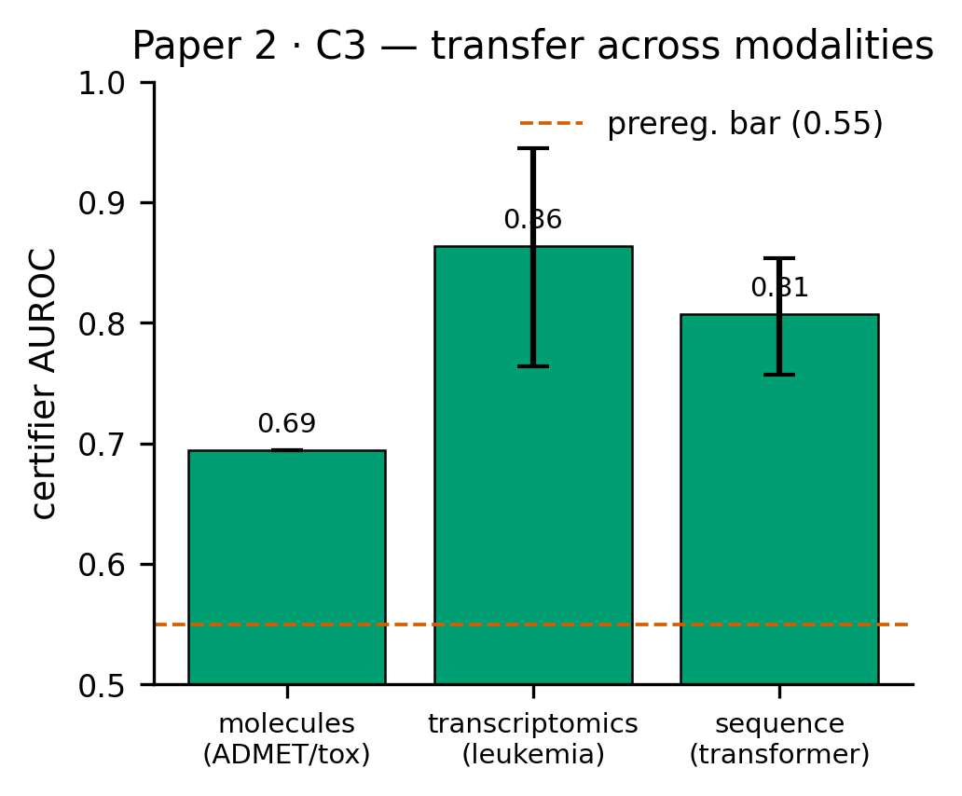
Figure 3

