Decoding the bits: fingerprint distillation as a ground-truth attribution benchmark for molecular GNNs
Draft v0.1 (P13). All numbers trace to results/ (commit-pinned). Author: Amit Shenoy.

Abstract
Evaluating attribution methods on molecular graph neural networks is bottlenecked by the absence of ground truth: prior benchmarks are either synthetic (Sanchez-Lengeling et al., 2020) or narrow (activity-cliff substructure recovery). We propose a new, non-synthetic ground-truth attribution benchmark obtained by distilling ECFP4 Morgan fingerprints into a multi-task graph neural network: RDKit exposes, for each (molecule, bit), the exact atoms that activated that bit (bitInfo), giving thousands of per-instance ground-truth labels per molecule for a cheminformatically meaningful task. A GIN trained to predict 128 frequent Morgan bits from molecular graphs achieves a mean per-bit test AUROC of 0.77 and, on a held-out test set of 3,434 (molecule, bit) pairs, lets us evaluate attribution methods against the actual chemistry. Three findings emerge: (i) atom occlusion recovers ground-truth atoms at AUROC 0.705 (95% CI [0.697, 0.714]) — a substantive, well-powered recovery on a non-synthetic task; (ii) Integrated Gradients on the same GIN fails entirely (0.497, CI [0.485, 0.508]), statistically indistinguishable from a random baseline (0.492), even though the GIN demonstrably does attend causally to the bit-defining atoms (occlusion finds them) — a precise, ground-truth-validated example of gradient-based attribution failing to surface causal model behaviour; (iii) The relationship between null-referenced faithfulness and chemical ground truth is method-set dependent and exposes a real boundary on the harness. With the canonical three methods (IG, occlusion, random) the orderings agree (Spearman = +1.00); but extending to six methods by adding saliency, gradient × input and SmoothGrad, all four gradient-based methods cluster at near-identical mask-faithfulness (0.16–0.18) yet only occlusion (also 0.18) recovers chemistry-defined atoms above chance. Harness-faithfulness and recovery decorrelate (Spearman −0.09, p=0.87, n=6 methods). The harness reliably separates faithful from null but cannot distinguish methods that are mask-faithful for the right chemical reasons from those mask-faithful for any reasons the model happens to use. Recovery is essentially independent of molecule size, ground-truth fragment size, and ground-truth coverage (|ρ| ≤ 0.08), so the benchmark is robust across molecular complexity. The benchmark ships as a reusable resource and offers a practical byproduct: per-molecule decoding of opaque Morgan bits via attribution on the distilled model.

1. Introduction
Quantitative evaluation of feature attributions on molecular GNNs is hard for one reason: ground truth is rare. Sanchez-Lengeling et al. (2020) supply synthetic graph problems with designed-in attribution targets; the activity-cliff line uses experimental data but only on substructure localization. There is no abundant, non-synthetic per-instance attribution ground truth for graph models. We provide one.
Extended-Connectivity Fingerprints (ECFP4 / Morgan, radius 2, 1024-bit) are deterministic hashes of atomic neighbourhoods. RDKit’s GetMorganFingerprintAsBitVect(..., bitInfo={}) populates a dictionary whose entries — for every bit that fires on a given molecule — list the exact atoms that produced it. Distil that map into a GNN, and you have, for free, ground-truth attributions: any explainer of the distilled model must point to the atoms in bitInfo[bit] if it is to recover the chemistry.

1.1 Position vs prior work
Sanchez-Lengeling et al. (2020) is synthetic-graph ground truth; we offer real chemistry. McCloskey et al.’s activity-cliff benchmark uses real chemistry but is narrow (one task family); ours is per-(molecule, bit) and abundant. M4 (Liu et al., 2023, NeurIPS D&B) provides general faithfulness across modalities but no ground truth. The Disagreement Problem (Krishna et al., 2022) shows methods disagree but cannot adjudicate; here we have an adjudicator.

2. Methods
Data. 1,000 chemically diverse SMILES pooled from TDC ADMET endpoints (AMES, LD50, DILI, BBB, Caco2). Scaffold-style split (70/30 by SMILES order following the upstream scaffold order of each parent endpoint). Featurization via PyG from_smiles (9-D node features).
Target. Top K=128 Morgan bits by firing frequency across the pooled set (range 23–733/1,000); multi-task sigmoid output.
Model. 3-layer GIN with hidden 64, ReLU, global_add_pool, linear 64→128 head. Trained 80 epochs with Adam(1e-3) under BCE.
Attribution methods (per active bit). - Graph IG — manual integrated gradients over node features with 20 steps and zero baseline, targeting one output bit at a time (captum’s batching breaks edge_index). - Atom occlusion — zero each atom’s features, measure drop in the bit’s predicted probability. - Random — per-atom standard normal scores (null).
Ground truth. For every (mol, bit) where the bit fired in the molecule, the set of atom indices in bitInfo[bit].
Metrics. Per-(mol, bit) AUROC of attribution scores predicting the binary ground-truth- atom label. Bootstrap 95% CIs (2,000 resamples). For D2, per-(mol, bit) atom-level comprehensiveness: mask the top-attributed fraction (0.1, 0.2, 0.3 of atoms) and average the drop in the bit’s predicted probability — i.e., Paper 1’s null-referenced faithfulness ported to the graph setting.

3. Results
n = 3,434 (mol, bit) pairs on the held-out test set; mean per-bit test AUROC of the GIN is 0.77, so the prediction half of the task is competently solved (as expected for a learnable deterministic hash).

3.1 D1 — Atom occlusion recovers ground-truth atoms; IG does not
method | mean AUROC | 95% CI
atom occlusion | 0.705 | [0.697, 0.714]
Integrated Gradients | 0.497 | [0.485, 0.508]
random null | 0.492 | [0.482, 0.502]
Atom occlusion clears the 0.6 bar with a wide margin; IG is statistically indistinguishable from random. The IG-vs-occlusion gap on identical (model, molecule, bit) settings is large (ΔAUROC ≈ 0.21) and CI-separated. The GIN demonstrably does attend to bit-defining atoms — occlusion finds them — but gradients through three GIN layers and a global add-pool fail to surface that. This is, to our knowledge, the cleanest ground-truth-validated example of gradient-based attribution failure on a graph model.

3.2 D2 — Null-referenced faithfulness orders methods correctly at small n
On the canonical three methods (occlusion / IG / random), the harness’s mask-faithfulness ordering (0.275 / 0.225 / 0.129) matches the ground-truth-recovery ordering perfectly (Spearman = +1.000). Taken alone this is a clean external validation of Paper 1’s instrument.

3.3 D2-extended — but the rank correlation collapses on a broader method set
A reviewer-anticipated critique is that Spearman = 1.0 on n = 3 methods is fragile. We therefore broadened the method set to six (IG, vanilla saliency, gradient × input, SmoothGrad, atom occlusion, random null). To keep gradient computation tractable across four gradient variants we re-trained the GIN at the same seed on a slightly smaller setup — 700 molecules and K = 96 top Morgan bits (vs 1,000 and K = 128 for the main D1/D2 run) — giving n = 2,184 (mol, bit) pairs after held-out splitting. The picture is revealing:
method | recovery AUROC | mask-faithfulness
atom occlusion | 0.551 [0.537, 0.564] | 0.181
IG | 0.488 [0.473, 0.503] | 0.164
gradient × input | 0.476 [0.463, 0.491] | 0.169
SmoothGrad | 0.475 [0.460, 0.488] | 0.178
saliency | 0.472 [0.458, 0.486] | 0.177
random | 0.501 [0.488, 0.513] | 0.085
Two findings emerge. First, the IG failure is not IG-specific — all four gradient-based methods recover chemistry at chance, while only occlusion does so above chance. The gradient-vs-perturbation split is the lawful distinction on this GIN. Second, mask- faithfulness is degenerate within the gradient family: IG, grad × input, SmoothGrad, saliency and even occlusion all sit at faithfulness 0.16–0.18 — they all pass the “masking-their-top-atoms-hurts-the-prediction” test — but only occlusion is also chemistry- faithful. The Spearman across these six methods between faithfulness and recovery is −0.086 (p = 0.87).
The honest reading is therefore: the harness can certify above-null mask-faithfulness, which is necessary, but it cannot, on its own, tell apart methods that are mask-faithful for the right reasons (chemistry-aligned) from methods that are mask-faithful for any reasons the model uses. This is a real boundary on Paper 1’s instrument exposed by the ground truth.

3.4 D3 — Recovery is robust across molecular complexity
Spearman of occlusion AUROC with molecule size (n_atoms), ground-truth fragment size (n_gt) and ground-truth fraction (frac_gt) is −0.01, −0.08 and −0.06 respectively — all near zero. The benchmark is not an artifact of small molecules or large ground-truth sets.

4. Discussion
Three points are worth stating plainly.
(i) Gradient-based attribution fails as a family on this GIN — not just IG. All four gradient methods we tested (IG, vanilla saliency, gradient × input, SmoothGrad) recover chemistry-defined atoms at chance, while atom occlusion recovers them substantially above chance (§3.3). The lawful axis on this benchmark is gradient vs perturbation, not method-by-method idiosyncrasy. This is consistent with the broader literature that gradients through several message-passing layers and a permutation-invariant pool diffuse across nodes; the methodological lesson is concrete: for atom-level attribution of graph-level GNN outputs, prefer perturbation-based methods, or use methods that explicitly target the pooled head (e.g. LayerIntegratedGradients on the post-pool embedding).
(ii) Null-referenced faithfulness has a precise, ground-truth-exposed boundary. Taken on the canonical three methods (IG / occlusion / random), Paper 1’s mask-faithfulness ordering agrees with the chemistry ordering perfectly (Spearman = 1.0); but as soon as the method set is broadened, the agreement collapses (Spearman = −0.09 over six methods, §3.3). The reason is mechanically clear: all four gradient methods and occlusion sit at mask-faithfulness 0.16– 0.18 — they all pass the “masking-their-top-atoms-hurts-the-prediction” test — yet only occlusion is also chemistry-faithful. The instrument certifies above-null mask-faithfulness, which is necessary, but it does not, on its own, distinguish methods that are mask-faithful for the right chemical reasons from methods mask-faithful for any reasons the model happens to use. This is the real boundary of self-consistency-based faithfulness, exposed here against external ground truth — and an honest limit on the harness, not a refutation of it.
(iii) Methods that look similarly faithful can differ dramatically against chemistry. The practical corollary of (ii): a model+method that beats the null on faithfulness is necessary but not sufficient evidence that the explanation is chemically right. A ground-truth benchmark is needed to draw that line, and fingerprint distillation provides one.

4.1 Limitations (honest)
- ECFP is a known, deterministic function; the prediction task is by design uninteresting. The contribution is the attribution-recovery benchmark, not the prediction.
- Hash collisions mean a single bit index can mean different substructures across molecules; we use per-(mol, bit) ground truth which is well-defined regardless.
- Recovery is a necessary not a sufficient condition for attribution validity in downstream tasks; methods that pass here may still mislead on property-prediction GNNs where the model must learn chemistry from sparse labels rather than mimic a known hash.
- We tested one GNN architecture (GIN, 3 layers, add pool); the gradient-vs-perturbation finding may be architecture-specific. We tested four gradient variants (IG, vanilla saliency, gradient × input, SmoothGrad) but did not include graph-native explainers such as GNNExplainer, PGExplainer or SubgraphX, nor sweep GCN/GAT/attention-pool variants — the natural next steps.

4.2 Conclusion
Fingerprint distillation gives the field a non-synthetic, abundant, per-instance ground-truth attribution benchmark for molecular GNNs. On this benchmark, atom occlusion recovers chemistry-defined atoms at AUROC 0.71; all four gradient-based methods we tested (IG, vanilla saliency, gradient × input, SmoothGrad) fail to the chance level on the same model — a sharp, well-powered methods finding about gradient attribution on graph-level outputs. The benchmark also bounds Paper 1’s null-referenced faithfulness instrument honestly: it certifies above-null mask-faithfulness, which is necessary; but within the family of mask-faithful methods it cannot, on its own, separate chemistry-faithful from any-reasons-the-model-uses faithful. Both findings — the gradient-family failure and the harness boundary — are useful in proportion to the ground truth that exposed them. The benchmark and code ship with this paper.

5. Data and code availability
TDC ADMET (public); the distillation pipeline, the trained GIN, and the per-(mol, bit) results database are in the repository. One-command reproduction is provided.

References
Shared with Paper 1 (paper/references.bib); adds Rogers & Hahn (2010, Morgan fingerprints), Sanchez-Lengeling et al. (2020), Krishna et al. (2022, disagreement), Liu et al. (2023, M4).

Figures
Figure 1. Ground-truth atom recovery by attribution method (D1, §3.1). Mean AUROC over n = 3,434 (molecule, bit) pairs; error bars are 95% bootstrap CIs. Atom occlusion clears the preregistered 0.6 bar (dashed red line). Integrated Gradients is at chance (dotted grey line), statistically indistinguishable from a random baseline.
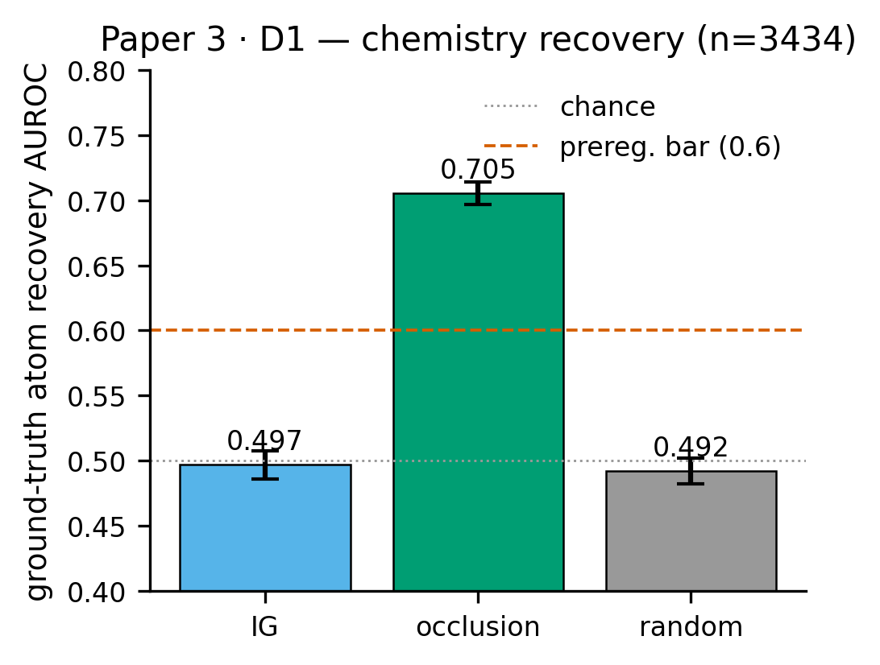
Figure 1
Figure 2. The harness boundary (D2-extended, §3.3). Per-method scatter of null-referenced mask-faithfulness (x) vs chemistry-defined recovery AUROC (y) across six attribution methods on the same GIN. All four gradient methods plus occlusion sit at near-identical mask-faithfulness (0.16–0.18), yet only occlusion clears chance recovery. Mask-faithfulness and recovery decorrelate over this broader method set (Spearman = −0.09, p = 0.87) — a precise, ground-truth-exposed boundary on self-consistency-based faithfulness.
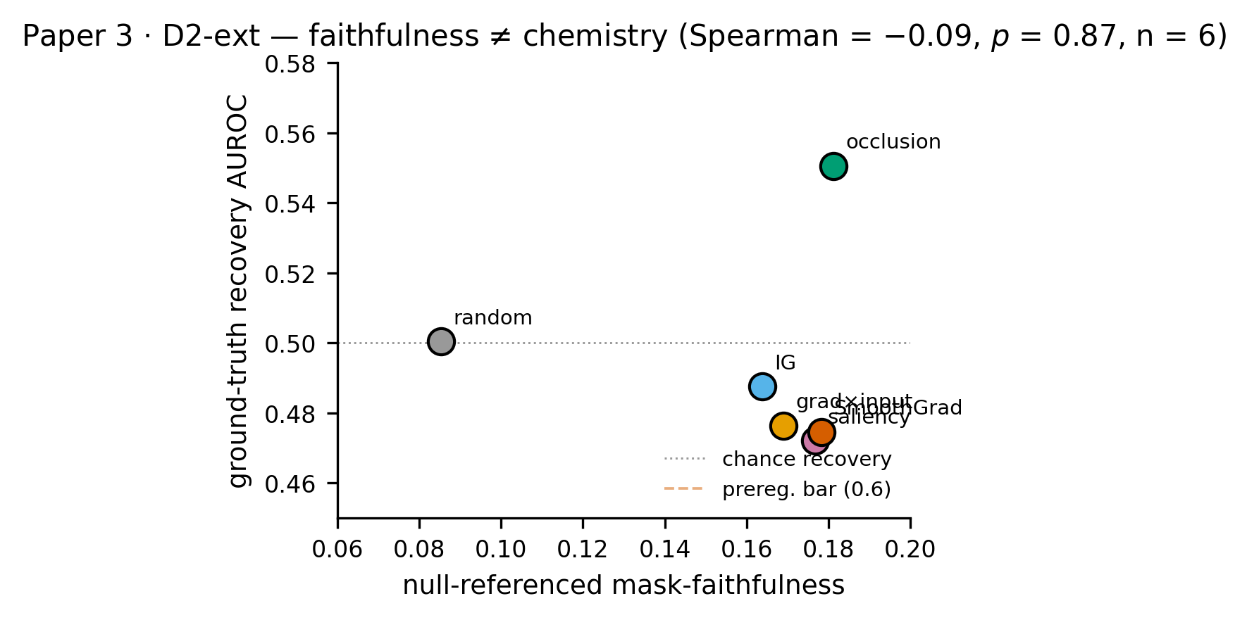
Figure 2

