**Chat Analysis**

**🔥Tobia x Shuyan🔥**

Between 13.05.2023 – 19.06.2023

Dear 淑妍,

I hope you doing great darling.

You know I love data and my work is data.

So I decided to use my skills to analyze our chat.

I hope you find it interesting. I had much fun doing that!

I needed 659 code lines, defined 14 functions and used a total of 390 variables.

>>> Chat-Analysis Results: Tobia and Shuyan <<<

(me=Tobia, her=Shuyan)

Amount of messages: 14338

from me: 6450

from her: 7888

Amount of text messages: 11793

Average amount of text messages per day: 310

from me: 148

from her: 162

Amount of words: 83613

Average amount of text messages per day: 2200

from me: 1513

from her: 688

Top used words:

1. I (4151)

2. you (3445)

3. to (1913)

4. the (1617)

5. and (1494)

Amount of pictures: 785

Average amount of picture messages per day:21

from me: 14

from her: 7

Amount of video: 350

Average amount of video messages per day: 9

from me: 6

from her: 4

Amount of emoji: 14761

Average amount of emoji messages per day: 388

from me: 241

from her: 151

Top used emoji:

1. 😂 (3454)

2. 🥰 (2652)

3. 😘 (1791)

4. 🤣 (1695)

5. 😅 (787)

Amount of sticker: 1230

Average amount of sticker messages per day: 32

from me: 2

from her: 31

38 days in a row daily written! From 13.05.2023 to 19.06.2023 🔥

Ein Bild, das Screenshot, Rechteck, Quadrat, Design enthält.

This shows which kind of messages we sent.

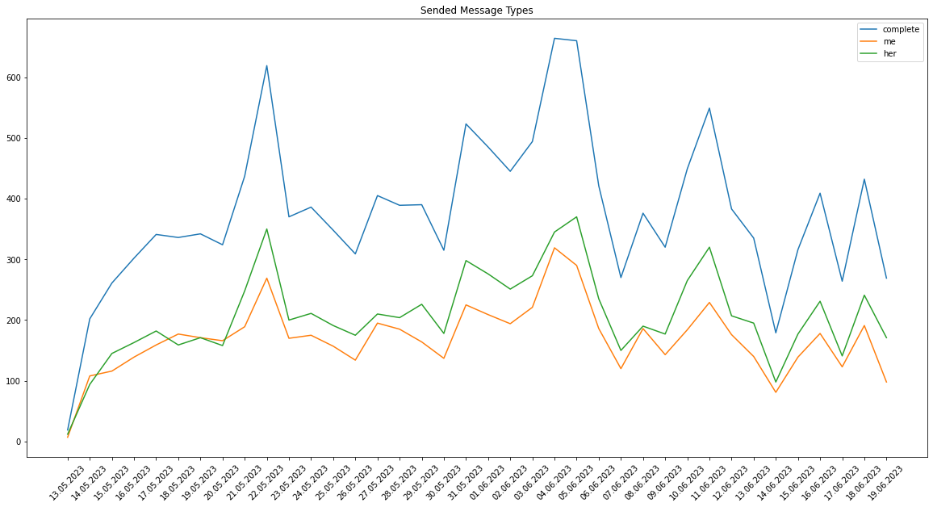

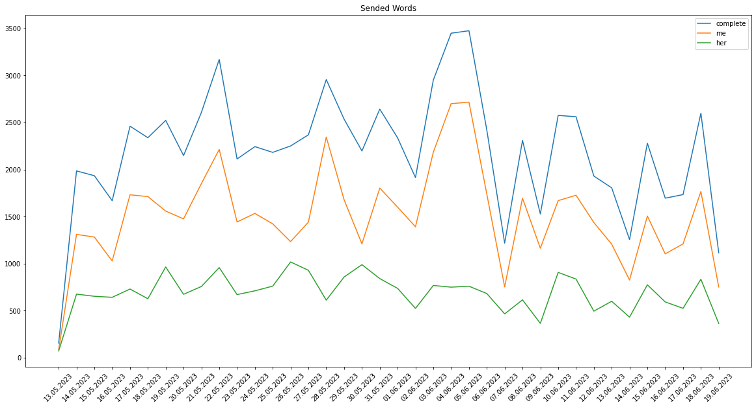

You send more and shorter messages. I send less but longer messages 😊

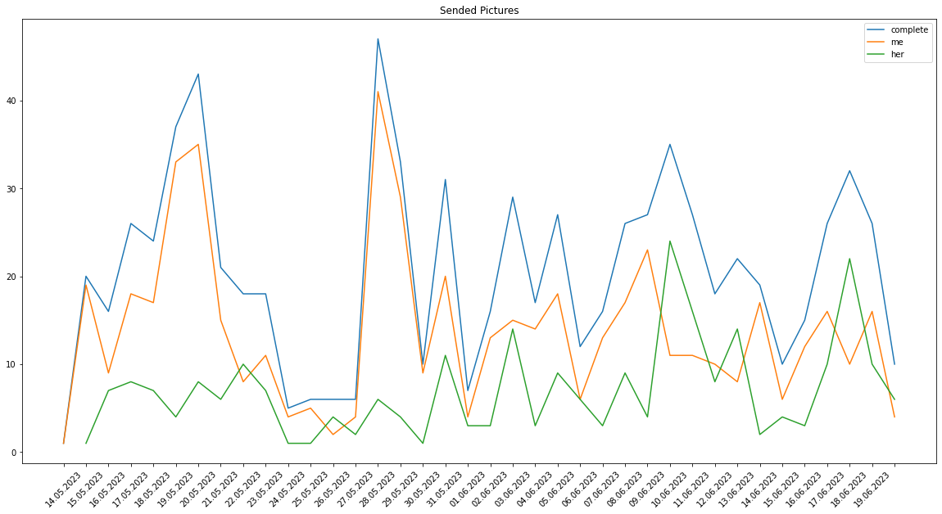

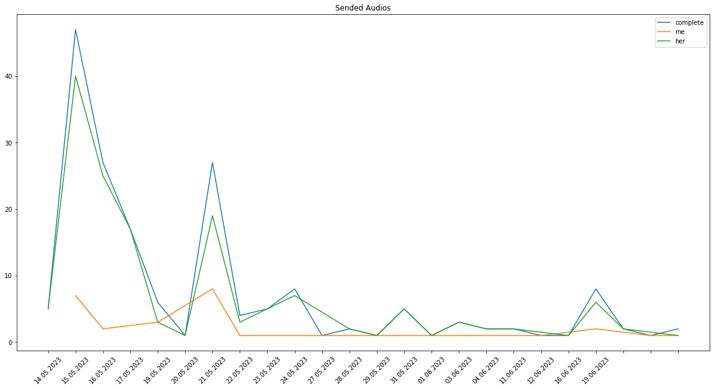

I love pictures, you love audios 🥰

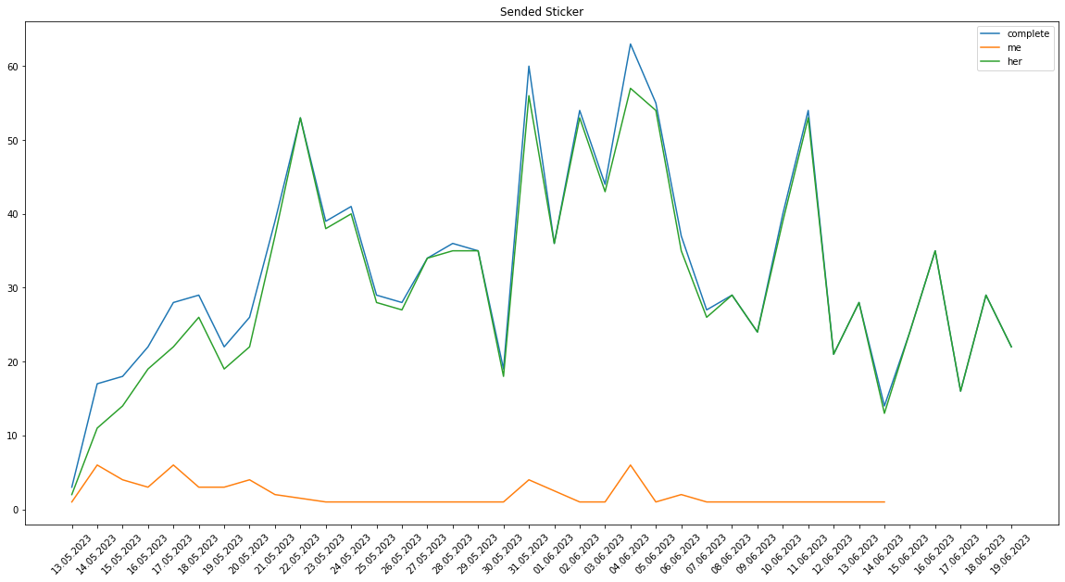

You love Stickers 😘

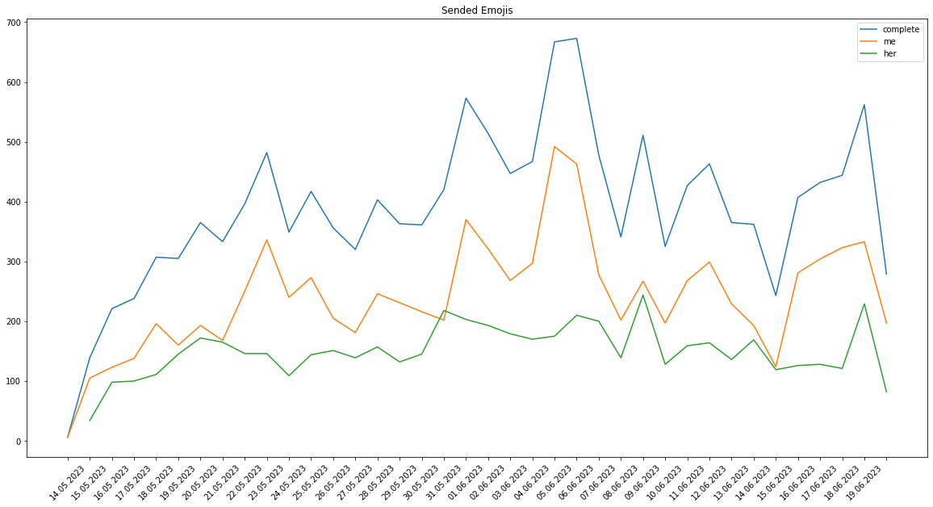

I’m more the oldschool emoji user 😊😂

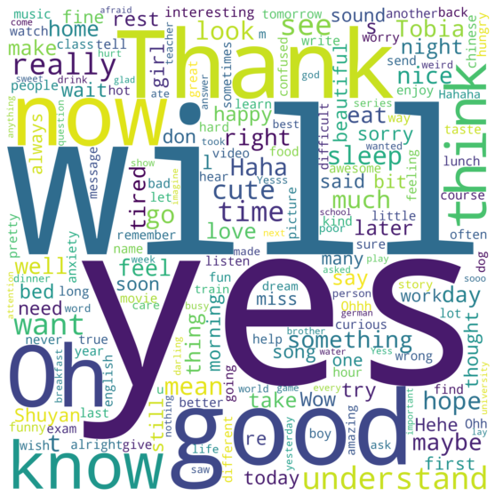At least I created word clouds from all our sent messages:

