Screenshots of at least 6 successfully executed queries.

Create the tables for academic_management_university database

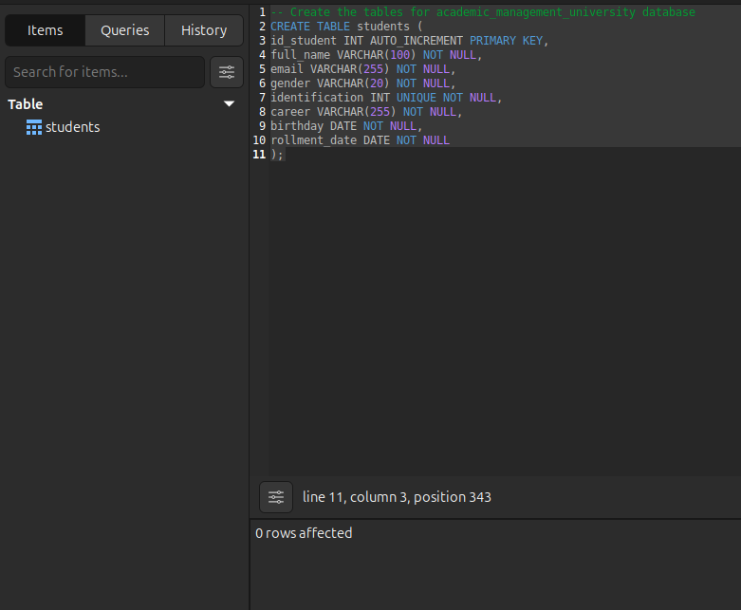

Insert sample data into the students

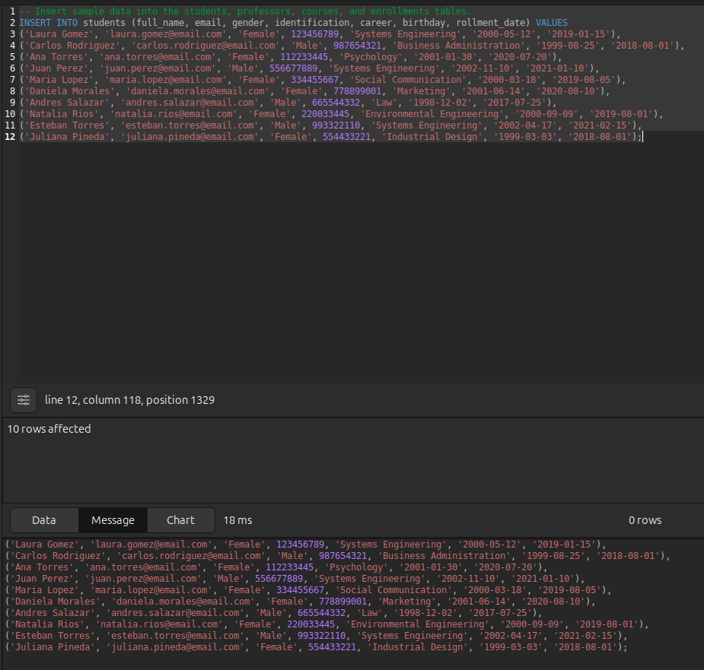

Get the list of all students along with their registrations and courses (JOIN).

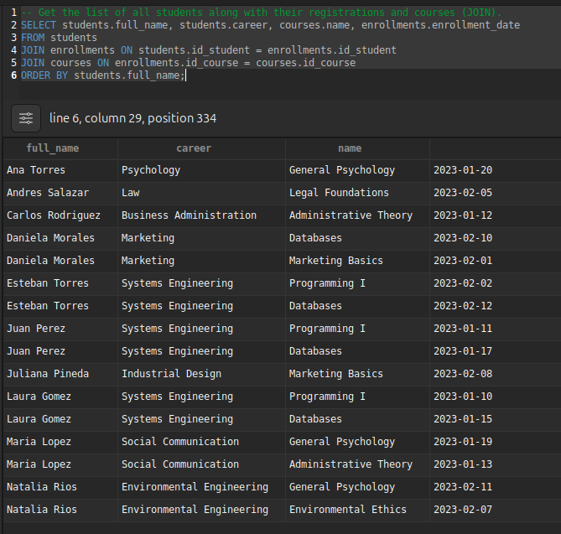

Show students who are enrolled in more than one course (HAVING COUNT(*) > 1).

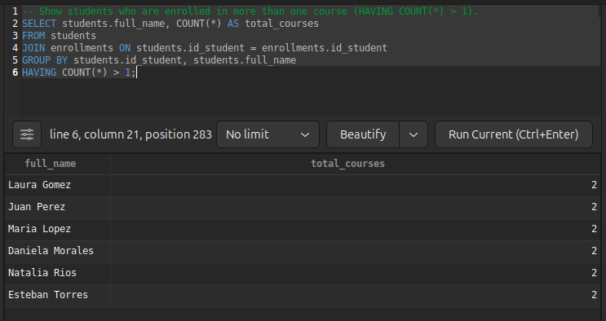  
  
Get the students whose average grade is higher than the general average (AVG() + subquery).

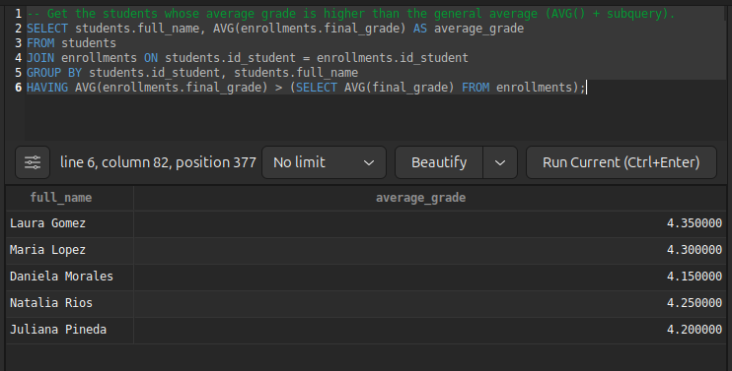

Create a view called view_academic_history

