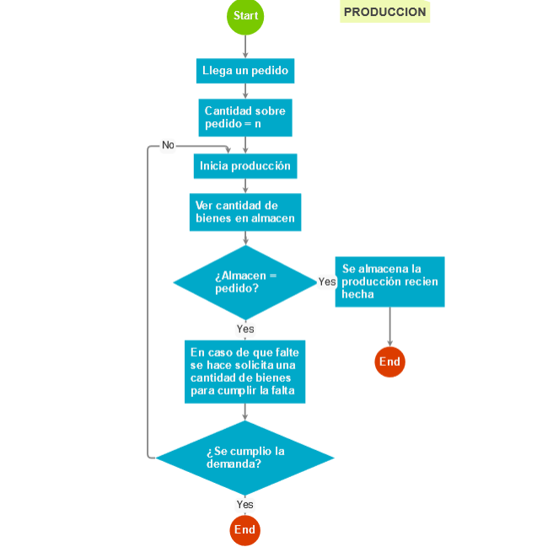

{ "class": "go.GraphLinksModel",

"linkFromPortIdProperty": "fromPort",

"linkToPortIdProperty": "toPort",

"nodeDataArray": [

{"category":"Comment", "loc":"360 -10", "text":"PRODUCCION", "key":-13},

{"key":-1, "category":"Start", "loc":"175 0", "text":"Start"},

{"key":2, "loc":"175 71.99999999999994", "text":"Llega un pedido"},

{"key":3, "loc":"174.99999999999994 133.99999999999994", "text":"Cantidad sobre pedido = n"},

{"key":4, "loc":"175.00000000000003 198", "text":"Inicia producción"},

{"key":6, "loc":"175 259.00000000000006", "text":"Ver cantidad de bienes en almacen"},

{"category":"Conditional", "text":"¿Almacen =\npedido?", "key":-3, "loc":"175.5 352"},

{"category":"End", "text":"End", "key":-4, "loc":"366.5 457"},

{"text":"Se almacena la producción recien hecha", "key":-2, "loc":"366.5 351"},

{"text":"En caso de que falte se hace solicita una cantidad de bienes para cumplir la falta", "key":-10, "loc":"174.5 470"},

{"category":"Conditional", "text":"¿Se cumplio la demanda?", "key":-11, "loc":"174.5 584"},

{"category":"End", "text":"End", "key":-12, "loc":"174.5 680"}

],

"linkDataArray": [

{"from":2, "to":3, "fromPort":"B", "toPort":"T", "points":[175,88.44999999999996,175,98.44999999999996,175,98.77499999999996,174.99999999999994,98.77499999999996,174.99999999999994,99.09999999999997,174.99999999999994,109.09999999999997]},

{"from":3, "to":4, "fromPort":"B", "toPort":"T", "points":[174.99999999999994,158.89999999999998,174.99999999999994,168.89999999999998,174.99999999999994,170.225,175.00000000000003,170.225,175.00000000000003,171.55,175.00000000000003,181.55]},

{"from":4, "to":6, "fromPort":"B", "toPort":"T", "points":[175.00000000000003,214.45000000000002,175.00000000000003,224.45000000000002,175,224.45000000000002,175,224.10000000000008,175,224.10000000000008,175,234.10000000000008]},

{"from":6, "to":-3, "fromPort":"B", "toPort":"T", "points":[175,283.9000000000001,175,293.9000000000001,175.25,293.9000000000001,175.25,292.2,175.5,292.2,175.5,302.2]},

{"from":-3, "to":-2, "fromPort":"R", "toPort":"L", "visible":true, "points":[272.5,352,282.5,352,283.25,352,283.25,351,284,351,294,351]},

{"from":-2, "to":-4, "fromPort":"B", "toPort":"T", "points":[366.5,384.34999999999997,366.5,394.34999999999997,366.5,410.50058139534883,366.5,410.50058139534883,366.5,426.6511627906977,366.5,436.6511627906977]},

{"from":-3, "to":-10, "fromPort":"B", "toPort":"T", "visible":true, "points":[175.5,401.8,175.5,411.8,175.5,415,174.5,415,174.5,418.2,174.5,428.2]},

{"from":-11, "to":4, "fromPort":"L", "toPort":"T", "visible":true, "points":[55.5,584,45.5,584,45.5,171.55,98.83333333333334,171.55,152.16666666666669,171.55,152.16666666666669,181.55], "text":"No"},

{"from":-10, "to":-11, "fromPort":"B", "toPort":"T", "points":[174.5,511.8,174.5,521.8,174.5,523,174.5,523,174.5,524.2,174.5,534.2]},

{"from":-11, "to":-12, "fromPort":"B", "toPort":"T", "visible":true, "points":[174.5,633.8000000000001,174.5,643.8000000000001,174.5,646.7255813953489,174.5,646.7255813953489,174.5,649.6511627906976,174.5,659.6511627906976]},

{"from":-1, "to":2, "fromPort":"B", "toPort":"T", "points":[175,24.709302325581397,175,34.7093023255814,175,40.12965116279068,175,40.12965116279068,175,45.549999999999955,175,55.549999999999955]}

]}