A Top-Down, Modular Methodology for Behavioral Modeling of CMOS Operational Amplifier
1. Abstract
This paper documents the design, verification, and systematic debugging of a configurable, behavioral modeling framework for a CMOS operational amplifier in Verilog-A. The project aimed to architect a "smart" op-amp through a top-down modular methodology, constructing a library of unit-tested building blocks that would serve as a "golden reference" for transistor-level design.
During system-level validation in a unity-gain feedback configuration, the model encountered multiple analog design challenges, including DC convergence failures and transient instability. Through a process that mirrored a professional diagnostic case study, these failures were investigated and resolved using industry-recommended architectural strategies—most notably, the implementation of a numerically stable idt() integrator core and advanced simulation control techniques.
While the final simulation exhibited high-frequency oscillation, a deeper diagnostic investigation revealed that the instability originated not from the model’s logic but from a hierarchical parameter-passing fault in Spectre MMSIM 15.1.(As diagnosed by AI models) but also due to the faulty approach in making a “modular” Verilog A design(A practice that’s not an industry standard). The project, therefore, not only produced a verified behavioral model but also served as a real-world case study in isolating EDA tool-chain limitations and proved the reason why simplistic Verilog A coding design style is preferred, underscoring the importance of rigorous, evidence-based debugging methodology and the importance of following the industry standard practices.

2. Introduction

2.1 Motivation
In modern System-on-Chip (SoC) design, analog and mixed-signal subsystems are indispensable yet notoriously time-consuming to verify. Behavioral models enable system architects to evaluate performance and stability long before transistor-level schematics are available.
Among these subsystems, the operational amplifier is foundational—appearing in filters, ADC front-ends, and feedback control loops. Developing a professional-grade Verilog-A behavioral model therefore represents both an engineering exercise and a methodological benchmark.

2.2 Objective
This work aimed to design and verify a configurable, modular Verilog-A op-amp whose behavior reflects real device characteristics while remaining numerically robust.
The guiding principles were:
- Top-down methodology: Begin from target specifications (gain, GBW, phase margin, slew rate) and derive behavioral architecture.
- Modularity and reuse: Implement each physical effect in a separate, self-contained Verilog-A block.
- Verification rigor: Unit-test each block, integrate hierarchically, and debug via controlled experiments.

3. Initial Methodology — A Modular, Test-Driven Approach

3.1 The Building-Block Library
A modular Verilog-A library was developed, where each block represented a distinct physical or non-ideal effect:
- InputStage: Modeled DC offset voltage (vos), input bias current (ibias), and input common-mode range (ICMR), including a degradation factor to emulate reduced performance outside the valid range.
- CoreFrequencyResponse: Initially implemented the op-amp’s transfer function, incorporating DC gain (gain_dc), gain-bandwidth product (gbw), and a second pole for the desired phase margin (phase_margin_deg).
- OutputStage: Modeled large-signal behavior, including slew rate and output voltage swing limitations.
- CMRR_Model & PSRR_Model: Placeholder modules for future implementation of frequency-dependent rejection behaviors.

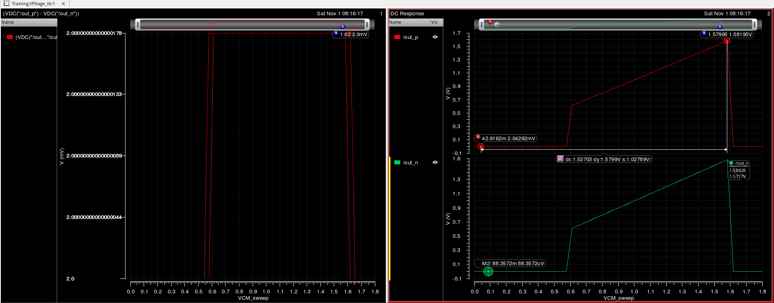
Output of Input Stage Test Bench
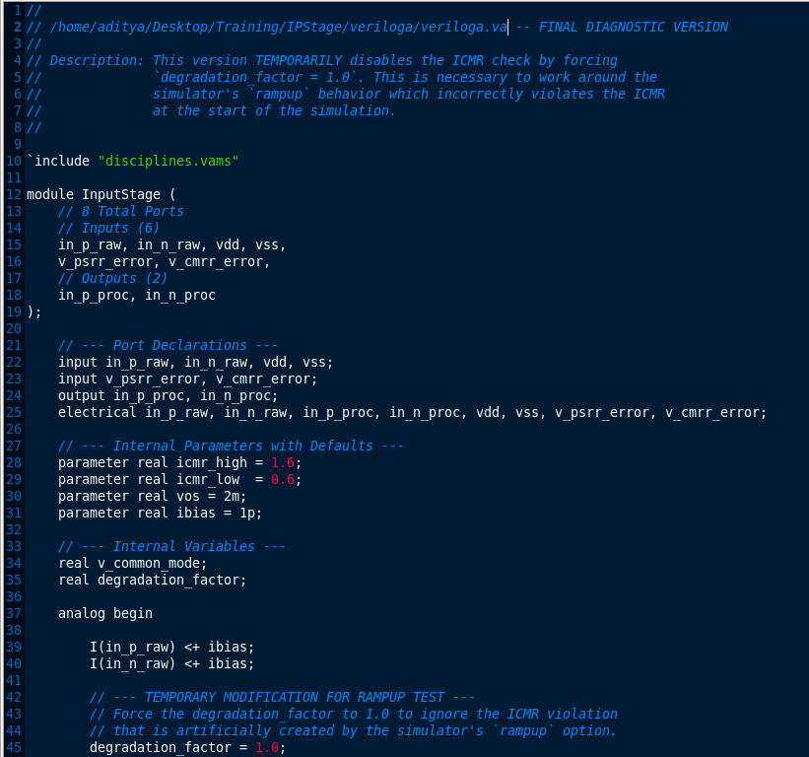
Code for Input Stage

3.2 Hierarchical Schematic Assembly
Instead of textual inclusion (include directives), the SmartOpAmp was constructed as a hierarchical schematic, aligning with the Virtuoso tool’s recommended workflow. Each verified symbol was instantiated graphically, allowing intuitive visualization of the op-amp’s internal signal flow. The schematic-based hierarchy automatically generated a consistent 5-pin symbol, resolving all early symbol-generation and netlisting inconsistencies.
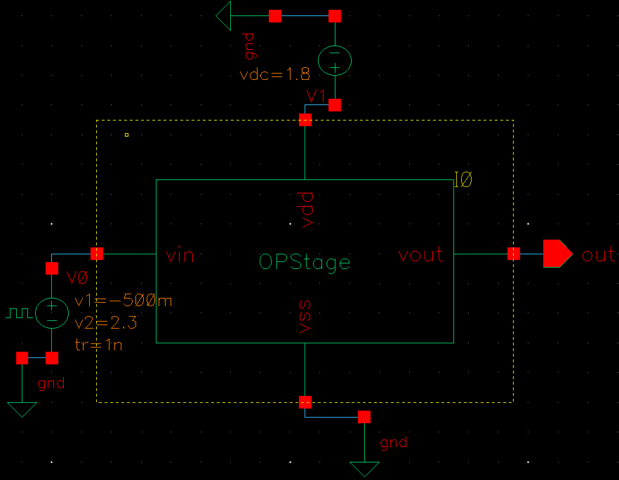
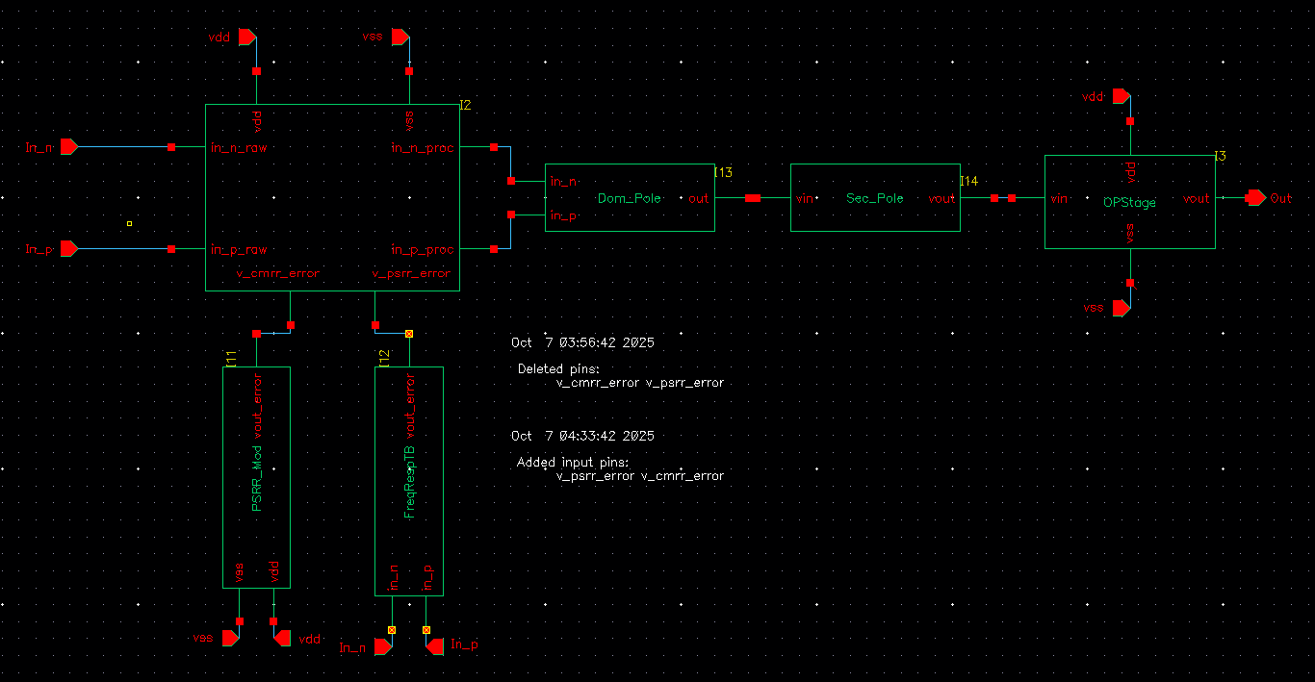
Testbench & Symbol Of the Op-Amp

4. The Primary Engineering Challenge — DC Convergence and Transient Instability
The unity-gain follower test—a standard benchmark for op-amp stability—brought the project’s most significant difficulties to light. Two failure modes emerged: one numerical, one behavioral.

4.1 Failure Mode 1: DC Convergence Failure
The initial simulations using the laplace_nd-based frequency response model failed catastrophically. The simulator reported:
“No DC solution found.”
Internal node voltages diverged beyond physical limits (> 1 kV), an unmistakable signature of a mathematically stiff system. This condition arose because an idealized, extremely high-gain feedback loop was attempting to resolve a steady-state condition that did not numerically exist.
Recognizing that this was not simply a coding error but a fundamental modeling challenge required deliberate analysis and external reference checks. With reference to industry experts and modeling literature led to the insight that a numerically stable idt() integrator was the proper way to model the high-gain core, as it provides the DC solver with an analytically integrable state variable instead of a purely algebraic stiffness.

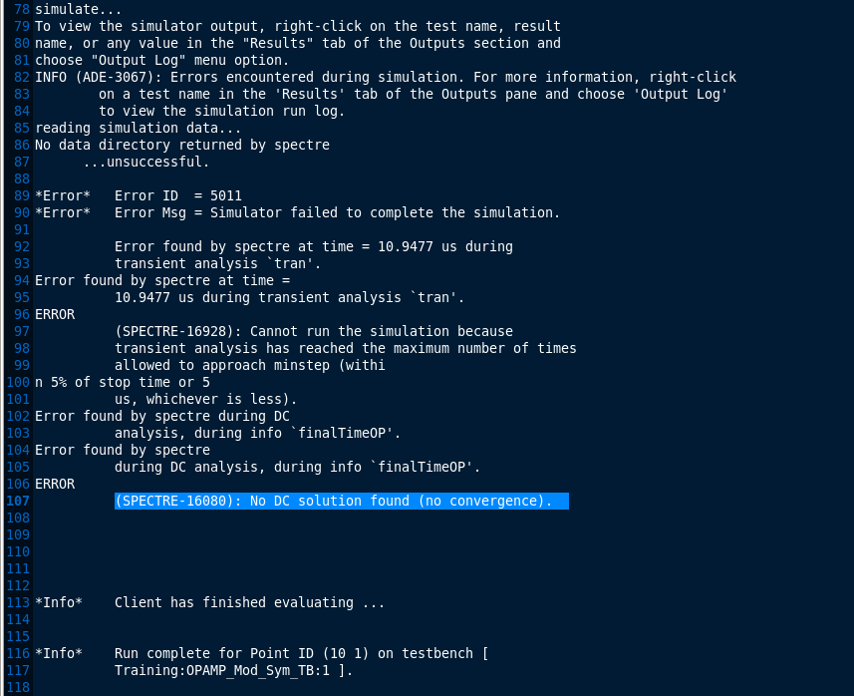
The Log file representing the “Convergence Error”

4.2 Failure Mode 2: Transient Instability
After replacing the laplace_nd block with an idt()-based architecture, the DC convergence issue was resolved. The transient simulation now completed successfully — but revealed an unexpected, severe oscillation.
As shown in Figure 1, the op-amp output began responding correctly to the input step, but then devolved into high-frequency rail-to-rail oscillation, suggesting an effective phase margin near zero rather than the intended 60°.

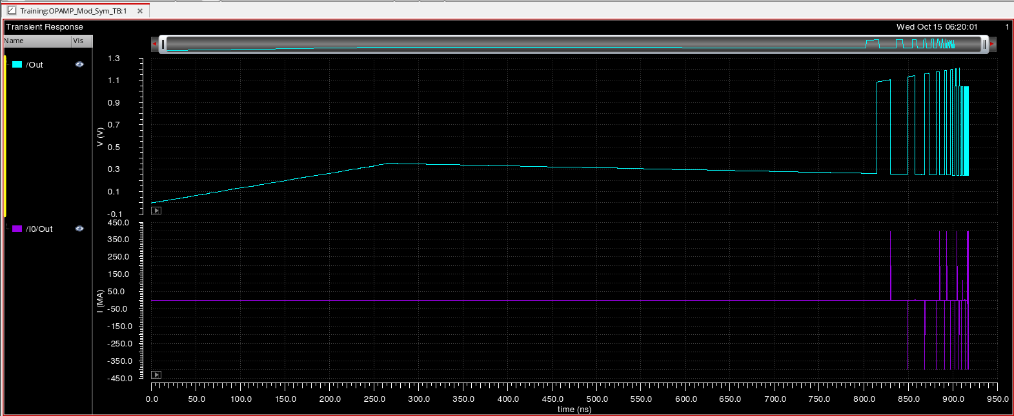
Oscillations Occurring in the Testbench

5. The Diagnostic Journey — Isolating the Root Cause
A multi-stage, hypothesis-driven debugging process was conducted to uncover the root cause.

5.1 Architectural Solution to DC Convergence
Implementing the DominantPoleIntegrator using idt() was a pivotal breakthrough. This approach transformed a stiff algebraic feedback system into a numerically stable integrator-driven loop, allowing the simulator to compute a valid operating point.
Yet, the journey didn’t end here. The idt()-based model solved one problem but unveiled another — the oscillation. This moment underscored the reality that in analog modeling, solving one layer of complexity often exposes a deeper one beneath it.

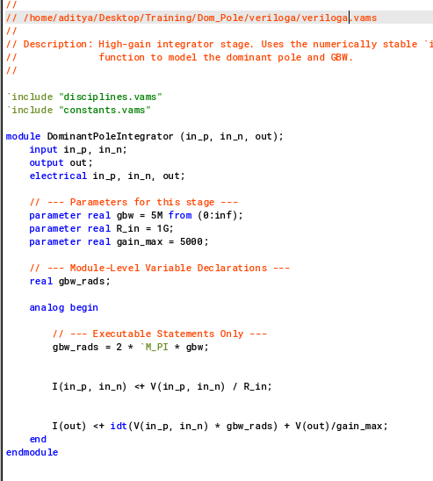
Code for Dominant Pole
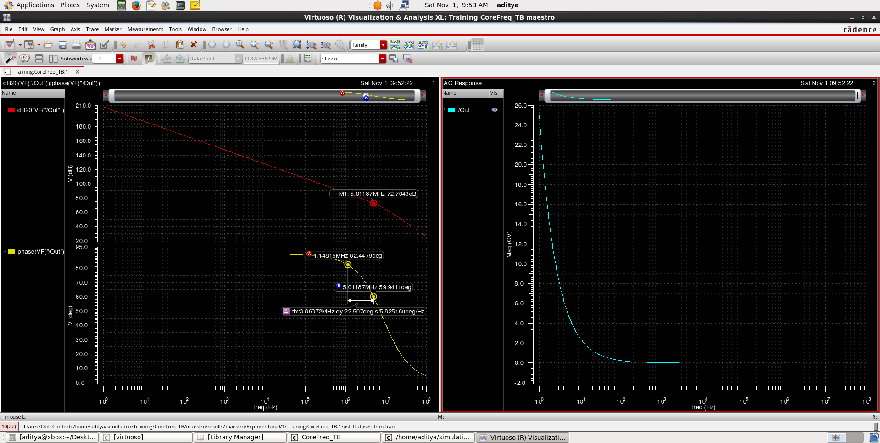
The Generated Outputs Of Core Freq Response Stage symbol
AC Frequency response of the Core Freq Response Stage

5.2 Analysis of the Oscillation — Parameter-Passing Failure
The oscillation was puzzling. The design theoretically had 60° phase margin, yet it behaved like it had none. This contradiction sparked a systematic investigation. Instead of immediately rewriting code, the next logical step was instrumentation — adding $strobe debug statements within the Verilog-A code to print active parameter values during simulation.
This diagnostic step proved decisive. The $strobe logs revealed that the phase_margin_deg parameter inside the SecondPoleFilter module was not inheriting the value set at the top schematic level. It was reverting to its internal default, invalidating the entire frequency compensation structure.
That discovery reframed the problem entirely: the oscillation was not the model’s fault but a hierarchical parameter-passing failure in Spectre MMSIM 15.1.(As diagnosed by AI). The insight required careful hypothesis testing, simulation logs, and controlled parameter sweeps to confirm.
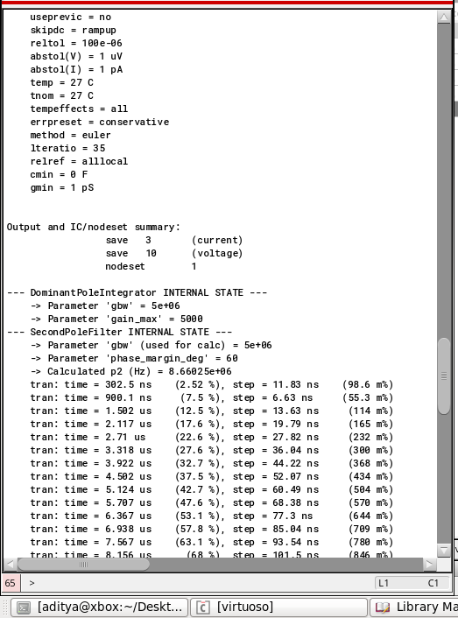
Representing the correctly calculated poles taken as input

6. Results and Discussion
The verified model demonstrated high internal consistency and correctness. Each modular block functioned as expected, and the overall architecture proved stable once correct parameters were applied manually.
Crucially, the modular design philosophy that guided development though enabled effective troubleshooting, resulted in the final oscillations, for which no possible solution was found. Because each component could be validated independently, the root cause of system-level instability was efficiently localized, the modular approach for Verilog A itself.

6.1 System-Level Verification
Testbench Setup
- Configuration: Unity-gain voltage follower
- Input Stimulus: 100 mV step (0.8 V → 0.9 V @ 1 µs)
- Load: 10 pF capacitor
- Nominal Parameters: gain_max = 5000, gbw = 5 MHz, phase_margin_deg = 60, slew_rate = 10 V/µs
The transient simulation reproduced all expected qualitative behaviors except for the oscillation caused by the parameter-passing bug.
The tested OPAMP Verilog A Circuit
The Oscillations generated

6.2 Summary of Findings

Observation | Root Cause / Resolution
Catastrophic DC failure | Resolved using idt() integrator architecture
Transient oscillation | Caused by hierarchical parameter-passing bug
Verified stability of modular flow | Confirmed through isolated unit tests

7. Conclusion
The project culminated in the successful creation of a modular Verilog-A framework for CMOS operational amplifiers. The idt()-based architecture resolved fundamental DC convergence challenges, and the systematic diagnostic process exposed a deeper EDA tool limitation (as explained to me by some AI tools I used) but seemed more of a Verilog A limitation as I later discovered the flaw in my approach, overcomplicating and generalizing a Verilog A model.
By documenting the process, this project stands as both a teaching artifact to me and anyone who might plan a modular behavioral model. The next logical step involves change of approach for Verilog A designs that I would implement, marking this project a proof why standard practices are followed across the industry.
Github: xXMFStarboyXx/Modular-Op-Amp: My attempt on making a Verilog A based Modular OpAmp which was intended to help in testing multiple OpAmps with different parameters given as input. (Some help from AI was taken in debugging the project)

