**Homework**

1. Given a (very) tiny computer that has a word size of 5 bits, what are the smallest negative

numbers and the largest positive numbers that this computer can represent in each of the

following representations?

Hint: show your answers in binary and decimal forms.

a. One's complement

The largest: 01111 = 15

The smallest: 10000 = -15

b. Two's complement

The largest: 01111 = 15

The smallest: 10000 = -16

2. Show how the floating point value of 26.625 would be stored using IEEE-754 double

precision with excess-1023 exponent (be sure to indicate the sign bit, the exponent, and the

significand fields):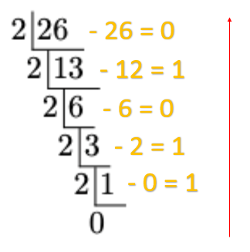

First step, Convert 26.625 to binary.

(26)10 = (11010)2

(0.625)10 = (0.101)2

(26.625)10 = (11010)2 + (0.101)2

= (11010.101)2 * 20

= (1.1010101)2 * 24

Second step, finding the exponent by adding 1023 to the exponent of our binary.

4 + 1023 = 1027

Convert (1027)10 = (10000000011)2

Final step, Because of the IEEE-754 double precision, we need a mantissa of 52 bits.

1010101 add 0 for 45 times = 1010101000000000000000000000000000000000000000000000

We will get answer is:

Sign = 0

Exponent = 10000000011

Mantissa = 1010101000000000000000000000000000000000000000000000

IEEE-754 double precision:

| 0 | 10000000011 | 1010101000000000000000000000000000000000000000000000 |
| --- | --- | --- |
| Sign [1] | Exponent [11] | Mantissa [52] |

3. Suppose a computer uses 4-bit one’s complement representation. Ignoring overflows, what value will be stored in the variable j after the following pseudocode routine terminates?

-2 → j // Store -2 in j.

6 → k // Store 6 in k.

while k ≠ -6

j = j-1

k = k+1

end while

First step, One complement:

6 = 0110 =====> -6 = 1001

Second step, start the loop:

Start from > 0110 + 1

1st run: 0110 + 1 = 0111

2nd run: 0111 + 1 = 1000

3rd run: 1000 + 1 = 1001

Final step, We need to add 3 times. In the while loop, it will run 3 times:

j = j + [(-1) 3 times]

j = -2 + (-3)

j = -5

4. Convert 9.5 and 1.25 to unsigned binary, then compute the multiplication of the two

values. Answer in 14-bit floating point model with bias-16 exponent.

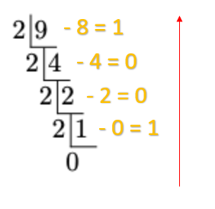

First step, Convert 9.5 to unsigned binary:

(9)10 = (1001)2

(0.5)10 = (0.1)2

(9 + 0.5)10 = (1001)2 + (0.1)2

= (1001.1)2 * 20

= (1.0011)2 * 23

Second step, Convert 1.25 to unsigned binary: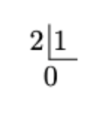

(1)10 = (0001)2

(0.25)10 = (0.01)2

(1 + 0.25)10 = (0001)2 + (0.01)2

= (0001.01)2 * 20

Third step, Multiply the binary numbers:

(1.0011 * 23) * (0001.01 * 20) = (1.0011 * 1.01 * 2(3+0))

= (1.011111 * 23)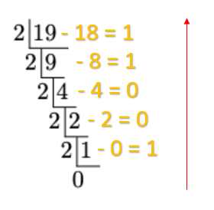

Fourth step, Biassed exponent for 3:

16 + 3 = 19

(19)10 = (10011)2

We will get answer is:

Sign = 0

Exponent = 10011

Mantissa = 01111100

IEEE-754 double precision:

| 0 | 10011 | 01111100 |
| --- | --- | --- |
| Sign [1] | Exponent [5] | Mantissa [8] |

**Group 2 (8 people)**

1. 65130500201 Kampol Suwannatam
2. 65130500204 Jirawat Rongsupan
3. 65130500207 Chewin Grerasitsirt
4. 65130500209 Natthanon Somroop
5. 65130500210 Nontakorn Chatkoonsathien
6. 65130500212 Nithit Lertcharoensombat
7. 65130500227 Issadaorn Kulsantao
8. 65130500237 Chayapol Mahatthanachai