1. Compute the minimum Hamming distance of the following code:

0000000101111111

0000001010111111

0000010011011111

0000100011101111

1001000011110111

1000000011111110

Ans: The minimum Hamming distance of the following code is 1001000011110111 [Line 5] and 1000000011111110 [Line 6]. The Hamming distance of Line 5 and Line 6 is 3.

Sol: 1001000011110111

1000000011111110

Hamming distance is a metric for comparing two binary data strings. While comparing two binary strings of equal length, Hamming distance is the number of bit positions in which the two bits are different.

2. Suppose we want an error-correcting code that will allow all single-bit errors to be corrected for memory words of length 10.

a. How many parity bits are necessary?

b. Assuming we are using the Hamming algorithm presented in this chapter to design our

error-correcting code, find the code word to represent the 10-bit information word:

1001100110. Assume even parity.

Ans:

a. In order to correct all single-bit errors, we can use a Hamming code with d=3, which means that any combination of three bits can be corrected. To compute the number of parity bits, we can use the formula p = log2(w + p) + 1 where w is the number of data bits and p is the number of parity bits. In this case, w=10 and p=4 (since 2^4 = 16 >= 10 + 4). Therefore, 4 parity bits are necessary.

b. To find the code word for the 10-bit information word 1001100110, we can use the Hamming algorithm with even parity.

|  |  |  |  |  |  |  |  |  |  |  |  |  |  |  |
| --- | --- | --- | --- | --- | --- | --- | --- | --- | --- | --- | --- | --- | --- | --- |
|  | 1 | 0 | 0 | 1 | 1 | 0 | P8 | 0 | 1 | 1 | P4 | 0 | P2 | P1 |
|  | 14 | 13 | 12 | 11 | 10 | 9 | 8 | 7 | 6 | 5 | 4 | 3 | 2 | 1 |
| Position number | 1110 | 1101 | 1100 | 1011 | 1010 | 1001 | 1000 | 0111 | 0110 | 0101 | 0100 | 0011 | 0010 | 0001 |

-Bit 1 (0001) checks the digits 3, 5, 7, 9, 11 and 13 -> 0

-Bit 2 (0010) checks the digits 3, 6, 7, 10, 11 and 14 -> 0

-Bit 3 (0100) checks the digits 5, 6, 7, 12, 13 and 14 -> 1

-Bit 4 (1000) checks the digits 9, 10, 11, 12, 13 and 14 - => 1

The answer is 10011010111000

3. Using the CRC polynomial 1101, compute the CRC code word for the information word,

01001101. Check the division performed at the receiver.

Ans: Division Check the division

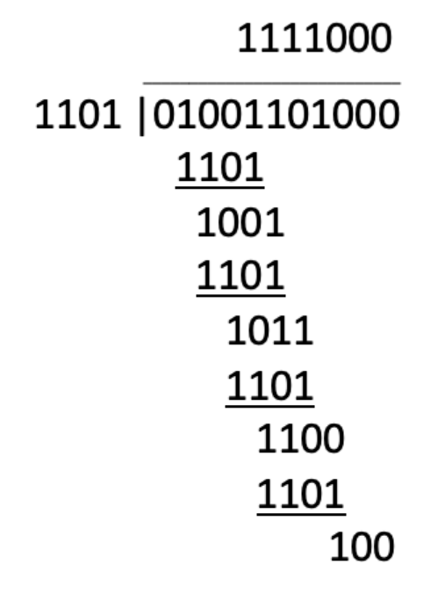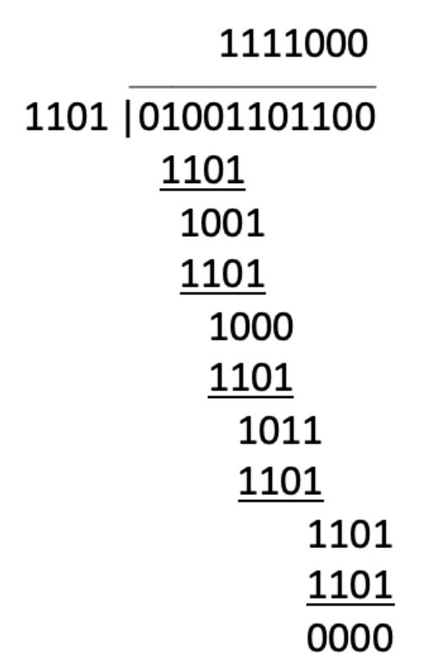

Append zeros to “01001101” to make it the same length as the polynomial. In this case, we add 3 zeros to make it the same length as the polynomial "1101". As a result, the new one is "01001101000". The remainder obtained after the division is the CRC code word. In this case, the remainder is "100".

To check the division performed at the receiver, we can perform the same division on the received word, which is the information word with the CRC code word appended to it. If the remainder obtained after the division is zero, it means that the received word is free of errors. If the remainder is not zero, it means that errors have occurred during transmission.

In this case, the received word is "01001101100" The division gives a remainder of zero, which means that the received word is free of errors.

4. Write the 7-bit ASCII code for the character 4 using the following encoding:

a. Non-return-to-zero

b. Non-return-to-zero-invert

c. Manchester Code

d. Frequency modulation

e. Modified frequency modulation

f. Run length limited

(Assume 1 is “high,” and 0 is “low.”)

Ans:

Non-return-to-zero [NRZ]

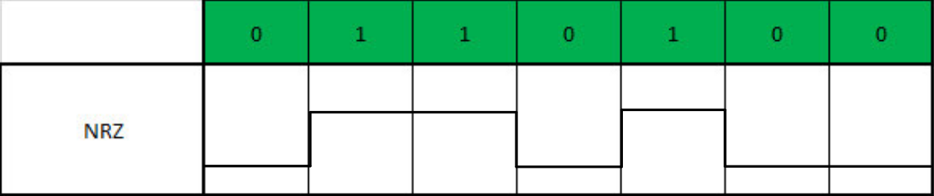

Non-return-to-zero-invert [NRZI]

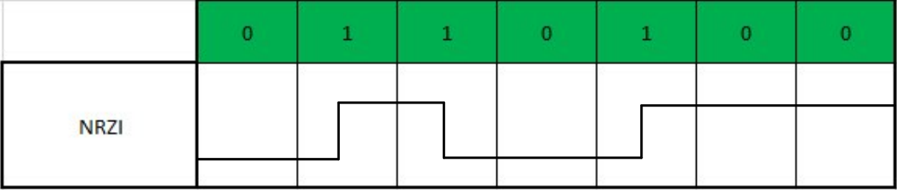

Manchester Code

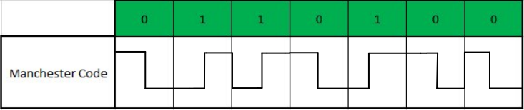

Frequency modulation [FM]

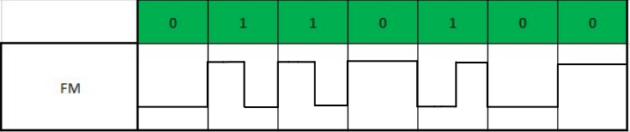

Modified frequency modulation [MFM]

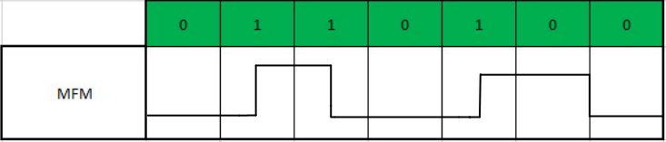

Run length limited [RLL(2,7)]

(Assume 1 is “high,” and 0 is “low.”)

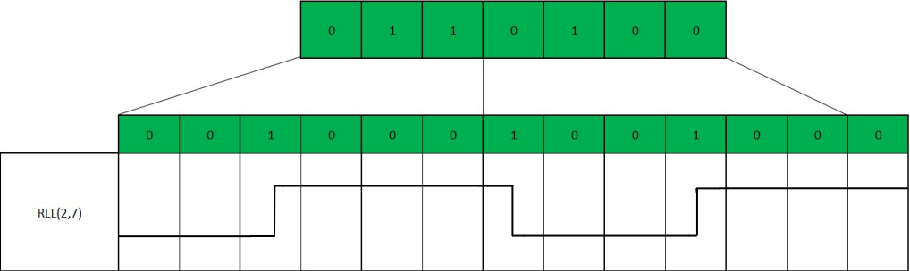

**Group 2 (8 people)**

1. 65130500201 Kampol Suwannatam
2. 65130500204 Jirawat Rongsupan
3. 65130500207 Chewin Grerasitsirt
4. 65130500209 Natthanon Somroop
5. 65130500210 Nontakorn Chatkoonsathien
6. 65130500212 Nithit Lertcharoensombat
7. 65130500227 Issadaorn Kulsantao
8. 65130500237 Chayapol Mahatthanachai