1. Construct a truth table for the following:

a. *(x + y)(x + z)(x' + z)*

**Ans**

| x | y | z | x' | x + y | x + z | x' + z | (x + y)(x + z)(x + z) |
| --- | --- | --- | --- | --- | --- | --- | --- |
| 0 | 0 | 0 | 1 | 0 | 0 | 1 | 0 |
| 0 | 0 | 1 | 1 | 0 | 1 | 1 | 0 |
| 0 | 1 | 0 | 1 | 1 | 0 | 1 | 0 |
| 0 | 1 | 1 | 1 | 1 | 1 | 1 | 1 |
| 1 | 0 | 0 | 0 | 1 | 1 | 0 | 0 |
| 1 | 0 | 1 | 0 | 1 | 1 | 1 | 1 |
| 1 | 1 | 0 | 0 | 1 | 1 | 0 | 0 |
| 1 | 1 | 1 | 0 | 1 | 1 | 1 | 1 |

*2. Show that x = xy + xy '*

*a. Using truth tables*

| x | y | y' | xy | xy' | xy + xy' |
| --- | --- | --- | --- | --- | --- |
| 0 | 0 | 1 | 0 | 0 | 0 |
| 0 | 1 | 0 | 0 | 0 | 0 |
| 1 | 0 | 1 | 0 | 1 | 1 |
| 1 | 1 | 0 | 1 | 0 | 1 |

*b. Using Boolean identities*

x = xy + xy*'* = x(y+y*'*) # Distributive Law

= x(1) # Inverse Law

= x # Identity Law

**Ans** ∴ x = xy + xy*'*

2. Given the function: F*(x,y,z)= xy'z + x'y'z + xyz*

a. List the truth table for F.

**Ans**

| x | y | z | x' | y' | xyz | xy'z | x'y'z | xy'z + x'y'z + xyz |
| --- | --- | --- | --- | --- | --- | --- | --- | --- |
| 0 | 0 | 0 | 1 | 1 | 0 | 0 | 0 | 0 |
| 0 | 0 | 1 | 1 | 1 | 0 | 0 | 1 | 1 |
| 0 | 1 | 0 | 1 | 0 | 0 | 0 | 0 | 0 |
| 0 | 1 | 1 | 1 | 0 | 0 | 0 | 0 | 0 |
| 1 | 0 | 0 | 0 | 1 | 0 | 0 | 0 | 0 |
| 1 | 0 | 1 | 0 | 1 | 0 | 1 | 0 | 1 |
| 1 | 1 | 0 | 0 | 0 | 0 | 0 | 0 | 0 |
| 1 | 1 | 1 | 0 | 0 | 1 | 0 | 0 | 1 |

b. Draw the logic diagram using the original Boolean expression

**Ans**

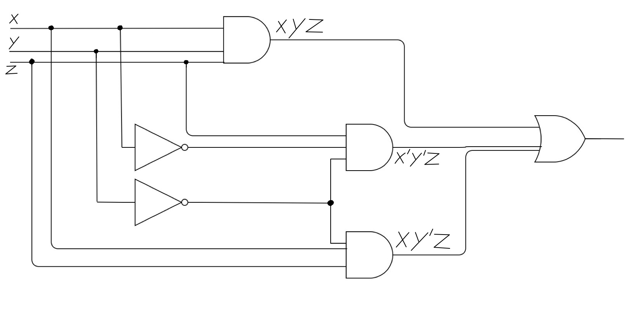

c. Simplify the expression using Boolean algebra and identities.

**Ans**

F(x,y,z) = xy'z + x'y'z + xyz # Idempotent Law

= z(xy' + x'y' + xy) # Distributive Law

= z(x(y + y') + x'y') # Commutative & Distributive Laws

= z(x(1) + x'y') # Inverse Law

= z(x + x'y') # Identity Law

= z((x + x')(x + y')) # Distributive Law

= z((1)(x + y')) # Inverse Law

= z(x + y') # Identity Law

= xz + y'z # Distributive Law

d. Simplify the expression using KMap

**Ans**

| x **\\** yz | 00 | 01 | 11 | 10 |
| --- | --- | --- | --- | --- |
| 0 | 0 | 1 | 0 | 0 |
| 1 | 0 | 1 | 1 | 0 |

xy*'*z xy*'z*

x*'*y*'*z xyz

y'z + xz —> y'z + xz # Simplified

e. List the truth table for your answer in Part d.

**Ans**

| x | y | z | y' | xz | y'z | y'z + xz |
| --- | --- | --- | --- | --- | --- | --- |
| 0 | 0 | 0 | 1 | 0 | 0 | 0 |
| 0 | 0 | 1 | 1 | 0 | 1 | 1 |
| 0 | 1 | 0 | 0 | 0 | 0 | 0 |
| 0 | 1 | 1 | 0 | 0 | 0 | 0 |
| 1 | 0 | 0 | 1 | 0 | 0 | 0 |
| 1 | 0 | 1 | 1 | 1 | 1 | 1 |
| 1 | 1 | 0 | 0 | 0 | 0 | 0 |
| 1 | 1 | 1 | 0 | 1 | 0 | 1 |

f. Draw the logic diagram for the simplified expression in Part d.

**Ans**

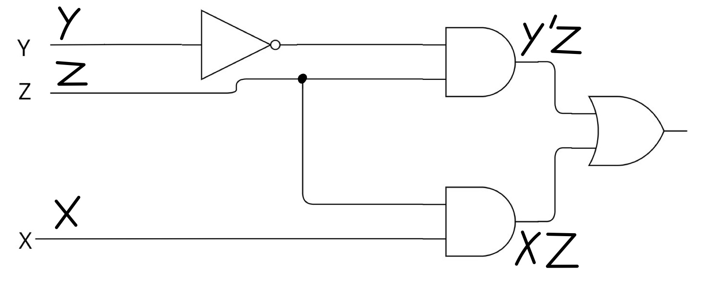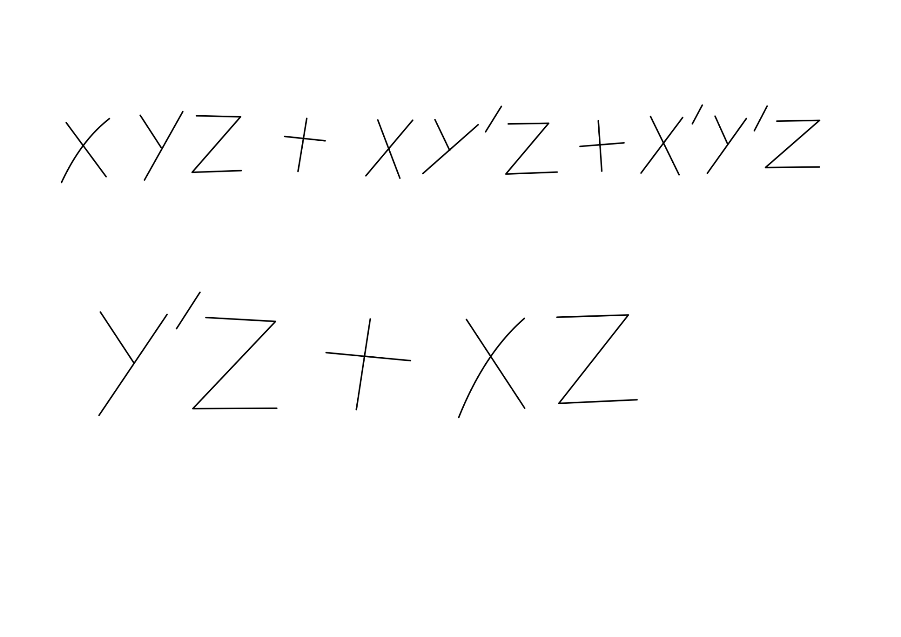

**Group 2 (8 people)**

1. 65130500201 Kampol Suwannatam
2. 65130500204 Jirawat Rongsupan
3. 65130500207 Chewin Grerasitsirt
4. 65130500209 Natthanon Somroop
5. 65130500210 Nontakorn Chatkoonsathien
6. 65130500212 Nithit Lertcharoensombat
7. 65130500227 Issadaorn Kulsantao
8. 65130500237 Chayapol Mahatthanachai