**Group 9 (SleepJanai) : Case8 - CureX**

**Target User**

* People who want to consult a doctor, but they are not convenient to go to the hospital.
* People who could not afford the expensive doctor’s fee
* People who forget to take their medicines on time.

List **all features (core and sub features)** that support the business requirements.

**Doctor**

According to the business goal, we want to ensure that our doctors meet the industry standards, and provide specialist doctors to cover all the symptoms the patients got. Moreover, we want to provide our patients the best service and convenience.

Search doctor

1. Serch department
2. Video consultation

**Medicine**

We want to help our patients to understand what pills they are taking by providing them with information about the pills, and make it easier by differentiating the pill by category.

1. Popular medicine
2. Category
3. Product details

**Ambulance**

We also provide the ambulance in case of emergency, and make sure that they can contact to the ambulance, so they will know basic first aid and keep them calm in case they’re panic or shock.

1. Select location
2. Available ambulance
3. Choose ambulance

**Profile**

We have our patients' medical records for them to make it easier to recognize their old medical records for accurate diagnoses. to be specific, the transaction history and prescription help our doctor to know previous symptom to be an information to diagnoses. Appointment Schedule and notification is for our patients to access their appointments easily and remind them of their appointments, and they can also edit their profile in case of drug allergy.

1. Edit profile
2. Transaction history
3. Appoinment Schedule
4. My prescription
5. Notification

**Information architecture:** Sitemap

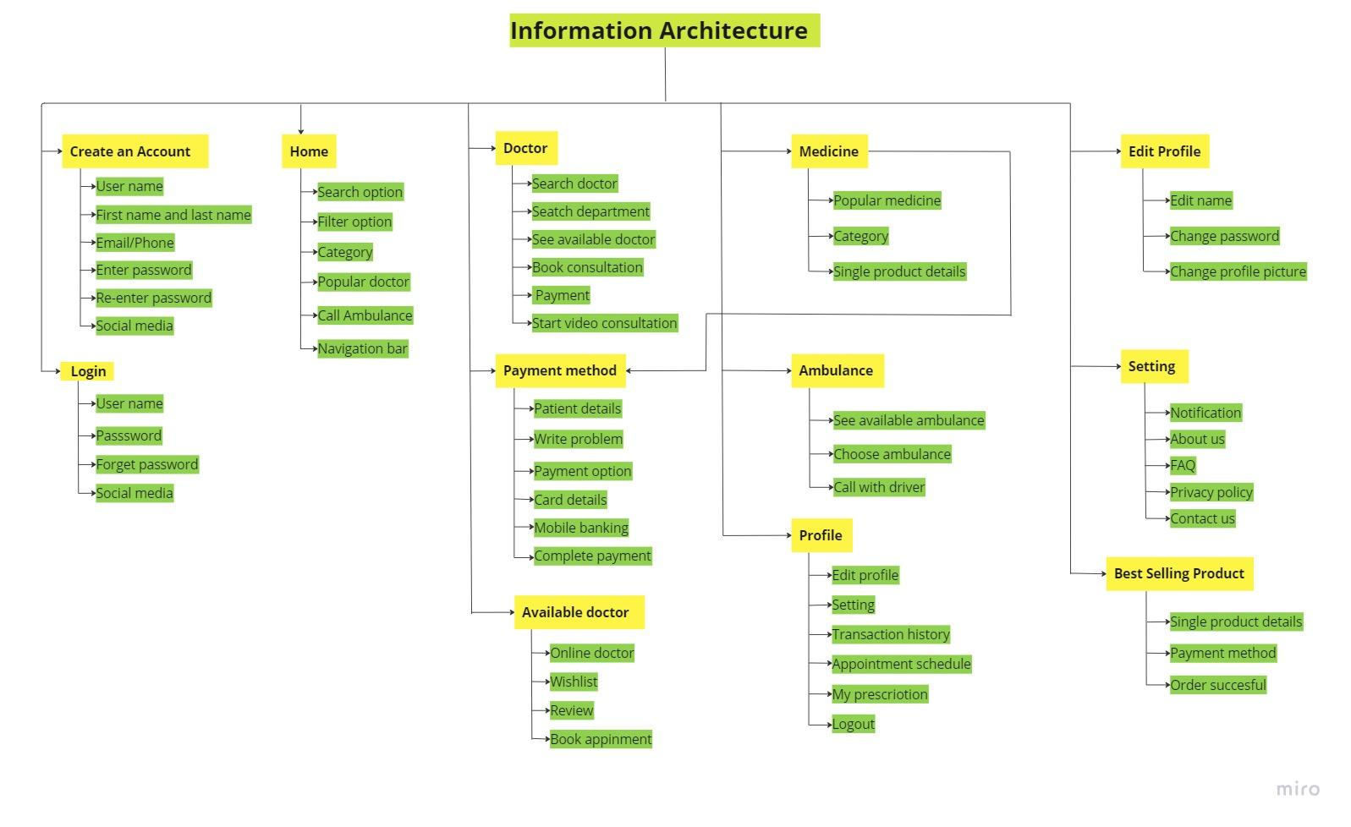

**Low-fidelity**

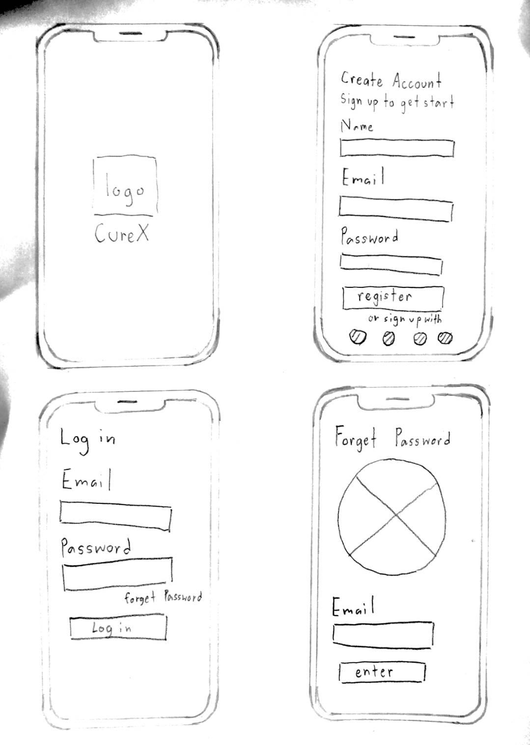

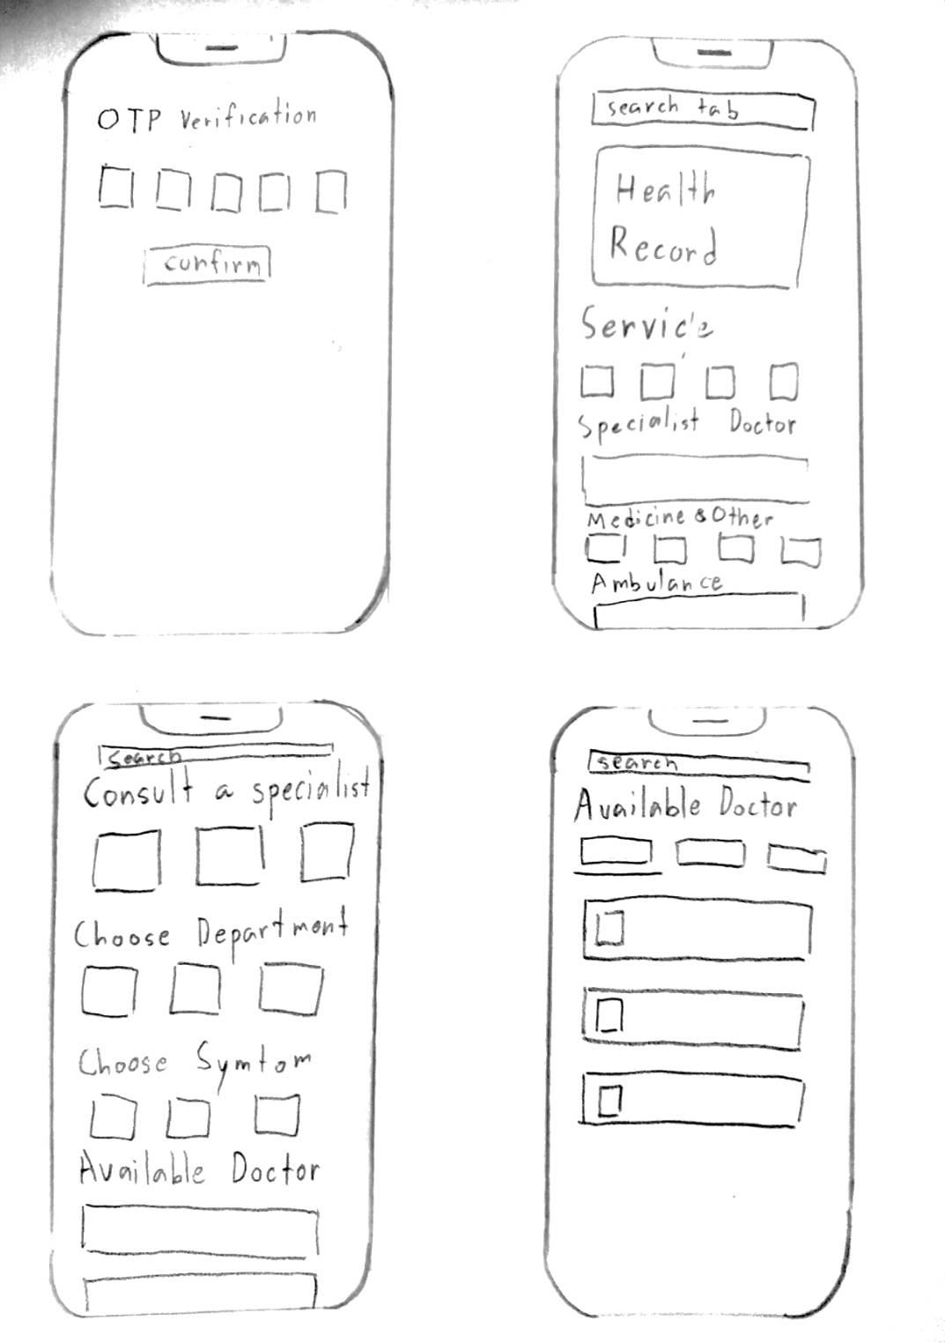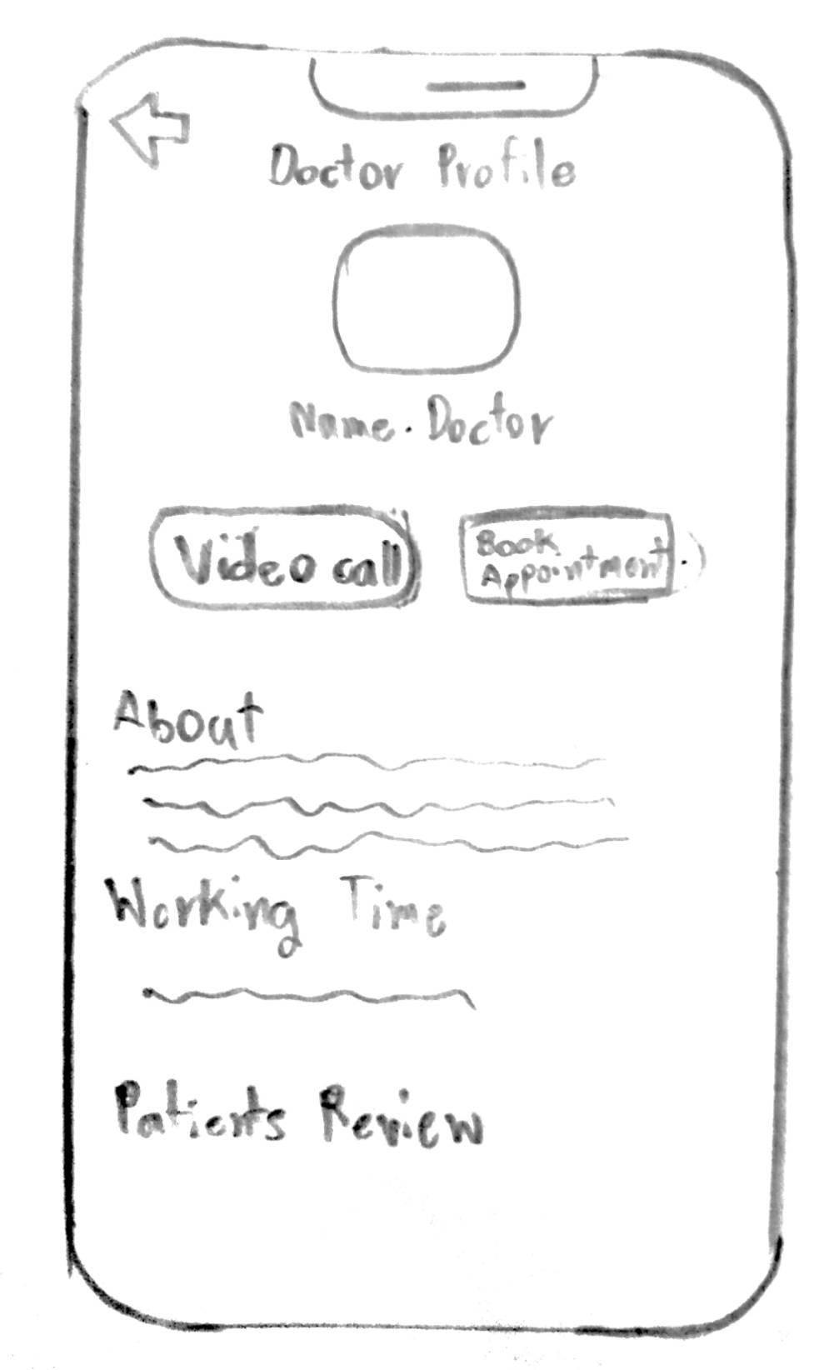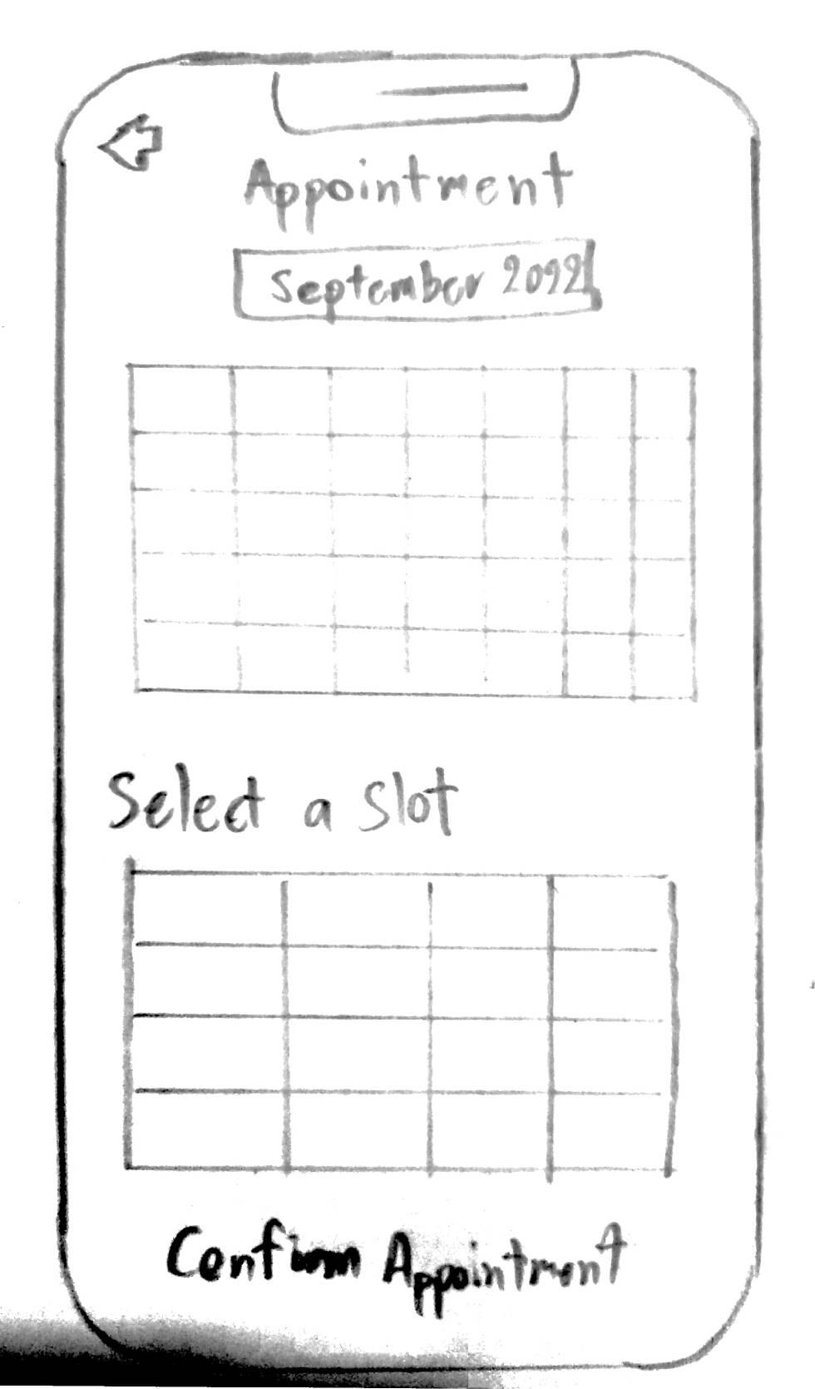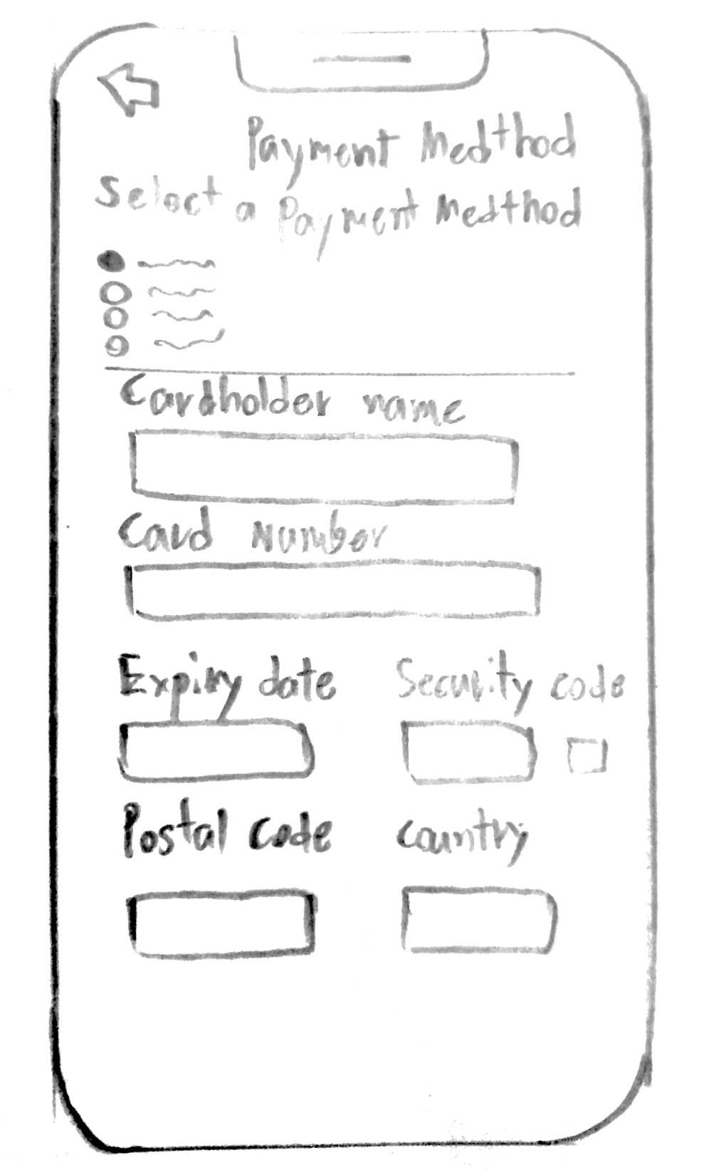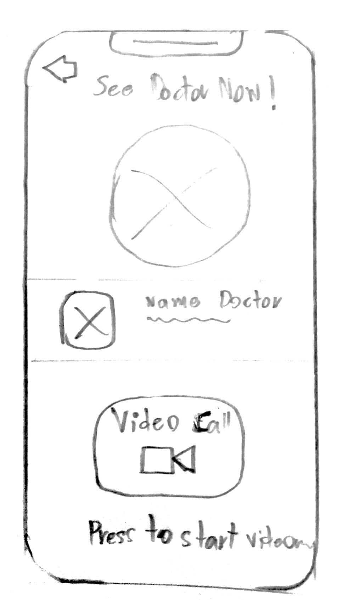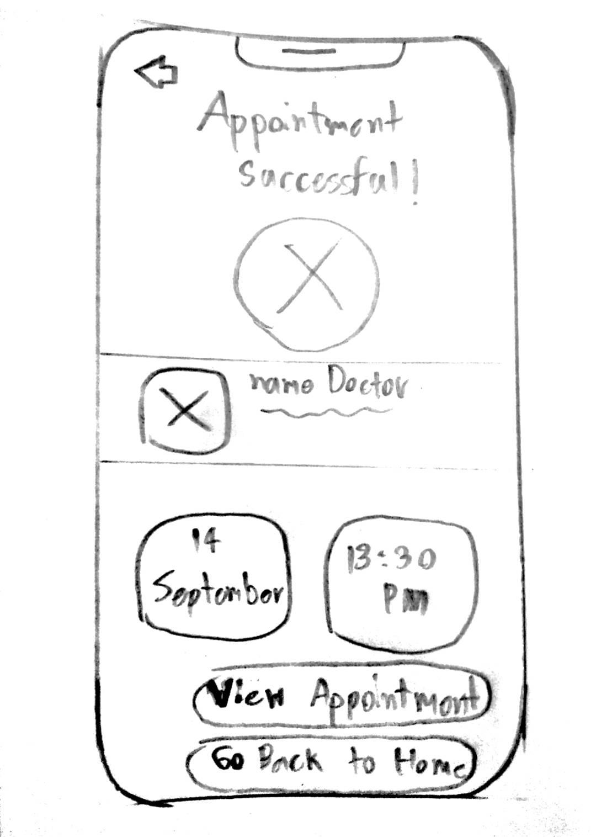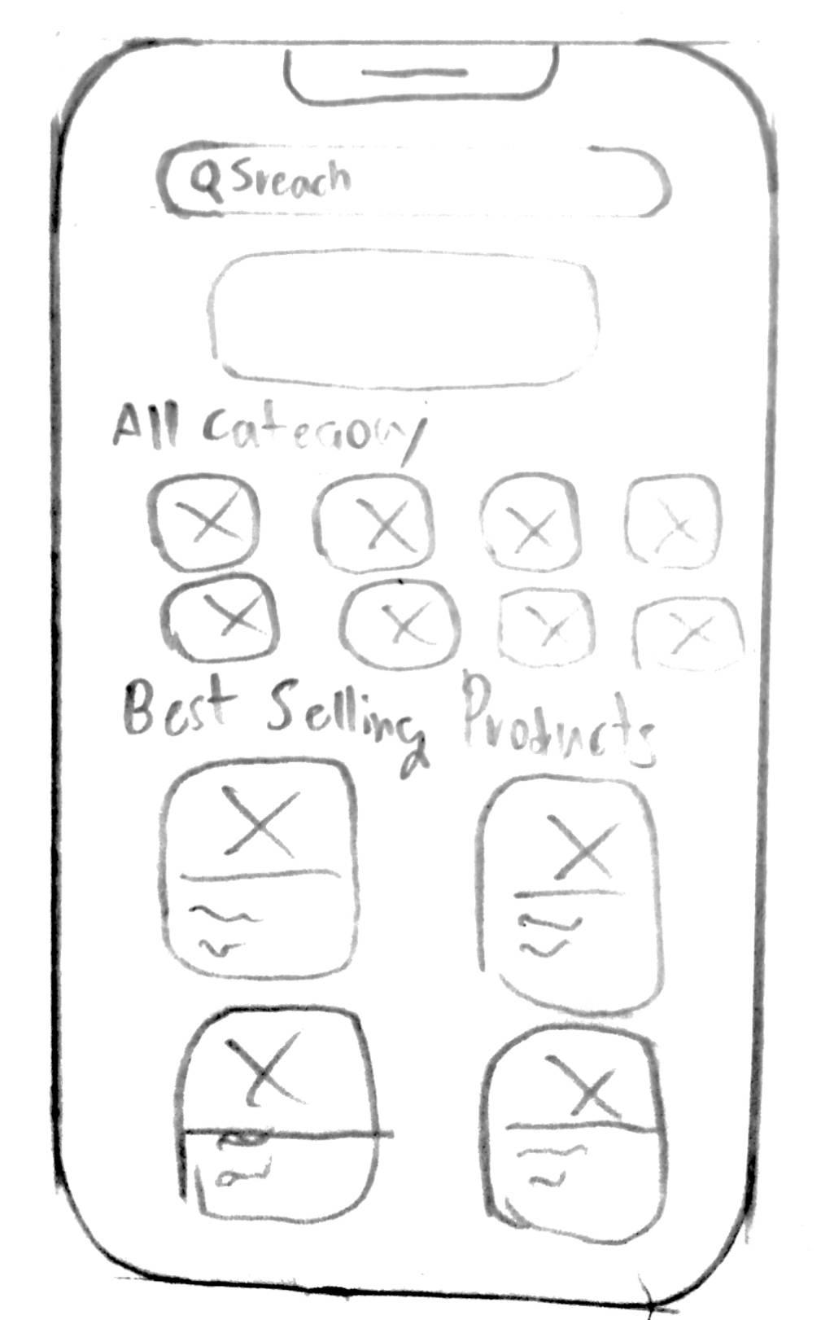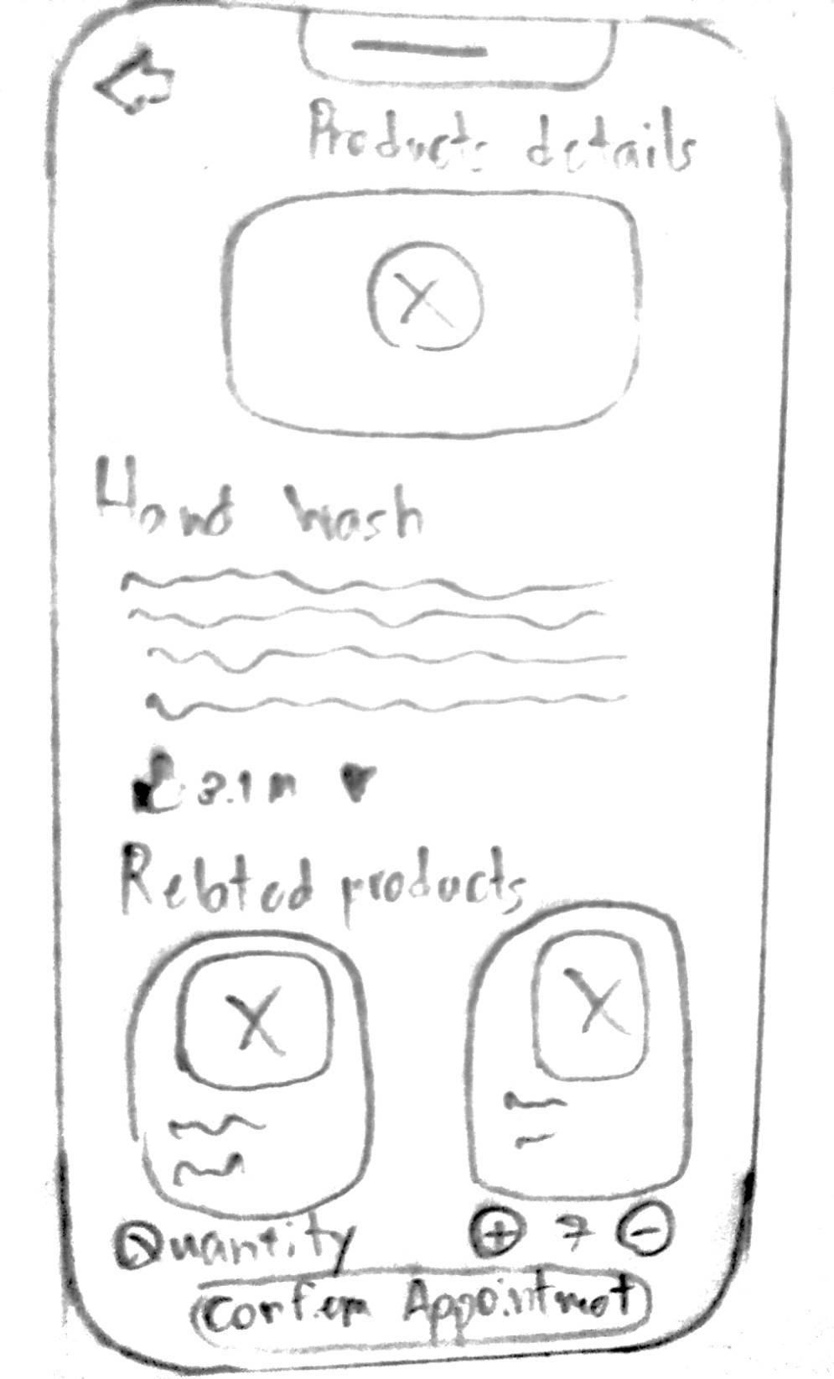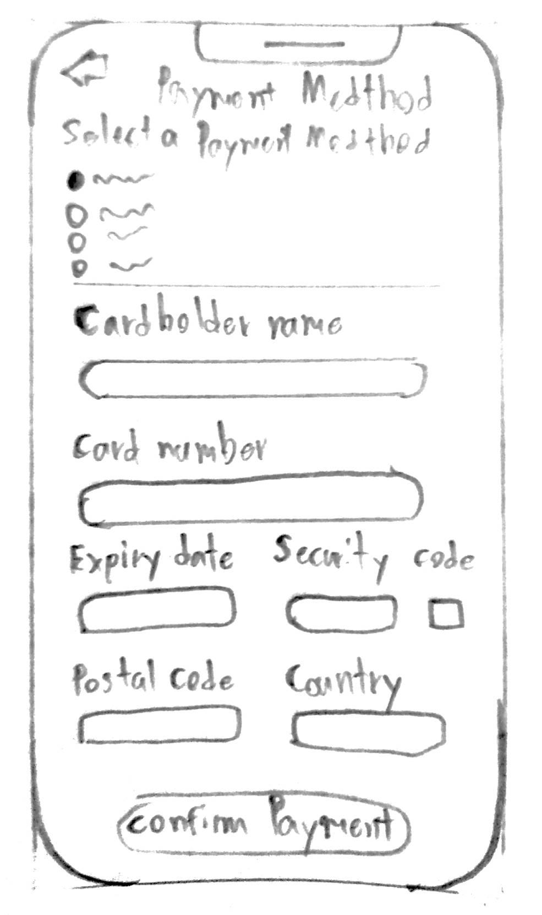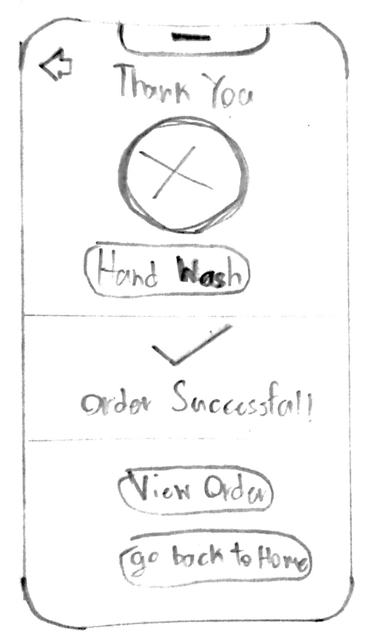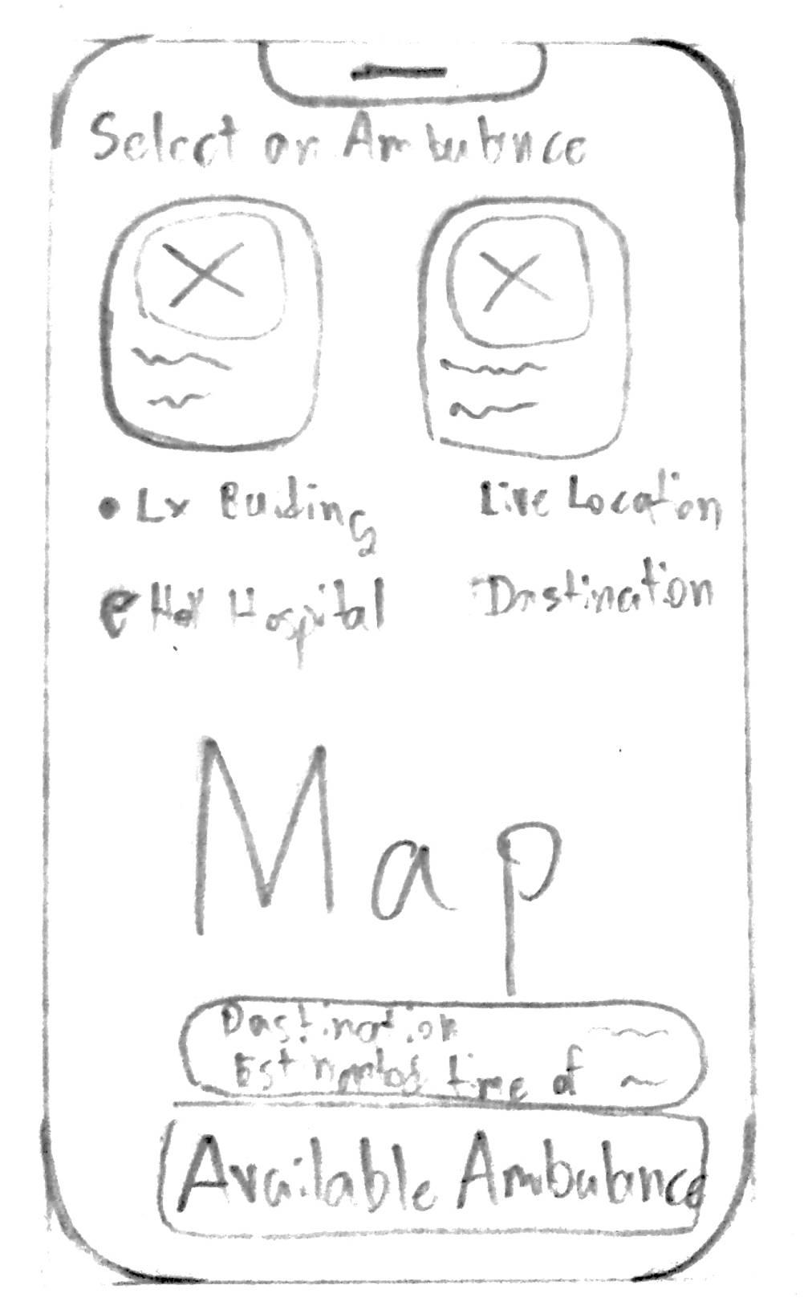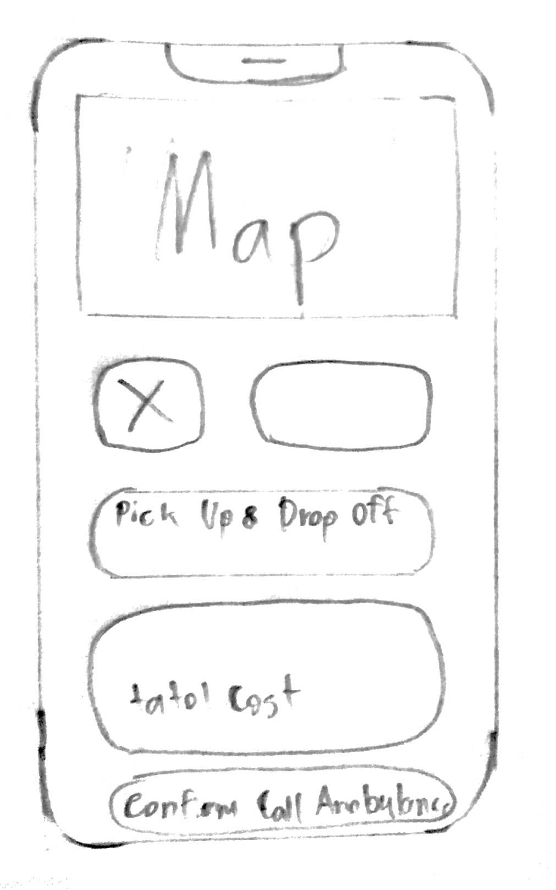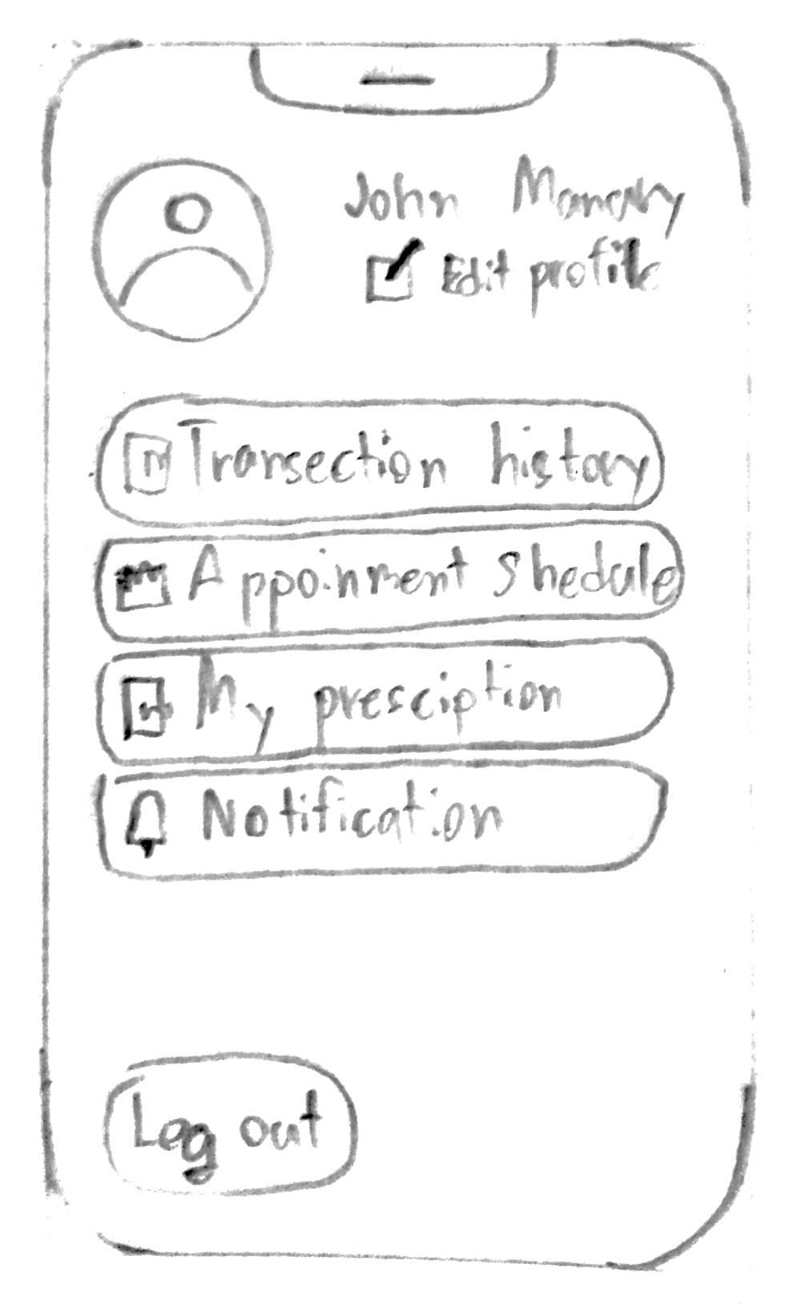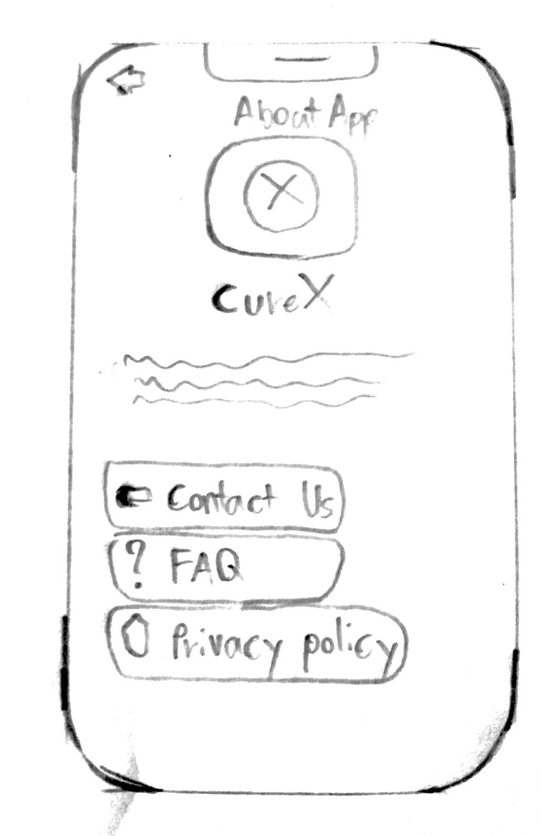

**Mid-fidelity**

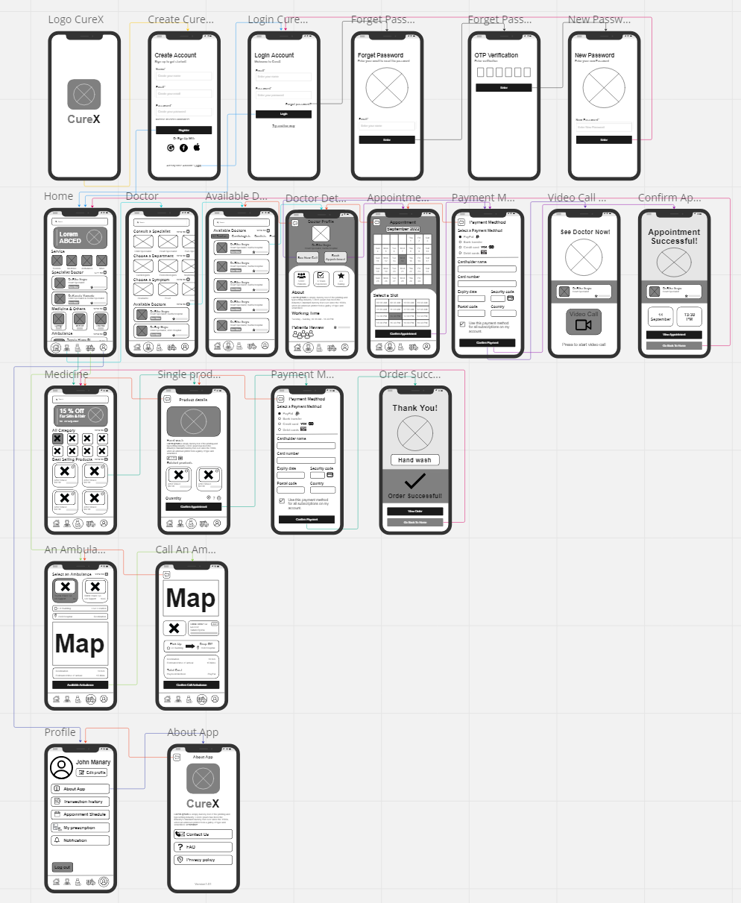

**Link to Miro:** https://miro.com/app/board/uXjVPj5eZlY=/#tpicker-content

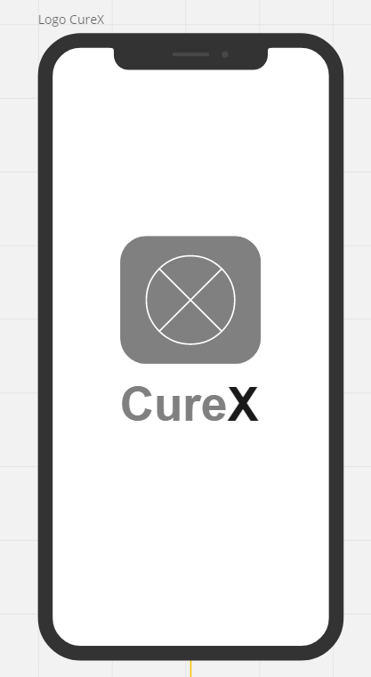

Start page - Open the app and you will see our logo, and it will take you to the sign up page automatically.

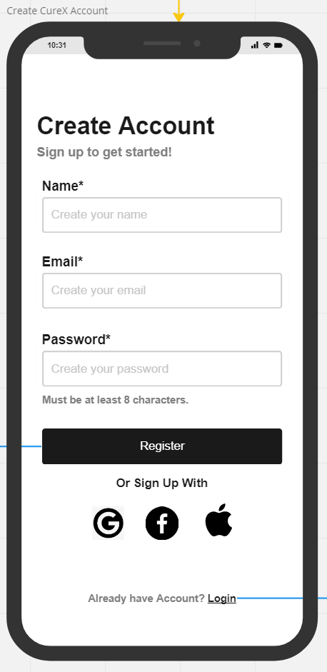

Create Account Page - If you don’t have an account. Register at this page and after done, it will bring to home page automatically. if you already have account, click login at bottom right.

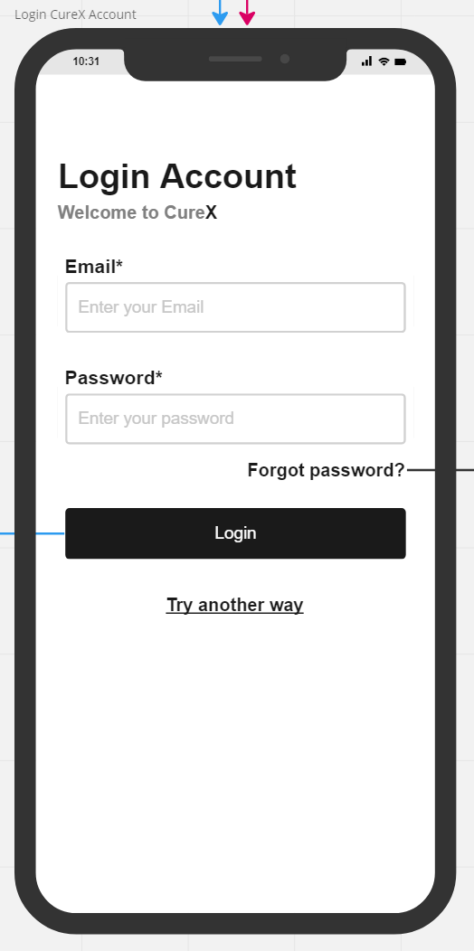

Login page - Login it and it will bring to home page. If you forgot the password, click “Forget password?” and it will bring to forget password page.

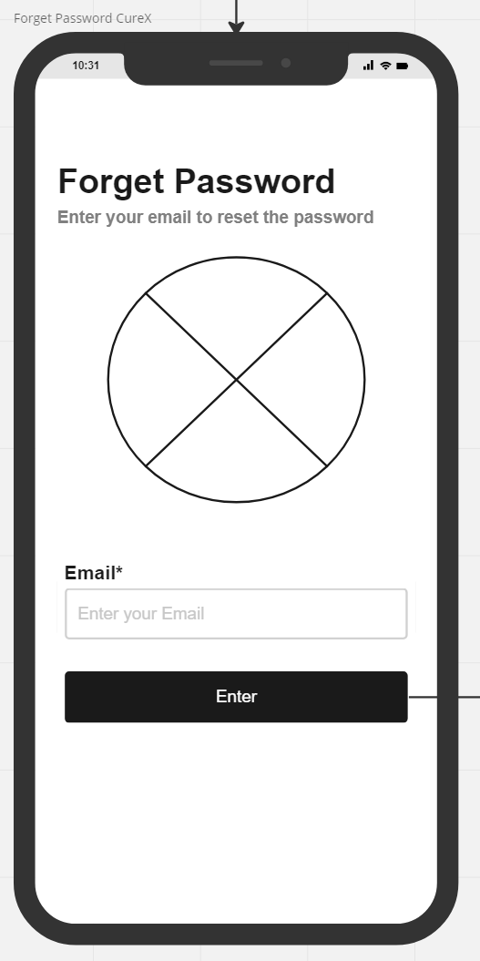

Enter your email and it will send the verification to your Email.

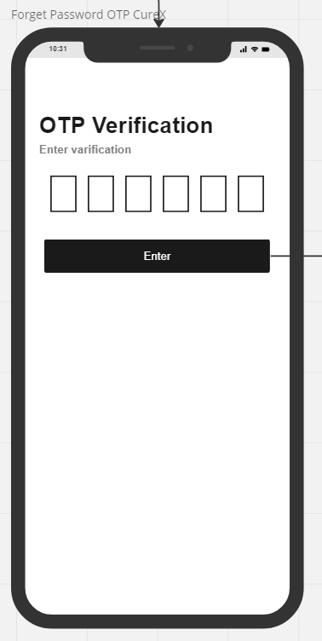

Enter verification code

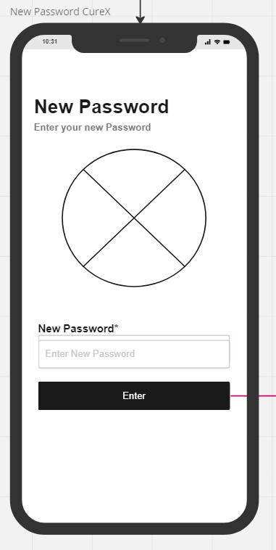

Enter a new password. After finish, it will bring back to the login page.

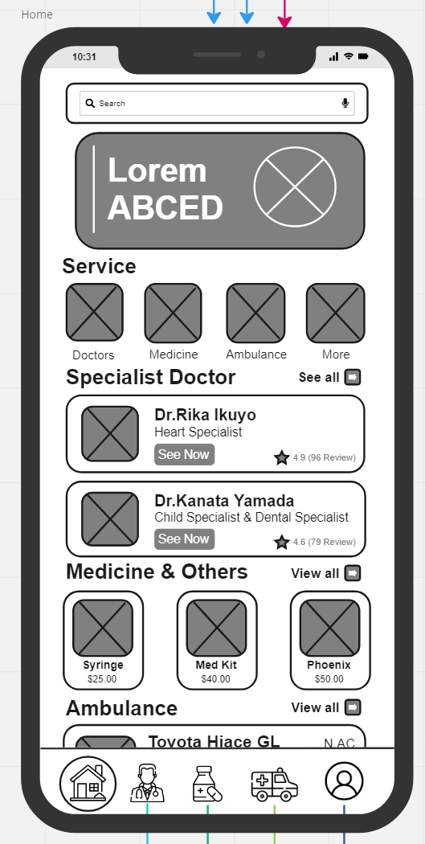

Home page - This page will show you your health records and our service.

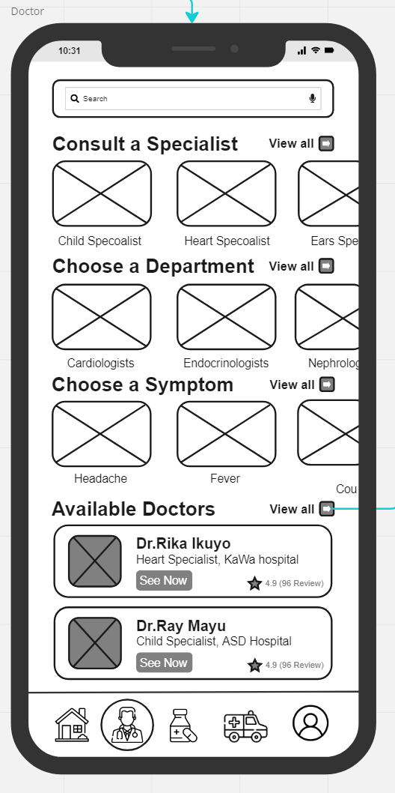  
Doctor main page - This is where you can find a doctor to consult or make an appointment. You can search a doctor by their specialty, department, or your symptoms, and you can also see the doctor available to consult or book and appointment in this page.

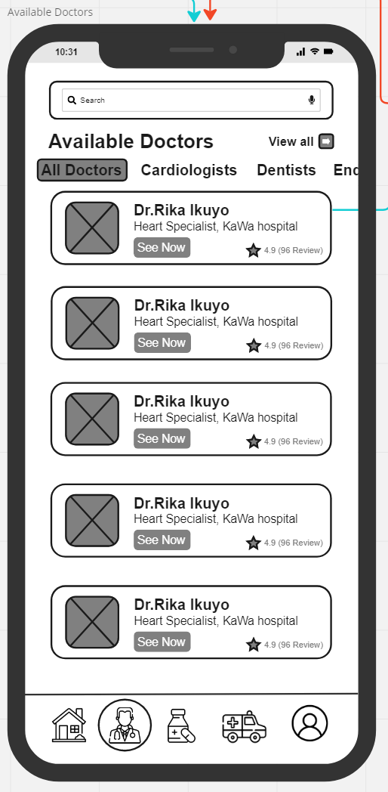

Here are all available doctors which you can also choose by category.

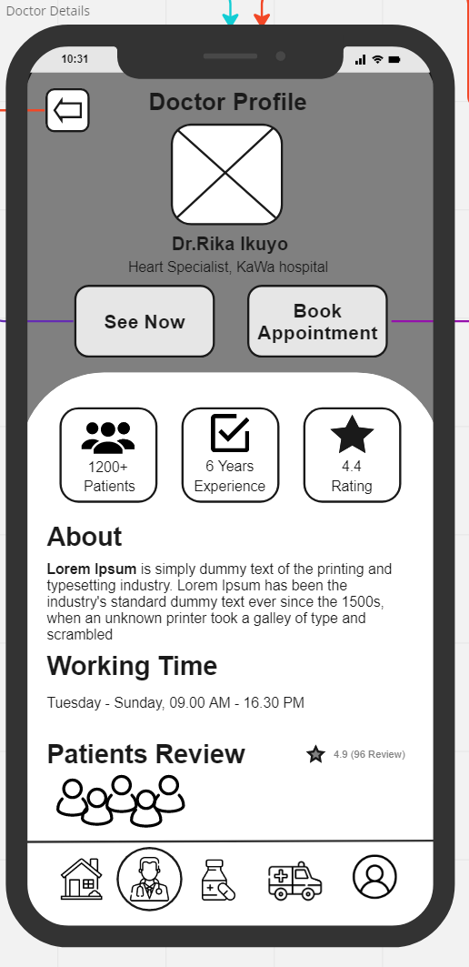

Doctor Profile page - This page provides information about doctor. Also, there are 2 features in this page. First, “See Now”, you can consult with a doctor right after the payment success. Second, “Book Appointment”, you can make an appointment in advance with this feature, and it will take you to book the time.

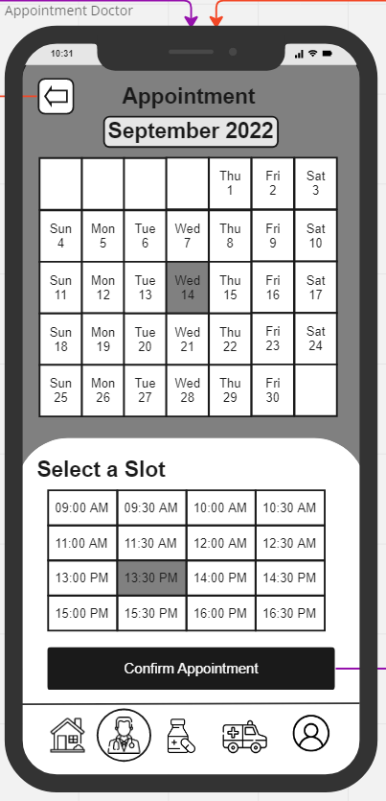

Appointment page - On this page we can make an appointment with the doctor by selecting date and time that you want to make an appointment. Then, it will take you to the payment page.

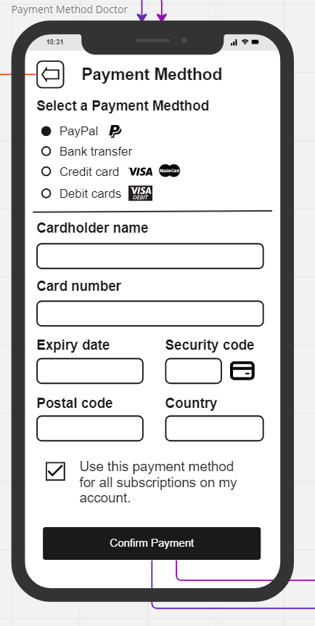

Payment Page - This is where you can make the transaction for both “See Now” and “Book Appointment”.

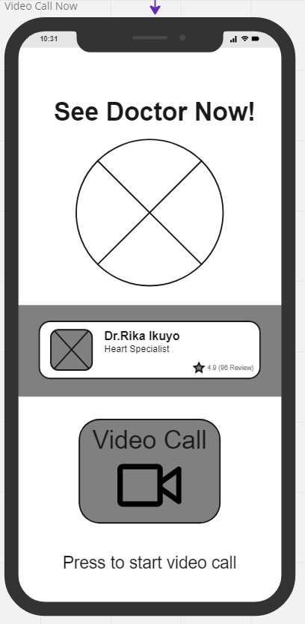

If you select “See Now” and finish the payment page. You can video call to consult with a doctor.

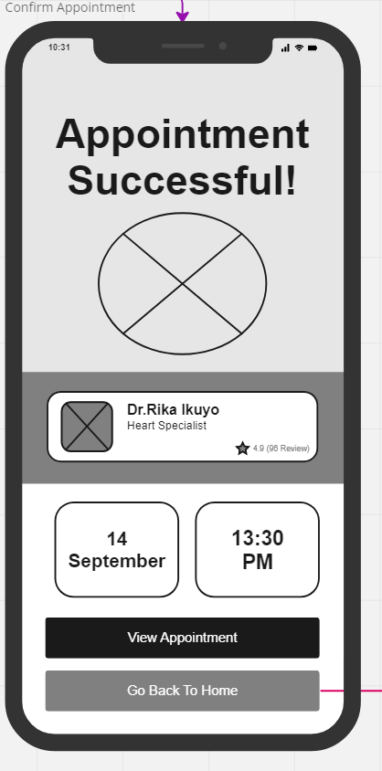

If you click "Book Appointment" and finish the payment page. That means the appointment is successful.

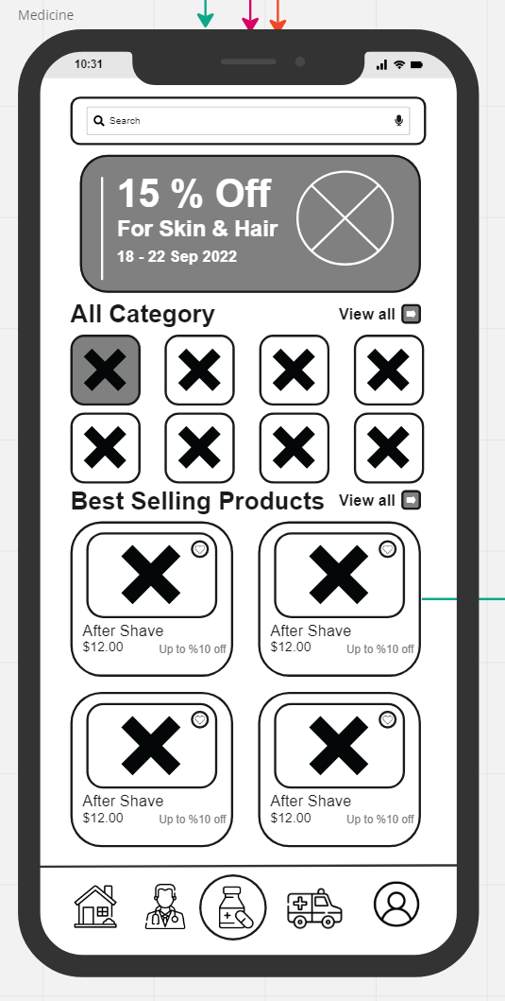

Medicine main page - This page will provide you a promotion, categories of medicines, and best selling products.

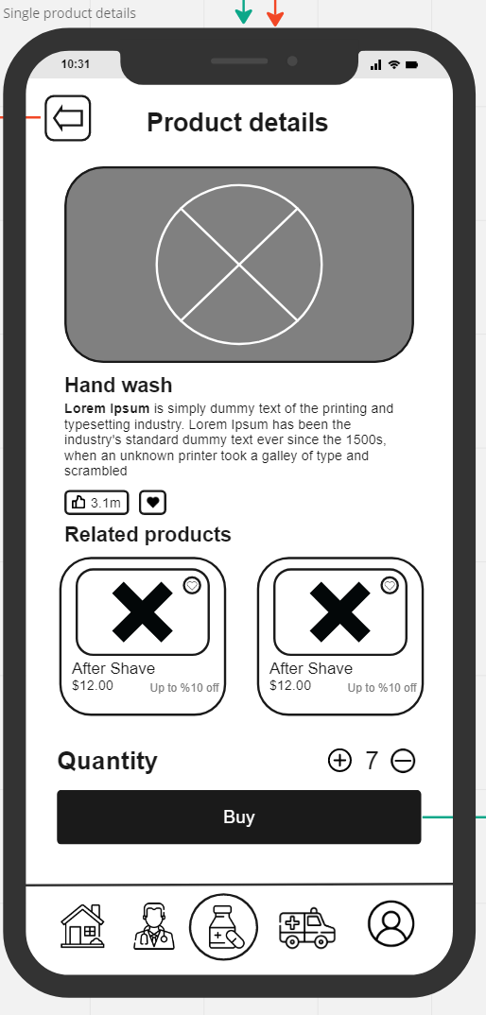

If you click on a product it will link to this page, providing you a product details, and it also show the related products. If you want to buy this product, Click “Buy” and it will take you to the payment page.

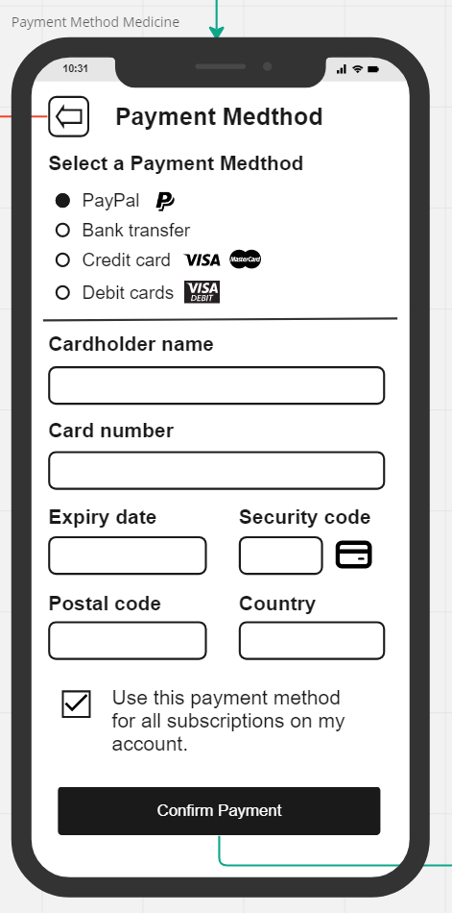

Payment page - After you finish selecting your medicine it will take you to the payment page to make a transaction.

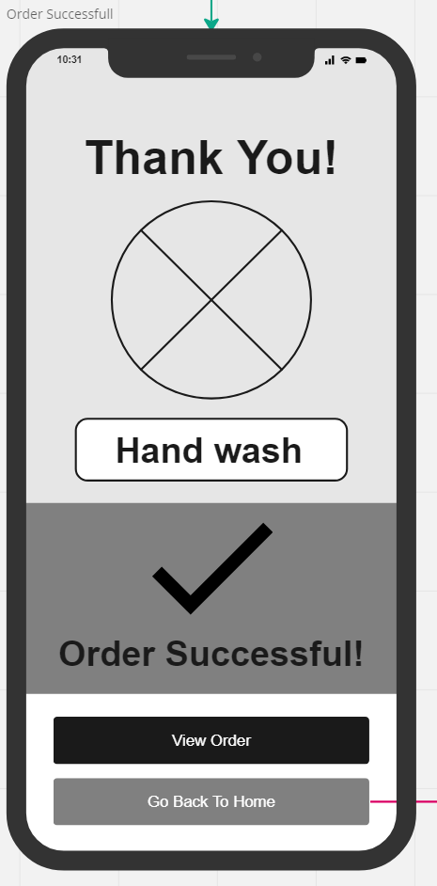

Successful purchase - After you finish your payment, it will take you to this page. You can see your order or go back to home.

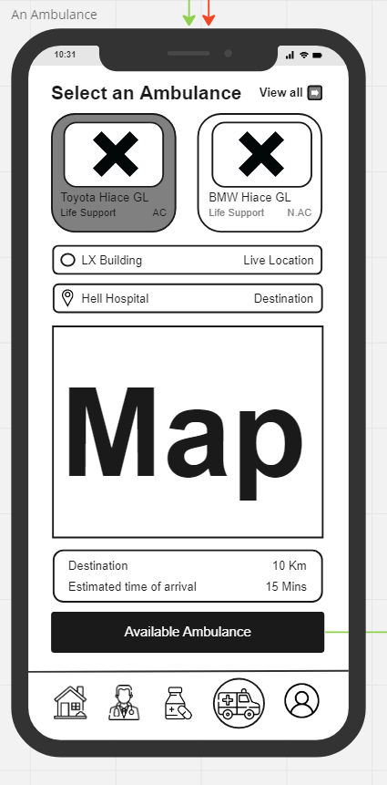

Ambulance page - You can select which ambulance you want them to pick you up and select where is the pick-up point and the destination hospital you want to go. The application will show how far and how long it takes to reach there.

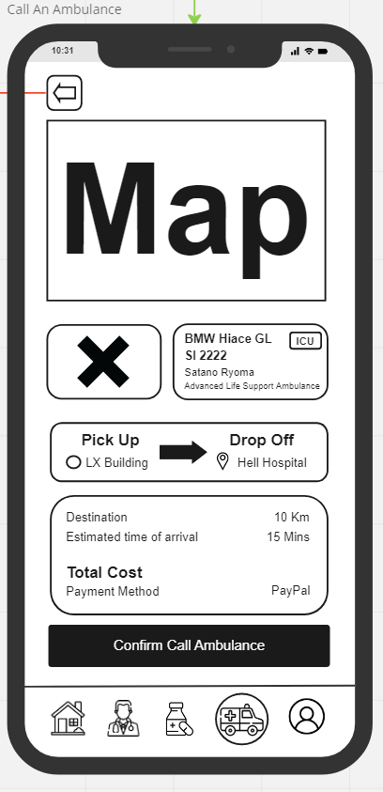

After that, the app will show all the information that you choose to check if the information is correct or not before you click “Confirm Call Ambulance”.

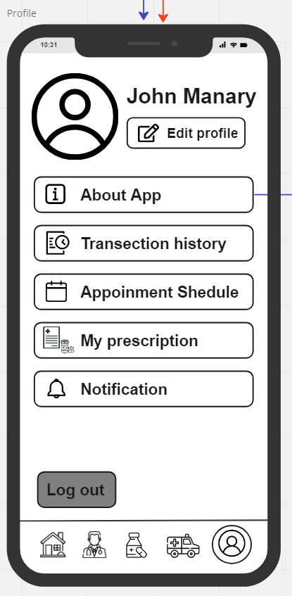

Profile main page - You can see all of your medical history, your appointment, and your prescription here. You can edit your personal information with “Edit profile” and custom your notification by yourself with “Notification.”

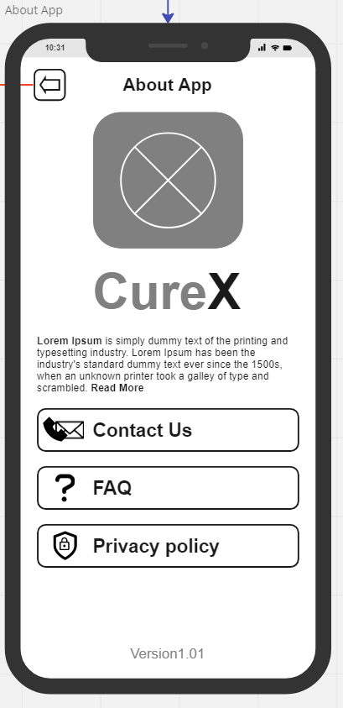

About App page - This page wil provide our information: you can contact us, ask a question, or see the privacy policy here.

**Group 09 : Case8 - CureX**

1. 65130500202 Kiadtikun Thansamai
2. 65130500212 Nithit Lertcharoensombat
3. 65130500227 Issadaorn Kulsantao