Reminder: You need to secure your reservation seat by paying your full amount.

After you paid your reservation seat within 24hrs you will receive a SMS

Notification of your E-ticket and Receipt with confirmation that we

Received your payment.

However, if you failed to pay your reservation within the given time(24hrs)

Your reservation for your seat/s will automatically cancel to our system.

Title 1. Here’s the 5 Steps on how to pay your Reservation Seat Via GCash App.

Title 2. How to Pay Your Reservation Seats Via GCASH App

//depende na sayo ssob mo ipwepwesto tong title nay an

//pero yang mga steps 1-5 iccenter mo pero ganyan positions nila

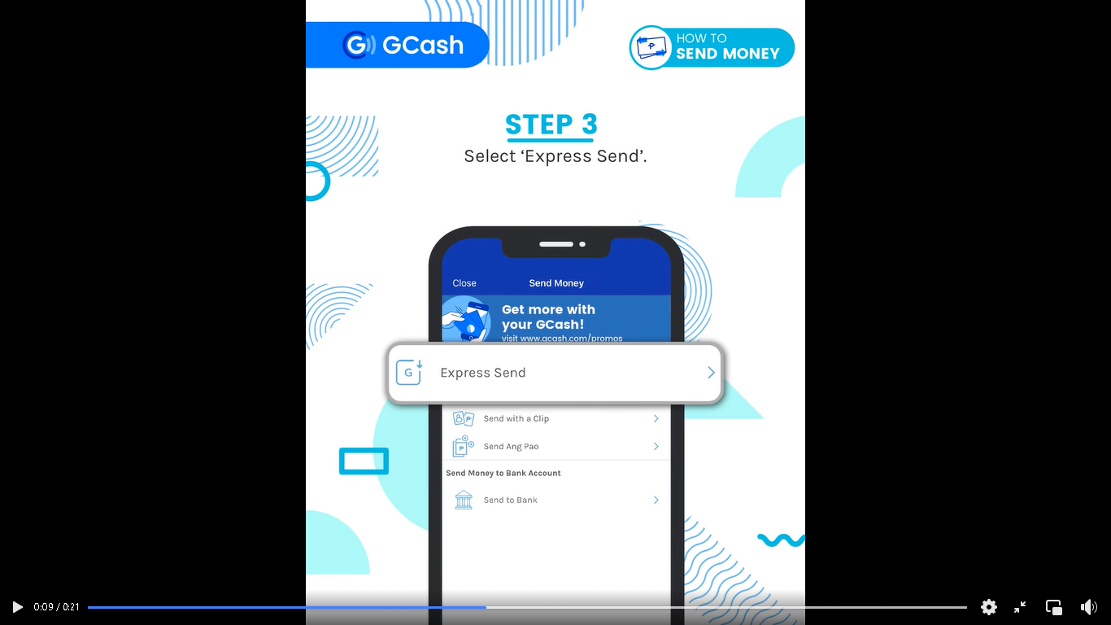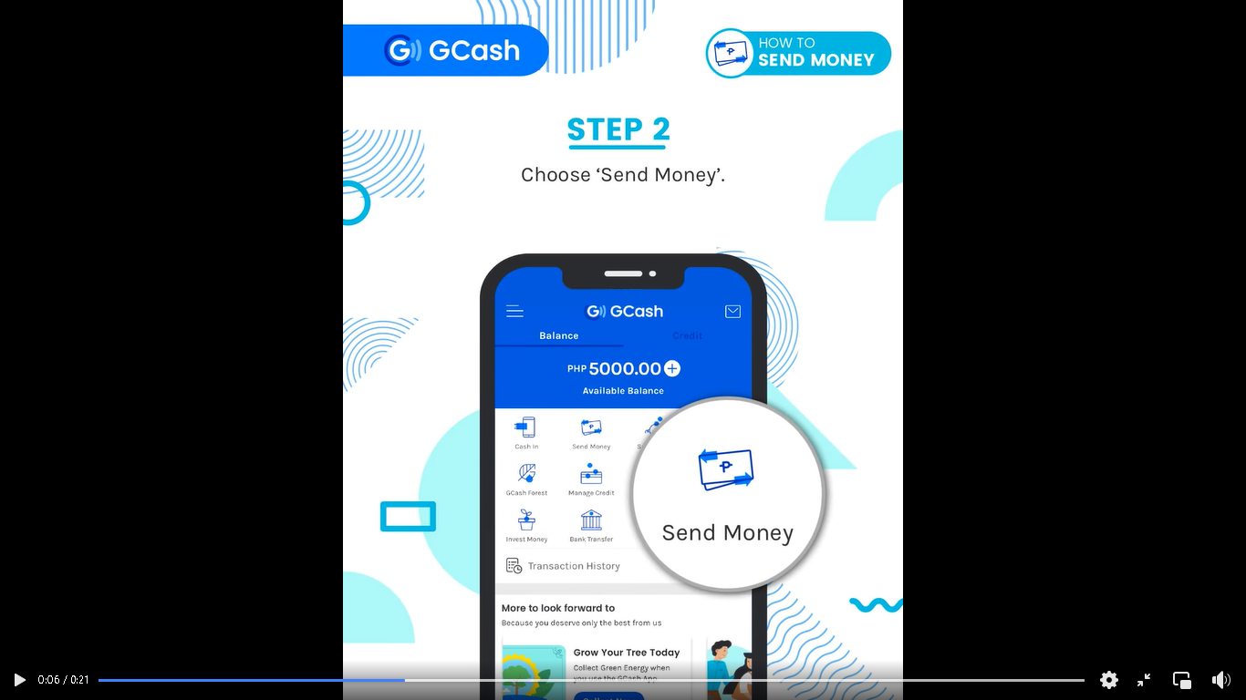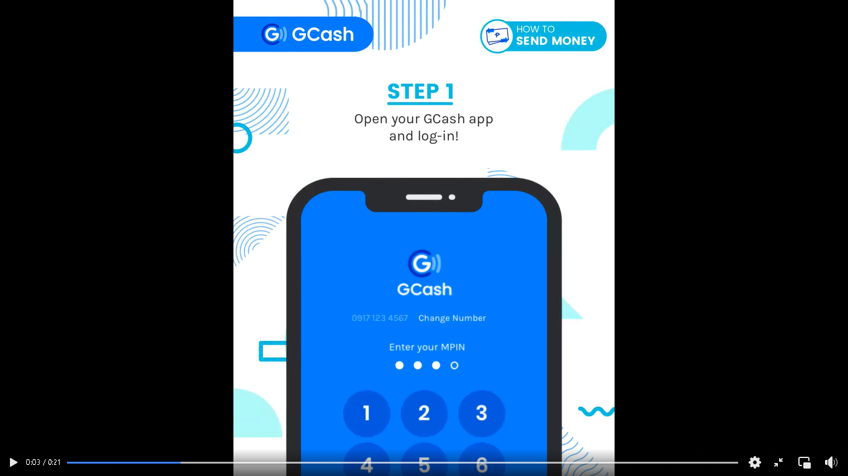

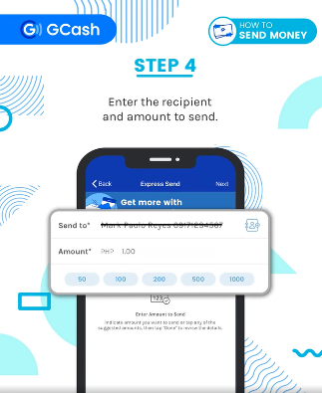

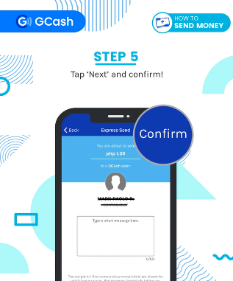

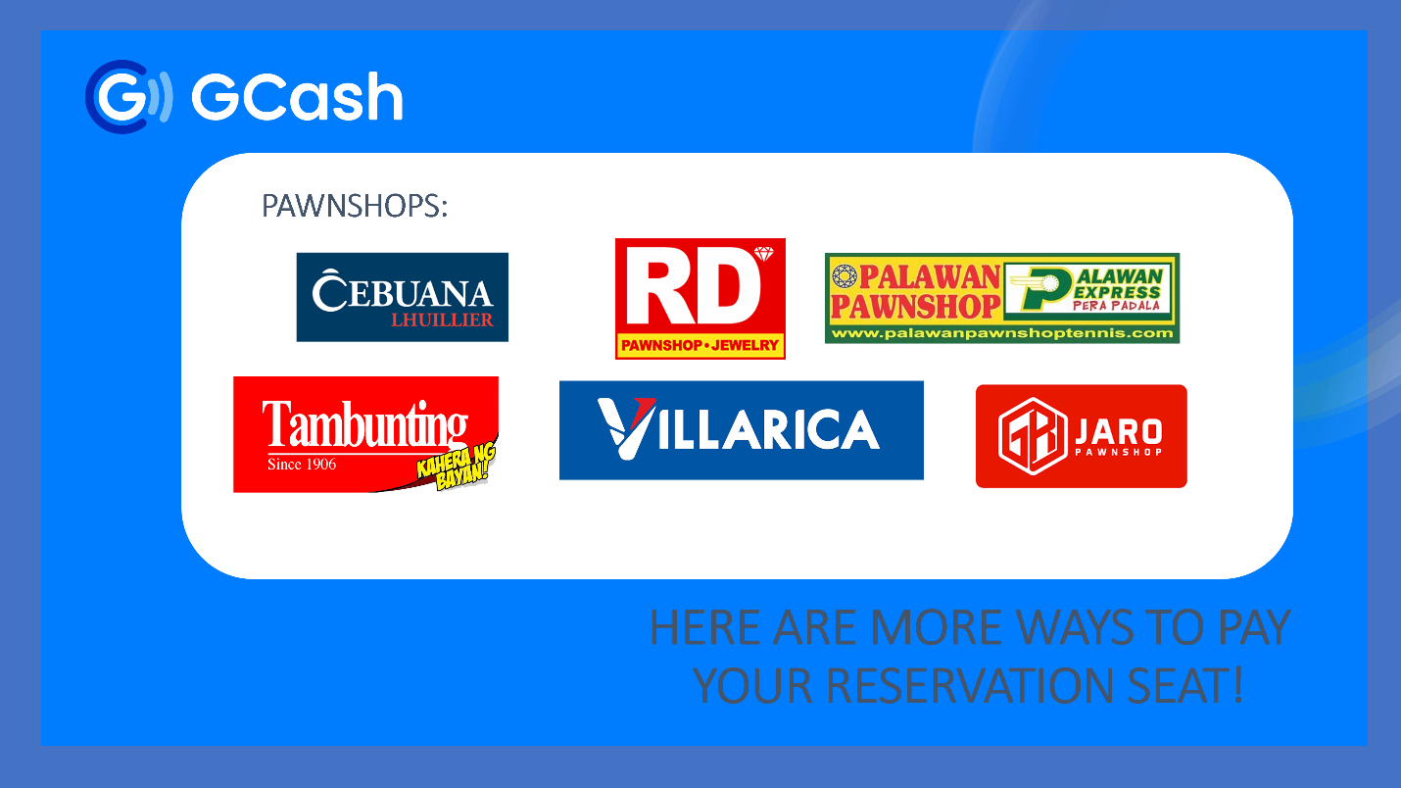Here Are the List Of GCASH Partners Outlets

Note: We will send you a messages about our GCASH Account and Number where you will send your Payment Reservation.