SECURITY ANALYSIS (BBAT35F97) · GROUP REPORT · DATA AS OF 13 OCT 2026
Pick, Price, Portfolio
An AI-augmented security analysis of Hindustan Unilever, Sun Pharma and ICICI Bank, and the 15-year SIP we would build from them
Investor: us, TAPMI BBA(H) Semester V students starting a ₹10,000 monthly SIP. Data: Yahoo Finance, Screener, BSE filings, RBI, MOSPI, Damodaran, Google News; frozen on 13 Oct 2026.
Our recommendation
Own the three stocks as a satellite (HUL 31%, Sun Pharma 19%, ICICI Bank 50%) around a Nifty 50 index core, and buy them monthly rather than as a lump sum. All three trade above our blended intrinsic values (HUL −14%, Sun Pharma −30%, ICICI Bank −37%), so HUL is a Buy and Sun Pharma and ICICI Bank are Holds. A Balanced investor (A = 4) puts 44% of savings into the three stocks and the rest into T-bills. A ₹10,000 SIP rising 10% a year has a median 15-year value of ₹64.8 lakh from ₹38.1 lakh invested.

1. Company selection: three sectors, three different drivers
We worked top-down (BKM Ch 17). India's real GDP grew 7.8% in Q1 FY27, led by investment (GFCF +11.9%) rather than household consumption (+7.1%); the repo rate is 5.25% and the 91-day T-bill 5.52% (MOSPI, RBI). We looked for stocks with (i) a different primary macro driver, (ii) a five-year daily-return correlation of 0.5 or less with each other, (iii) Nifty 50 liquidity and at least six quarters of call transcripts, and (iv) a business that a standard valuation model fits.
Company | Sector and main driver | Role in the portfolio | Beta | CAGR 2016–26 | Sharpe
Hindustan Unilever | FMCG: consumption, input costs | Defensive anchor: lowest beta, in the weakest sector (FMCG 10.6% below its 200-day average) | 0.60 | 9.6% | 0.28
Sun Pharma | Pharma: chronic therapy, US specialty, USD/INR | Defensive growth: demand ignores the cycle and US sales earn dollars | 0.65 | 8.7% | 0.24
ICICI Bank | Private bank: credit growth, rates, asset quality | Growth engine of an investment-led cycle: loans +19.6% a year | 1.29 | 19.1% | 0.55
Nifty 50 (est. TR) | Benchmark | Price index + 1.22% a year estimated dividends | 1.00 | 12.0% | 0.45
Table 1. The three picks. Risk and return from daily data, 2016 to 13 Oct 2026.
Pairwise correlations are 0.16–0.24 over 2016–2026 (0.15–0.20 over five years), so the three diversify each other. We rejected Media, the strongest sector (11.2% above its 200-day average): at A = 4 its certainty equivalents are −8% to −38%, below the T-bill, and buying it now would be recency bias. Infosys, our first choice, was replaced by Sun Pharma, which keeps the dollar hedge at a lower beta (0.65 vs 0.82); HDFC Bank's 2023 merger and ITC's 2025 demerger break their histories. Honesty note: we chose Sun Pharma partly after its strong run, which flatters our 2023–26 back-test (§4).

2. Traditional analysis: good companies at full prices
The cost of equity is the CAPM required return, r = rf + β × ERP, with rf = 5.52% and Damodaran's India ERP of 7.08%. HUL pays out 67% of its profit, so we value it with a two-stage dividend discount model. Sun Pharma (payout 34%) and ICICI Bank, whose borrowings are raw material, use a two-stage residual-income model, equivalent to a justified P/B of (ROE − g) / (r − g). Peer multiples give a second view (P/E for HUL and Sun Pharma, ROE-adjusted P/B for ICICI), and the blended value averages the two. Every working is a live formula in valuation.xlsx, with r × g sensitivity grids.
Stock | Price | r | Model value | Peer value | Blended | Blended vs price | Implied growth | Analyst target
HUL | ₹1,862 | 9.8% | ₹1,079 | ₹2,105 | ₹1,592 | −14% | 7.4% | ₹2,396 (+29%)
Sun Pharma | ₹1,760 | 10.1% | ₹748 | ₹1,702 | ₹1,225 | −30% | 8.6% | ₹2,174 (+24%)
ICICI Bank | ₹1,351 | 14.7% | ₹575 | ₹1,139 | ₹857 | −37% | 13.9% | ₹1,747 (+29%)
Table 2. Intrinsic value vs market price, 13 Oct 2026. Implied growth: the perpetual growth rate at which our model equals the price.
Stock | P/E | P/B | ROE | Payout | Beta | Jensen's α | Treynor | Max drawdown | Daily VaR 95%
HUL | 39.1 | 9.0 | 21.9%* | 67% | 0.60 | +1.8% | 10.2% | −36% | 2.0%
Sun Pharma | 33.4 | 5.1 | 13.7% | 34% | 0.65 | +2.0% | 10.3% | −62% | 2.5%
ICICI Bank | 16.8 | 2.7 | 15.0% | 14% | 1.29 | +7.1% | 12.8% | −48% | 2.5%
Table 3. Key ratios. FY26 fundamentals extracted from the annual reports (§3); market ratios 2016–2026. *HUL ROE excludes a one-off gain of about ₹3,900 Cr.
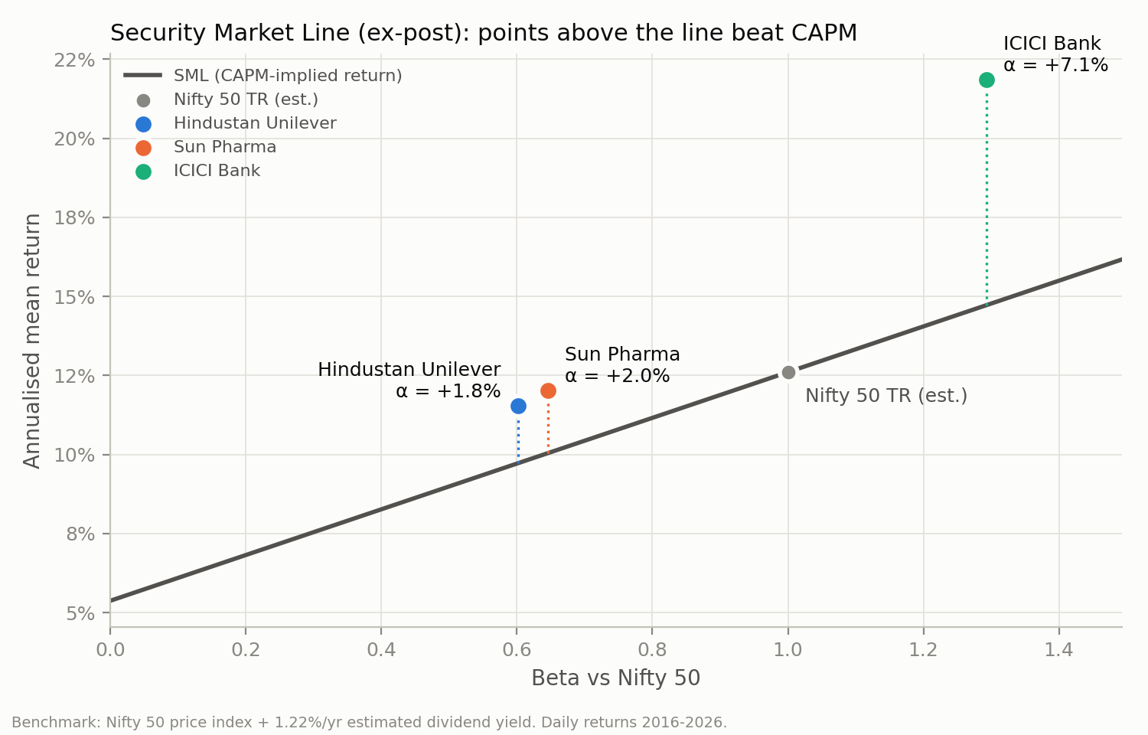  Figure 1. Ex-post Security Market Line, 2016–2026. | Every price is above our blended value, but reversing the models shows why. The market implies perpetual growth of 7.4% (HUL), 8.6% (Sun Pharma), 13.9% (ICICI Bank). ICICI is growing loans 19.6% a year, so most of its gap is our 14.7% discount rate (β 1.29), not unrealistic growth. Analysts are more bullish, with mean targets 24%–29% above the price.  On the SML (Figure 1), ICICI earned a Jensen's α of +7.1% a year above its CAPM return; HUL and Sun Pharma sit close to the line. Past alpha is not a forecast, which is why the portfolio uses forward-looking CAPM returns (§4).

3. AI-augmented analysis: five tasks, each checked
We used AI where it reads or labels text faster than we can, and checked each task against an independent benchmark. Numbers are computed in Python, never generated by a model. The prompts (P1–P5) and their outputs are saved in docs/ai_prompts.md and data/ai/.
Task (brief) | What the AI did | Checked against | Result
Ratio extraction from PDFs | Claude read the FY26 annual reports and returned 47 line items as JSON, each with a page reference | Yahoo Finance and Screener | 44 of 47 within 1%; 3 definition differences (e.g. Yahoo's bank cash includes money at call); 0 errors
Sentiment: calls and news | FinBERT scored 2,428 headlines (12 months) and 9,133 call sentences, split into management and analysts | Claude's call tone (P4): same sign on 3 of 3 latest calls | Management sounds more positive than analysts on every call: gap 0.28 (HUL), 0.08 (Sun Pharma), 0.14 (ICICI Bank)
Behavioural bias, news framing | Claude tagged 120 headlines for gain/loss framing, anchoring on targets, authority, herding, hype, fear and recency | FinBERT labels (70% agreement) | 41% carry a bias cue, mostly authority and herding; 14% are not about the company; Sun Pharma coverage 60% gain-framed
Forecasting; is TA possible? | 50/200-day trend and RSI rules after 0.25% costs; earnings event study (CAR[−1,+1]); consensus EPS and targets | Buy-and-hold; earnings surprises | 0 of 8 rules beat buy-and-hold on Sharpe; +1.2% after beats, −1.6% after misses (72 events)
Risk heatmaps | Correlation, 120-day rolling correlation, risk contribution, stress tests | Four sell-offs since 2020 | ICICI supplies 57% of risk at 50% weight; P fell less than the Nifty in 4 of 4
Table 4. The five AI tasks in the brief, with their checks.
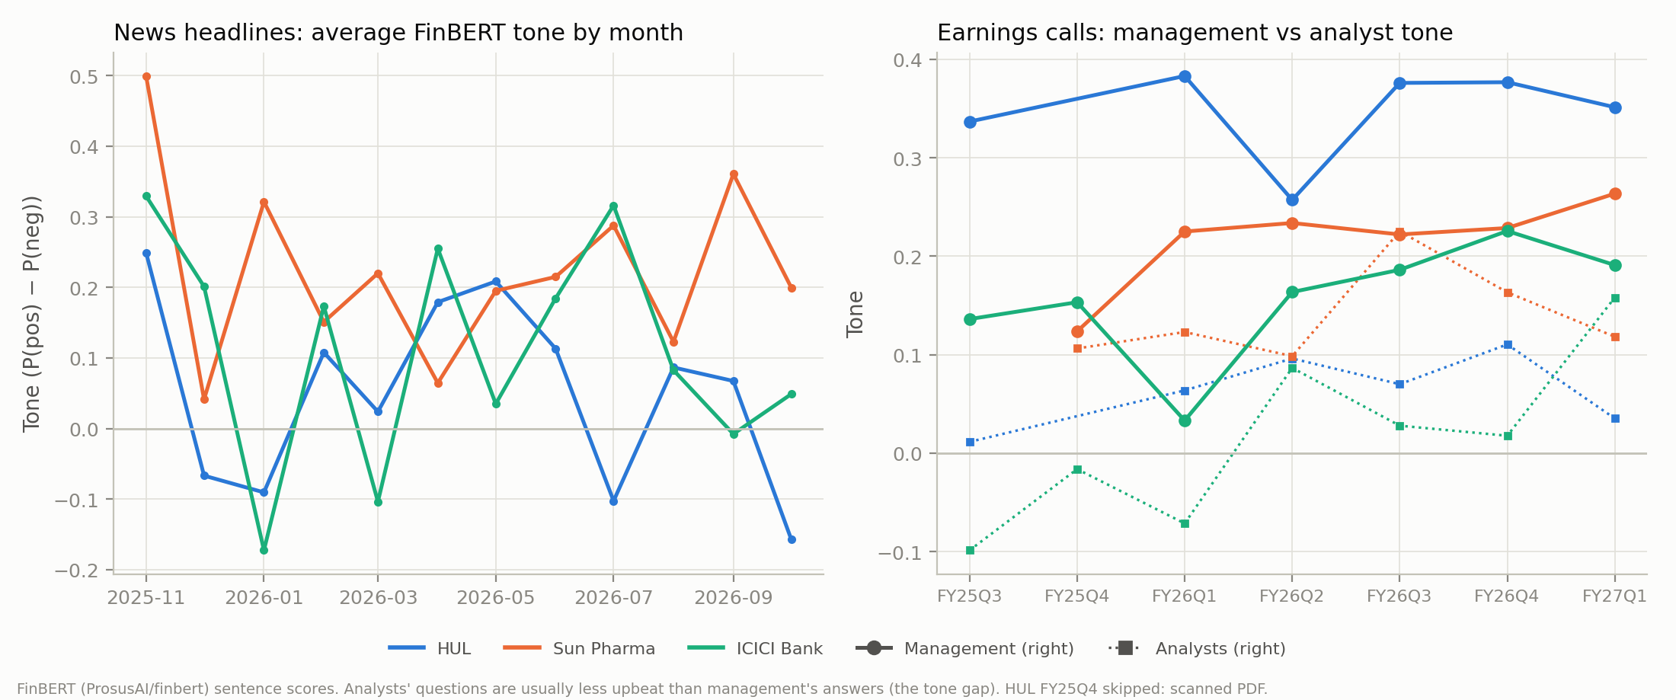
Figure 2. FinBERT tone: headlines by month (left) and earnings calls, management vs analysts (right).
What we learned. AI made it practical to read every page and headline, but two findings argue for scepticism. Managements talk up their results, so we discount call tone. Sun Pharma's coverage is 60% gain-framed and only 3% loss-framed, the one-sided optimism our valuation warns about. And technical analysis is not profitable here after costs: the rules cut drawdowns but lose return, consistent with weak-form efficiency, while prices absorb earnings news within days (semi-strong form).

4. Portfolio and the long-term plan
We maximise the Sharpe ratio with 10–60% in each stock, using the 2016–26 covariance matrix. With historical mean returns, the optimiser pushes ICICI to the 60% cap (Sharpe 0.58), which is hindsight: weights fitted on 2016–22 earned 3.2% a year in 2023–26, against 7.4% for the Nifty. We therefore use forward-looking CAPM expected returns, which give P = HUL 31%, Sun Pharma 19%, ICICI 50%: E(r) 12.3%, σ 19.7%, Sharpe 0.34. Fitted the same way on 2016–22, they earned 7.9% a year out of sample.
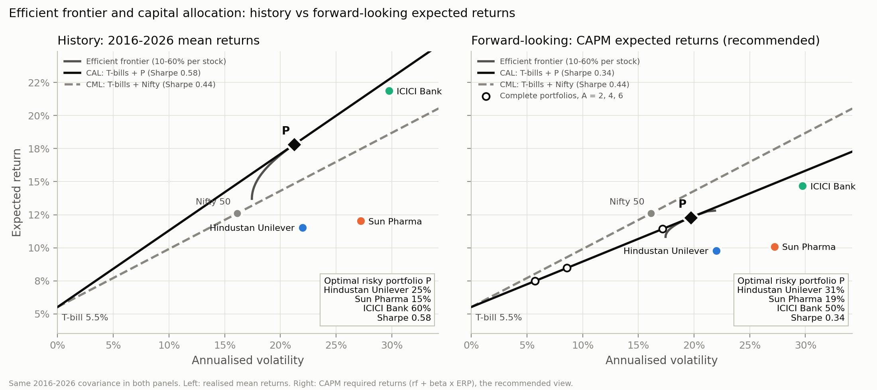
Figure 3. Efficient frontier, CAL (T-bills + P) and CML (T-bills + Nifty) under historical and forward-looking expected returns.
P's Sharpe ratio (0.34) is below the market's (0.44): three stocks cannot match the index's diversification, so our CAL lies under the CML. That is why the long-term plan is core-satellite. Each investor's share in P is y* = (E[rP] − rf) / (AσP²), capped at 100% (no borrowing); the rest goes to T-bills.
Profile | A | Share in P | E(rc) | σc | Certainty equiv. | 1-yr 95% VaR on ₹1 lakh | P(loss), 1 yr | 15-yr SIP median | P(≥ ₹75 lakh)
Aggressive | 2 | 87% | 11.4% | 17.2% | 8.5% | ₹16,138 / ₹15,984 | 28% / 27% | ₹69.5 lakh | 36% / 29%
Balanced | 4 | 44% | 8.5% | 8.6% | 7.0% | ₹5,582 / ₹5,465 | 17% / 16% | ₹64.8 lakh | 19% / 11%
Conservative | 6 | 29% | 7.5% | 5.7% | 6.5% | ₹1,940 / ₹1,822 | 10% / 9% | ₹61.3 lakh | 4% / 1%
Table 5. Complete portfolios and their risk. Pairs are parametric (normal) / block-bootstrap Monte Carlo, 10,000 paths each.
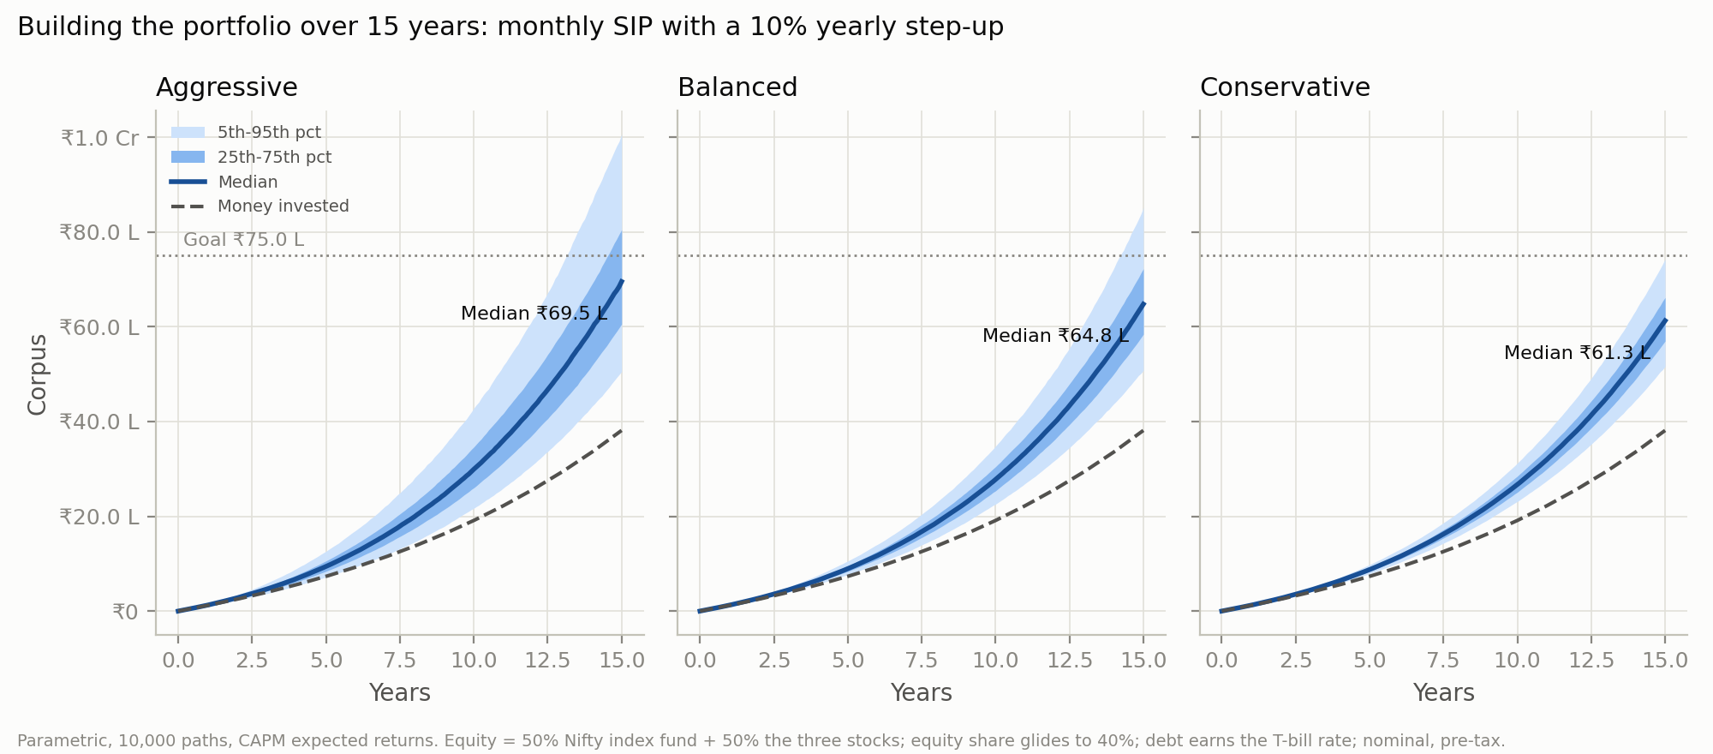
Figure 4. Corpus from a ₹10,000 monthly SIP rising 10% a year: median, 25th–75th and 5th–95th percentiles, against money invested.
Building it over the years. Each of us estimates A with a short questionnaire (docs/risk_questionnaire.md) and starts a ₹10,000 SIP that rises 10% a year: half into a Nifty 50 index fund and half into P, with equity gliding to 40% as the goal nears. Our Investment Policy Statement sets the rules. Keep six months of expenses outside the portfolio. Rebalance yearly, with new money first. Review after every results season. Never sell in the month after a 20% fall, and never buy because a stock has just risen. The bootstrap keeps real fat tails and volatility clustering; its VaR is close to the normal model's, so fat tails matter little over one year.

5. Recommendation, risks and limitations
Stock | Call | Range | Price | Why
Hindustan Unilever | BUY | ₹1,592–₹2,396 | ₹1,862 | Fairly valued on our models; lowest beta; bought while its sector is out of favour
Sun Pharma | HOLD | ₹1,225–₹2,174 | ₹1,760 | Residual income says expensive, peers say fair; momentum and one-sided coverage argue for patience
ICICI Bank | HOLD | ₹857–₹1,747 | ₹1,351 | Highest expected return, but 57% of portfolio risk and a price that needs 13.9% growth for ever
Table 6. Calls. The range runs from our blended value to the analysts' mean target. Hold = add only through the SIP.
Risks. Concentration: ICICI is 50% of the weight but 57% of the risk. Valuation: all three prices assume high growth for ever. Regulation: a proposed cap on trade margins for anti-cancer drugs (Sun Pharma). Cycle: a credit slowdown would hit ICICI and the Nifty together.
Sell-off | HUL | Sun Pharma | ICICI Bank | Portfolio P | Nifty 50
COVID crash (Feb-Mar 2020) | −18.4% | −19.6% | −47.9% | −34.6% | −37.2%
Rate-hike sell-off (Jan-Jun 2022) | −10.9% | −6.3% | −16.2% | −12.3% | −16.1%
Election-result shock (4 Jun 2024) | +6.0% | −1.6% | −7.6% | −2.3% | −5.9%
2026 drawdown (02 Jan 2026 to 13 Oct 2026) | −19.9% | +2.8% | +0.5% | −5.1% | −13.7%
Table 7. Stress tests: price change through four real sell-offs. P fell less than the Nifty in 4 of 4.
Limitations. One risk-free rate is applied to 2016–26; the Nifty total return is estimated (+1.22% a year); CAPM is a single-factor model and forward returns depend on the ERP; the Monte Carlo assumes stable volatility and correlation; results are pre-tax and before fees; and Sun Pharma was chosen after its run. This is coursework, not investment advice.

APPENDIX · NOT PART OF THE FOUR-PAGE REPORT

A. How to view the dashboard
Link: added once the app is deployed on Streamlit Community Cloud (see README).
- If you see “This app has gone to sleep”, click the button; it loads in about a minute. Free apps sleep when idle.
- The data selector opens on Submission, the numbers in this report. Latest is refreshed every weekday evening after the NSE close.
- The risk-aversion slider recomputes your share in P and the complete portfolio for any A. “Ask the portfolio” answers questions from the computed results, citing the file behind each number.
Code and data: GitHub repository (link added once published); a ZIP of the tagged submission is attached.

B. What we submit
File | Contents
SA_Portfolio_Report.pdf | This report
SA_Portfolio_Deck.pptx / .pdf | The 10–12 minute presentation, with speaker notes
valuation.xlsx | DDM, residual income, peer multiples and sensitivity grids, as live formulas
sa-portfolio (GitHub / ZIP) | Python pipeline, tests, dashboard, AI outputs and the frozen data behind every number

C. Data sources and AI steps
Source | Used for
Yahoo Finance (yfinance) | Daily prices 2016–2026, statements, analyst consensus, earnings dates
Screener.in | Ten-year financials; peer multiples
BSE filings, company IR sites | FY26 annual reports and 6–7 quarters of call transcripts per company
RBI; MOSPI | Risk-free rate (91-day T-bill, 5.52%) and repo rate; GDP and demand mix
Damodaran (Jan 2026) | India equity risk premium, 7.08%
Google News RSS; Zerodha Aftermarket Report | 12 months of headlines; sector distance from moving averages (12 Oct 2026)
P1, P4, P5: Claude (Anthropic) | Ratio extraction; call aspects and guidance; headline framing and bias tags
P2, P3: FinBERT (ProsusAI/finbert) | Sentence-level tone of calls and headlines

