**Blood Classification**

*PHASE: I*

Architecture: mobilenet

Version:3

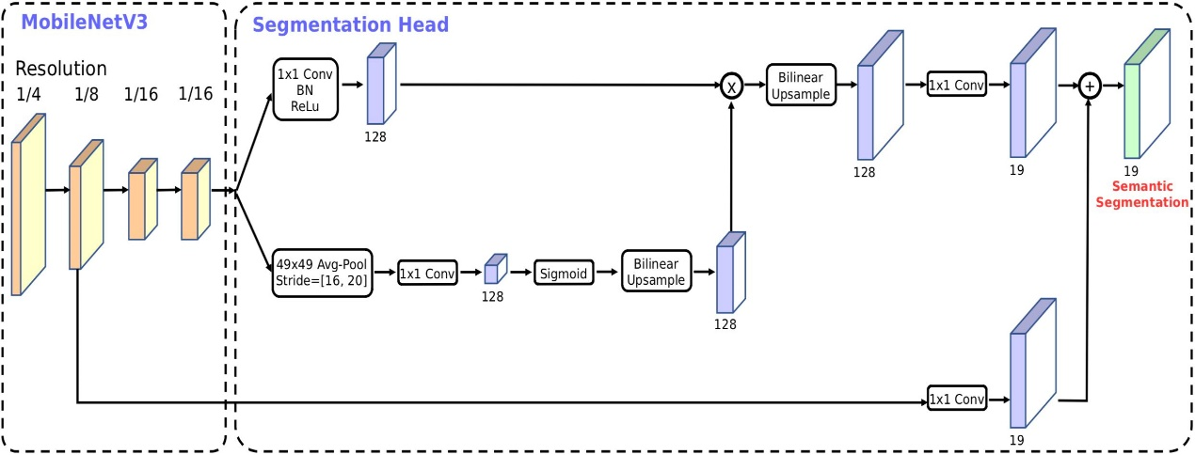

Activation function: Sigmoid

Layer: Dense

Optimizer: root mean square prop

Loss function: sparse categorical cross entropy

Classes: 4

Epoch: 10

Accuracy: 0.56

Loss: 0.94

PHASE – II

platfoem: Tensorflow model

Architecture: Deep convolution neural network

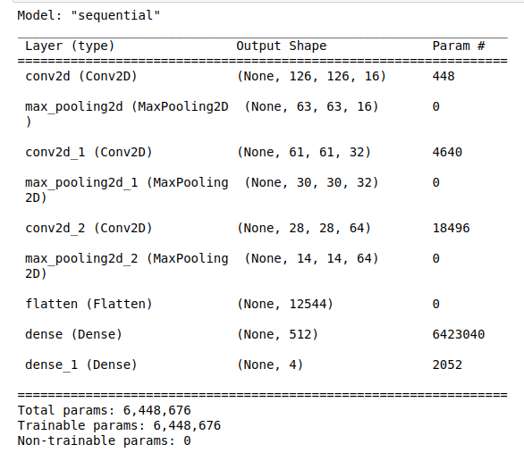

Layers : 9

Activation function: softmax

Layer: Dense

Optimizer: Adam

Loss function: sparse categorical cross entropy

Classes: 4

epochs: 9

accuracy : 0.96

loss : 0.2

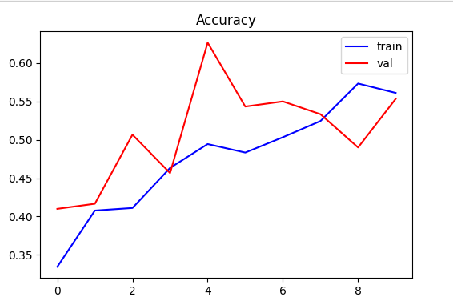

accuracy plot:

Achieved image aggumented for multiply test image for more accuracy rate from phase I.