**Blood Classification**

***PHASE – II***

platfoem: Tensorflow model

Architecture: Deep convolution neural network

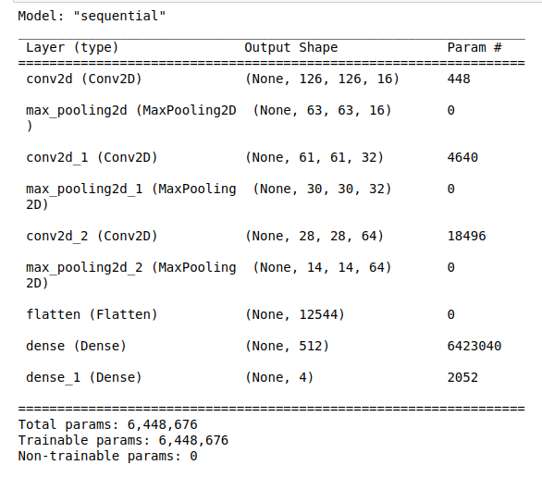

Layers : 9

Activation function: softmax

Layer: Dense

Optimizer: Adam

Loss function: sparse categorical cross entropy

Classes: 4

epochs: 9

accuracy : 0.96

loss : 0.2

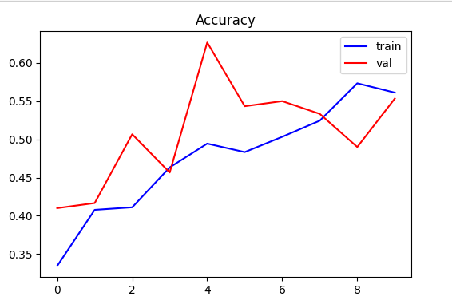

accuracy plot: