**BRAIN TUMOR DETECTION AND CLASSIFICATION IN MRI IMAGE**

**Phase – 1: TUMOR STAGE DETECTION*:***

By user uploaded MRI image of brain it will identify the tumor among the 4 type that is ‘no_tumor','glioma_tumor','meningioma_tumor','pituitary_tumor'.

**ARCHETUCTURE:**

|  |  |  |  |
| --- | --- | --- | --- |
| *Conve 2D + Relu* | *3*3* | *16* | *1*1* |
| *Max Pool* | *2*2* | *-* | *2*2* |
| *Dropout* | *-* | *-* | *-* |
| *Conve 2D + Relu* | *3*3* | *32* | *3*3* |
| *Max Pool* | *2*2* | *-* | *2*2* |
| *Dropout* | *-* | *-* | *-* |
| *Conve 2D + Relu* | *3*3* | *64* | *3*3* |
| *Max Pool* | *2*2* | *-* | *2*2* |
| *Dropout* | *-* | *-* | *-* |
| *Flatten* | *-* | *-* | *-* |

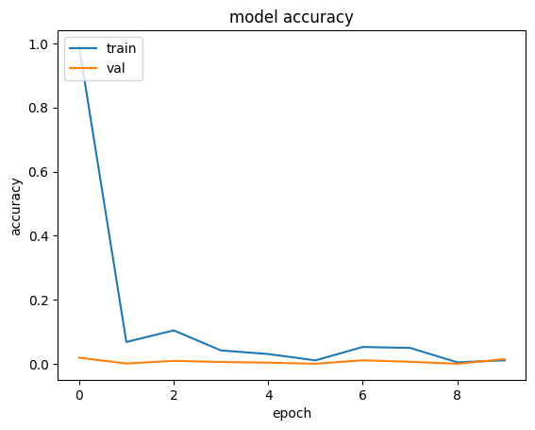

*Loss curve from phase II:*

***Data preparation:***

Downloaded the MRI image of brain with various pixel rate and make it all standard for all with size of 224 x224 pixel and convert that to NumPy array to feed into KERAS model then flatten it and gave to model

***sample normal mri image :***

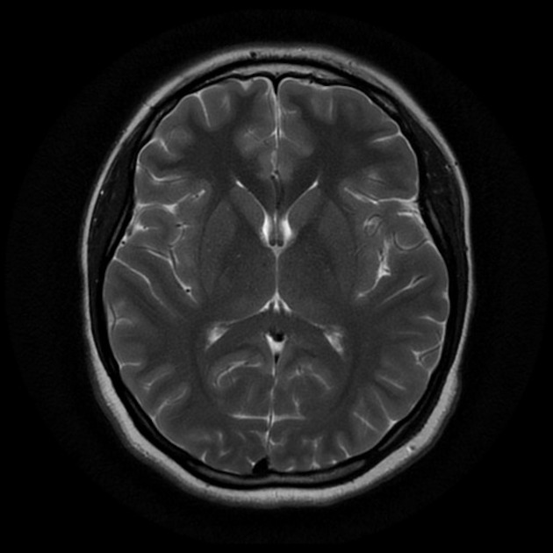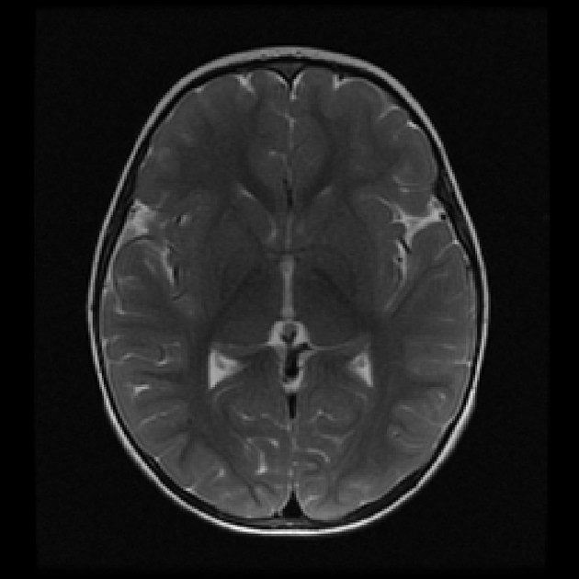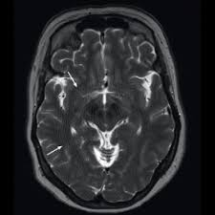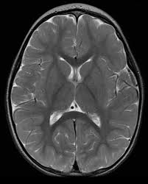

***sample glioma tumor mri image :***

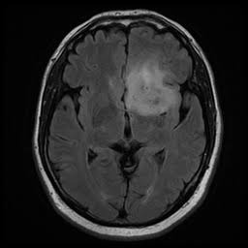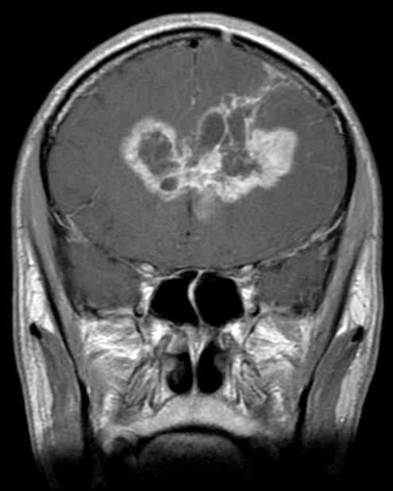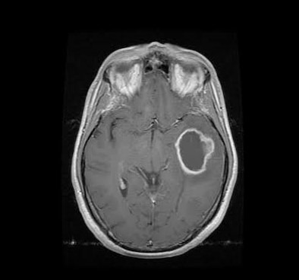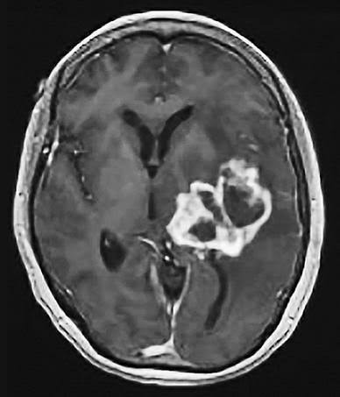

***sample pitutary rumor mri image:***

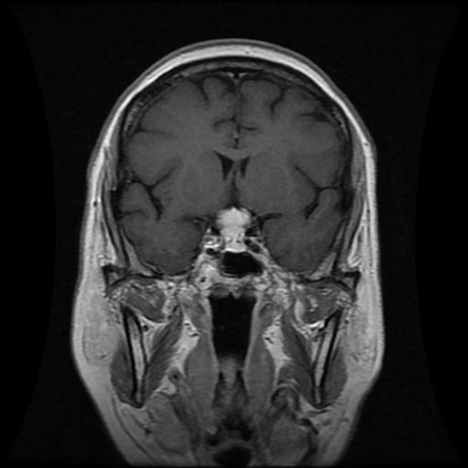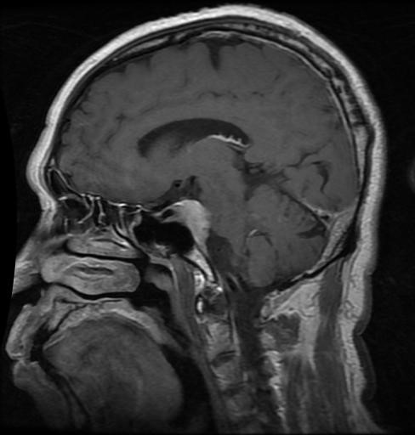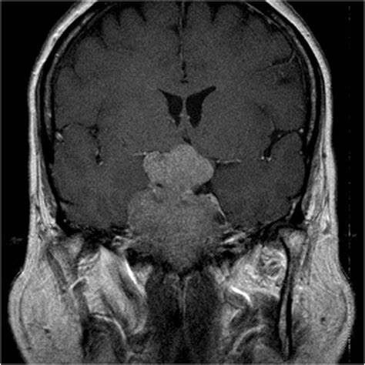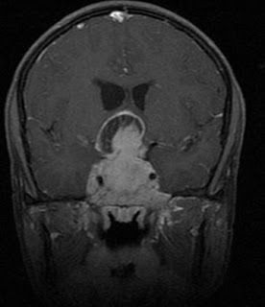

***sample meningima tumor mri image:***

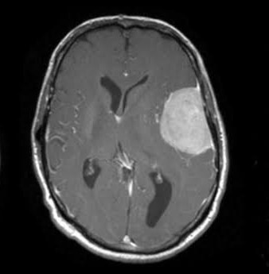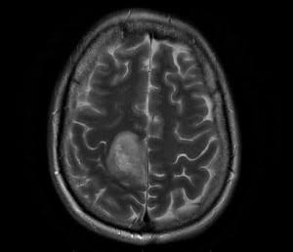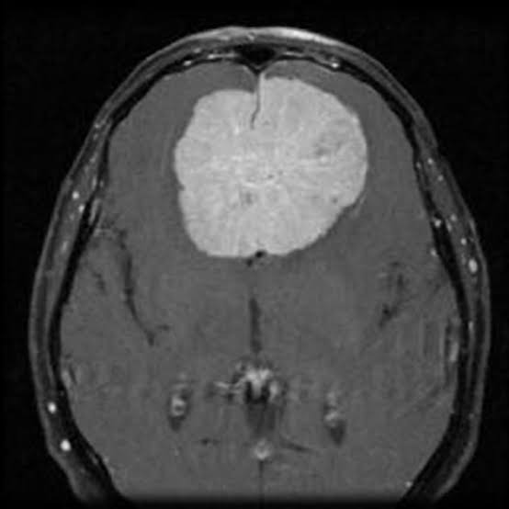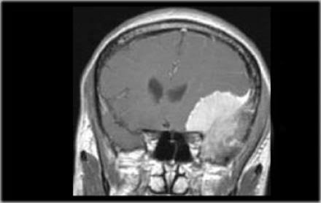

***Phase II:Tumor detection:***

After image was calssified with in 3 stages, model can create a bounding box around the tumor with the possiblity range it is tumor.

**ARCHETUCTURE:**

YOLO version 5

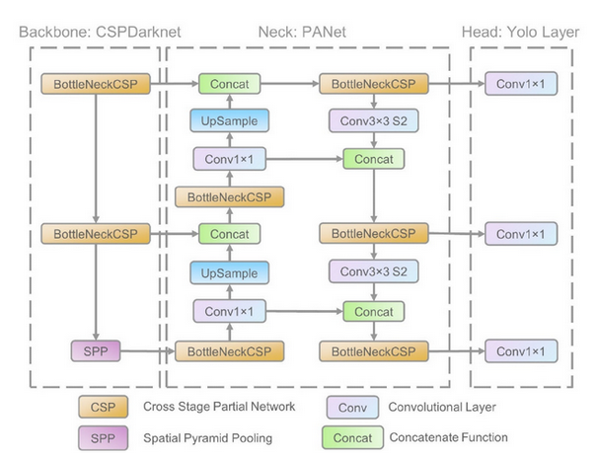

model confident : 75%

