**Eye Disease Classification**

*PHASE: II*

Model: fully connected neural network.

max_pooling2d (MaxPooling2D (None, 63, 63, 16) 0)

conv2d_1 (Conv2D) (None, 61, 61, 32) 4640

max_pooling2d_1 (MaxPooling (None, 30, 30, 32) 0 2D)

conv2d_2 (Conv2D) (None, 28, 28, 64) 18496

max_pooling2d_2 (MaxPooling (None, 14, 14, 64) 0 2D)

conv2d_3 (Conv2D) (None, 12, 12, 204) 117708

max_pooling2d_3 (MaxPooling (None, 6, 6, 204) 0 2D)

flatten (Flatten) (None, 7344) 0

dense_1 (Dense) (None, 512) 3760640

dense_2 (Dense) (None, 3) 1539

=================================================================

Model parameters:

Total params : 3,903,471

Trainable params : 3,903,471

Non-trainable params : 0

Activation function : Sigmoid

Layer : sequential

Optimizer : RMSprop

Learning rate :0.001

Loss function : sparse categorical cross entropy

Classes : 4

Types : 'CNV','DME','DRUSEN','NORMAL'

Epoch : 20

Accuracy : 0.96

Loss : 0.4

Model accuracy and loss graph:

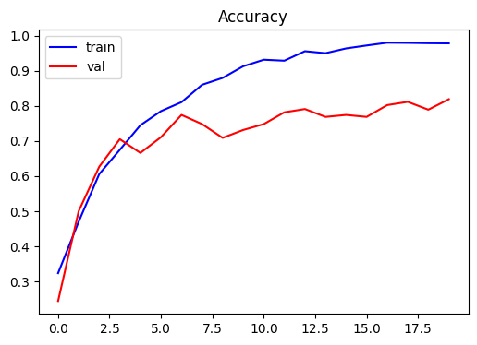

Sample result:

