**LUNG CANCER DETECTION:**

**PHASE I**: *semantic segmentation with VGG-U-NET*:

Cancer is detection are the hardest task in the medical field so in that specifically extraction the region of lungs which is affected the challenging task

with the help of Unet model with backbone of VGG we can extract the lung part separately so that we can process the affect lung clearly with help of ai.

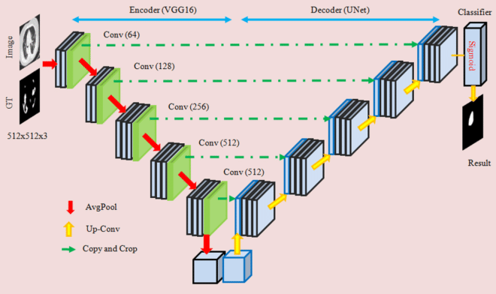

VGG-U-NET architecture

**Dataset:**

Took 90 mri images for sample training then mask that manually with LabelMe software then and feed the dataset into standard unet model.

With dataset from The Iraq-Oncology Teaching Hospital/National Center for Cancer Diseases (IQ-OTH/NCCD) lung cancer dataset was collected in the above-mentioned specialist hospitals over a period of three months in fall 2019.

The dataset contains 3 classes they are:

* Begin case (120)
* malignant case (561)
* Normal case (416)

Dataset contains only images for classifications so we make it manually.

total training images: 90

mri image size: 256x256x3

total mask image: 90

mask image size: 256x256x1

**samples:**

Normal case Beginning stage Malignant case

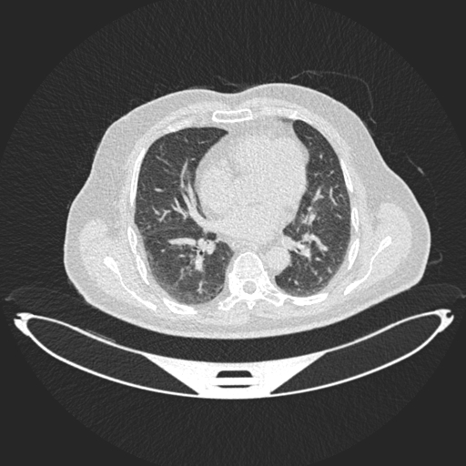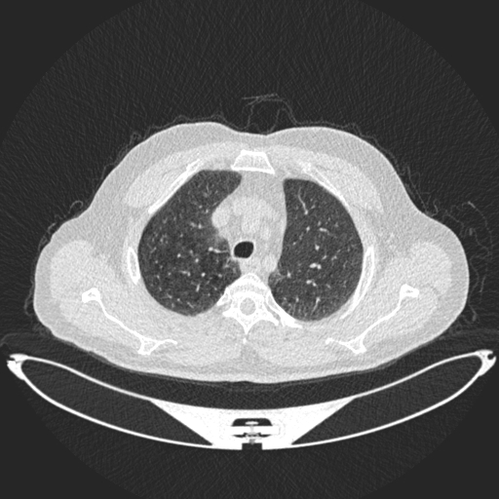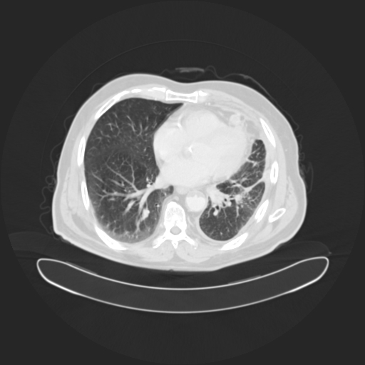

**Masked image:**

Normal case Beginning stage Malignant case

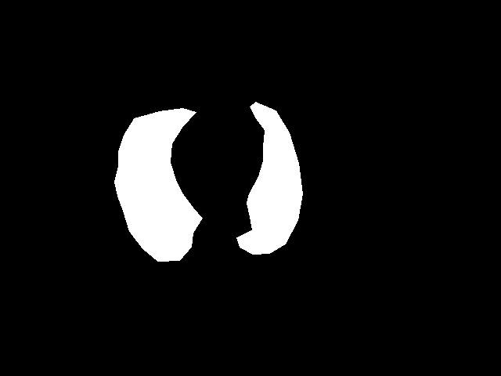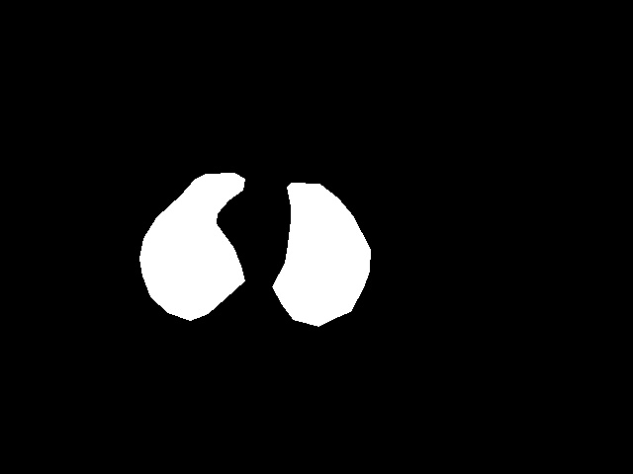

**Predicted image:**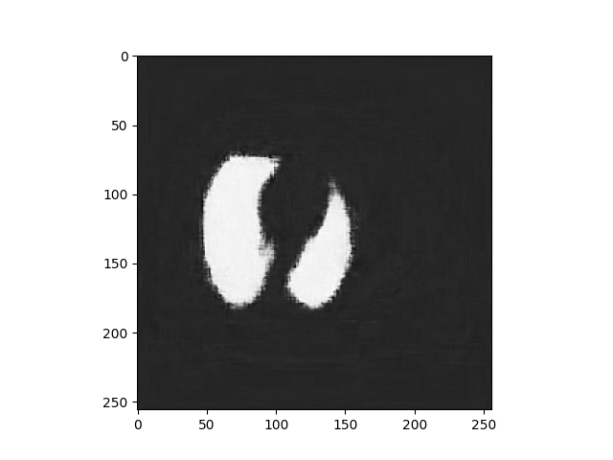

Normal case Beginning stage 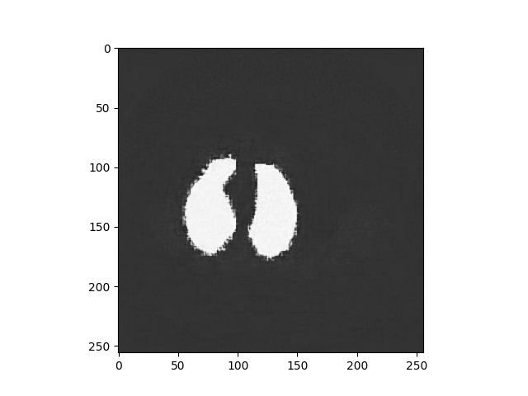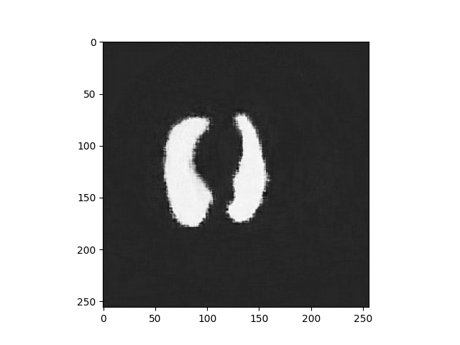 Malignant case

IoU:8.9 IoU:8.6 IoU:8.5

Binary focal loss:1.2 Binary focal loss:1.4 Binary focal loss:1.2

**MODEL:**

INPUT : 256 X 256 X 3 OF 90

OUTPUT : 1 (Binary)

OPTIMIZER : Adam

LEARNING RATE : 1e-4

LOSSFUNCTION : BinaryFocalLoss

EOICHS : 50

ACCURACY : 97.6 %

LOSSES : 5.2 %

**PROCESS:**

VGG16 architecture is used as backbone (layers) in this Unet for improve the model accuracy to segment lung region to focus more on tumour, with the help of IoU accuracy we calculated semantic accuracy and Binary focal loss got lost pixel.