**LUNG TUMOR CLASSIFICATION IN MRI IMAGE**

**Phase – 1: TUMOR STAGE DETECTION*:***

Dataset from Iraq-Oncology Teaching Hospital/National Center for Cancer Diseases (IQ-OTH/NCCD) lung cancer dataset was collected in the above-mentioned specialist hospitals over a period of three months in fall 2019.

The dataset contains 3 classes they are:

* Begin case (120)
* malignant case (561)
* Normal case (416)

***Data preparation:***

Downloaded the MRI image of brain with various pixel rate and make it all standard for all with size of 224 x224 pixel and convert that to NumPy array to feed into KERAS model then flatten it and gave to model

***sample normal mri image:***

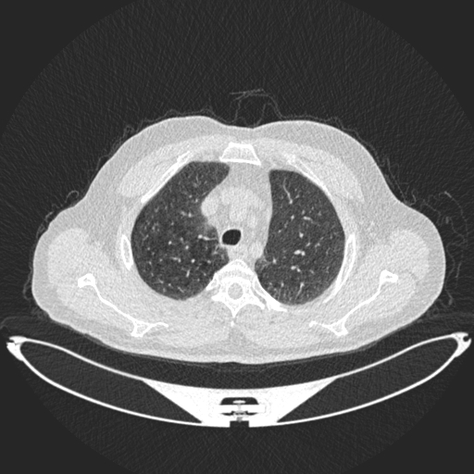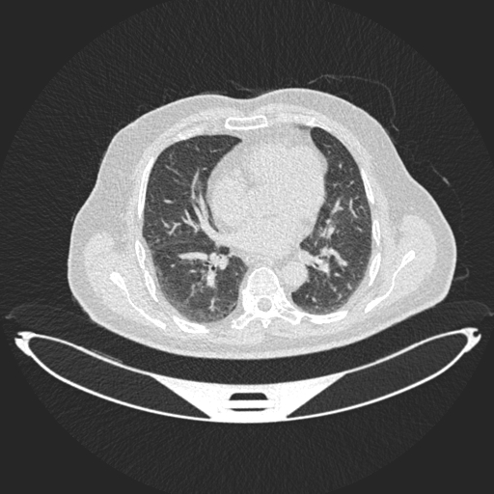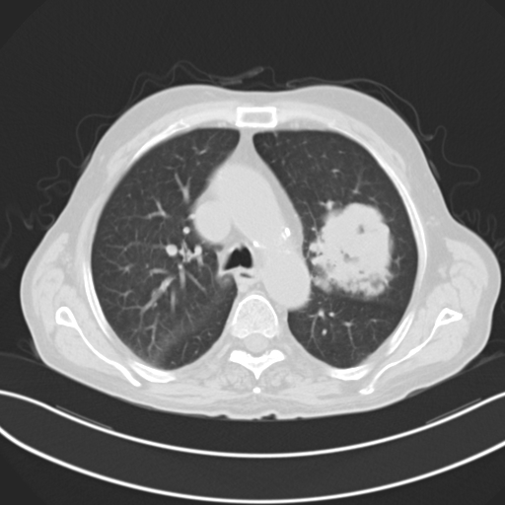

**NORMAL BEGINNING MALIGNANT**

**ARCHETUCTURE:**

VGG architecture is used in this phase for classify the types of tumor from lungs.

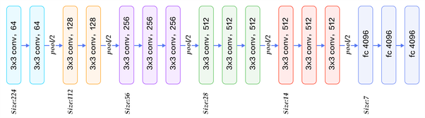

MODEL:

LOSS : sparse_categorical_crossentropy

OPTIMIZER : adam

ACTIVATION : softmax

EPOCHS : 15

LOSS : 35.5%

ACCURACY : 86.2%

*Accuracy curve &loss curve:*

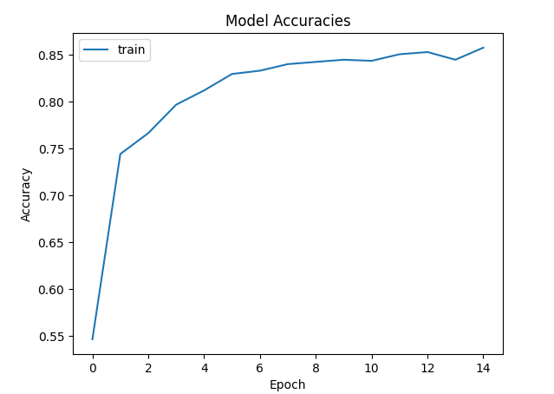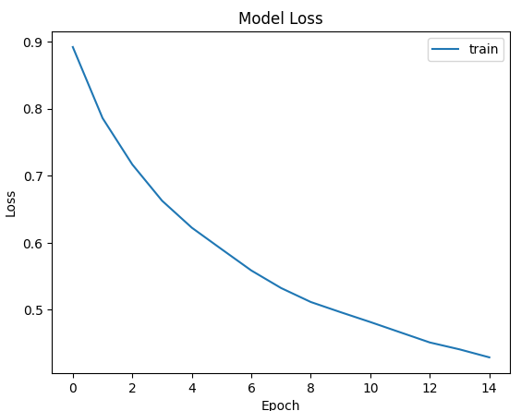

sample result:

