Skin Disease Classification
PHASE: I
Architecture: efficientnet

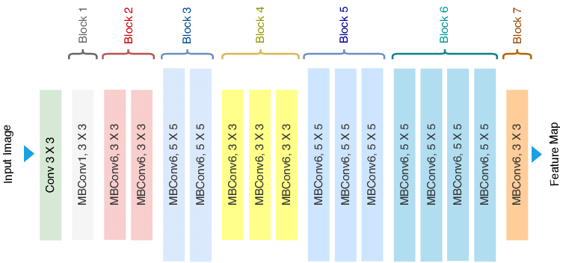

Activation function: Sigmoid
Layer: cnn, maxpooling, Dense
Optimizer: root mean square prop
Loss function: sparse_categorical_crossentropy
Classes: 8
Epoch: 50
Accuracy: 0.75
Loss: 0.44

Train test validation:
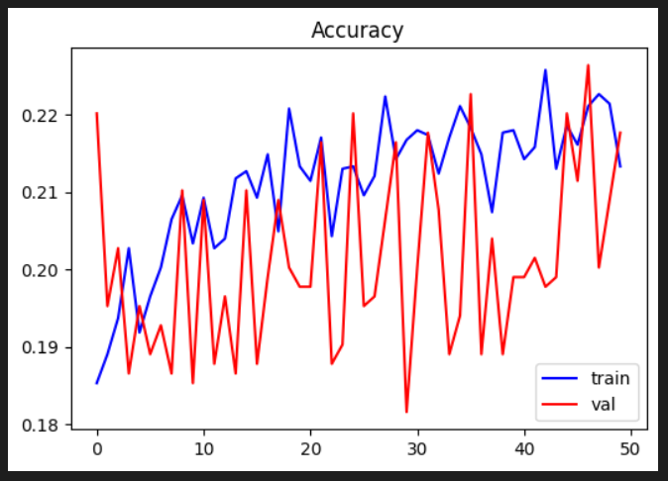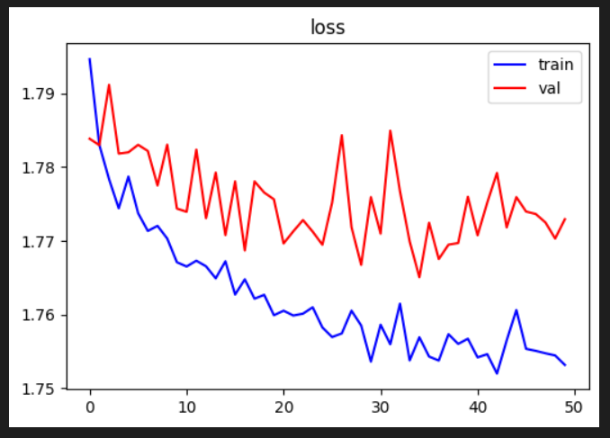
Confusion matrix:
Tabulation:

