**Skylark Synchronization**

Instructions

SkylarkSync is a software that help you protect your precious data from be damage.With a right configuration it will create a historical file library. You can extract any historical state of your file from it.

Task assignment

To assign task, you need to do these:

1st Install jre8

2nd create a text file under folder SkylarkSync\tasks\

3rd Edit it. A valid configure looks like that:

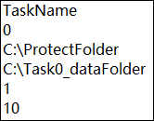

4th Multitasking is supported,if you want to assign more task just create a new task file under folder SkylarkSync\tasks\

5th What do these variable means?

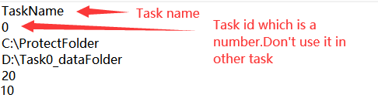

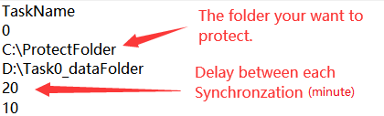

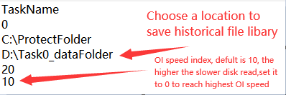

6th **Check wither ProtectFolder and historical file library folder exist or not.**

7th Double lick Run.bat

8th Create a link of Run.bat and,put the link to

C:\Users\YOUR USER NAME\AppData\Roaming\Microsoft\Windows\Start Menu\Programs\Startup

Extraction

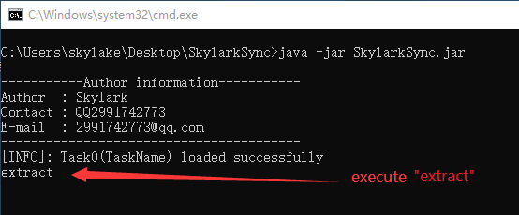

Optimization

Execute “optimize” to minimize the disk usage which means the programme will only reserve time points by follow rules :

Now ~ 1 day ago : 6 time point

1 day ago ~ 10 days ago : 3 time point

10 days ago ~ 30 days ago : 2 time point

30 days ago ~ infinite days ago : 1 time point per 60 days

Other command

pause

continue

exit

version

help

merge