The New York Public Library
_____________________________________________________________________________

Jail & Prison Services DATE, 2024
40 West 20th Street
New York, NY 10011

FirstName LastName #12345678
Whatever Correctional Facility
P.O. Box 12345
New York, NY 12345

Dear (Insert Name),

Thank you for your letter asking for information regarding state's use of algorithms for monitoring inmates and its influence on parole. A variety of algorithms are used throughout the criminal justice cycle, from pretrial to parole.

- AI Used Throughout the Criminal Justice Cycle……………………………………………..2
  - The Tools
  - How the Tools are Used
Table 1. Well-Known/Used AI Pretrial Risk Assessments
Table 2. An Example of the PSA Scoring System
  - Results/Case Studies
  - The “Black Box”
  - Survey of Current Uses of Risk Assessment Tools
- AI Surveillance in Prisons…………………………………………………………………………….15
  - Gang Related Crime Detection
  - Covid-19
  - Further Uses
- Algorithm’s Influence on Parole…………………………………………………………….…....17
  - Ongoing Research

Please let us know if we can be of any assistance in the future. And, we've changed our address, please direct all future letters to Jail & Prison Services, 40 West 20th Street, New York, NY 10011.
Sincerely,
Jace
Jail and Prison Services
The New York Public Library
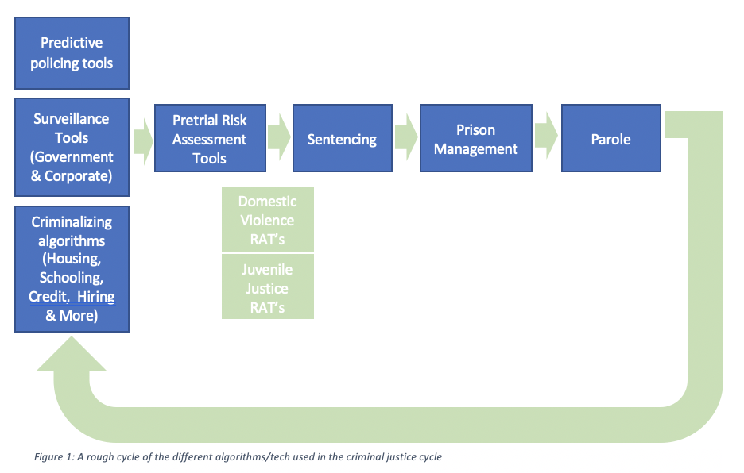

AI Used Throughout the Criminal Justice Cycle
Sourced from: https://epic.org/issues/ai/ai-in-the-criminal-justice-system/

THE TOOLS

i. Predictive Policing
Predictive Policing Tools include “any policing strategy or tactic that develops and uses information and advanced analysis to inform forward-thinking crime prevention,” according to the National Institute of Justice. Predictive policing comes in two main forms: location-based and person-based. Location-based predictive policing works by identifying places of repeated property crime and trying to predict where they would occur next, while person-based predictive policing aims to pinpoint who might be committing a crime – trying to measure the risk that a given individual will commit crimes. Both are used in different jurisdictions and use past policing data as the main driver of these predictions, necessarily creating a self-fulfilling prophecy of arresting resources. The Bureau of Justice Assistance has and continues to give grants to police departments around the country to create and pilot these programs. However, two high-profile systems in Chicago and Los Angeles have been shut down due to limited effectiveness and significant demonstrated bias.

ii. Surveillance
Surveillance tools encompass a large swath of technologies and functions that can be used to watch, track, and store information about a person. This ranges from Ring doorbells, whose servicer has direct partnerships with law enforcement, to facial recognition systems at the border and in U.S. cities.

iii. Criminalizing Algorithms
Criminalizing algorithms include algorithms used in housing, credit determinations, healthcare, hiring, schooling, and more. Many of these have been shown to make recommendations and decisions that negatively affect marginalized communities, encoding systemic racism, and contribute to the entry of the Criminal Justice system. All of the other tools discussed here are affected by the results and data points produced by these criminalizing algorithms.

iv. Risk Assessments
Risk Assessment Tools are used in almost every state in the U.S. – and many use them pretrial, although they exist at sentencing, in prison management, and for parole determinations. There are also specific risk assessment tools for different functions in the criminal justice system, such as domestic violence risk or juvenile justice risks, with the understanding that different factors are used in those contexts than in a general criminal risk or violent criminal risk of rearrest or re-offense.

HOW THE TOOLS ARE USED
Pre-trial Risk Assessment tools are designed to attempt to predict future behavior by defendants and incarcerated persons, and quantify that risk. They use socioeconomic status, family background, neighborhood crime, employment status, and other factors to reach a supposed prediction of an individual’s criminal risk, either on a scale from “low” to “high” or with specific percentages or numbers. Research has shown outcomes to be biased based on the race, ethnicity, and age of the accused. The tools vary but often estimate:

- the likelihood that the defendant will re-offend before trial (“recidivism risk”)

- the likelihood the defendant will fail to appear at trial (“FTA”)

These often pretrial techniques are used to set bail, determine sentences, and even contribute to determinations about guilt or innocence. Yet the inner workings of these tools are largely hidden from public view. As a result, two people accused of the same crime may receive sharply different bail or sentencing outcomes based on inputs that are beyond their control; they have no way of assessing or challenging the results.

As criminal justice algorithms have come into greater use at the federal and state levels, they have also come under greater scrutiny. Many criminal justice experts have denounced “risk assessment” tools as opaque, unreliable, and unconstitutional.

Table 1. Well-Known/Used AI Pretrial Risk Assessments
Sourced from: https://www.rstreet.org/

Assessment Name | What it Predicts | Factors Considered in Algorithm
Colorado Pretrial Assessment Tool (CPAT and CPAT-R) | • Failure to appear  • New criminal arrests | CPAT created 2012; revised 2020  • Both CPAT and CPAT-R:  – Age at first arrest  – Active warrants  – Pending cases  – Currently on supervision  – Past or current problems with alcohol (CPAT-R adds drugs)  • CPAT only:  – Having home or cell phone  – Residence (own vs. rent)  – Residential payment contribution  – Past or current mental health treatment  – Past jail sentence(s)  – Past prison sentence(s)  – Revoked bond or supervision history  • CPAT-R only:  – Current employment/education  – Prior arrests  – Arrests within past year  – Prior failure(s) to appear  – Prior failure(s) to appear (past year)
Correctional Offender Management Profiling for Alternative Sanctions (COMPAS) | • Recidivism | • Criminal history  • Substance use  • Family  • Employment/education  • Living situation
Federal Pretrial Risk Assessment Instrument (PTRA) | • Failure to appear  • New criminal arrests  • Technical violations | • Number of felony convictions  • Prior failure(s) to appear  • Pending felonies or misdemeanors  • Current offense type  • Offense class  • Age at interview  • Highest education  • Employment status  • Residence (own vs. rent)  • Current drug problems  • Current alcohol problems  • Foreign risk factors (e.g., citizenship, connections outside of United States, passport access)
Ohio Risk Assessment System (ORAS) | • Failure to appear  • New criminal arrests | • Age at first arrest  • Number of failure-to-appear warrants (past 24 months)  • Number of prior jail incarcerations  • Employment at time of arrest  • Residential stability  • Illegal drug use (past 6 months)  • Severe drug-use problem
Public Safety Assessment (PSA) (see Table 2) | • Failure to appear  • New criminal arrests  • New violent criminal arrests | • Age at current arrest  • Current violent offense  • Pending charge(s) at time of offense  • Prior misdemeanor conviction  • Prior felony conviction  • Prior violent conviction  • Prior failure(s) to appear (past two years)  • Prior failure(s) to appear (older than two years)  • Prior sentence to incarceration
Virginia Pretrial Risk Assessment Instrument (VPRAI and VPRAI-R) | • Failure to appear  • New criminal arrests  • Technical violations | Created 2003; updated 2009; revised 2016  • Both VPRAI and VPRAI-R:  – Felony charge (VPRAI-R limits to felony drug, theft or fraud)  – Pending charge(s)  – Number of misdemeanors or felony convictions  – Prior failure(s) to appear  – Number of violent convictions  – Employment at time of arrest  – History of drug abuse  • VPRAI only:  – Time at current residence  • VPRAI-R only:  – Active community criminal justice supervision

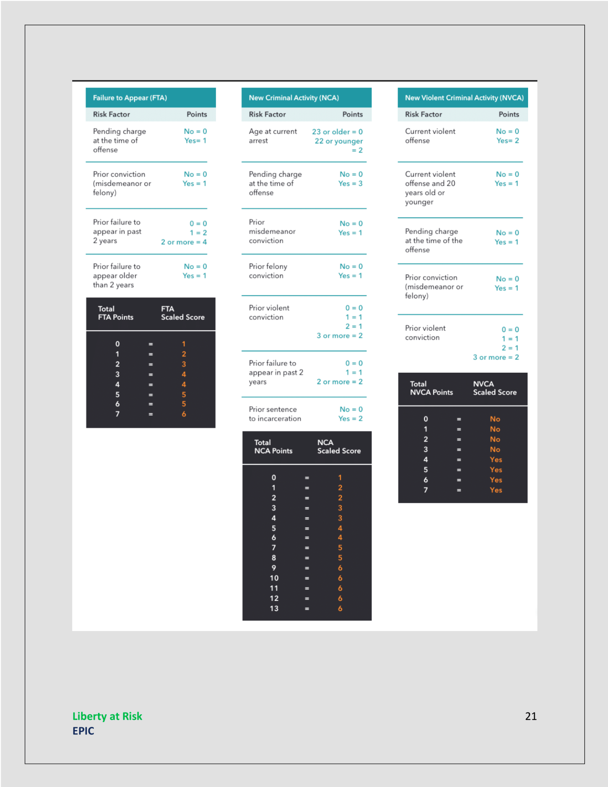
Table 2. An example of the PSA scoring system

C. RESULTS/CASE STUDIES
Sourced from: https://www.propublica.org/article/machine-bias-risk-assessments-in-criminal-sentencing

On a spring afternoon in 2014, Brisha Borden was running late to pick up her god-sister from school when she spotted an unlocked kid’s blue Huffy bicycle and a silver Razor scooter. Borden and a friend grabbed the bike and scooter and tried to ride them down the street in the Fort Lauderdale suburb of Coral Springs. Just as the 18-year-old girls were realizing they were too big for the tiny conveyances — which belonged to a 6-year-old boy — a woman came running after them saying, “That’s my kid’s stuff.” Borden and her friend immediately dropped the bike and scooter and walked away.
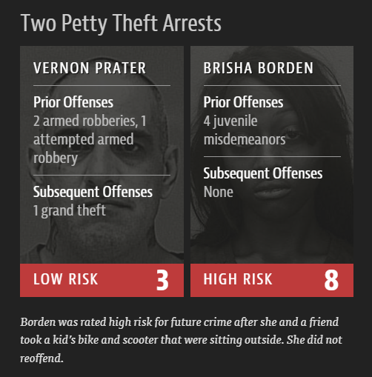
But it was too late — a neighbor who witnessed the heist had already called the police. Borden and her friend were arrested and charged with burglary and petty theft for the items, which were valued at a total of $80.

Compare their crime with a similar one: The previous summer, 41-year-old Vernon Prater was picked up for shoplifting $86.35 worth of tools from a nearby Home Depot store. Prater was the more seasoned criminal. He had already been convicted of armed robbery and attempted armed robbery, for which he served five years in prison, in addition to another armed robbery charge. Borden had a record, too, but it was for misdemeanors committed when she was a juvenile.

Yet something odd happened when Borden and Prater were booked into jail: A computer program spat out a score predicting the likelihood of each committing a future crime. Borden — who is black — was rated a high risk. Prater — who is white — was rated a low risk. Two years later, we know the computer algorithm got it exactly backward. Borden has not been charged with any new crimes. Prater is serving an eight-year prison term for subsequently breaking into a warehouse and stealing thousands of dollars worth of electronics

This 2016 investigation by ProPublica tested the COMPAS system adopted by the state of Florida using the same benchmark as COMPAS: a likelihood of re-offending in two years. It found:

- the formula was particularly likely to falsely flag black defendants as future criminals, wrongly labeling them this way at almost twice the rate as white defendants

- white defendants were mislabeled as low-risk more often than black defendants

- only 20% of the people predicted to commit violent crimes actually went on to do so

- when misdemeanors were considered, 61% of the candidates deemed liked to re-offend were arrested for any subsequent crimes within two years

- In a statistical test that isolated the effect of race from criminal history and recidivism, black defendants were still 77% more likely to be pegged as at higher risk of committing a future violent crime and 45% more likely to be predicted to commit a future crime of any kind

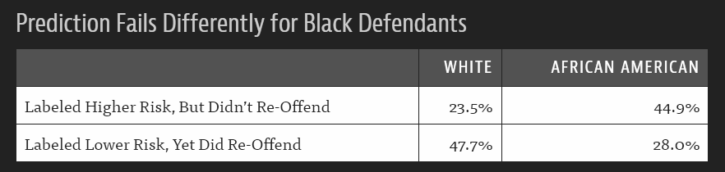

According to ProPublica, some miscalculations of risk stemmed from inaccurate inputs (for example, failing to include one’s prison record from another state), while other results were attributed to the way factors are weighed (for example, someone who has molested a child may be categorized as low risk because he has a job, while someone who was convicted of public intoxication would be considered high risk because he is homeless).

Most modern risk tools were originally designed to provide judges with insight into the types of treatment that an individual might need — from drug treatment to mental health counseling. “What it tells the judge is that if I put you on probation, I’m going to need to give you a lot of services or you’re probably going to fail,” said Edward Latessa, a University of Cincinnati professor who is the author of a risk assessment tool that is used in Ohio and several other states.

Florida’s Broward County, where Brisha Borden stole the Huffy bike and was scored as high risk, does not use risk assessments in sentencing. “We don’t think the [risk assessment] factors have any bearing on a sentence,” said David Scharf, executive director of community programs for the Broward County Sheriff’s Office in Fort Lauderdale.

Broward County has, however, adopted the score in pretrial hearings, in the hope of addressing jail overcrowding. In 2008, the sheriff’s office decided that instead of building another jail, it would begin using risk scores to help identify which defendants were low-risk enough to be released on bail pending trial. Since then, nearly everyone arrested in Broward has been scored soon after being booked. (People charged with murder and other capital crimes are not scored because they are not eligible for pretrial release.)

The scores are provided to the judges who decide which defendants can be released from jail. “My feeling is that if they don’t need them to be in jail, let’s get them out of there,” Scharf said.

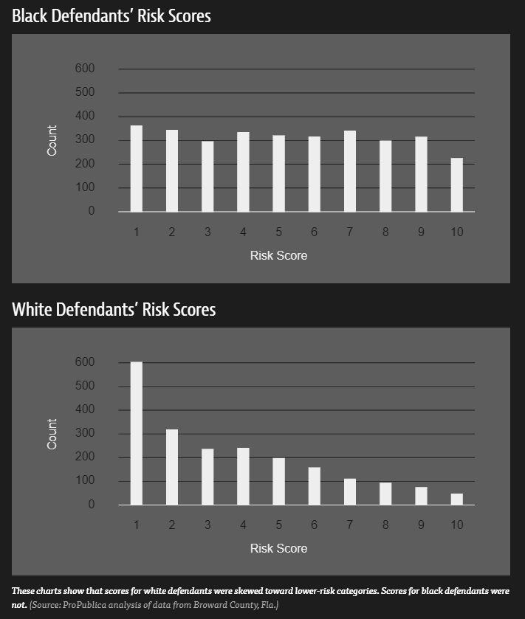

D. THE “BLACK BOX”
If computers could accurately predict which defendants were likely to commit new crimes, the criminal justice system could be fairer and more selective about who is incarcerated and for how long. The trick, of course, is to make sure the computer gets it right. If it’s wrong in one direction, a dangerous criminal could go free. If it’s wrong in another direction, it could result in someone unfairly receiving a harsher sentence or waiting longer for parole than is appropriate.

Transparency is seldom required with pre-trial risk assessments. One of the primary criticisms of these risk assessment tools is that they are proprietary tools, developed by technology companies that refuse to disclose the inner workings of the “black box.” The black box holds the code for the algorithm - no one but the developers can see inside to understand how the algorithm works. The collected data on a defendant is the input, the risk assessment score is the output.

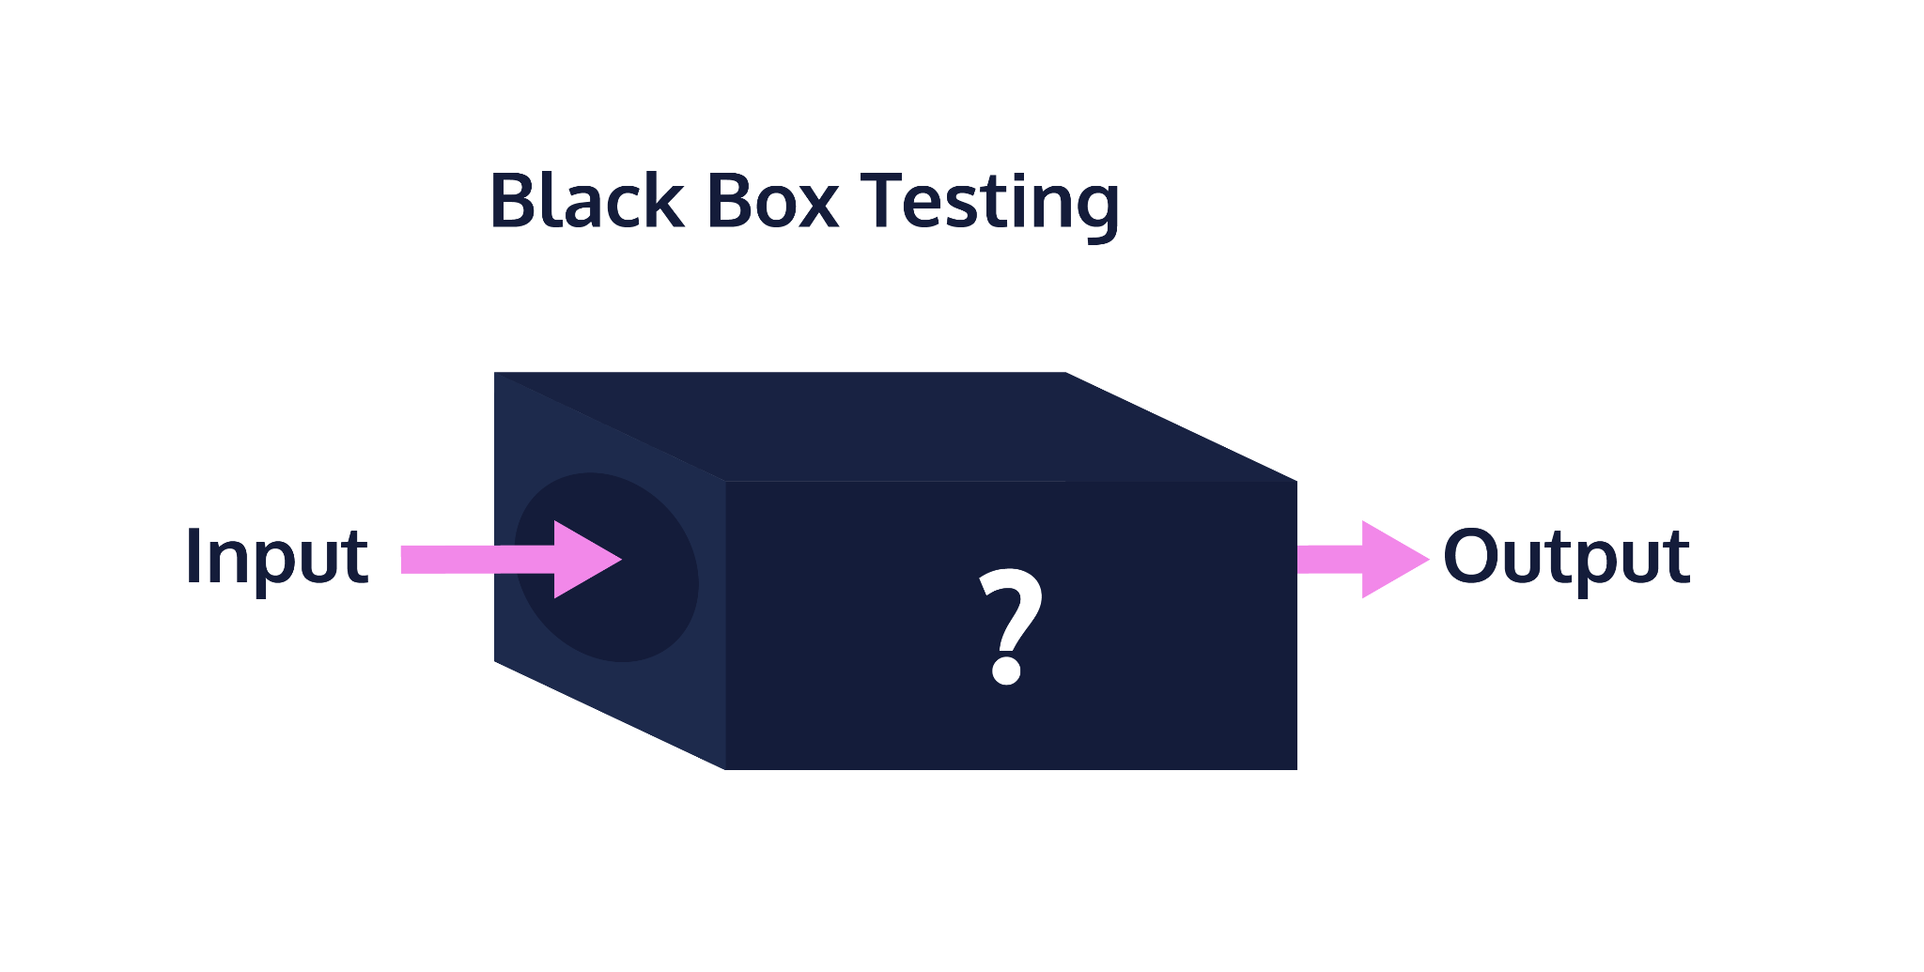
People are being convicted based on the results of these potentially flawed forensic algorithms without the ability to challenge this evidence due to the intellectual property interests of the software’s developers.

Only the developers know how these algorithms work. Judges consistently side with developers and defendants are being denied the ability to challenge the evidence used against them and evaluate how these algorithms work because of the developers’ trade secret protections. This presents a threat to due process rights and violates the confrontation rights guaranteed for defendants in the Constitution’s Bill of Rights, as well as in federal, local, and state law.

In March 2019, Idaho became the first state to enact a law specifically promoting transparency, accountability, and explainability in pre-trial risk assessment tools. The law prevents a trade secrecy or IP defense, requires public availability of all documents, data, records, and information used by the builder to build or validate the pretrial risk assessment tool,’ and empowers defendants to review all calculations and data that went into their risk score.

This year, Rep. Mark Takano (D-Calif.) and Rep. Dwight Evans (D-Penn.) reintroduced a similar bill, called the Justice in Forensic Algorithms Act of 2024, that would, at a national level:

- Prohibit the use of trade secrets privileges to allow the defense access to source code and other information about software used to process, analyze, and interpret evidence in criminal proceedings;

- Direct the National Institute of Standards and Technology to establish both Computational Forensic Algorithm Testing Standards and a Computational Forensic Algorithm Testing Program; and require federal law enforcement to comply with standards and testing requirements in their use of forensic algorithms

E. SURVEY OF CURRENT USES OF RISK ASSESSMENT TOOLS
The following table summarizes the results of a survey of state practices conducted by the Electronic Privacy Information Center (EPIC) between September 2019 and July 2020. Some of these tools are used outside of the pretrial context. This information was compiled through a combination of publicly available resources and documents obtained by EPIC’s Freedom of Information requests. There is no official, public compendium of Pretrial Risk Assessments used by states. This lack of transparency is a chief issue for advocates of reforming Pretrial Risk Assessments

LEGEND:
COMPAS - Correctional Offender Management Profiling for Alternative Sanctions
PSA - Public Safety Assessment
PTRA - Pretrial Risk Assessment Instrument
CPAT - Colorado Pretrial Assessment Tool
PRRS - Pretrial Release Risk Scale
DELPAT - Delaware Pretrial Assessment Tool
ODARA - Ontario Domestic Assault Risk Assessment Tool
MNPAT - Minnesota Pretrial Assessment Tool
ORAS - Ohio Risk Assessment System
LS/CMI - Level of Service/Case Management Inventory
PRAISTX - Pretrial Risk Assessment Information System
VPRAI - Virginia Pretrial Risk Assessment Instrument
IRAS - Indiana Risk Assessment System
IYAS - Indiana Youth Assessment System

Validation: The process of examining whether a given instrument actually works as intended. For pre-trial risk assessment, it compares how the tools estimated risk for certain individuals with whether those individuals actually failed to appear at their trial or committed another crime.

STATE | TYPE/SCOPE OF USE | WAS THERE A VALIDATION STUDY?
Alabama | VPRAI / Jefferson County | Yes
Alaska | State Created / Statewide | Yes
Arizona | PSA / Statewide  VPRAI / 2 County Superior Courts | Unknown
Arkansas | State Created / Statewide | Yes
California | PSA / 3 counties  PRRS II / 2 Counties | In progress
Colorado | CPAT / Statewide  ODARA for DV / Statewide | In progress
Conneticut | State created / Statewide | Yes
Delaware | State created (DELPAT) / Statewide | Yes
District of Columbia | Developed with Urban Institute and Maxarth | Yes
Florida | PSA / Volusia County  COMPAS - Sentencing / Statewide  State Created / 6 Counties | Yes
Geogia | State created / Some counties | Unknown
Hawaii | PSA / Statewide  ORAS-PAT / Statewide | Yes
Idaho | State created / Statewide  Revised IPRAI / Ada County | Yes
Illinois | PSA / 4 counties  VPRAI/RVRA / Most Courts | Yes
Indiana | Mandatory use of IRAS and IYAS / Statewide | Yes
Iowa | PSA / 4 Counties via Pilot Program  IRR (Iowa Risk Revised) | Yes
Kansas | State created / Johnson County | Unknown
Kentucky | PSA / Statewide | Yes
Lousiana | PSA / New Orleans | Yes
Maine | ODARA (sex offenders) / Statewide | Yes
Maryland | State created / Most counties | Yes
Massachusetts | COMPAS / Statewide  LS/CMI / Statewide | N/A
Michigan | COMPAS for Sentencing / Statewide | Yes
Minnesota | MNPAT / Statewide | In progress
Mississippi | CRJ (Crime Justice Institute) / Statewide | HB 585 Requires Validation Every 3 Years – passed in 2017, no validation studies published yet.
Missouri | PSA / 1 County  State created / Statewide  Separate statewide system for Juvenile and Sex Offenders  Use Oregon Public Safety Checklist for Sentencing | Yes  - Missouri Sentencing Advisory Commission (MOSAC) Risk Score: Validation Study (published in 2009 MOSAC Biennial Report)  - Missouri Board of Probation and Parole Risk Assessment (validation studies, policies and procedures)
Montana | PSA / 2 Counties and 5 Pilot Counties | Yes
Nebraska | STRONG-R | Yes
Nevada | State created / Statewide | Yes
New Hampshire | Yes | N/A
New Jersey | PSA / Statewide | Yes
New Mexico | PSA / 4 Counties  ODARA for DV | Yes
New York | (NYC) City Created / Citywide  State Created / State-wide for Parole | Yes
North Carolina | PSA / 1 County  Developing another statewide one | Yes
Ohio | PSA / 3 Counties  ORAS-PAT / Statewide | Yes
Oklahoma | ORAS for Pretrial Services Program + LSI/R / Statewide | Yes
Oregan | Public Safety Checklist | Yes
Pennsylvania | PSA / Allegheny County  State created / 1 County | Yes
Rhose Island | PSA / Statewide | Yes
South Carolina | State Created - Cash Bail Use | Unknown
South Dakota | PSA / 2 Counties | Yes
Tennessee | PSA / 2 Counties  State Created / One Judicial District Test | In progress
Texas | PSA / Harris + Dallas County  PRAISTX (derivative of ORAS) / Statewide Parole Board | Yes
Utah | PSA / Statewide | Yes
Vermont | ORAS | No
VIrginia | VPRAI revised by Luminosity / Statewide  Use Oregon Public Safety Checklist for Sentencing | Yes  - Re-Validation of the Nonviolent Offender Risk Assessment Instrument  - 2012 Virginia Criminal Sentencing Commission Annual Report  - 2001 Virginia Criminal Sentencing Commission Annual Report  - Offender Risk Assessment in Virginia: A Three-Stage Evaluation  - Assessing Risk Among Sex Offenders in Virginia
Washington | PSA / 3 Counties | Yes
West Virginia | LS/CMI | Yes
Wisconsin | PSA / 4 Counties  COMPAS / Statewide | Yes
Wyoming | COMPAS for Prisoners / Statewide | Unknown
Federal | PTRA | Yes

II. AI Surveillance in Prisons
Correctional institutions have for decades had staff listen to incoming and outgoing phone calls that they suspected might discuss criminal activity, but that surveillance system has evolved. Verus is a machine learning program that scans incoming and outgoing calls, including to inmates’ friends and family, and does automatic searches for keywords selected by prison officials and the technology company’s employees. It uses speech-to-text technology powered by Amazon to transcribe the content of conversations that include those keywords.

The company that owns the software, Leo Technologies, said the technology will help officials get notifications “in near real-time about past or potential criminal events.” Content gathered by the company is shared with local, state, and federal law enforcement, along with prosecutors. Inmates and callers are told they may be monitored and the only calls excluded from monitoring are communications with lawyers, doctors, and spiritual advisers.

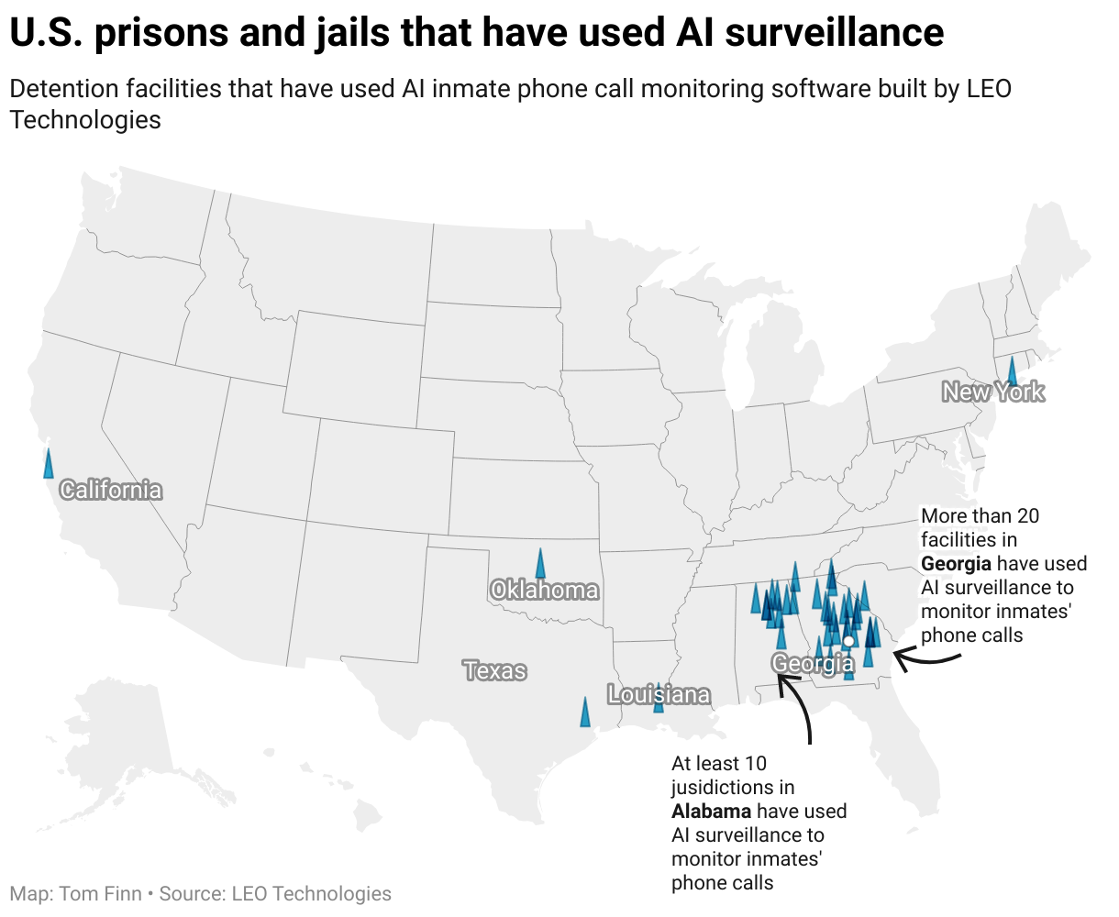
This map is from a 2021 report. As of 2023, Florida has implemented Verus.
In March 2020, the Georgia Department of Corrections began using Verus. By April of the next year, more than 7.5 million calls had been monitored and “delivered actionable evidence of criminal activity in 1,612 calls”. The criminal activity was identified both inside and outside of prisons.

A number of states in recent years have begun using artificial intelligence to monitor conversations, with prison officials saying the use of the technology has helped deter violent crimes, human trafficking, and drug smuggling and helped prevent suicides. But questions are being raised about how law enforcement officials use the program. In Suffolk County alone, Verus was used to monitor more than 2.5 million phone calls between its implementation in April 2019 and May 2020 - leading to 96 "actionable intelligence reports". But it’s not clear whether the 96 reports justified sweeping up several million phone calls.

GANG RELATED CRIME DETECTION
Scott Kernan, CEO of LeoTech, wrote on the company’s website in 2022 that his company provides insight into prisons that can prevent gang-related crime. “We know gang confederates discuss, plan, and direct crimes from behind bars. The use of intelligence from inmate phones can be a uniquely effective tool for investigators,” Kernan wrote.

In Suffolk County, emails from the sheriff's office show officials sometimes searched for words with multiple or benign meanings such as "mara", which can mean gang or simply a group of friends. Using Verus to link people on prison phone calls to gang activity risks sweeping in innocent people, too.

"There's often no way to figure out if you're on that kind of list, and how to get off it," said Beryl Lipton, a researcher who investigates prison surveillance systems, adding that law enforcement in Suffolk County had a history of erroneously labeling Latino men as gang members.

COVID-19
At the height of the COVID-19 pandemic, LeoTech - in partnership with prison authorities - expanded its focus to monitoring telephone conversations about the virus in detention facilities. A data table circulated by the company to clients showed it had flagged thousands of calls based on keywords including "cough" and "infection" in the spring of 2020, highlighting its role in containing outbreaks among prisoners.

In Suffolk County, New York, the technology flagged and transcribed a conversation in which an incarcerated man told his father that there was a COVID-19 outbreak and alleged that prison officials were covering it up, Reuters reported. The conversation was shared with several prison officials and LeoTech employees.

FURTHER USES
A 2021 Reuters news story examining the use of the technology in eight other states found that Verus was programmed to record conversations that included words like “abogado” and “abogada,” Spanish words for lawyer. In Alabama, the technology listened for keywords that could potentially help a sheriff fight off lawsuits from incarcerated people and civil rights activists regarding prison safety and sanitation. Prison authorities used Verus to identify phone calls in which prisoners vouched for the cleanliness of the facility, looking for potential ammunition to fight lawsuits.

iii. Algorithms Influence on Parole
Over the last decade, there has been an effort by lawmakers to reduce incarceration in the United States without impacting public safety. This effort includes parole boards making risk-based parole decisions — releasing people assessed to be at low risk of committing a crime after being released. To determine how effective the current system of risk-based parole is, researchers used machine learning to analyze parole data from New York. They suggest the New York State Parole Board could have more than doubled the release rate without increasing the total or violent felony arrest rate. And they could have achieved these gains while simultaneously eliminating racial disparities in release rates.

The research team used the machine-learning algorithm SuperLearner to predict any arrest, including a violent felony arrest, within three years of an individual being released from prison. The algorithm found that the predicted risks for those denied parole and those released are very similar. This suggests that low-risk individuals may have remained incarcerated, while high-risk individuals were released. The authors note they are not advocating replacing human decision-makers with algorithms to assess who should be released from prison. Instead, they see a role for algorithms to diagnose problems in the current parole system.

A. Ongoing Research
Marcus Rogers and Umit Karabiyik of Purdue Polytechnic’s Department of Computer and Information Technology are leading an ongoing project focused on using AI-enabled tools and technology to reduce the recidivism rates for convicted criminals who have been released.

They aim to identify risky behaviors, stressful situations and other behavioral and physiological factors connected to a risk of individuals returning to criminal behavior. Artificial intelligence will give researchers a window into the parolee’s daily life through bracelets that collect health information, including stress and heart rate. Smart phones carried by each person also will collect information, ranging from where they are at any given time to the photos they may take.

“The goal of the study is to identify opportunities for early intervention to better assist those individuals to integrate back into general society successfully,” he said.

The project will work with 250 parolees as they are released. Of that total, 125 people will be in a treatment group that will have the devices and use the system. The other 125 people will be a control group observed to compare the differences. All are volunteers who consent to participate in the research, and their family members are notified of the project.

In addition to determining the factors that draw parolees back, the research also will study the effect of offering assistance to the individuals as they integrate back into society. For example, Karabiyik said the AI tools could recommend communities or jobs that would work well for the parolees, helping them feel comfortable and eliminating their high-risk status.

Rogers said the research will look at how technology can be used to teach better coping and life skills to those individuals and to allow overburdened caseworkers to more easily work with them. “In the end, we want to develop a system that will allow the caseworkers to more quickly identify those individuals that seem to be on a path that would lead to recidivism,” Rogers said.

