Pre-Lab

- Python 3.9+ installed
- Text editor or IDE
Part 1: Your First Login Checker (Valid Accounts)

1. Open your editor and create a file called login_checker.py.

2. Write a program that:
- Asks the user for a username (input("Enter username: ")).
- Asks for a password.
- If username = "admin" and password = "admin123", print "LOGIN SUCCESS".
- Otherwise, print "LOGIN FAILED".
3. Run your script three times, trying different inputs.
Deliverable: Screenshot of three runs (one successful, two failed).
Part 2: Simple Brute Force with a Loop

Create a file called bruteforce_simulator.py.
- Inside it:
- Make a dictionary of accounts like:
- Write a loop that lets the user try 3 times.
- Each time, ask for a username and password.
- If it matches, print "Success for USERNAME" and stop the loop.
- If it fails, print "Failed attempt" and keep going.
- At the end, print how many failures happened.
Deliverable: Screenshot showing at least one success and one failure.

Part 3: Counting Failed Logins from a File

1. Create a file called login_log.txt with at least 8 lines. Example:

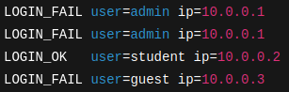

2. Create failed_counter.py. It should:
- Open login_log.txt.
- Loop through each line.
- Count how many lines have LOGIN_FAIL.
- Print:
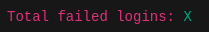

3. Bonus (if comfortable): Also count per user (e.g., admin: 2, guest: 1).
Deliverable: Screenshot of your script output.

