# Báo cáo thực hành Tuần 2

* Họ và tên: Đinh Hoàng Hải Đăng
* MSSV: 17100261
* Nhóm thực hành: 2 (Thứ 4 / Tiết 10-12)

## Bài 1

* Phương trình phân lớp: (Hàm trả về tỉ lệ phần trăm đi trễ tại một thời gian input)

def check_prob_late(min):  
 s = in_time_dict.get(min,0)  
 if s == 0:  
 return 0  
 else:  
 m = too_late_dict.get(min,0)  
 return s/(s+m)

Sử dụng hàm ở trên ta tìm khoảng thời gian quyết định chủ yếu việc đi trễ (>50%)

# find threadHold  
min = 101  
threadHole = -1  
for minute in range(16):  
 prob = check_prob_late(minute)  
 if abs(prob-0.5) < min:  
 min = abs(prob-0.5)  
 threadHole = minute

* Tỉ lệ đi trễ nếu rời nhà lúc 6:34, 6:35, 6:36, 6:37, 6:38:  
  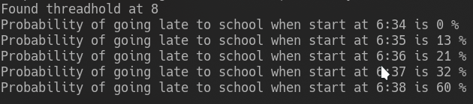

## Bài 2

* Lớp xử lý đặc trưng:

class Feature:  
 def __init__(self, data, name=None, bin_w=None):  
 self.name = name  
 self.bin_w = bin_w  
 if bin_w:  
 self.min, self.max = min(data), max(data)  
 bins = np.arange((self.min // bin_w) * bin_w,  
 (self.max // bin_w) * bin_w,  
 bin_w)  
 self.freq_dict = dict(zip(*np.histogram(data, bins)[::-1]))  
 else:  
 self.freq_dict = Counter(data)  
 self.freq_sum = sum(self.freq_dict.values())  
  
 def get_freq(self, value):  
 # P(x)  
 if self.bin_w:  
 value = (value // self.bin_w) * self.bin_w  
 return self.freq_dict.get(value, 0)

* Lớp tính độ tương quan (likelyhood):

class NaiveBayes:  
 def __init__(self, name, *features):  
 self.features = features  
 self.name = name  
  
 def prob_value_giving_feature(self, *feature_value):  
 '''  
 can be know as giving a feature how probability that value is in the giving feature  
 P(x | wi)  
 '''  
 result = 1  
 for f, fv in zip(self.features, feature_value):  
 if f.freq_sum == 0:  
 return 0  
 else:  
 result *= f.get_freq(fv) / f.freq_sum  
 return result

* Hàm phân lớp:

class Classifier:  
 def __init__(self, *nbClass):  
 self.nbClass = nbClass  
  
 def prob_feature_giving_value(self, data, best_only=True):  
 # P(wi | x)  
 prob_list = list()  
 for nbc in self.nbClass:  
 prob_list.append( (nbc.prob_value_giving_feature(*data), nbc.name) )  
 prob_sum = sum( [v[0] for v in prob_list] )  
 if prob_sum == 0:  
 # In case of not found  
 # Distribute evenly between every class  
 # This make sure the final result <= 1  
 number_class = len(self.nbClass)  
 prob_list = [ (1/number_class, name) for _, name in prob_list ]  
 else:  
 prob_list = [ (value/prob_sum, name) for value, name in prob_list ]  
  
 if best_only:  
 return max(prob_list)  
 else:  
 return prob_list

* Kết quả thu được:

Sử dụng đặc trưng chiều cao:  
(140,) (0.5, 'male')  
(200,) (1.0, 'male')  
(153,) (1.0, 'female')  
(188,) (1.0, 'male')  
(159,) (0.875, 'female')  
(160,) (0.6153846153846154, 'female')  
(180,) (0.5555555555555556, 'male')  
(150,) (1.0, 'female')  
(170,) (0.5384615384615385, 'female')  
  
Sử dụng đặc trưng tên:  
('Edgar',) (0.5, 'male')  
('Benjamin',) (1.0, 'male')  
('Fred',) (1.0, 'male')  
('Albert',) (1.0, 'male')  
('Laura',) (1.0, 'female')  
('Maria',) (1.0, 'female')  
('Paula',) (1.0, 'female')  
('Sharon',) (1.0, 'female')  
('Jessie',) (0.6666666666666667, 'female')  
  
Sử dụng đặc trưng tên + chiều cao:  
('Maria', 140) (0.5, 'male')  
('Anthony', 200) (1.0, 'male')  
('Anthony', 153) (0.5, 'male')  
('Jessie', 188) (1.0, 'male')  
('Jessie', 159) (0.9333333333333333, 'female')  
('Jessie', 160) (0.761904761904762, 'female')

* Nhận xét: Ta thấy rằng nếu chỉ dựa vào tên thì Jessie không được chia rõ ràng, khi ta kết hợp với đặc trưng chiều cao thì nếu Jessie cao 188cm thì đảm bảo người ấy là male, còn nếu càng thấp thì khả năng thành female càng cao.

## Bài 3

* Hàm tính mean:

def mean(arr):  
 if len(arr.shape) == 1:  
 return sum(arr)/len(arr)  
 return sum(mean(xi) for xi in arr)/len(arr)

* Hàm tính var:

def var(arr):  
 m = mean(arr)  
 return sum((xi - m)**2 for xi in arr)/len(arr)

* Kết quả:  
  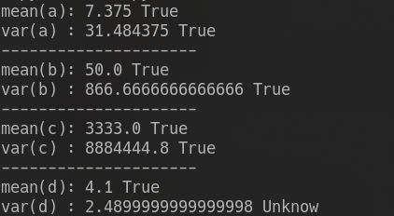

## Bài 4

* Hàm tính mean:

def mean(arr):  
 if len(arr.shape) == 1:  
 return sum(arr)/len(arr)  
 return sum(mean(xi) for xi in arr)/len(arr)

* Hàm tính cov:

def cov(dataset):  
 row, col = dataset.shape  
 mean_ar = list()  
 matrix_result = list()  
 for r in range(row):  
 mean_ar.append(mean(dataset[r]))  
 for r1 in range(row):  
 for r2 in range(row):  
 result = 0  
 for c in range(col):  
 result += (dataset[r1][c] - mean_ar[r1])*(dataset[r2][c] - mean_ar[r2])  
 matrix_result.append(result/(col-1))  
 return np.array([matrix_result]).reshape(row, row)

* Kết quả:  
  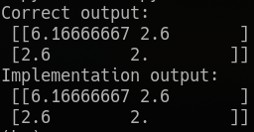

## Bài 5-6

* Plot kết quả:  
  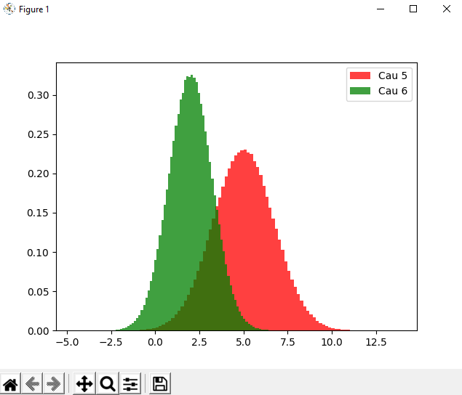
* Nhận xét: Hàm phân phối chuẩn của câu 6 hội tụ hơn của câu 5, hai hàm mật độ này giao nhau ở (3.75, 0.15)

## Bài 7

* Plot kết quả (với 3 điểm đỏ tương ướng với các điểm [0 0], [3 4], và [1 2]: 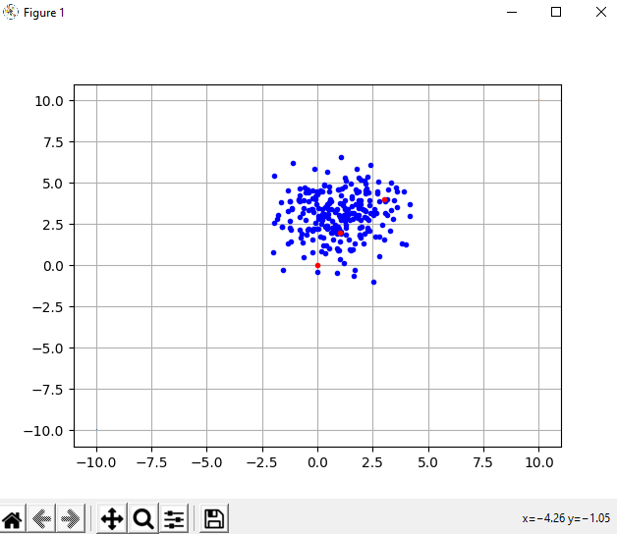
* Khoảng cách Mahalanobis:

Mahalanobis distance:  
[[3.00457555 0.62112092 1.49059994]  
 [3.61261148 1.46249739 2.06424028]  
 [1.34324352 2.42770063 0.91678538]  
 [1.29456559 2.46126083 0.90746535]  
 [1.66081174 2.48665952 0.74528775]  
 [2.21084808 2.05412458 0.89099893]  
 [2.85849621 0.812946 1.25597243]  
 [1.99239299 3.32038678 1.69383425]  
 [2.515939 1.8951884 1.11979934]  
 [2.44663813 1.34090819 0.83455611]  
 [2.2729228 3.25997646 1.79921411]  
 [4.02308408 0.91445625 2.61562287]  
 [2.51070354 1.32130413 0.90256961]  
 [1.60231268 2.03350861 0.04774629]  
 [3.03591539 0.78272342 1.42098496]  
 [2.59324146 1.00620813 1.03976986]  
 [1.64577781 2.83251979 1.08752195]  
 [3.9263172 0.96803622 2.31391308]  
 [1.74842565 1.94925121 0.1612879 ]  
 [2.32029463 2.13223987 1.05529177]  
 [1.67803162 1.96508336 0.07058076]  
 [0.63401059 3.26181002 1.22726597]  
 [2.62340526 1.32690106 1.02942415]  
 [2.12025314 2.23695123 0.9321168 ]  
 [3.09968305 3.17379121 2.26703213]  
 [1.49845879 2.26109488 0.29262164]  
 [3.3868615 2.44937384 2.14467148]  
 [4.27981693 0.74779656 2.75573217]  
 [2.58354294 1.6002744 1.06449409]  
 [4.20867022 1.17999287 2.59884583]  
 [2.25791468 1.51945004 0.65226383]  
 [2.74038849 1.14663906 1.44394583]  
 [4.03076531 0.45725078 2.44563742]  
 [3.09678968 3.15526729 2.25513008]  
 [3.7657253 1.35253007 2.19276275]  
 [2.53185638 1.80124009 1.09158824]  
 [1.6869087 2.77658347 1.0587273 ]  
 [0.78033888 3.57853129 1.83434294]  
 [2.49544139 3.7832747 2.28510229]  
 [2.24946595 1.47561932 0.99019012]  
 [2.70187695 3.57118574 2.25340841]  
 [3.3367751 1.90962551 1.91300186]  
 [1.55033796 3.07033088 1.2638441 ]  
 [3.46752005 1.59565449 1.95282526]  
 [3.26475987 2.23743837 1.96079294]  
 [3.1841877 0.96341107 1.86488498]  
 [1.64213159 2.06899149 0.14470095]  
 [2.85403658 0.76037844 1.34040852]  
 [3.61735143 0.57945135 2.17270686]  
 [2.16116395 3.58470621 1.97942606]  
 [2.45132179 1.81193905 1.54917327]  
 [2.32710028 1.95262425 0.95091544]  
 [4.04629237 1.22850864 2.44637806]  
 [3.6942917 1.17253744 2.41978506]  
 [2.31181926 2.08146936 1.01444462]  
 [4.13262045 0.54620655 2.57975982]  
 [2.07632115 1.6213486 0.85514421]  
 [3.14437628 0.5235468 1.54944968]  
 [2.4473109 1.17533661 0.8596986 ]  
 [2.84026443 0.91382458 1.22597401]  
 [1.63276408 1.96970595 0.22263094]  
 [2.41663631 1.7036132 0.91845274]  
 [3.79056616 0.34887146 2.27409797]  
 [2.83126192 0.79344056 1.24517842]  
 [1.50273372 2.2375345 0.25706329]  
 [1.6491482 4.28142624 2.3495831 ]  
 [1.76531252 2.22804435 0.55393321]  
 [2.67076914 1.24906893 1.06760791]  
 [3.07386527 0.5244169 1.52119407]  
 [2.25438151 1.48851568 0.64164029]  
 [3.44898595 1.63604797 1.94436285]  
 [2.84907843 0.74912378 1.30194666]  
 [1.86227202 2.30425568 0.73699337]  
 [2.28832075 1.47105787 0.67727428]  
 [2.10440928 2.55152326 1.77446156]  
 [2.63467 1.99267483 1.28676177]  
 [1.69556053 2.09576341 0.28699073]  
 [4.47113939 1.71635159 2.89543901]  
 [4.75322705 3.59050971 3.60998682]  
 [3.53107787 1.96881215 2.10535123]  
 [3.71922021 0.36356643 2.11658182]  
 [2.13595646 1.99790509 0.76768422]  
 [2.08550843 3.69774107 2.57012325]  
 [0.58461963 3.02721564 1.03150959]  
 [2.21096951 1.39919493 0.76606781]  
 [1.6471384 2.56522789 0.81940379]  
 [3.68575547 0.12214153 2.13450082]  
 [2.85086822 1.48435636 1.31579707]  
 [2.57735085 2.20666025 1.3421002 ]  
 [2.94660908 0.97062092 1.33216589]  
 [1.3210285 3.49704599 2.01347497]  
 [0.87975853 3.09467268 1.40242954]  
 [2.69956591 1.91498682 1.31478299]  
 [3.03205307 2.42244439 1.84124704]  
 [2.01946862 1.64534842 0.40478197]  
 [2.2114353 2.28458705 1.05414907]  
 [1.71776173 2.10146395 0.33004331]  
 [2.32170753 1.61632562 0.76581867]  
 [2.8128252 1.82706223 1.390419 ]  
 [4.74006979 1.64117446 3.13510058]  
 [0.89978887 2.81500619 0.78090215]  
 [3.10751671 0.82153377 1.49148636]  
 [2.77220392 1.91063374 1.38413359]  
 [2.53032756 2.42579656 1.42532254]  
 [4.25058145 0.65252394 2.68076378]  
 [3.87720546 1.592452 2.33411299]  
 [2.29115029 1.58130629 0.71359941]  
 [3.58739971 2.13709467 2.20472923]  
 [4.02230983 1.09546358 2.41384979]  
 [2.52021398 1.63593352 1.00736986]  
 [2.53720094 2.43474806 1.43636374]  
 [1.74768864 3.07933992 1.36917254]  
 [2.96168952 2.30785363 1.73015176]  
 [0.60182402 3.63609228 1.60197226]  
 [3.04831406 2.85245608 2.06216976]  
 [0.9427547 2.67360401 0.80586074]  
 [2.2289637 1.45803276 0.9266242 ]  
 [3.58662704 0.08697469 2.03712157]  
 [2.54558576 1.13165785 0.93579496]  
 [3.34496971 2.31967214 2.06001083]  
 [2.07819693 2.33379008 0.96824516]  
 [1.54511743 2.16074002 0.75119421]  
 [1.16867513 3.2562712 1.30326733]  
 [2.42798068 2.76530434 1.5577087 ]  
 [0.80924798 2.95694543 1.18254118]  
 [2.51512865 2.54204832 1.48268566]  
 [4.36960721 2.80027013 3.05320236]  
 [1.44405399 3.55208095 1.66452304]  
 [2.28160217 1.65442509 1.22546906]  
 [2.93419497 2.53676783 1.81567501]  
 [1.8912446 3.32409498 1.64694775]  
 [3.39614534 0.56394022 1.95023422]  
 [2.14643484 1.6644192 0.56397795]  
 [3.14553922 3.44907159 2.44752024]  
 [1.89219829 1.76555564 0.69320201]  
 [2.38492187 1.68405348 1.38008882]  
 [3.60788409 0.64207693 1.99201585]  
 [1.44811901 2.94379079 1.09259947]  
 [2.61549512 0.9829573 1.08024577]  
 [2.26728501 1.41239885 0.65296299]  
 [3.30258261 2.1347245 1.95614596]  
 [2.3473556 1.30982935 0.73964305]  
 [2.29467016 1.37377846 0.94364283]  
 [2.57067521 1.16427693 0.95482301]  
 [1.914949 1.744094 0.70555885]  
 [3.05976193 2.86781166 2.07844603]  
 [2.12679301 1.48164441 0.69407121]  
 [4.16349672 0.8238074 2.54911188]  
 [1.16745271 2.90815542 0.93818209]  
 [3.56339069 1.08289679 1.96587827]  
 [3.53442893 0.96741702 1.92795624]  
 [1.40999599 3.17970979 1.30825647]  
 [1.30829512 2.61896473 0.65918684]  
 [0.29931543 3.8302569 1.88201149]  
 [2.82629604 1.43604106 1.70996838]  
 [3.54127383 2.89199872 2.44786489]  
 [2.88791404 0.71430591 1.35352753]  
 [2.18887385 3.56316639 1.97672258]  
 [2.72849978 3.08672792 1.96759836]  
 [3.51318546 1.52580683 1.98158756]  
 [3.46517961 0.99285887 1.86091384]  
 [3.44756999 2.64294685 2.27110021]  
 [2.87769272 1.38351921 1.31866256]  
 [3.58970396 3.30076276 2.66714361]  
 [2.47905268 1.6922223 0.98450506]  
 [3.26246456 1.1052667 1.66833614]  
 [2.04028595 1.92263998 0.59207243]  
 [1.23370987 2.41346034 0.38640988]  
 [2.56647523 1.04527199 1.07416523]  
 [4.33395347 0.77385424 2.73962627]  
 [3.53566035 0.70373554 1.91961193]  
 [4.87573142 2.46014634 3.37747542]  
 [3.33146023 0.47603165 1.7246419 ]  
 [1.90392108 1.91598974 0.39288615]  
 [2.67266411 1.34882895 1.0888828 ]  
 [2.04610727 2.22332105 0.8477322 ]  
 [2.53918655 2.07451536 1.23537393]  
 [2.81408688 1.1135968 1.20439575]  
 [2.14935071 1.58597322 0.53885703]  
 [2.73659922 2.2560172 1.51036185]  
 [3.64069711 0.77191014 2.02532419]  
 [2.90656457 1.76579222 1.46047502]  
 [2.26864513 1.63153574 0.70652524]  
 [1.79952249 2.18061417 0.53920662]  
 [3.14720345 1.09127651 1.54943306]  
 [4.09139386 1.33959821 2.4995018 ]  
 [3.18276242 2.25718904 1.89805993]  
 [2.70635996 3.24581137 2.05056291]  
 [2.99651041 2.81530553 2.0047137 ]  
 [1.51964805 2.14297774 0.10921996]  
 [1.81785126 1.91131915 0.24571774]  
 [1.53794647 2.07376678 0.4652373 ]  
 [1.17873828 4.51025421 2.47779316]  
 [4.18696205 2.32633346 2.76828568]  
 [3.37492206 2.21914904 2.04868251]  
 [2.39736964 2.41388026 1.30582584]  
 [1.27192289 2.32733494 0.41067154]  
 [2.95850037 2.10959911 2.19594812]  
 [3.25243528 2.8470245 2.21114475]  
 [2.98829488 2.6910422 1.93510115]  
 [1.87672168 1.75763146 0.27717608]  
 [3.19550403 1.4613842 1.66070712]  
 [2.98054463 1.80084899 1.54473999]  
 [1.66045203 2.64353712 0.91030526]  
 [2.65669737 2.71704543 1.69687301]  
 [2.78279084 3.0823691 2.00134242]  
 [2.27747583 2.88781672 1.53601505]  
 [2.62138276 1.36244102 1.03492619]  
 [1.25514966 2.46249154 0.85305072]  
 [2.57565865 1.19501962 0.95990229]  
 [3.34882024 2.67028435 2.20508416]  
 [3.1614241 0.84276638 1.54620961]  
 [2.43923941 1.16109245 0.8869787 ]  
 [3.72978585 0.79304833 2.11443351]  
 [3.06882069 2.202724 2.3354014 ]  
 [1.29546379 3.24515355 1.78857411]  
 [2.39418461 1.469095 0.80105523]  
 [1.74868424 2.2500037 0.56088342]  
 [1.67552879 2.22887449 0.45083227]  
 [0.85245617 2.76840934 0.76376746]  
 [1.56939452 2.10679302 0.09059568]  
 [2.60237132 1.04466166 1.00251374]  
 [3.14754262 0.72211758 1.73016232]  
 [3.11794179 2.32668429 1.87121793]  
 [3.33517229 2.57626198 2.15431896]  
 [3.01218136 1.3192351 1.44547356]  
 [1.26289797 2.57125883 0.57551113]  
 [1.56706696 2.71706005 0.92465571]  
 [1.76910749 2.0705214 0.97596892]  
 [3.64510373 2.17227356 2.26528842]  
 [0.98016025 2.63792335 0.78219255]  
 [4.35265857 3.89808203 3.45466627]  
 [4.00328961 1.7063017 2.46954062]  
 [2.78437943 1.38661928 1.21984585]  
 [2.58970002 3.65533476 2.24683158]  
 [0.91224522 2.76120012 0.73159144]  
 [2.94583654 0.8709187 1.33006283]  
 [1.91138034 2.48022404 0.94600247]  
 [1.87278329 1.82256091 0.76582631]  
 [3.17495409 0.77165648 1.55885475]  
 [3.46924375 0.15284112 1.89512137]  
 [0.62563697 3.04277615 1.0207299 ]  
 [3.17611587 0.59929945 1.71610711]  
 [2.11451278 2.75007748 1.32237191]  
 [0.97681221 2.62544706 0.72322085]  
 [3.55400775 2.75192535 2.3988299 ]  
 [1.44863456 3.6707336 1.77174051]  
 [2.83083899 1.83829479 1.41249472]  
 [3.77221513 0.4193233 2.1668819 ]  
 [2.86610487 0.77474912 1.2729774 ]]

## Bài 8

* Thiếu hai tập dữ liệu class1.txt và class2.txt

## Bài 9

* Kết quả thu được:

*CLASS1:  
Feature1:  
 +Mean: 0.06218687500000001  
 +Var : 0.8717452837660599  
  
Feature2:  
 +Mean: 0.05867279999999998  
 +Var : 1.0685284890658253  
  
Feature3:  
 +Mean: 2.96126355  
 +Var : 3.039673866930216  
  
Feature4:  
 +Mean: 0.08500643333333335  
 +Var : 0.9921645930659284  
  
Covariance giữa Feature1 với Feature2 là:  
[[0.87174528 0.04184359]  
 [0.04184359 1.06852849]]  
  
Covariance giữa Feature1 với Feature3 là:  
[[ 0.87174528 -0.0425842 ]  
 [-0.0425842 3.03967387]]  
  
Covariance giữa Feature1 với Feature4 là:  
[[ 0.87174528 -0.07247153]  
 [-0.07247153 0.99216459]]  
  
Covariance giữa Feature2 với Feature3 là:  
[[1.06852849 0.05295708]  
 [0.05295708 3.03967387]]  
  
Covariance giữa Feature2 với Feature4 là:  
[[ 1.06852849 -0.07206057]  
 [-0.07206057 0.99216459]]  
  
Covariance giữa Feature3 với Feature4 là:  
[[ 3.03967387 -0.03565163]  
 [-0.03565163 0.99216459]]  
  
*CLASS2:  
Feature1:  
 +Mean: 0.06021218181818183  
 +Var : 0.8649525687273167  
  
Feature2:  
 +Mean: 0.0535757603305785  
 +Var : 1.0601799186312004  
  
Feature3:  
 +Mean: -0.03323852066115702  
 +Var : 1.019089111137485  
  
Feature4:  
 +Mean: -2.8515889752066115  
 +Var : 3.4766801685859914  
  
Covariance giữa Feature1 với Feature2 là:  
[[0.86495257 0.04081435]  
 [0.04081435 1.06017992]]  
  
Covariance giữa Feature1 với Feature3 là:  
[[ 0.86495257 -0.0217829 ]  
 [-0.0217829 1.01908911]]  
  
Covariance giữa Feature1 với Feature4 là:  
[[ 0.86495257 -0.12831742]  
 [-0.12831742 3.47668017]]  
  
Covariance giữa Feature2 với Feature3 là:  
[[1.06017992 0.02422017]  
 [0.02422017 1.01908911]]  
  
Covariance giữa Feature2 với Feature4 là:  
[[ 1.06017992 -0.12980585]  
 [-0.12980585 3.47668017]]  
  
Covariance giữa Feature3 với Feature4 là:  
[[1.01908911e+00 5.03602239e-05]  
 [5.03602239e-05 3.47668017e+00]]

* Plot histogram: 