南京信息工程大学 实验（实习）报告

|  |  |  |  |  |  |
| --- | --- | --- | --- | --- | --- |
| 日期 |  | 得分 |  | 指导教师 |  |
| 班级 |  | 学号 |  | 姓名 |  |

扩展欧几里得算法

1．实验目的：

1. 理解扩展欧几里得算法；
2. 实现扩展欧几里得算法并进行验证。

2．实验内容：

1. 实现扩展欧几里得算法；
2. 运行多个例子，验证两个数互素和不互素的情况。

3．Experiment Steps

3.1 Code（Python implementation）：

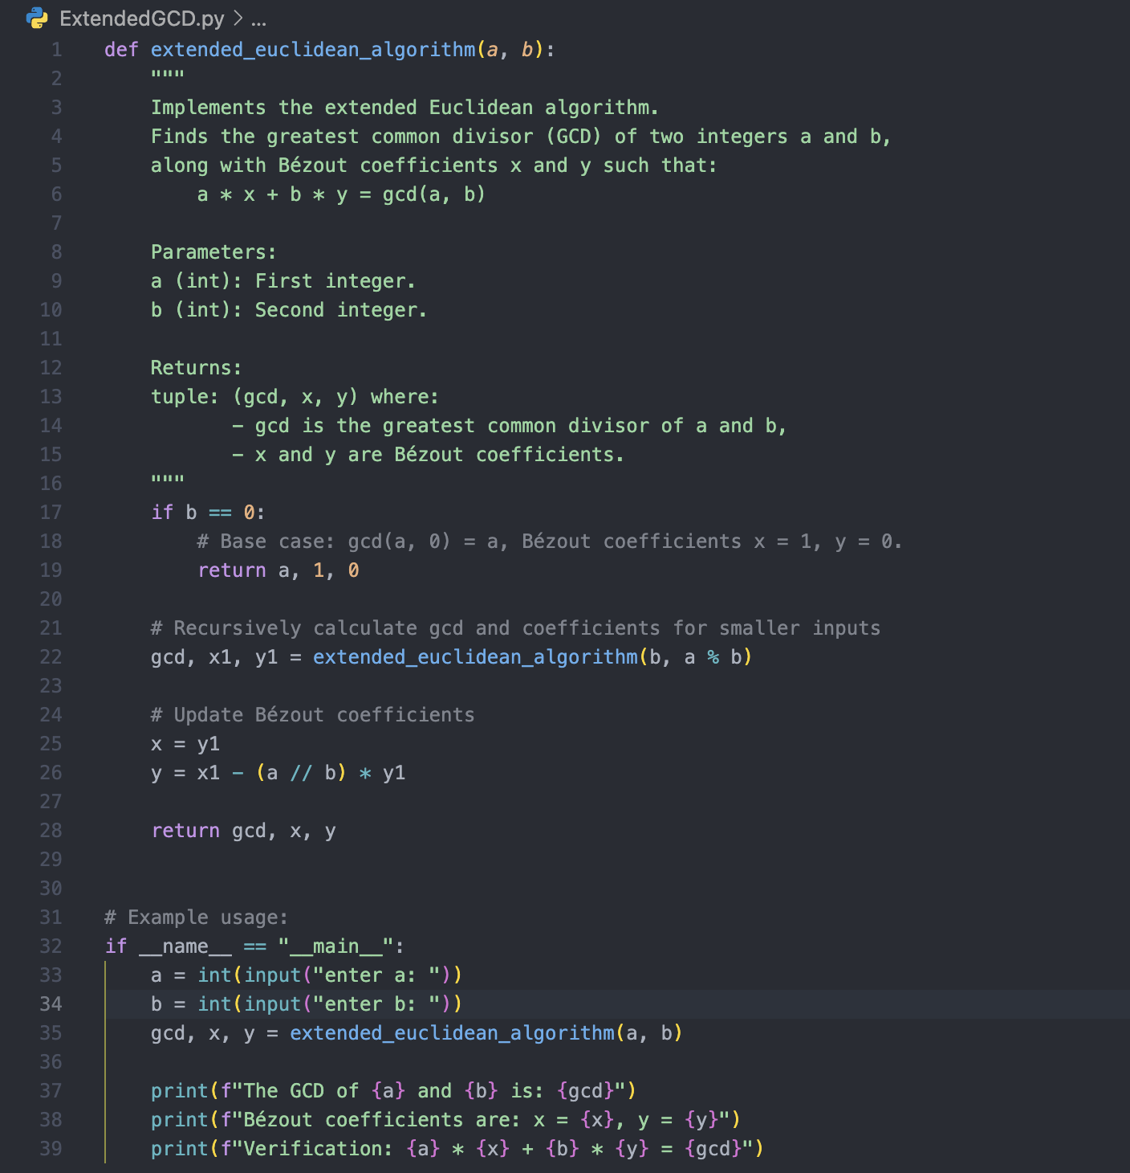

3.2 Program outcome：

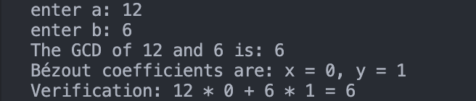

3.3 Program Introduction: Extended Euclidean Algorithm

This program implements the Extended Euclidean Algorithm, which calculates the greatest common divisor of two positive integers and , and finds the coefficients and that satisfy Bézout’s identity.

Bézout’s Identity:

$$X⋅a+Y⋅b=\text{gcd}\left(a,b\right)$$

Program Features:

1. Input:

The user enters two positive integers and .

2. Output:

• The greatest common divisor $\text{gcd}\left(a, b\right)$  of the two numbers.

• A unique solution(X, Y) that satisfies .

3. Verification:

• The program verifies that the results satisfy Bézout’s identity to ensure the correctness of the output.

4. $Experiment Analysis and Summary:$

$$The Extended Euclidean Algorithm is designed to solve the following problem:given two$$

$$positive integers a and b, not only compute their greatest common divisor \text{gcd}\left(a,b\right), but also$$

$$find a unique pair of integers \left(X,Y\right) such that:$$

$$X⋅a+Y⋅b=\text{gcd}\left(a,b\right)$$

$$Algorithm Principle:$$

$$According to the Euclidean algorithm, the greatest common divisor \text{gcd}\left(a,b\right) can be computed$$

$$using recursion:$$

$$\text{gcd}\left(a,b\right)=\text{gcd}\left(b,a mod b\right)$$

$$Using this relationship, we can derive a recursive solution for Bézout’s identity. The detailed$$

$$derivation is as follows:$$

$$a⋅x_{1}+b⋅y_{1}=\text{gcd}\left(a,b\right).$$

$a⋅x_{2}+\left(a mod b\right)⋅y_{2}=\text{gcd}\left(b,a mod b\right)$

$$x_{1}=y_{2}$$

$$y_{1}=x_{2}-\left(\frac{a}{b}\right)⋅y_{2}$$