南京信息工程大学 实验（实习）报告

RSA加密算法的实现与分析

1．实验目的：
- 掌握RSA算法流程
- 实现并应用RSA算法

2．实验内容：
- 实现RSA加解密算法
- 应用RSA对文件进行加密，并测试加密时间。

3．实验步骤
RSA加密算法的代码如下。此代码主要由两部分构成；大素数生成算法，以及加密算法。大素数生成算法允许用户输入一个值N，然后生成一个N位（对应的二进制位数为N）的大素数p和q。
import random
from random import randint

def proBin(w):
list = []
list.append('1')
for _ in range(w - 2):
c = random.choice(['0', '1'])
list.append(c)
list.append('1')
res = int(''.join(list),2)
return res

def X_n_mod_P(base, exponent, n):
bin_array = bin(exponent)[2:][::-1]
r = len(bin_array)
base_array = []

pre_base = base
base_array.append(pre_base)

for _ in range(r - 1):
next_base = (pre_base * pre_base) % n
base_array.append(next_base)
pre_base = next_base

a_w_b = __multi(base_array, bin_array, n)
return a_w_b % n

def __multi(array, bin_array, n):
result = 1
for index in range(len(array)):
a = array[index]
if not int(bin_array[index]):
continue
result *= a
result = result % n
return result

def MillerRabin(a, p):
if X_n_mod_P(a, p - 1, p) == 1:
u = (p-1) >> 1
while (u & 1) == 0:
t = X_n_mod_P(a, u, p)
if t == 1:
u = u >> 1
else:
if t == p - 1:
return True
else:
return False
else:
t = X_n_mod_P(a, u, p)
if t == 1 or t == p - 1:
return True
else:
return False
else:
return False

def testMillerRabin(p, k):
while k > 0:
a = randint(2, p - 1)
if not MillerRabin(a, p):
return False
k = k - 1
return True

def makeprime(w):
while 1:
d = proBin(w)
for i in range(50):
u = testMillerRabin(d+2*(i), 5)
if u:
b = d + 2*(i)
break
else:
continue
if u:
return b
else:
continue

dict = {'a':'31','b':'32','c':'33','d':'34','e':'35','f':'36','g':'37',
'h':'38','i':'39','j':'10','k':'11','l':'12','m':'13','n':'14',
'o':'15','p':'16','q':'17','r':'18','s':'19','t':'20','u':'21',
'v':'22','w':'23','x':'24','y':'25','z':'26','1':'41','2':'42',
'3':'43','4':'44','5':'45','6':'46','7':'47','8':'48','9':'49',
'0':'40',' ':'50'}
def transferToNum(str):
m = ""
for d in str:
m += dict[d]
return m

def transferTostr(num):
n = ""
for i in range(0,len(num),2):
n += {value:key for key,value in dict.items()}[num[i]+num[i+1]]
return n

def ext_gcd(a, b):
if b == 0:
x1 = 1
y1 = 0
x = x1
y = y1
r = a
return r, x, y
else:
r, x1, y1 = ext_gcd(b, a % b)
x = y1
y = x1 - a // b * y1
return r, x, y

def exp_mode(base, exponent, n):
bin_array = bin(exponent)[2:][::-1]
r = len(bin_array)
base_array = []

pre_base = base
base_array.append(pre_base)

for _ in range(r - 1):
next_base = (pre_base * pre_base) % n
base_array.append(next_base)
pre_base = next_base

a_w_b = __multi(base_array, bin_array, n)
return a_w_b % n

def __multi(array, bin_array, n):
result = 1
for index in range(len(array)):
a = array[index]
if not int(bin_array[index]):
continue
result *= a
result = result % n
return result

def gen_key(p, q):
n = p * q
fy = (p - 1) * (q - 1)
e = 65537
a = e
b = fy
x = ext_gcd(a, b)[1]

if x < 0:
d = x + fy
else:
d = x
print("公钥:"+"("+str(n)+","+str(e)+")\n私钥:"+"("+str(n)+","+str(d)+")")
return (n, e), (n, d)

def encrypt(m, pubkey):
n = pubkey[0]
e = pubkey[1]

c = exp_mode(m, e, n)
return c

def decrypt(c, selfkey):
n = selfkey[0]
d = selfkey[1]

m = exp_mode(c, d, n)
return m

if __name__ == "__main__":

print("输入数字N, 代表RSA算法中所用素数的位数, N应该足够大: ", end='')
N = int(input())
p = makeprime(N)
q = makeprime(N)
print("p的值是:",p)
print("q的值是:",q)
print()
print("所生成的公私钥信息如下")
pubkey, selfkey = gen_key(p, q)

print("3.输入明文, 支持小写英文字母和数字")
plaintext = str(input())
m = int(transferToNum(plaintext))

c = encrypt(m, pubkey)
print("密文:",c)

d = decrypt(c, selfkey)
print("明文:",transferTostr(str(d)))

代码的运行结果如图所示：
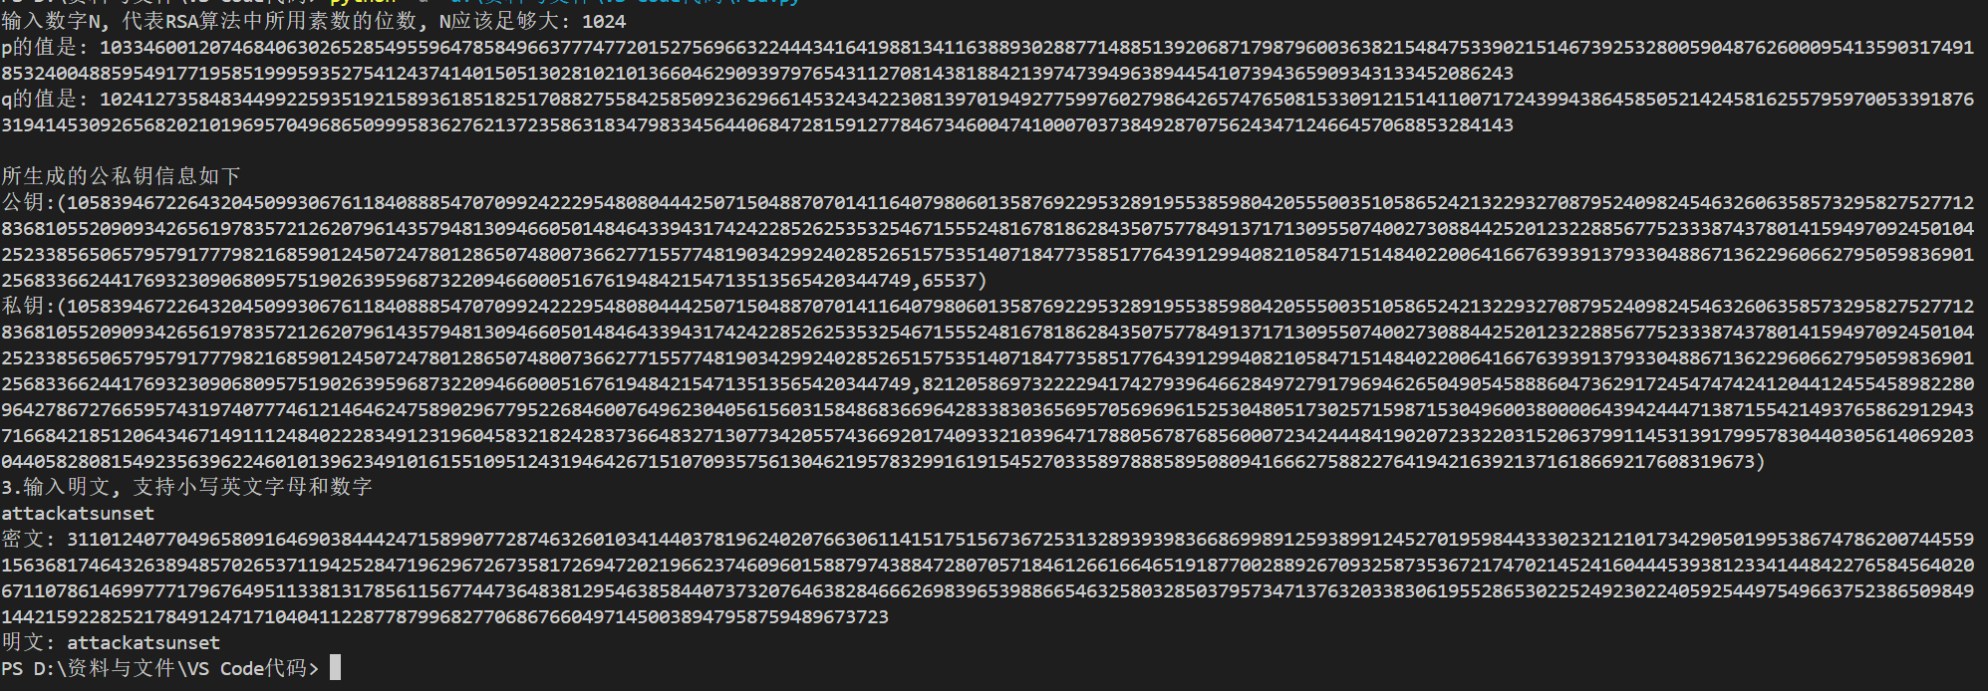
生成了如图所示的很长的素数p和q，并生成了公私钥对(pk, sk)。输入明文信息attackatsunset得到密文信息。经过解密，可以得到原本的明文信息。

4．实验分析和总结
通过本实验，掌握了RSA算法流程实现，并利用Python对RSA的流程进行了简单的实现。

