**Experiment 1: Potentiometer - Capacitor Circuit Experiment Report**

**Title**: Experimental Study of the Potentiometer - Capacitor Circuit

**Date**: 2024-12-6

**Name**: 徐安博 XU Anbo

**Student Number**: 202283890035

**I. Introduction and Purpose**

This experiment aims to explore the behavior of a simple RC (Resistor - Capacitor) circuit and understand its response to changes in input voltage. By using a linear potentiometer as a variable resistor in the circuit, the influence of the potentiometer on the charging and discharging rate of the capacitor is studied, and then the time constant and overall behavior of the circuit are analyzed.

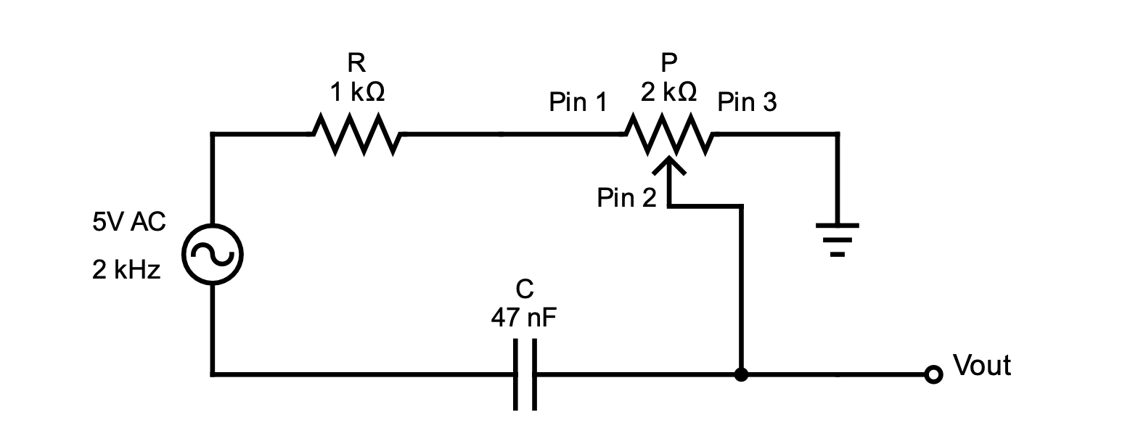

**II. Theory**

1. **Principle of the Potentiometer**
   * A potentiometer is a three - terminal resistor with an adjustable tap that can change the resistance value along its length. In this experiment, a linear potentiometer is used to change the resistance in the RC circuit, thereby controlling the charging and discharging rate of the capacitor.
2. **Related Theory of the RC Circuit**
   * In an AC circuit, the impedance of a resistor ZR = R∠0Ω (where R is the resistance value), and the impedance of a capacitor ZC = 1/(2πfC)∠ - 90Ω (where f is the frequency and C is the capacitance). For a series RC circuit, the current I = IR = IC is constant. The total impedance ZT = ZR + ZC = R - jXC (where XC is the capacitive reactance), the total source voltage VS = VR + VC, and VC = (ZC / (ZC + ZR))VS, VR = (ZR / (ZC + ZR))VS. VR is in phase with the current I, VC is out of phase with I by π/2 (90 degrees), VR "leads" VS, and VC "lags" VS. As the frequency increases, the capacitive reactance XC of the capacitor decreases, the total impedance Z decreases, and the phase angle θ decreases. The amplitudes and phase angles of VR and VC are both frequency - dependent.

**III. Experimental Methods and Results**

1. **Experimental Methods**
   * **Experimental Equipment**: Signal generator, digital oscilloscope, linear potentiometer (10kΩ), resistors (2kΩ, 1kΩ), capacitor (47nF), etc.
   * **Experimental Steps**
     + **Part 1: Setup and Measurement**
       - Connect the circuit according to the circuit diagram, and use the signal generator to provide a 5V AC signal with a frequency of 2kHz.
       - Add probes with a digital oscilloscope to measure the peak - to - peak voltage VP across pins 1 and 2 of the potentiometer and the peak - to - peak voltage VC across the capacitor.
       - Starting from the potentiometer at 0% (leftmost), take 6 readings of VP and VC at regular intervals until 100% (rightmost).
       - Repeat the above process with the AC signal frequency set to 2kHz, 5kHz, 10kHz, 20kHz, 50kHz, and 100kHz respectively.
       - For each frequency, plot the relationship curve between VP and VC on the same graph.
     + **Part 2: Multisim Simulation**
       - Set up the same circuit as the actual circuit in Multisim, and use an AC source to provide a 5V signal with a frequency of 1kHz.
       - Add voltage probes to measure the peak - to - peak voltage VP across the potentiometer and the peak - to - peak voltage VC across the capacitor, and set them to periodic measurement to display the peak - to - peak voltages.
       - Place a reference pin on the negative side of each component and set the voltage probes to the corresponding reference.
       - Start the simulation in interactive mode and ensure its normal operation.
       - Starting from the potentiometer at 0.5% (leftmost), take 6 readings of VP and VC until 100% (rightmost).
       - Repeat the above process with the AC signal frequency set to 2kHz, 5kHz, 10kHz, 20kHz, 50kHz, and 100kHz respectively.
       - For each frequency, plot the relationship curve between VP and VC.
     + **Part 3: AC Sweep Simulation**
       - Set the potentiometer to 0.5% and run the AC sweep simulation to generate a graph of the circuit's response and determine the cutoff frequency (the cutoff frequency fc = 1/(2πRC), defined as the frequency at which the output voltage is equal to - 3dB (or 70%) of the input voltage).
       - Repeat the AC sweep with the potentiometer set to 100% to determine the cutoff frequency and thus obtain the full adjustable frequency range of the circuit.
2. **Experimental Results and Discussion**
   * **Measurement Data Recording** (Here, a table can be filled in according to the actual measurement data, including VP, VC, etc. data at different frequencies).
   * **Graph Analysis**
     + As the resistance value of the potentiometer changes, the values of VP and VC change accordingly. At a lower frequency, the capacitive reactance of the capacitor is relatively large, and the voltage division effect is obvious, so VC is relatively large; as the frequency increases, the capacitive reactance of the capacitor decreases, and VR relatively increases.
   * **Result Analysis**
     + The experiment basically achieved the purpose of exploring the behavior of the RC circuit. However, due to the limitations of the measurement instrument's accuracy and some parasitic parameters in the circuit, there is a certain deviation between the measurement results and the theoretical values. For example, when calculating the cutoff frequency, the actual measurement value may not be completely consistent with the theoretical calculation value. By carefully evaluating the measurement errors in the experiment, such as the accuracy of the oscilloscope in measuring voltage and the stability of the signal generator's frequency, improvements can be made to the experiment. For example, using a higher - precision measurement instrument, ensuring the stability of the circuit connection, and reducing the influence of parasitic capacitance and inductance.

**IV. Conclusion**

Through this experiment, the behavioral characteristics of the potentiometer - capacitor circuit under different frequency inputs are deeply understood, including the control effect of the potentiometer on the charging and discharging of the capacitor and the voltage distribution and phase relationship in the circuit. At the same time, through the comparison and analysis of the experimental results and the theory, the error sources in the experiment are recognized, and improvement measures are proposed, providing a valuable reference for further research and application of RC circuits.