1. Creating and Renaming Files/Directories
- Create a directory named test_dir using mkdir.
Command – mkdir test_dir
- Inside test_dir, create an empty file called example.txt.
Command – touch test_dir/example.txt
- Rename example.txt to renamed_example.txt using mv
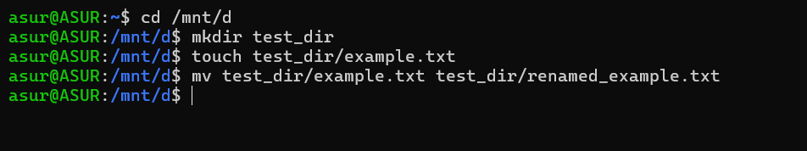
Command – mv test_dir/example.txt test_dir/renamed_example.txt

2. Viewing File Contents
- Use cat to display the contents of /etc/passwd.
Command – cat passwd
- Display only the first 5 lines of /etc/passwd using head.
Command – head -n 5 passwd
- Display only the last 5 lines of /etc/passwd using tail.
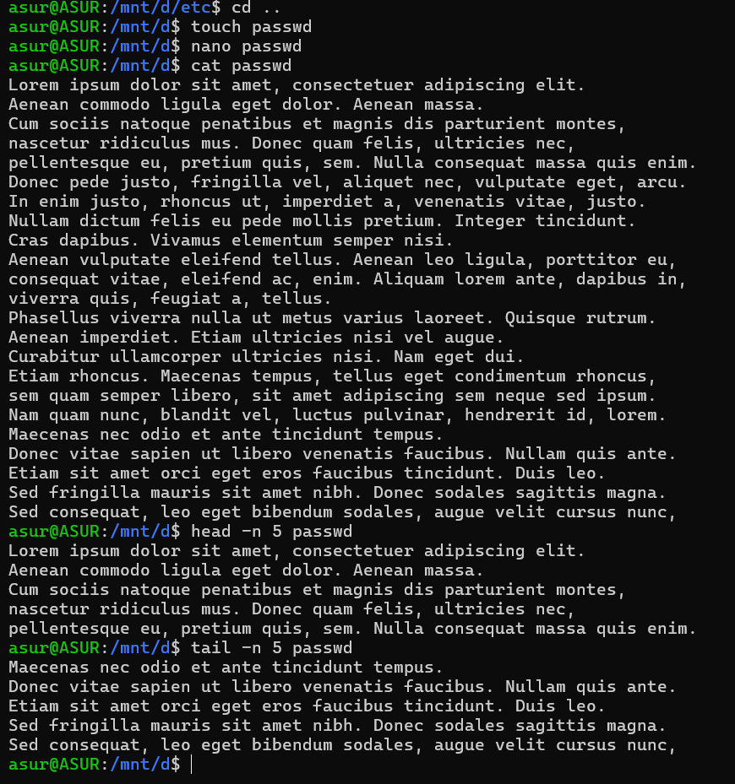
Command – tail -n 5 passwd

3.Searching for Patterns
- Use grep to find all lines containing the word "root" in /etc/passwd.
Command – grep root passwd
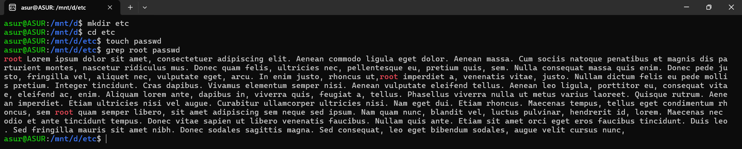
4. Zipping and Unzipping
- Compress the test_dir directory into a file named test_dir.zip using zip.
Command – zip -r test_dir.zip test_dir
- Unzip test_dir.zip into a new directory named unzipped_dir.
Command – mkdir unzipped_dir
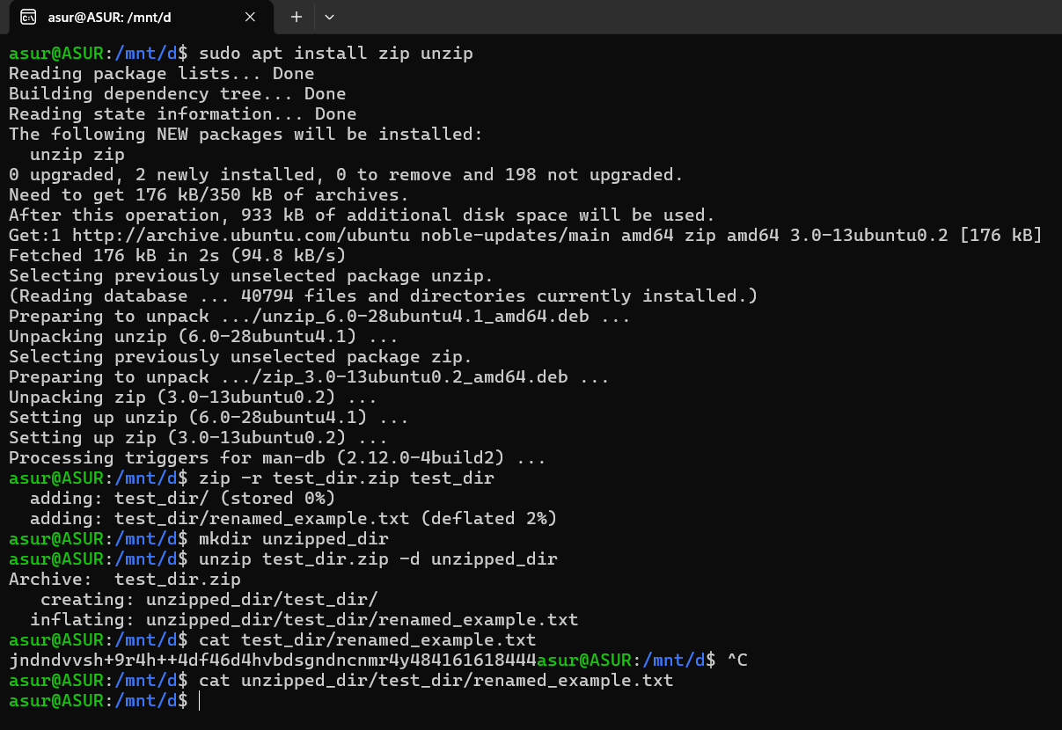
Unzip test_dir.zip -d unzipped_dir

5. Downloading Files
- Use wget to download a file from a URL (e.g., https://example.com/sample.txt).
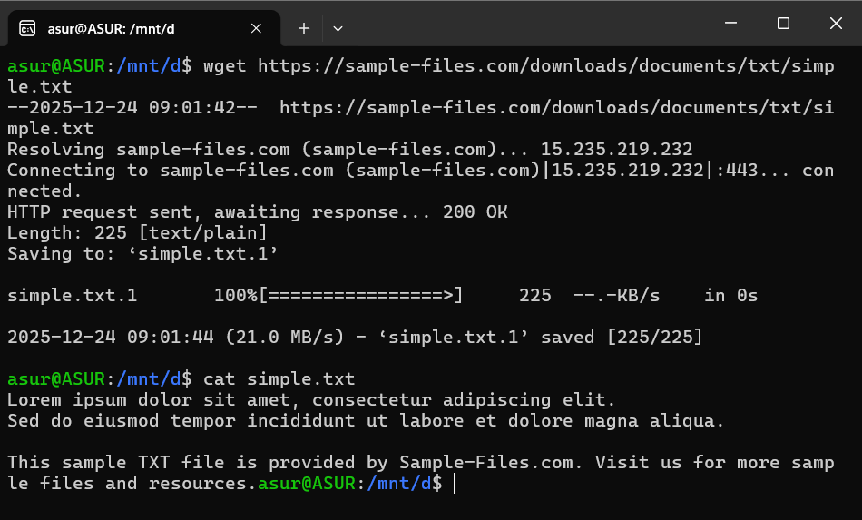
Command – wget https://sample-files.com/downloads/documents/txt/simple.txt

6. Changing Permissions
- Create a file named secure.txt and change its permissions to read-only for everyone using chmod.
Command - touch secure.txt
chmod 444 secure.txt
“4” is used for Read Permission only and “444” denotes Read-only for owner, group and others
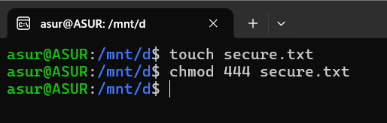

7. Working with Environment Variables
- Use export to set a new environment variable called MY_VAR with the value "Hello, Linux!".
Command - export MY_VAR=”Hello, Linux!”
echo $MY_VAR
“export” sets an environment variable for current session.
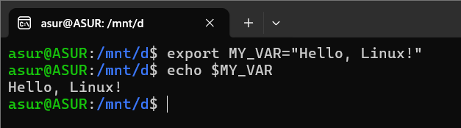

Submission Guidelines -: Attach Screenshots or command along with explanation and submit in doc(google doc or microsoft doc) format also attach github repo link

Github Repo Link - https://github.com/xabc60541-web

