1. Create a new GitHub repository.
- Clone the repository to your local machine using SSH (generate an SSH key if needed, add the public key to your GitHub account).
- Create a new branch named after your username (e.g., Tutedude).
- Add your Flask project files to this branch.
- Commit the changes and merge the branch into the main branch.
Step 1 – Create a new github Repo and get the SSH url
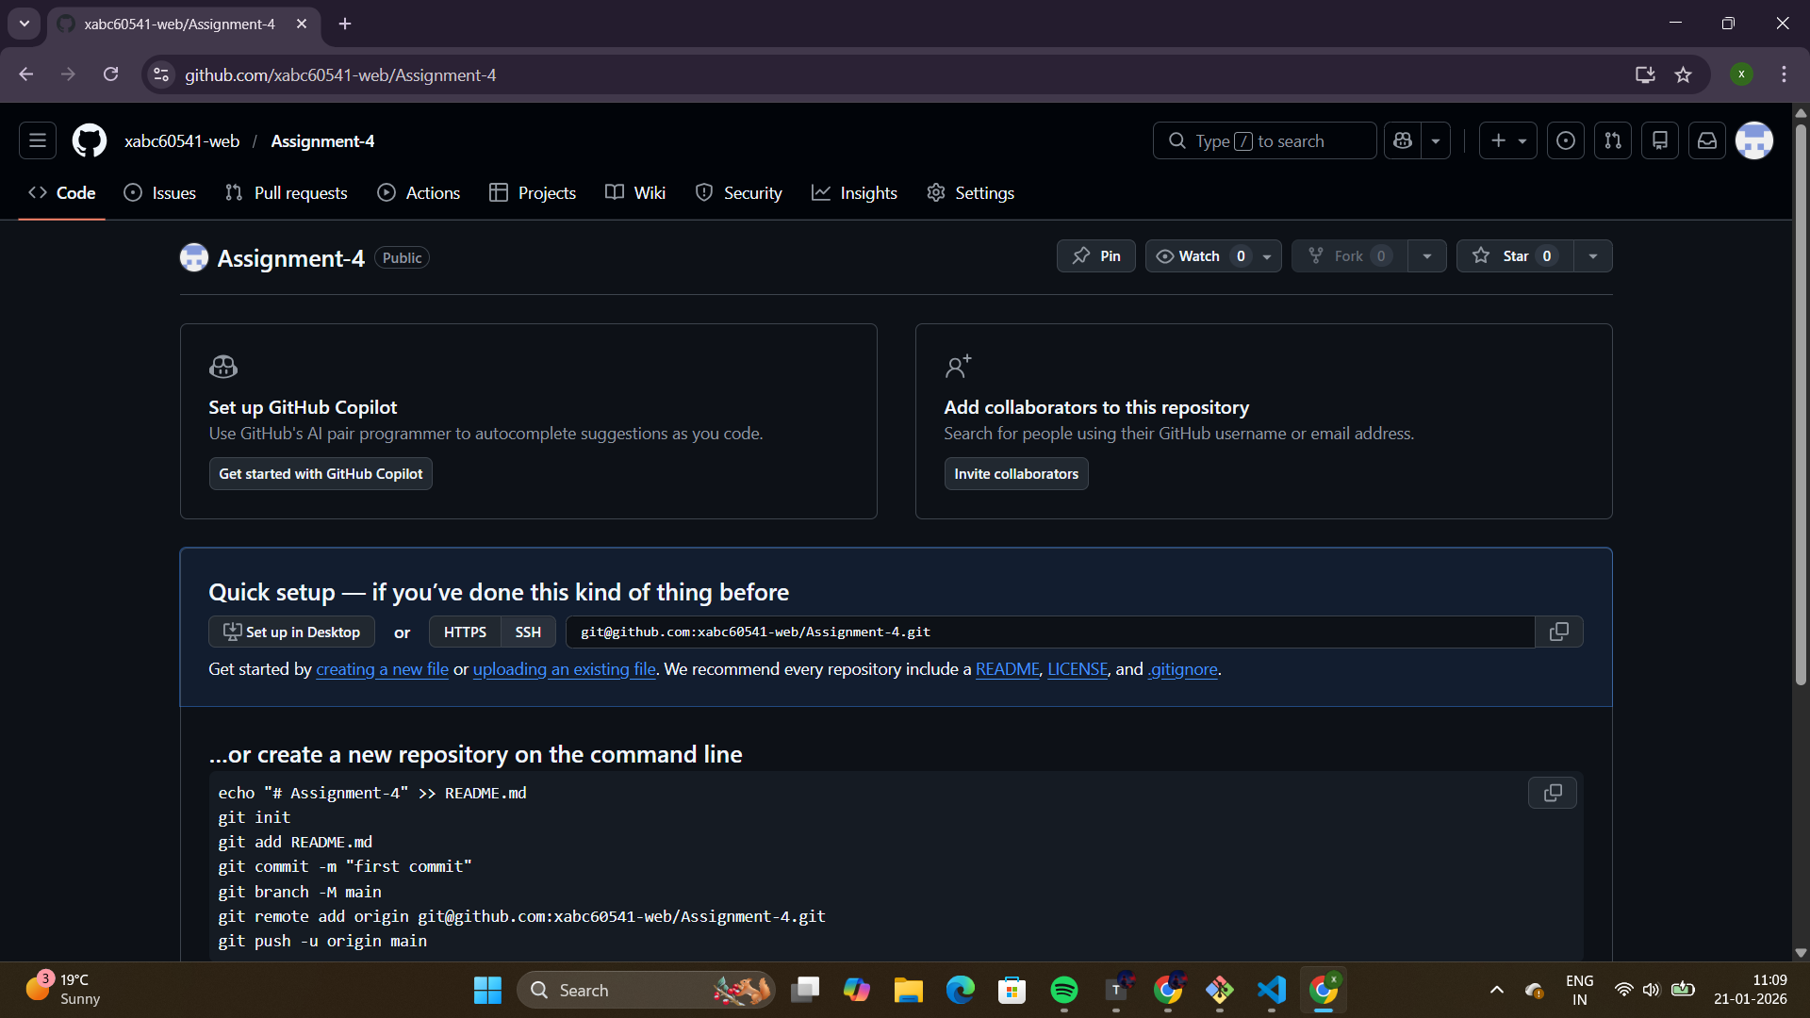
Step 2 – Generate a SSH key
  - Generate SSH key
ssh-keygen -t ed25519 -C “xabc60541@gmail.com”
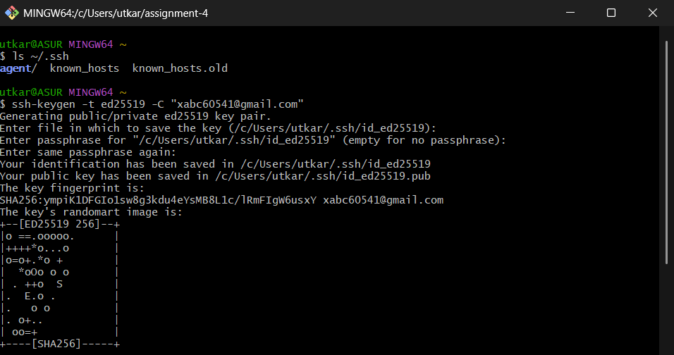
  - Start SSH agent
eval “$(ssh-agent-s)”
ssh-add ~/.ssh/id_ed25519
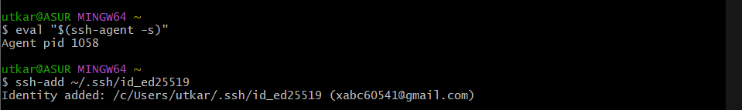
  - Copy the public key
cat ~/.ssh/id_ed25519.pub
  - Copy the out from above command and add it to github setting using the SSH keys
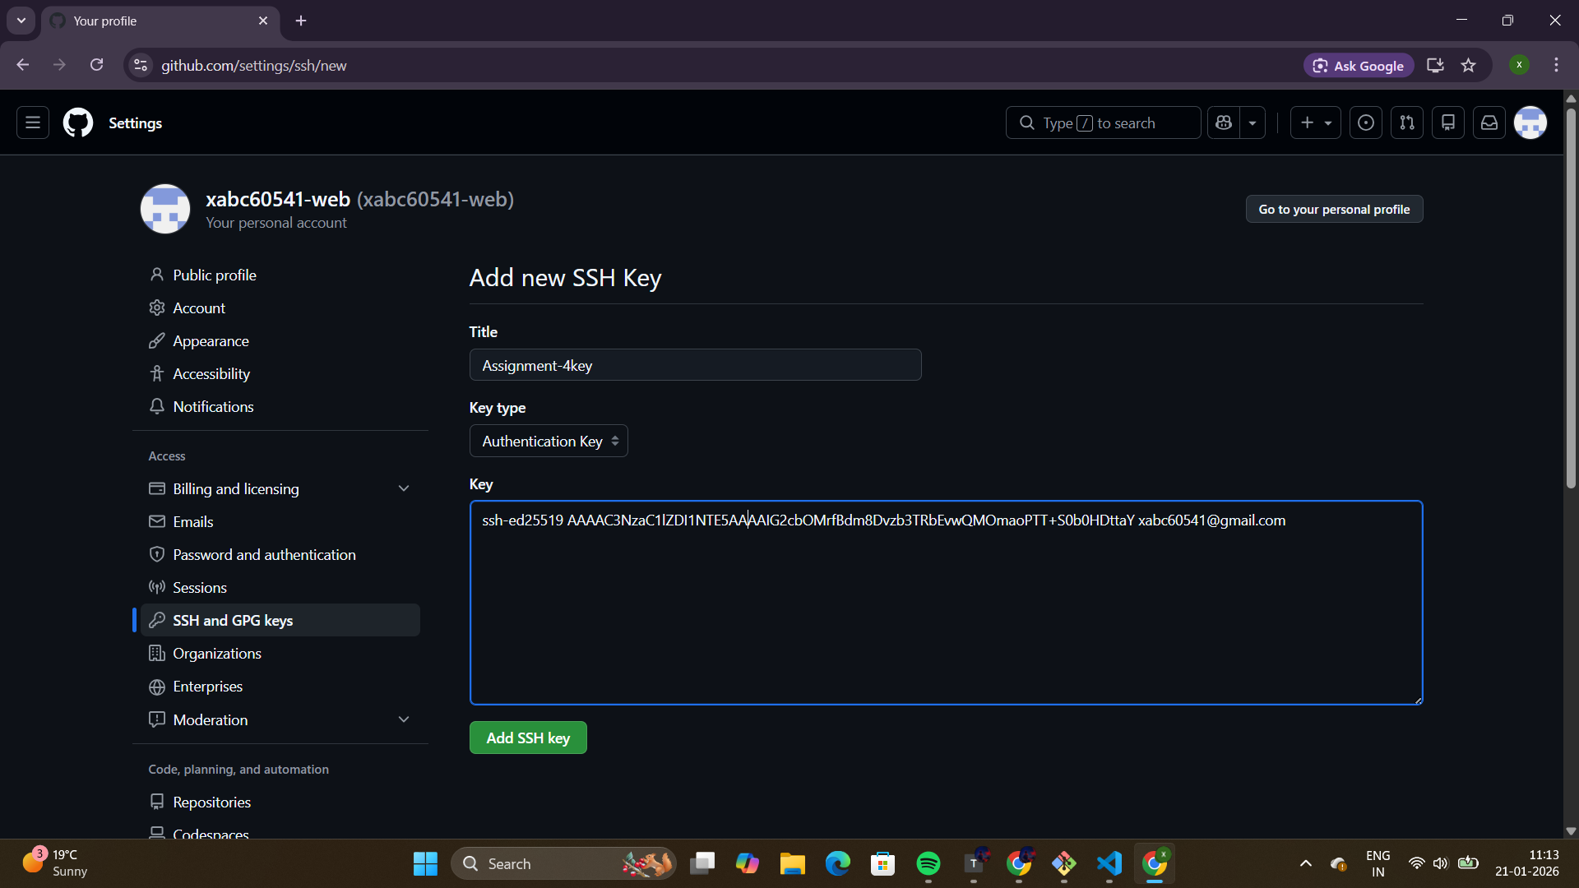
  - Test SSH
ssh -T git@github.com
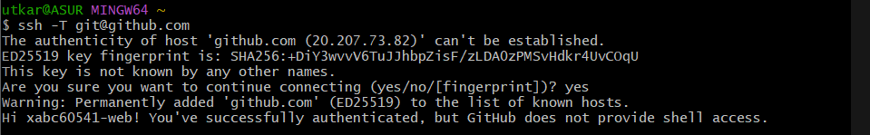

Step 3 – Clone the repo created in first step
git clone git@github.com:xabc60541-web/Assignment-4.git
cd Assignment-4
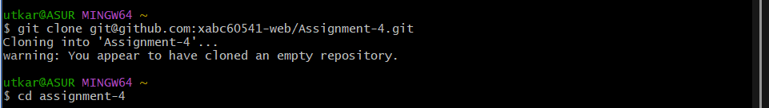
Step 4 – Copy all the Project files to clone repo
Step 5 – Create a branch
git checkout -b utkarsh
Step 6 – Add, commit and push to github
git add .
git commit -m “Added initial flask Login project”
git push -u origin utkarsh
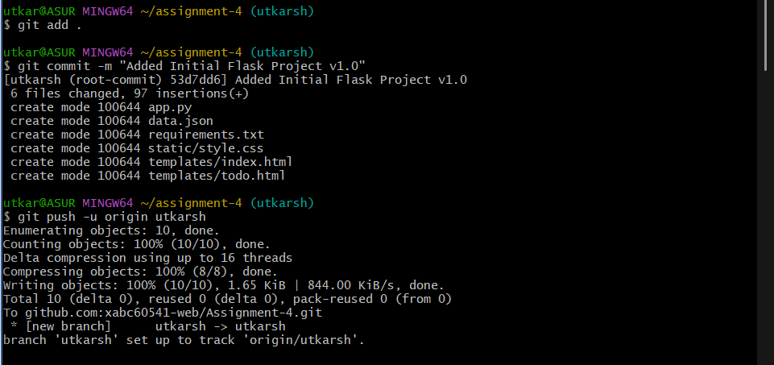

Step 7 – Merge the branch to main
If main branch not created automatically
git branch -m main
push the main branch to github
git push -u origin main
Now, merge the utkarsh branch to main
git checkout -b utkarsh
git push -u origin utkarsh
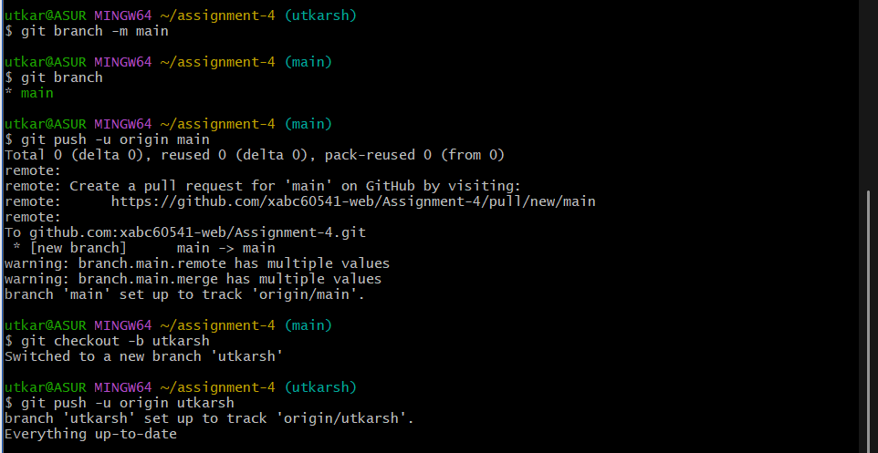
Step 8 – Everything done, verify the files in the github.
