2. Create a new branch named <your_name>_new (e.g., Tutedude_new).
- Update the content of the JSON file used for the /api route in this branch.
- Merge the <your_name>_new branch into the main branch.
- If there are conflicts during the merge, resolve them by accepting the changes from the <your_name>_new branch.
- Add the resolved changes to the staging area, commit them, and push the updates to the remote repository.
Step 1 – Switch to main branch
git checkout main
verify:
git branch
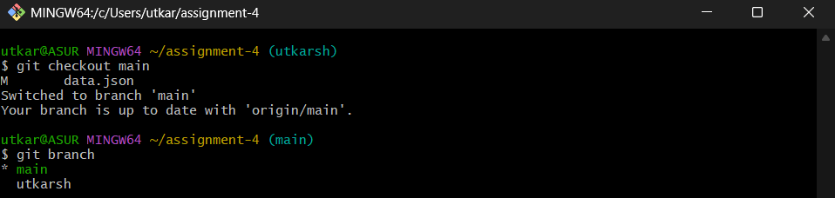
Step 2 – Create a new Branch
git checkout -b utkarsh_new
Step 3 – Update some files in our project, consider data.json
Before
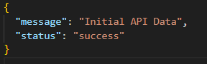
After
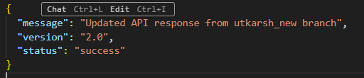

Step 4 – Commit changes in utkarsh_new
git add data.json
git commit -m “Updated json file”
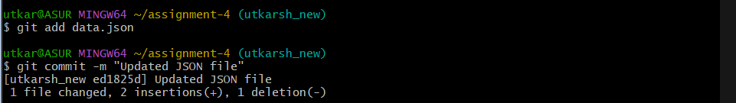
Step 5 – Merge utkarsh_new into main
git checkout main
git merge utkarsh_new
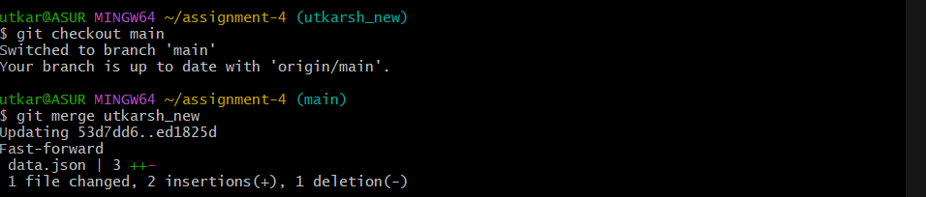
Step 6 – Push the main branch to github
git push origin main
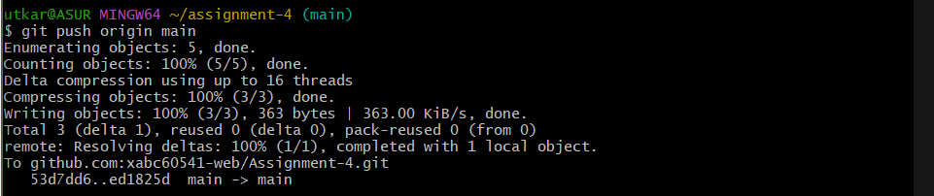

Step 6 – Verify it on github
