3. Branch Creation:
- Create two branches: master_1 and master_2 from the main branch.
- Feature Development in master_1:
- In the master_1 branch, create a To-Do Page in the frontend.
  - The page should contain a form with the following fields:
    - Item Name
    - Item Description
- Backend API in master_2:
- In the master_2 branch, create a backend route named /submittodoitem.
- This route will:
  - Accept itemName and itemDescription via a POST request.
  - Store these details in a MongoDB database.
- Merging Changes:
- Merge the changes from both master_1 and master_2 into the main branch.
Step 1 – Create 2 branches from main
First branch
git checkout main
git checkout -b master_1
Back to main and Second branch
git checkout main
git checkout -b master_2
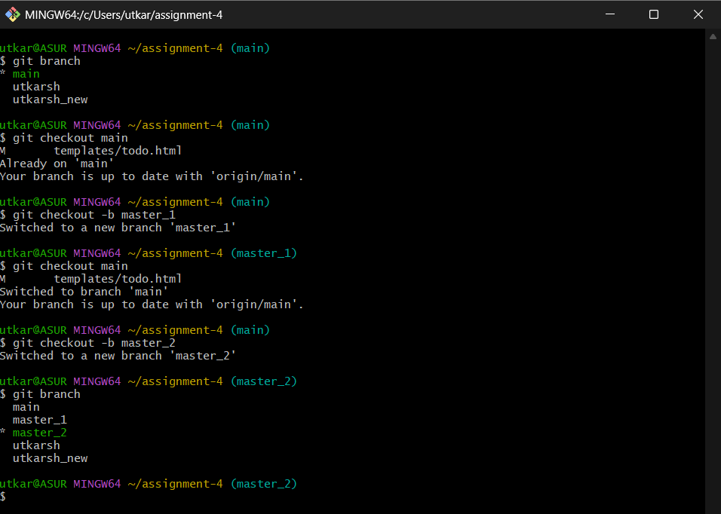
Step 2 – Add a feature in todo list in the first branch
git checkout master_1
Initial
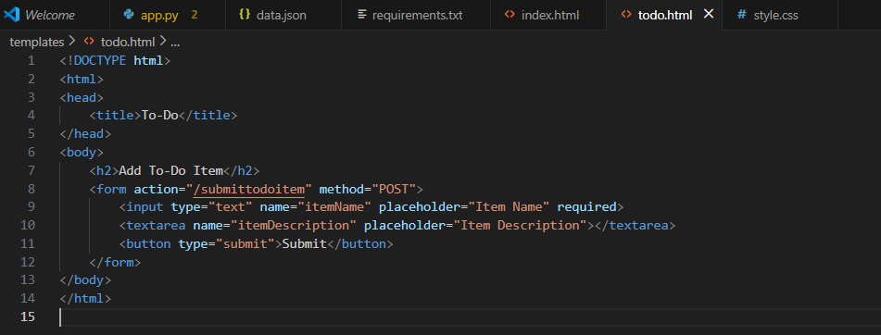

New
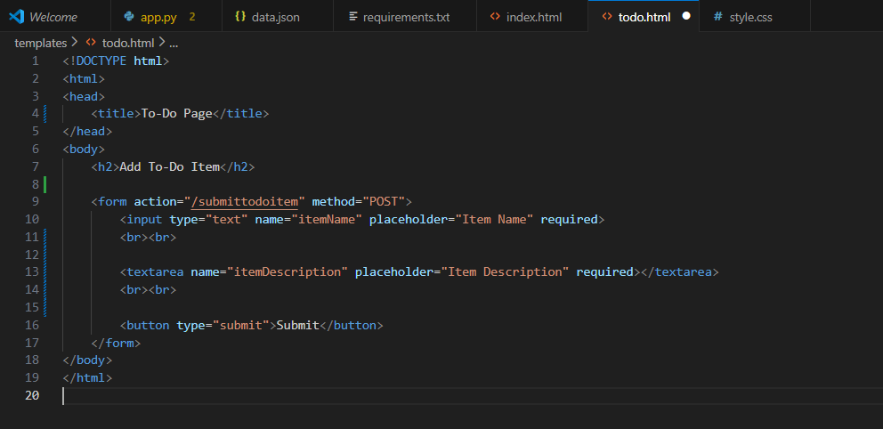
Commit Frontend changes
git add templates/todo.html app.py
git commit -m “New frontend”
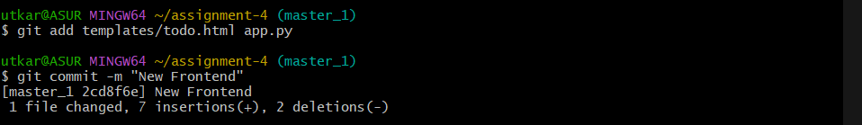
Step 3 – Backend API in master_2
git checkout master_2
Commit Backend Changes
git add app.py
git commit -m “Backend changed”
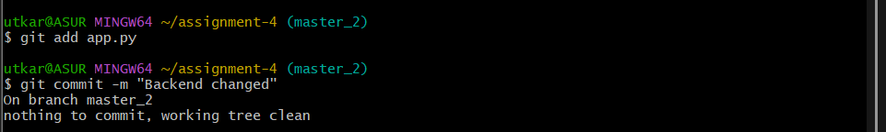
Step 4 – Merge both branches to main
Merge master_1 to main
git checkout main
git merge master_1
Merge master_2 to main
git merge master_2
Commit Final changes
git push origin main
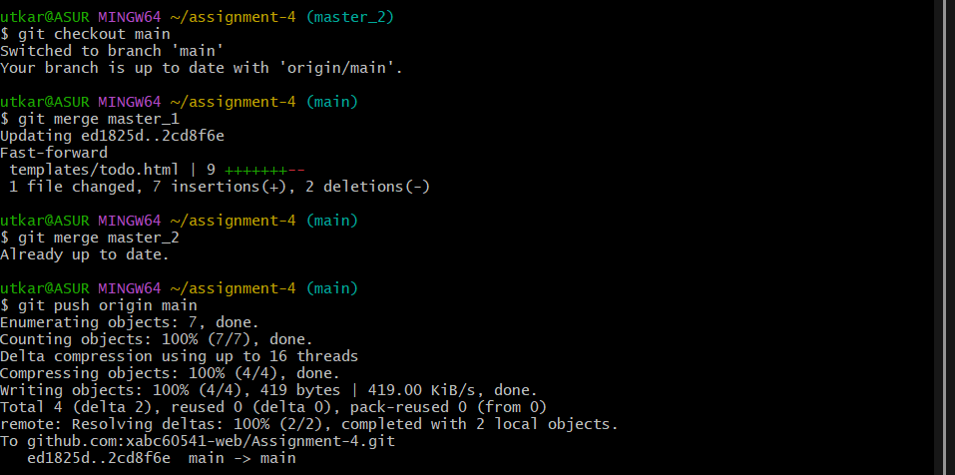
Step 5 – Verify on GitHub
