4. Enhancing the To-Do Form in master_1:
- In the master_1 branch, add the following fields to the To-Do form:
  - Item ID
  - Item UUID
  - Item Hash
- Committing in Sequence:
- Add and commit each field separately in the following order:
  - First commit: Add Item ID field.
  - Second commit: Add Item UUID field.
  - Third commit: Add Item Hash field.
- Merging to main:
- Merge the master_1 branch into the main branch.
- Git Reset and Commit Deletion:
- In the main branch, use Git Reset to roll back to the commit where only the Item ID field was added.
- Use git reset --soft to ensure changes remain staged.
- Re-commit this state to the main branch.
- Merge this updated state to the main branch.
- Rebasing Changes:
- Rebase the updated changes in the main branch to the master_1 branch.
Clarification:
  - During rebasing, preserve individual commits to maintain the commit history for each change (i.e., do not squash commits).
  - Use git rebase main master_1 to integrate changes from the main branch back into the master_1 branch.

Step 1 – Add fields to the todo list
    - Item ID Field
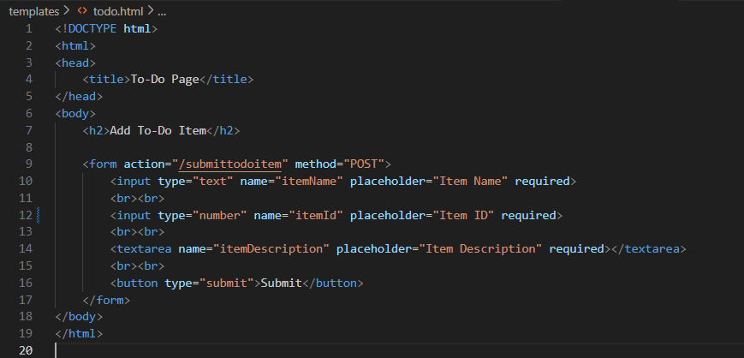
Commit the changes (1st commit)
git add templates/todo.html
git commit -m “Added Item ID field to to-do form”
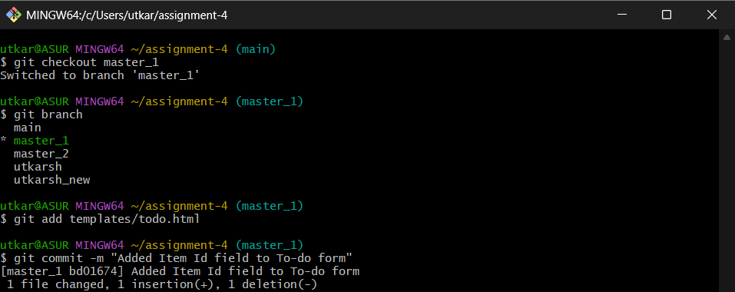

    - Item UUID Field
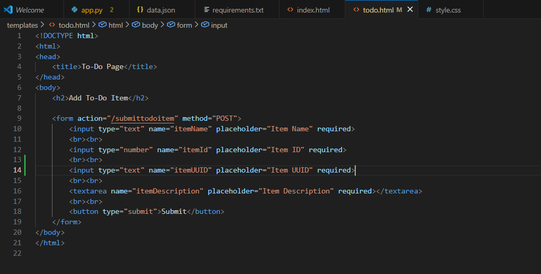
Commit the changes (2nd commit)
git add templates/todo.html
git commit -m “Added Item UUID field to to-Do form”
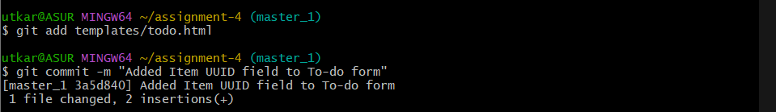
    - Item Hash Field
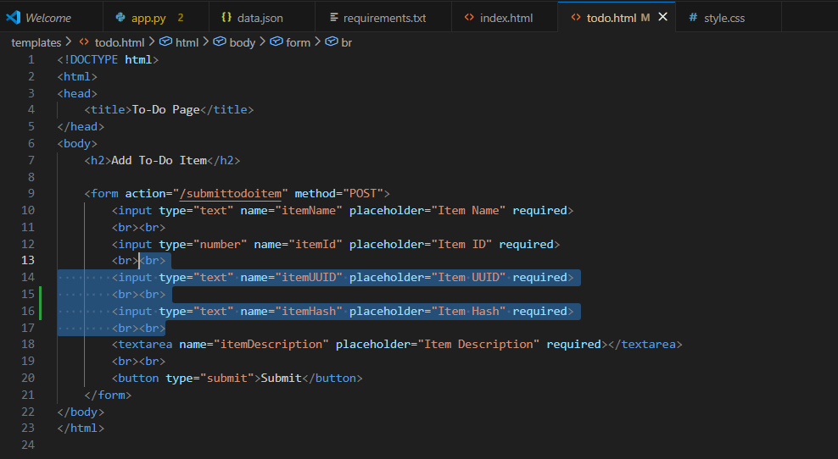
Commit the changes (3rd Commit)
git add templates/todo.html
git commit -m “Added Item Hash field to to-Do form”
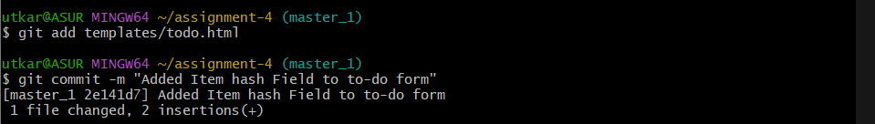
Step 2 – Merge master_1 to main and push
git checkout main
git merge master_1
git push origin main
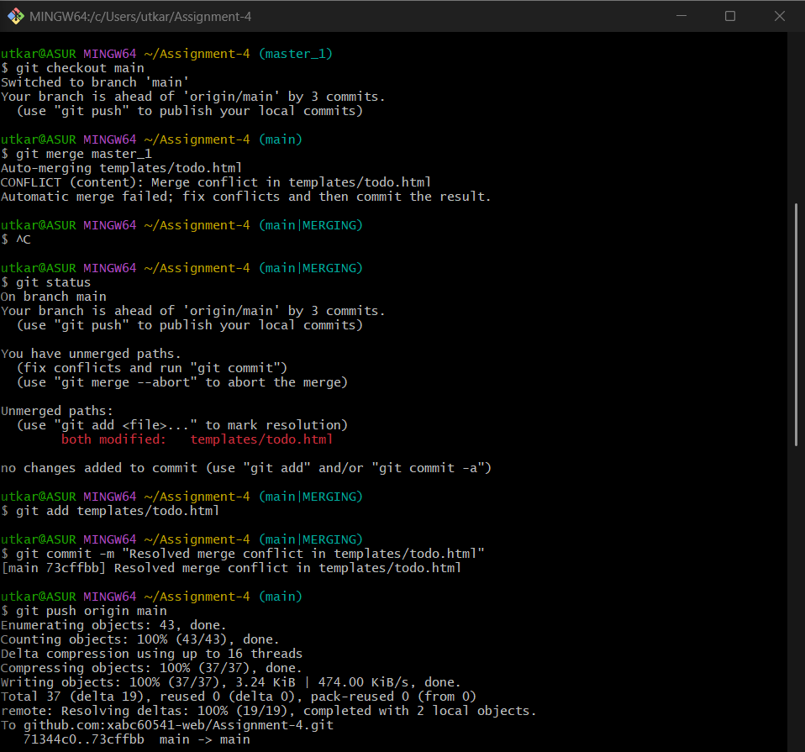

Step 3 - Git reset (roll back to item id only)
git log - -oneline
git reset –soft 8444d14
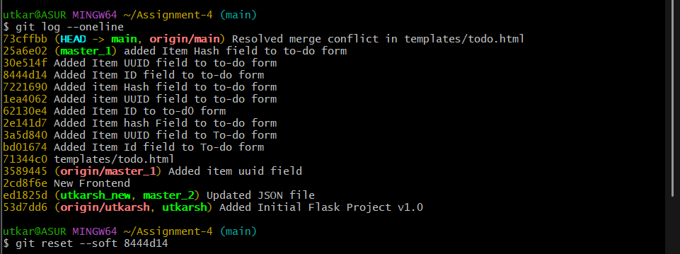
Step 7 – Recommit this state
git commit -m “Reset to-do form to item id field only”
git push origin main –force
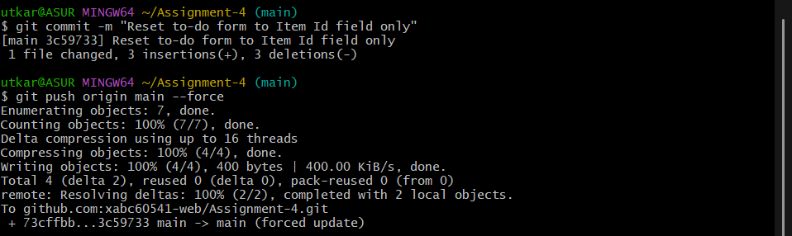
Step 8 – Rebase main to master_1 without squashing
git checkout master_1
git rebase main
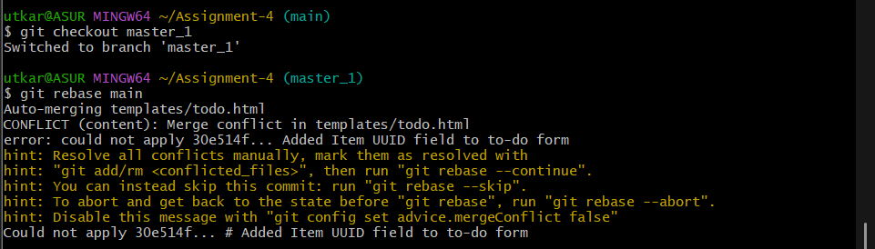
Here we face error of both modified, where we need to check
git status
To solve this issue, Open the todo.html and remove the incoming parts.
Then,
git add templates/todo.html
git rebase --continue
git push origin master_1 --force
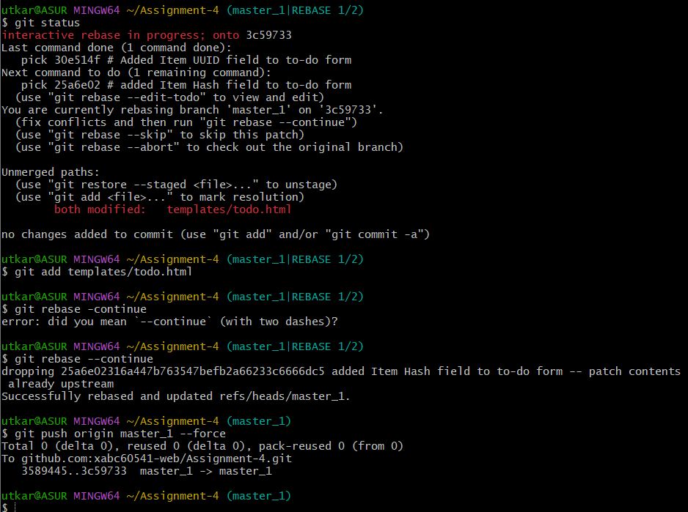

Final github image
