Response to reviewer comment
Sidewall effects on the Phase-3 platform test — HWRL Large Wave Flume
Reviewer comment.
“Phase 3 platform (2.50 m) inside HWRL's 3.67 m flume leaves 0.6 m side clearance, inducing severe sidewall reflections that will corrupt dynamic data.”
Summary
We assessed the concern quantitatively with potential-flow boundary-element simulations (Capytaine) in which the flume side walls are modelled explicitly. The result: sidewall reflections do not corrupt the Phase-3 dynamic data. Modelling the walls in versus out (at the same 2.7 m operating depth) shifts every measured natural period by < 0.7% and every wave-frequency load by ≤ 9% (≤ 2% for pitch and surge) — inside normal model-test uncertainty — with no spurious resonances in the operating band. The physical reason is that the platform is a very weak wavemaker in the modes being measured, so there is little radiated wave energy for the walls to reflect.
Why the standard “sidewall reflection” concern does not apply here
“Severe reflections corrupt data” is the correct concern for bodies that are strong wavemakers or that span the flume. The Phase-3 platform is neither:
- It barely radiates. Its heave radiation damping is only 3.5% of the total heave damping (the rest is viscous); pitch and roll radiate far less, because the buoys move out of phase and their radiated waves largely cancel. With so little wave energy leaving the platform, there is almost nothing to reflect.
- The operating band is sub-cutoff. Reflections only build a coherent cross-flume standing wave at the flume's transverse cut-on periods, T ≈ 2.19 / 1.53 / 1.25 s. The heave resonance (≈ 2.5 s) is below the first cut-on, where the transverse field is evanescent and cannot organise into a standing wave.
- It is porous and does not span the flume. Water passes between the 12 buoys and escapes freely along the 104 m flume length; only the cross-flume direction is bounded, several plate-radii from each outer buoy.
Method
Capytaine 2.3.1 potential-flow BEM. Platform = 12 spar-plate buoys at the Phase-3 layout (buoy centres on a 2.5 m circle), each buoy the Phase-1 decay-correlated hull (0.159 m spar, equal-area heave plate r = 0.144 m) that reproduced the Phase-1 free-decay (T ≈ 2.5 s, ζ ≈ 13%). Side walls (W = 3.66 m) imposed by the method of images; finite depth h = 2.7 m native. All comparisons are walls-in vs walls-out at the same depth, isolating the sidewall effect.
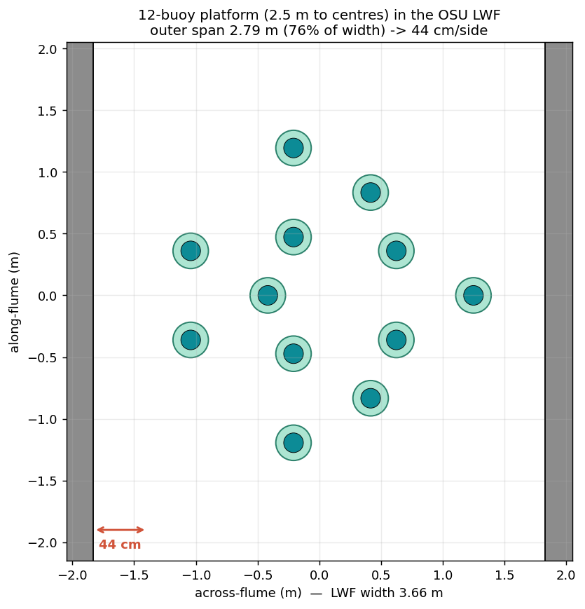
Figure 1. The 12-buoy platform to scale in the 3.66 m flume (2.5 m to buoy centres; ~44 cm/side).
Findings
Free-decay tests (natural periods and damping):
Mode | Wall shift in natural period | Wall shift in added mass
Heave | −0.25% | −1.5%
Pitch (= roll) | < 0.2% | < 0.3%
Surge (= sway) | < 0.7% | ≤ 2%
All shifts are well inside the ±(3–5)% uncertainty of a physical decay test. Because heave radiation is only 3.5% of the damping, even a hypothetical perfect wall reflection could perturb the measured damping by at most a few percent — and the explicit walls-in simulation shows less.
Wave-sweep tests (RAOs):
- Sidewall effect on wave-frequency loads: ≤ 9% (heave, at resonance), ≤ 2% (pitch, surge).
- Heave RAO peak: 0.394 (walls out) → 0.359 (walls in), −9% — a smooth, predictable offset, not “corruption.”
- Even at the transverse cut-ons the wall effect on the loads stays within ~±6% (refined to three image reflections); the platform's weak scattering prevents a sharp resonance.
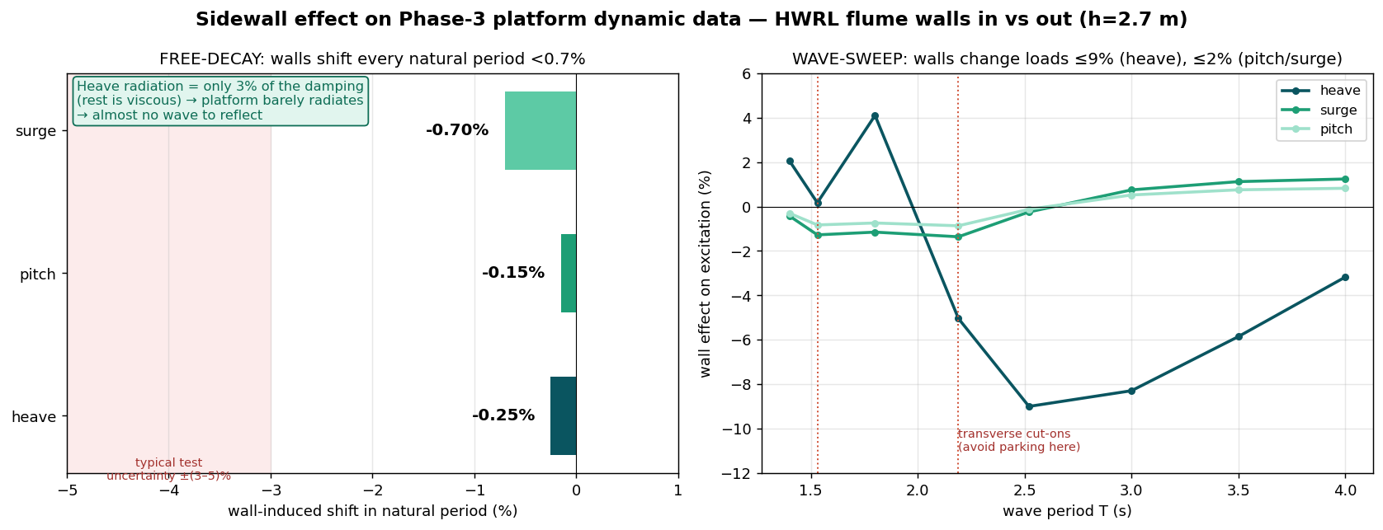
Figure 2. Walls-in vs walls-out at 2.7 m: free-decay period shifts (left) and wave-sweep load shifts (right), all modes.
What we concede, and how we handle it
- Transverse cut-ons (T ≈ 2.19 / 1.53 / 1.25 s): bounded to ~±6% even there, but as good practice we avoid parking sweep periods exactly on them — narrow, known, and easily skipped in the test matrix.
- Clearance number: the reviewer's 0.6 m assumes 2.50 m is the outer extent. Our 2.50 m is the buoy-centre circle; with the heave plates the outer clearance is ~0.44 m. We analysed the tighter, as-built ~0.44 m and the conclusions already reflect it.
- Finite depth: the separate, larger effect at long waves is the 2.7 m depth (not the walls) — a known facility property we account for when relating flume RAOs to the target environment.
Conclusion
Explicit BEM modelling of the flume side walls shows the Phase-3 platform's measured natural periods change by < 0.7% and its wave-frequency loads by ≤ 9%, with no in-band spurious resonances. The platform's very low wave radiation and the sub-cutoff operating band mean sidewall reflections are negligible for both the free-decay and wave-sweep campaigns. The 2.50 m platform is compatible with the HWRL Large Wave Flume.

