• Article •
Title
Author Author ¹， Author Author ²， Author Author ¹， Author Author ^{1*}
1. Department of xxxxxxxx, University of xxxxx, xxxx, CA 94804, USA
2. Department of xxxxx xxxxx, University of xxxx, xxxxx, CA 94804, USA
* Corresponding author， xxxxx@xxx.xxxx
Received: 10 October 2018 Accepted: 18 December 2018
Supported by xxxxxxxxxxxxxxxxxxxx.

Abstract Background This work aims to build a comprehensive and effective fire emergency management system based on the Internet of Things (IoT) and achieve an actual intelligent fire rescue. A smart fire protection information system was designed based on the IoT. A detailed analysis was conducted on the problem of rescue vehicle scheduling and the evacuation of trapped persons in the process of fire rescue. Methods The intelligent fire visualization platform based on the three-dimensional (3D) Geographic Information Science (GIS) covers project overview, equipment status, equipment classification, equipment alarm information, alarm classification, alarm statistics, equipment account information, and other modules. The live video accessed through the visual interface can clearly identify the stage of the fire, which facilitates the arrangement of rescue equipment and personnel. The vehicle scheduling model in the system primarily used two objective functions to solve the Pareto Non-Dominated Solution Set Optimization: emergency rescue time and the number of vehicles. In addition, an evacuation path optimization method based on the Improved Ant Colony (IAC) algorithm was designed to realize the dynamic optimization of building fire evacuation paths. Results The experimental results indicate that all the values of detection signals were significantly larger in the smoldering fire scene at t=17s than the initial value. In addition, the probability of smoldering fire and the probability of open fire were relatively large according to the probability function of the corresponding fire situation, demonstrating that this model could detect fire. Conclusions The IAC algorithm reported here avoided the passages near the fire and spreading areas as much as possible and took the safety of the trapped persons as the premise when planning the evacuation route. Therefore, the IoT-based fire information system has important value for ensuring fire safety and carrying out emergency rescue and is worthy of popularization and application.

Key words Smart fire protection information system; Internet of things; Rescue vehicle scheduling; Optimal evacuation routes

1. Introduction
In recent years, fire hazards have been increasing yearly, and various safety factors have been interwoven and infiltrated, leading to an even more enormous fire safety (FS) pressure^{[1‒3]}. However, the people have put forward higher expectations and requirements than ever for social management innovation and service optimization, including fire protection (FP) work. Social public FP usually has weak fundamental strength but faces many complex supervision objects, which brings tremendous pressure to fire management (FM) work. The concept of Smart Earth has attracted the attention of various industries and fields since its proposal. Immediately, smart cities, smart water conservancy, and SFP (Smart Fire Visualization Information Platform) were proposed one by one^{[4,5]}. SFP has become a new idea and path to solving urban FS’s dilemma. The urban SFP system constructed using technologies such as fire Internet of Things (IoT), Geographic Information System (GIS), and FP Big Data (BD) can effectively integrate all social forces, monitor urban fire hazards in real-time, scientifically grasp urban fire hazards, furnish accurately scientific early-warning and judgment, and systematically build an urban fire prevention and control (FPC) system to ensure urban safety. Under the background of the current Smart City (SC), BD, Cloud Computing (CC), Mobile Internet, GIS, and other technologies are combined with the public security network (the fire information network and the command and dispatch network), border access platforms, and public security Police GIS. In this way, it is possible to realize command, scheduling analysis, and decision-making for firefighting and rescue through one graph^{[6]}.
Most traditional fire monitoring and decision-making (FMDM) systems using the Client/Server structure can only perform artificial tracking and management, failing to realize the remote monitoring (RM) and management of the FP status of each building and equipment state in time and accurately^{[7‒9]}. The three-dimensional (3D) digital urban FP information system based on CC and the IoT can provide fire departments with comprehensive information on fire resource management, central hidden danger management, plan management, auxiliary decision-making, video surveillance, and building structures^{[10]}. It can excavate and make full use of the value of information resources, meet the needs of government departments, enterprises and institutions, and all sectors of society for fire-fighting resource information in various forms, and improve the fire-fighting resource information service. While maintaining the particularity of each city, the SFP information system pays attention to overall prevention and control, presents diversified development, and is synchronized with the construction of Smart City (SC). IoT, CC, and other technical means to achieve intelligent operation, alarm, prevention, and control and management are of great significance in standardizing urban fire management and improving supervision efficiency^{[11]}. Current approaches to applying Spike-based robust continuum learning to real-world decision-making tasks without costly trial-and-error can be divided into two main categories. One is the strategy of directly imitating human experts through imitation learning. The other is to train the policy in a simulator and then adapt it to the real world.
The SFP information system realizes the omnidirectional digital fusion of the presentation of project management, safety behavior identification, RM, and emergency rescue (ER). The infrared fire detector sends sound and light early warning immediately after the disaster. Then, the intelligent construction platform analyzes and identifies the disaster data, forms instructions, directly transmits them to the command center for comprehensive evaluation of the disaster situation, starts the emergency rescue plan, and quickly organizes intellectual multi-arm equipment to carry out rescue^{[12,13]}. Typically, resource layout planning is completed before an emergency occurs. Since the specific resource scheduling problem is an implementation process in emergency management, the timeliness of dispatching transportation will directly reflect the timeliness of emergency management. When a fire occurs, the time rescue vehicles arrive at the accident scene directly affects the timeliness of rescue. Therefore, the path planning of emergency rescue and the dispatch of emergency rescue vehicles now determine the ability and effect of fire rescue. It is imperative for the emergency plan information system to efficiently and accurately formulate the optimal evacuation path for the trapped personnel and ensure the safe evacuation of the personnel.
According to the above-mentioned actual needs, an IoT-based emergency plan information system is designed to dispatch rescue vehicles and the emergency plan for trapped persons during a fire rescue. Firstly, the construction and application of the intelligent fire visualization platform based on 3D Geographic Information Science (GIS) are expounded, and an FMDM (fire monitoring and decision-making) system is proposed based on IoT. The main advantage of the algorithm is high execution efficiency. In addition, the dispatching problem of emergency rescue vehicles under different emergency needs is discussed to achieve rapid response in a fire emergency. The main innovation of the research is that an emergency plan optimization method based on an improved Ant Colony Algorithm is designed through the visualization method of the fire emergency plan to dynamically optimize the building fire emergency plan.

2. Related work

2.1 Small form-factor pluggable information system
The SFP came into being in the context of FP needs in the new era. SFP is an integral part of SC construction, mainly reflected in four aspects: smart prevention and control, smart management, smart operations, and smart command^{[14]}. Its application field covers all scenarios requiring FPC, such as public buildings, commercial buildings, real estate communities, and entertainment venues, especially in production enterprises with high risks, including factories of petroleum, chemical, flammable, and explosive materials. Entering the BD era, the continuous development of the computer technology revolution has significantly impacted the operation mode of each industry and provided technical support for the innovation of FP business^{[15]}. Menon and Vishnu-Menon^{[16]} pointed out that the intelligent FM system applies high-end technologies such as GIS, Wireless Communication Technology, Global Positioning System (GPS), and IoT terminals to the management, supervision, collection, and monitoring services of FP. These functions are reflected as the platform presentation in FM work, such as real-time updates and dynamic monitoring of various data, closed-loop management of inspection operation and maintenance work, and online display of personnel work conditions. The system integrates all elements and links in FP, breaks the barriers of information transmission, combines matches, and optimizes the online monitoring data and FP content, making the process of each link of FP management clearer. Alqourabah et al. implemented an intelligent fire detection system to detect fires using integrated sensors and alert homeowners and local fire departments to protect lives and assets^{[17]}. This system collects signals from different integrated detectors to forecast the probability of a fire and broadcast the prediction to all parties using the Global System for Mobile Communication modulator-demodulator associated with the system.

2.2 Emergency rescue
EM is a system process problem, including information collection, transportation, emergency response, and material distribution. Wang et al. put forward the idea of active disaster relief in response to the ER of sudden fires, that is, the coordinated, centralized control of ventilation, air exhaust, smoke blocking, smoke exhausting, and other facilities to assist passengers in evacuation and firefighting^{[18]}. The authors analyzed complex subways’ ventilation and smoke exhaust methods at multi-layer intersections, selected a typical transfer station, and established a numerical model. Besides, the combined control of fire smoke was analyzed using six ventilation modes, and several numerical simulations were carried out using the fire dynamics simulator software. Then, according to the characteristics of different fire sources and smoke control scenarios, a multi-element information fusion RM model was established, such as ventilation paths, fan characteristics, smoke exhaust channels, and smoke blocking facilities. The author finally proved that the ER platform is conducive to efficient fire rescue and the safe escape of personnel in emergencies. Tang et al. established a timely and effective Satellite Remote Sensing Emergency Monitoring Information Service (SRSEMIS) framework as a vital part of the natural disaster ER^{[19]}. It focuses on key technologies such as comprehensive data management, multi-source data processing, disaster response information analysis, and rapid release of information services. Meanwhile, the SRSEMIS framework realized the real-time transmission of disaster data before and after the disaster through the specific application in the emergency remote sensing monitoring of the 3.30 Forest fire in Muli County, Sichuan. In the ER process, it is imperative to release remote sensing interpretation images of disaster areas promptly and improve comprehensive information services such as 3D terrain characterization, rescue accessibility prediction, and fire change analysis.

2.3 Intelligent fire evacuation path
When a fire occurs, the intelligent fire evacuation system implements fire evacuation guidance in the form of optical ground flow according to the fire alarm information of the fire alarm system and the direction of the spread of smoke. It can accurately give Evacuation Paths (EPs) instructions, help people in the building choose the escape route, guide the safe escape direction, and ensure the personal safety of the masses^{[20]}. After a fire, an AI application can guide occupants to secure evacuation routes while helping rescuers enter the building. Gomaa et al. proposed an integrated trained AI and sensor-based data collection system for the short-term prediction of fire occurrence behavior, structural integrity, and optimal escape paths. It can also issue escape instructions to users via mobile devices or public address systems^{[21]}. Cao et al. proposed an intelligent EP optimization scheme for dense crowds in buildings^{[22]}. First, they used an artificial Fish Swarm Algorithm-based agglomeration model without the help of an instructor. Second, a single-layer evacuation model based on the improved K-Nearest Neighbors algorithm was used to classify individuals. This model could help individuals choose the nearest stairs, saving escape time.
Existing studies have systematically discussed the design of SFP systems and the application of critical technologies. This work built an SFP information system based on visualization technology and combined it with IoT technology to achieve high application value in FMDM. In addition, in-depth research was carried out on the most critical RV scheduling and personnel escape path optimization in the SFP information system.

3. Traffic information processing and task scheduling in digital twins scenarios
3.1 Smart fire visualization information platform based on the three-dimensional geographic information science
At present, the main problem with fire rescue is that the arrangement of rescue resources is not systematic enough. Most SFP systems in operation or under research are developed based on two-dimensional (2D) geographic information systems. The 2D geographic information system can only display the plane information of buildings and structures but cannot display the 3D geographic data. The new large-scale and low-cost 3D modeling technology is gradually maturing^{[4]}, which has significant practical value for the critical units of FP, FM, information entry, firefighting plan, and on-site command of key monitoring areas of FP^{[23]}. The 3D trend for the SFP platform has become unstoppable. Therefore, it is imminent to design and implement a high-load, high-integration SFP information platform based on 3D GIS. Figure 1 shows the architecture of the IFFV platform designed here. After successfully logging in to the platform, users will see the main content displayed on the home page, including project overview, device status, device classification, device alarm information, alarm classification, alarm statistics, and device account information. Users can select the map as a Building Information Modeling model to display warnings from any sensors. Hidden hazard management includes hazard inspection, hazard treatment, and hazard records. The purpose of hidden danger inspection is to enable the system to distribute work orders to engineering personnel after an alarm or a hidden danger occurs. After processing, engineers fill in relevant work order task records in the system for the historical query.
Figure 1 The architecture of the IFFV platform.

Figure 1 suggests that the fire point can be accurate to a specific county in the GIS interface, and the fire area can be determined according to the terrain. GIS is often used in conjunction with GPS. In large-scale, open-air inspections, inspectors generally hold GPS inspection equipment and receive GPS satellite positioning information (time, longitude, latitude) in real-time. According to the pre-set time interval^{[24‒26]}, the positioning information is automatically or manually sent to the wireless communication front-end device at a specific location. After the wireless communication front-end machine receives the positioning information, it transmits the data to the management system platform. In the later stage of comprehensive fire development, with the continuous reduction of volatile substances and the number of combustibles in the interior, the blazing speed of the fire decreases, the temperature gradually drops, and the fire is finally extinguished^{[27,28]}.

3.2 Fire monitoring and decision-making system based on internet of things
The IFFV platform built above utilizes BD technology to extract and analyze multi-dimensional data on FP elements, such as fire, rescue force, equipment, personnel quality, IoT data, and grid data. This operation aims to ensure the smooth development of subsequent FR work^{[29]} and `realize the comprehensive evaluation of command and combat capability, fire early warning, intelligent research and judgment, analysis of fire risk coefficient, etc. Figures 2 and 3, respectively show the monitoring effect of the interior of the building in the case of fire in the visual information platform and the search process of materials and water sources in the rescue process.
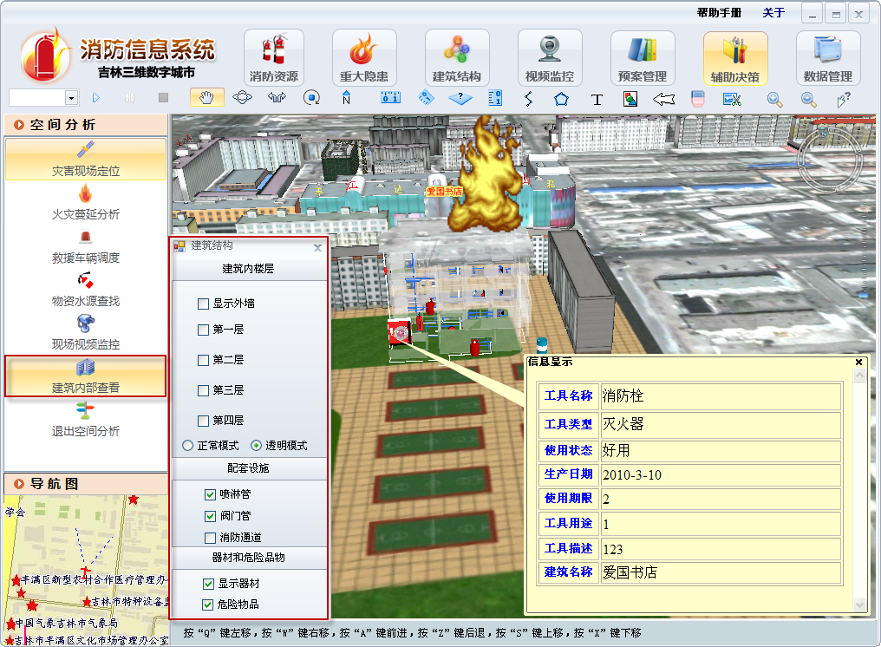
Figure 2 Building interior view-transparent mode.

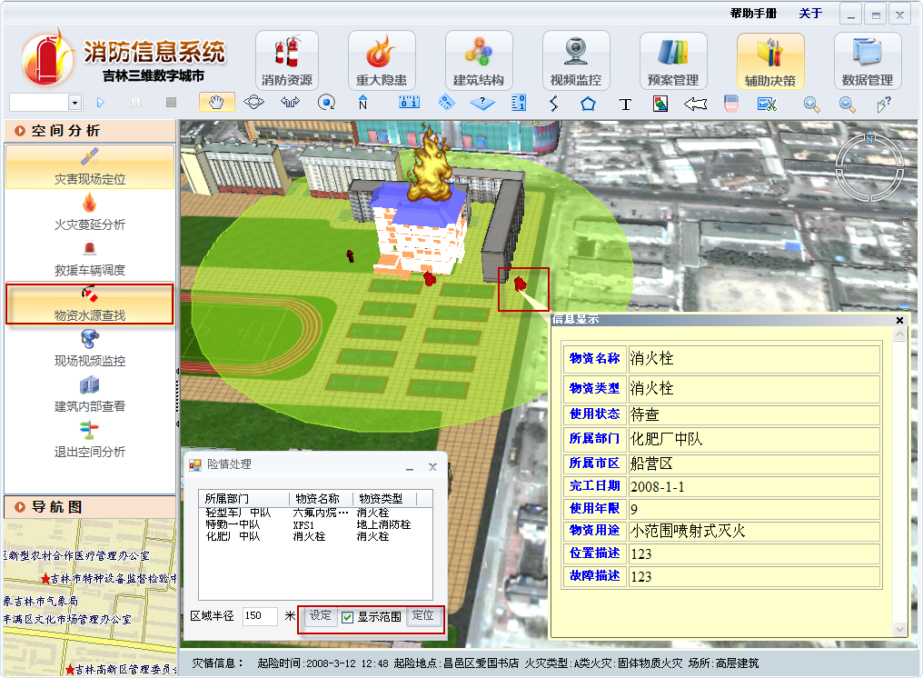
Figure 3 The process of finding material and water sources.

The fundamental purpose of the FMDM system developed here is to realize the perception, transmission, and storage of building FP data and ensure that users can access and monitor remotely through multiple platforms. Figure 4 illustrates the architecture of the FMDM system based on the IoT, mainly consisting of the perception layer, the CC center, and the final application service layer.
Figure 4 Architecture of the FMDM system based on IoT.

In the system architecture of Figure 4, the perception layer mainly includes the IoT monitoring node, the client, and the user information transmission module. Among them, the monitoring node is responsible for collecting the water pressure data in the firefighting water pressure system and the data in the existing firefighting control cabinet in the building. It then encapsulates the data according to the prescribed protocol and then transmits it to the user information transmission module through Wireless Fidelity or the RS-485 Bus Network. The client transmits the maintenance personnel’s relevant maintenance and repair plans of firefighting equipment to the user information transmission module. The last user information transmission module is responsible for summarizing the collected data and transmitting all data to the CC center. As the core part of the whole system, the CC center is in charge of the virtualization operation and scheduling management of physical resources by using the virtualization method based on Hyper-V technology and has formed Infrastructure as a Service (IaaS), which provides an essential platform for Software as a Service (SaaS) in the system^{[30‒32]}. The servers and storage devices of the physical layer will be virtualized in the platform resource pool. The resource management module principally implements the management of databases, virtual machines, and load balancing. The application service layer is mainly responsible for providing users with SaaS for fire monitoring and decision-making. Users can remotely monitor the fire safety status of buildings through applications^{[33,34]}.
The most important thing for a comprehensive FMDM system after obtaining firefighting data through the monitoring module is to analyze the data and information in a unified manner and then make reasonable rescue decisions. In the intelligent decision-making scheme studied here, firstly, an ontology model was constructed according to the FP data in the database and related FP knowledge; then, the values in the ontology and the collected data were queried and compared; finally, the Analytic Hierarchy Process was used to evaluate the FS level, infer the proper ER decision, and display the fire ontology analysis conclusion on the application.

3.3 Fire emergency rescue vehicle dispatching model
The urban GIS-based FP system is excellent in quickly inquiring about the specific fire location, prioritizing the firefighting squadron with the nearest location, and automatically matching the best driving route of the firefighting squadron. In addition, it also has the role of supervision. This system displays the driving track of the firefighting vehicles and checks whether it is driving according to the assigned route. The scheduling of emergency RVs first needs to ensure the minimum total response time (allocation time and travel time). In addition, it is necessary to ensure that sufficient vehicles arrive at the emergency location within a reasonable time frame. Figure 5 reveals the intelligent dispatching interface of RVs in the IFFV platform.
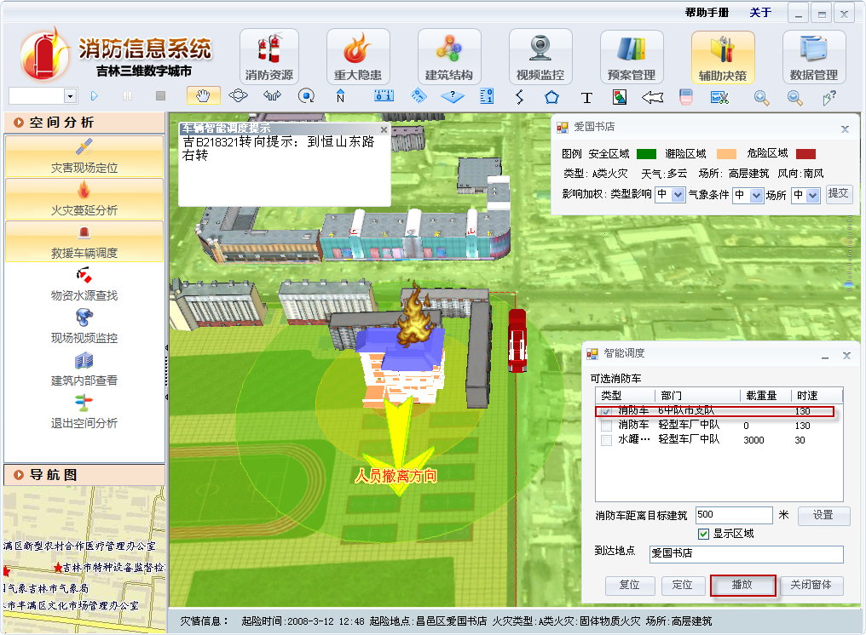
Figure 5 The interface of intelligent RV dispatch.

Based on the above analysis, the RV scheduling model constructed in this work mainly uses two objective functions to solve the Pareto non-dominated solution set optimization: ER time and the number of RVs.
Firstly, a fire spread (FS) model was constructed based on FS:
(1)
(2)
where represents the FS speed; denotes the initial FS speed; stands for the wind speed; , and signify the combustible material type coefficient, terrain slope coefficient, and wind coefficient; , and are regional coefficients; indicates temperature (°C); refers to the wind scale.
Suppose that each fire truck with the same number of firefighting equipment and rescue personnel has the same firefighting speed. In addition, each fire fighting vehicle can only go to one fire point after receiving the task and return to the starting point after extinguishing the fire point. Based on the constraints of RVs and the number of vehicles at each fire point, taking into account the minimization of the two objectives, the established mathematical model can be described as:
(3)
(4)
(5)
(6)
(7)
In the above equations, denotes the fire extinguishing time of the i-th fire point; and represent the total number of possessed vehicles and the minimum number of vehicles required in the ER dispatch process; and represent the lower and upper limit of the number of cars heading to the i-th fire point, respectively; refers to the binary variable.
The objective function corresponding to the minimization of the fire extinguishing time is related to the arrival time of the rescue convoy at each fire point, as shown in Eq. (8).
(8)
In Eq. (8), represents the average speed of the fleet from location 0 and fire point i to the i-th fire point, and refers to the travel distance between location 0 and the the i-th fire point.
Eq. (9) indicates the mathematical relationship among , , and according to the actual fire situation.
(9)
In Eq. (9), means the fire area before the fire rescue team arrives, and denotes the fire area during the period from the arrival of the rescue team to the end of the rescue. On this basis, the fire extinguishing time of the i-th fire point can be deduced as Eq. (10).
(10)
Eq. (11) defines the ultimate target function.
(11)
In Eq. (11), $v_{Si}$ represents the number of rescue vehicles; $v_{m}$ refers to the rescue speed; $t_{Ai}$ denotes the fire extinguishing time of the rescue. It can be seen that increasing the number of dispatched vehicles can reduce the firefighting time and improve the success rate of fire rescue in the case of increasing the number of rescue teams.
This work combined the Genetic Algorithm (GA) and Particle Swarm Optimization (PSO) for the optimal solution of the RV scheduling model, forming the hybrid Particle Swarm Optimization-Genetic Algorithm (PSO-GA). The PSO is initialized as a group of random particles and then iteratively finds the optimal solution. In each iteration, the particle updates itself by tracking two extremes . After finding these two optimal values, the particle updates its velocity and position according to:
(12)
(13)
where represents the speed of the particle; stands for the current position of the particle; denotes a random number between (0, 1); and are learning factors.
This leads to the standard form of PSO as shown in Eq. (14).
(14)
In Eq. (14), stands for the inertia factor. Fig. 6 presents the flow of the hybrid PSO-GA algorithm.
Figure 6 Flow chart of the hybrid PSO-GA algorithm.

GA can automatically acquire and accumulate knowledge about the search space during the search process and adaptively control the search process to obtain the best solution^{[35‒37]}. During the model solving process, the position number of each fire point is determined by the combat priority of that point; that is, the higher the combat priority, the higher the position. Compared with the genetic algorithm, the hybrid PSO-GA algorithm will mutate each individual to ensure the diversity of the population and continuously optimize individual offspring in. When the maximum cycle algebra is reached, the algorithm stops running, gives the found optimal value, and generates the optimal path scheduling scheme. First, the algorithm generates an initial population, updates the population, and records individual extreme values and values. Second, local optimization of the model is performed by running the crossover operator. Finally, the individual weights are updated through global optimization, and the loop is terminated when the conditions are met.

3.4 Fire evacuation route programming based on the improved ant colony algorithm
The intelligent fire evacuation refers to the dynamical plan of the optimal EP of the location based on the fire location, regional temperature, population density, smoke situation, and other information detected by the fire detection device in the building^{[38‒40]}. In this work, the heuristic function and pheromone update strategy of the Ant Colony algorithm were optimized to realize the dynamic evacuation RP from the global consideration. At the moment when , n ants are randomly placed into m nodes. During the process of the ant moving from the starting point to the ending point , the direction of movement depends on pheromone concentration. The ant moves from the current position to the next node according to the pseudo-random proportional rule , and its probability can be expressed as Eq. (15).
(15)
In Eq. (15), and represent the information heuristic factor and the expectation heuristic factor, respectively; refers to the heuristic function; stands for the expected degree of the ant k from i to j; represents the set of directions in which the ant can choose to move.
After each ant goes from the current node to the next node , it needs to update the pheromone immediately to avoid interference with the heuristic information. The pheromone update rules are:
(16)
(17)
where represents the pheromone volatilization rate, and denotes the pheromone increment of the ant between nodes and . The pheromone increment caused by the ant on the walking edge is calculated according to Eq. (18).
(18)
In Eq. (18), stands for the total amount of information and is a constant; denotes the optimal path found by the ant after traversing all nodes.
However, since the traditional Ant Colony algorithm has the problems of cumbersome calculation, long search time, and easy to fall into local optimum in the process of solving practical problems. Therefore, this work optimized it by adaptively changing the pheromone volatilization rate value and introduced the fire index to evaluate the influence of risk factors on evacuation to effectively improve the optimization efficiency of the algorithm. In the actual fire scene, the fire index mainly includes the environmental temperature , carbon monoxide concentration , the visibility of evacuation passages, and the influence coefficient of crowd congestion on evacuation. can be written as Eq. (19).
(19)
The obstacle coefficient of path passage can be obtained by calculating the walking speed of the crowd in the fire environment:
(20)
The passage obstruction coefficient is inversely proportional to the passage speed. The crowd’s walking speed is about 1.3m/s under normal circumstances. Therefore, the moving speed of the evacuated people in the fire can be expressed as Eq. (21).
(21)
The equivalent length of the evacuation channel can be expressed as Eq. (22).
(22)
In Eq. (22), denotes the length of the evacuation channel. It can be seen that is inversely proportional to the fire index and proportionate to the obstruction coefficient .
In the fire evacuation algorithm, the heuristic function represents the heuristic degree of people moving between nodes, which can be expressed as Eq. (23).
(23)
If most ants choose the path with a strong pheromone, the algorithm will fall into the optimum local situation.
The parameter value of the IAC algorithm will directly affect the convergence speed and optimization ability of the algorithm. The parameters of the algorithm were initialized before verifying the performance. The average value of each parameter was taken after ten simulations. The value was finally determined to be 0.5; and are 1 and 10, respectively; the number of ants was 100; the maximum number of iterations was 200.

4. Results and discussion
4.1 Effect of fire detection in the multi-information building
The PyroSim software was used to simulate the fire scene. The combustion reaction was wood burning, and the total burning time (no fire → start of fire → end of combustion) was set to 600s. Sensors for temperature, smoke, and water vapor were arranged on the roof of the room. This work processed different signal quantities and obtained the change curve of each data source signal with time to clearly define the changing trend of each signal change with the fire, as shown in Figure 7.
Figure 7 Variation curve of fire signal with time.

It can be seen from Figure 7 that when a fire occurs, with the time, the temperature of the fire field gets higher and higher, the moisture content is gets less and less, the oxygen content in the air is gradually decreasing, and the concentration of CO and smoke is getting higher and higher. The rescue of personnel put forward high demands. According to the specific phenomenon of the fire occurrence process, a fire disaster is divided into three types: no fire state, smoldering fire state, and open fire state. Figure 8 provides the primary probability function construction result of the signal source covering four data sources: temperature, CO concentration, smoke concentration, and O₂ concentration difference.
Figure 8 Basic probability function construction of the signal source.

Figure 9 illustrates the changing curves of temperature, CO concentration, smoke concentration, O₂ concentration, and heat release rate in the fire detection signal in the open fire scene within 0‒60s. It can be seen that before 6s, all the detection signals showed no change compared with the initial; they started to increase gradually with the delay of time after 6s. In the initial stage of the fire, the signal changed slowly, and the value was small. It is found that the probability of smoldering fire and the probability of open fire is small according to the probability function of the corresponding fire situation, so the fire occurrence cannot be detected. Therefore, the fire can only be detected when the detection signal changes significantly after a certain period accumulation.
Figure 9 Changing curves of the fire detection signal in the open fire scene within 0‒30s. (a) Smoke concentration, temperature, and CO concentration; (b) O₂ concentration difference and heat release rate.

Figure 10 displays the change curves of temperature, CO concentration, smoke concentration, O₂ concentration, and heat release rate in the fire detection signal in the smoldering fire scene within 0‒60s. All the detection signals changed significantly at t=17s compared with the initial value, which was larger. In addition, the probability function judgment according to the corresponding fire situation suggests that the probability of smoldering fire and the probability of open fire were relatively large at this time so that the fire could be detected.

Figure 10 Variation curves of the fire detection signal in smoldering fire scene within 0‒30s. (a) Smoke concentration, temperature, and CO concentration; (b) O₂ concentration difference and heat release rate.

4.2 Verification of the fire evacuation route programming scheme
This work formulated a 40×40 grid network model in the Matlab environment following the first-floor layout of a building and proportionally reduced the evacuation space of the building. Finally, only some obstacles affecting the evacuation of personnel were retained in the internal structure of the building. Figure 11 provides the definite grid model. The black area in Figure 11 represents the obstacles inside the floor, and the red area represents the fire area. The marked regions of these two parts are not passable; only the white spots are passable. There are three safety exits for personnel evacuation.
Figure 11 Schematic diagram of the building fire scene grid network model.

The evacuation process of trapped people after a fire in a building is primarily based on three stages: the initial stage of the fire, the FS period, and the FS period. To verify the effectiveness of the IAC algorithm, the classical Ant Colony algorithm was used as a comparison to simulate the EPs of trapped persons in three different development periods during the fire in the building. At the initial stage of the fire, the temperature around the fire location, toxic gas concentration, and smoke visibility index obtained by PyroSim smoke simulation were low. Therefore, the safe evacuation speed of personnel is hardly affected by the above-mentioned environmental factors. Figure 12 reveals the shortest paths to the three exits obtained by the two evacuation RP algorithms after determining the location of the fire point. It can be seen that under the circumstance that the environmental influence factors are almost negligible, the IAC algorithm used here had a shorter planning distance for the EP.
Figure 12 Planning of the optimal evacuation route in the early stage of fire. (a) Classical ant colony algorithm; (b) the IAC algorithm.

According to Figure 12, the minimum and maximum boundaries of the grid area are 0 and 40, respectively. With the extension of the fire occurrence time and the continuous spread of the fire, the impact of fire products such as CO concentration and high-temperature environment on the evacuated personnel was increasingly evident. At this time, the information of each node and channel in the building needs to be updated, and the temperature, visibility, and dimming coefficient of the fire field should also be reset accordingly. Figure 13 shows the shortest paths to the three exits during the FS period obtained by the two evacuation RP algorithms. The comparative analysis proves that the IAC algorithm in this work avoids the passages near the fire area and the spreading area as much as possible and takes the safety of the trapped people as the premise when planning the EP. In contrast, the traditional Ant Colony algorithm selected a relatively complex route without considering the safety of people.
Figure 13 Optimal evacuation RP during the FS period. (a) the classical Ant Colony algorithm; (b) the IAC algorithm.

As the fire continued to grow, the area around the fire point was entirely covered by the fire, and factors such as CO concentration, high-temperature environment, visibility, and movement speed of people were seriously affected by the fire. Figure 14 shows the shortest evacuation paths during FS obtained by two evacuation RP algorithms. It can be found that the traditional Ant Colony Algorithm still lacks the consideration for the safety of trapped personnel in the EP planning process. The RP algorithm proposed here considers the effects of factors such as fire extent, temperature, and CO concentration in the FS area. In addition, the nodes with short geometric lengths are abandoned, and the fire area and the area about to spread are avoided as much as possible to complete the optimal evacuation RP. Therefore, the IAC algorithm can find the optimal solution faster than the algorithm before optimization in the three stages of fire. Besides, under the premise of ensuring the safety of trapped people, the optimal safe evacuation path can be dynamically calculated according to the changes in fire parameters to realize the way most suitable for personnel evacuation needs in the actual building fire process.
Figure 14 Optimal evacuation RP during the FS period. (a) the classical Ant Colony algorithm; (b) the IAC algorithm.

In summary, the planning results of the classical Ant Colony Algorithm and the IAC algorithm for fire evacuation paths are difficult to meet expectations, and the hybrid PSO-GA algorithm proposed here can efficiently solve the evacuation problem of trapped people. In addition, Jiang et al. researched the industrial application of Digital Twins technology, redefined Digital Twins as a virtual replica of real-world products and systems, and focused on using Digital Twins in the industry in the context of intelligent manufacturing^{[41]}. They found that Digital Twins connect virtual cyberspace with physical entities and are therefore considered the backbone of Industry 4.0 and future innovations. The research has specific reference value for the design and implementation of the intelligent manufacturing system in the context of IoT.

5. Conclusion
The FP information can directly reflect the characteristics of the FP business and guide the FP business. This work proposed an FMDF system for FP based on popular IoT and CC technologies and studied its key technologies. The fundamental purpose of the FMDM system is to realize the perception, transmission, and storage of building FP data and ensure that users can access and monitor the scene remotely through multiple platforms.
How to evacuate the people in the building to a safe area quickly and safely when faced with a sudden fire has become a new issue of disaster prevention and mitigation. Therefore, this work conducted an in-depth study on the most critical RV scheduling and personnel escape path optimization problems in the SFP information management system. Besides, a hybrid PSO-GA algorithm was proposed for the optimal solution of the RV scheduling model, and each individual was subjected to mutation operation to ensure the diversity of the population. In the problem of evacuation RP for trapped persons, a global dynamic evacuation RP was realized by optimizing the heuristic function and pheromone update strategy of the conventional Ant Colony algorithm. The IAC algorithm reported here can find the optimal solution faster than the classical algorithm in the three stages of fire. This work implements an IoT-based emergency plan information system and systematically studies the most critical emergency plan evacuation issues, which is of great significance for efficiently completing disaster relief tasks. Nonetheless, the research still has some areas for improvement. For example, the impact of crowding on evacuation was not considered in personnel evacuation. The follow-up work should focus on a comprehensive fire emergency evacuation system.

Declaration of competing interest
We declare that we have no conflict of interest.

Reference
1 Mu X W, Zhou X, Wang W, Xiao Y L, Liao C, Han L F, Kan Y C, Song L. Design of compressible flame retardant grafted porous organic polymer based separator with high fire safety and good electrochemical properties. Chemical Engineering Journal, 2021, 405, 126946
DOI:10.1016/j.cej.2020.126946
2 Li L, Shao X M, Zhao Z, Liu X L, Jiang L C, Huang K, Zhao S. Synergistic fire hazard effect of a multifunctional flame retardant in building insulation expandable polystyrene through a simple surface-coating method. ACS Omega, 2020, 5(1): 799–807
DOI:10.1021/acsomega.9b03541
3 Xu W Z, Yan H Y, Wang G S, Qin Z Q, Fan L J, Yang Y X. A silica-coated metal-organic framework/graphite-carbon nitride hybrid for improved fire safety of epoxy resins. Materials Chemistry and Physics, 2021, 258, 123810
DOI:10.1016/j.matchemphys.2020.123810
4 Zhang G W, Yan S, Zhu G Q, Feng P Y, Jia B Y. Smart firefighting construction in China: status, problems, and reflections. Fire and Materials, 2020, 44(7): 479–486
DOI:10.1002/fam.2800
5 Ning H S, Li Y F, Shi F F, Yang L T. Heterogeneous edge computing open platforms and tools for Internet of Things. Future Generation Computer Systems, 2020, 106: 67–76
DOI:10.1016/j.future.2019.12.036
6 Meena S R, Albrecht F, Hölbling D, Ghorbanzadeh O, Blaschke T. Nepalese landslide information system (NELIS): a conceptual framework for a web-based geographical information system for enhanced landslide risk management in Nepal. Natural Hazards and Earth System Sciences, 2021, 21(1): 301–316
DOI:10.5194/nhess-21-301-2021
7 Sungheetha D A, Sharma R D R. Real time monitoring and fire detection using internet of things and cloud based Drones. Journal of Soft Computing Paradigm, 2020, 2(3): 168–174
DOI:10.36548/jscp.2020.3.004
8 Yahyaoui A, Abdellatif T, Yangui S M, Attia R. READ-IoT: reliable event and anomaly detection framework for the Internet of Things. IEEE Access, 9: 24168–24186
DOI:10.1109/access.2021.3056149
9 Badshah A, Ghani A, Ahsan Qureshi M, Shamshirband S. Smart security framework for educational institutions using Internet of Things (IoT). Computers, Materials & Continua, 2019, 61(1): 81–101
DOI:10.32604/cmc.2019.06288
10 Jo B W, Khan R M A, Javaid O. Arduino-based intelligent gases monitoring and information sharing Internet-of-Things system for underground coal mines. Journal of Ambient Intelligence and Smart Environments, 2019, 11(2): 183–194
DOI:10.3233/ais-190518
11 Naresh V S, Pericherla S S, Sita Rama Murty P, Reddi S. Internet of Things in healthcare: architecture, applications, challenges, and solutions. Computer Systems Science and Engineering, 2020, 35(6): 411–421
DOI:10.32604/csse.2020.35.411
12 Wu X Q, Park Y, Li A, Huang X Y, Xiao F, Usmani A. Smart detection of fire source in tunnel based on the numerical database and artificial intelligence. Fire Technology, 2021, 57(2): 657–682
DOI:10.1007/s10694-020-00985-z
13 Beg A, Qureshi A R, Sheltami T, Yasar A. UAV-enabled intelligent traffic policing and emergency response handling system for the smart city. Personal and Ubiquitous Computing, 2021, 25(1): 33–50
DOI: 10.1007/s00779-019-01297-y
14 Eini R, Linkous L, Zohrabi N, Abdelwahed S. Smart building management system: Performance specifications and design requirements. Journal of Building Engineering, 2021, 39: 102222
DOI: 10.1016/j.jobe.2021.102222
15 Zhang Y C, Geng P P, Sivaparthipan C B, Muthu B A. Big data and artificial intelligence based early risk warning system of fire hazard for smart cities. Sustainable Energy Technologies and Assessments, 2021, 45, 100986
DOI:10.1016/j.seta.2020.100986
16 Menon A, Vishnu-Menon R G. Management strategies for prevention of forest fire and environmental degradation in tropics with special reference to western ghats of Kerala region, India. Journal of Tropical Forest Science, 2022, 34(1): 24–33
DOI:10.26525/jtfs2022.34.1.24
17 Alqourabah H, Muneer A, Fati S M. A smart fire detection system using iot technology with automatic water sprinkler. International Journal of Electrical and Computer Engineering (IJECE), 2021, 11(4): 2994
DOI:10.11591/ijece.v11i4.pp2994-3002
18 Wang K, Cai W Y, Zhang Y C, Hao H Q, Wang Z T. Numerical simulation of fire smoke control methods in subway stations and collaborative control system for emergency rescue. Process Safety and Environmental Protection, 2021, 147: 146–161
DOI:10.1016/j.psep.2020.09.033
19 Tang X, Liu K, Wang J, Gan Y, Lou L. Design and application of satellite remote sensing emergency monitoring information service framework—a case study of forest fire in Muli, Sichuan Province. Bulletin of Surveying and Mapping, 2020, (12), 110‒113
DOI: 10.13474/j.cnki.11-2246.2020.0403
20 Jiang H X. Mobile fire evacuation system for large public buildings based on artificial intelligence and IoT. IEEE Access, 7: 64101–64109
DOI:10.1109/access.2019.2915241
21 Gomaa I, Adelzadeh M, Gwynne S, Spencer B, Ko Y, Bénichou N, Ma C Y, Elsagan N, Duong D, Zalok E, Kinateder M. A framework for intelligent fire detection and evacuation system. Fire Technology, 2021, 57(6): 3179–3185
DOI:10.1007/s10694-021-01157-3
22 Cao Y X, Luo C M, Liu Y Y, Teng S R, Xin G F. Path intelligent optimization for dense crowd emergency evacuation in heritage buildings. Journal of Cultural Heritage, 2021, 47: 180–187
DOI:10.1016/j.culher.2020.06.007
23 Wu X Q, Zhang X N, Jiang Y S, Huang X Y, Huang G G Q, Usmani A. An intelligent tunnel firefighting system and small-scale demonstration. Tunnelling and Underground Space Technology, 2022, 120: 104301
DOI:10.1016/j.tust.2021.104301
24 Shetye N, Khadas R, Bhogal V. Sonic Wave fire fighter robot using master slave concept. VIVA-Tech International Journal for Research and Innovation, 2021, 1(4): 1‒6
25 Akhloufi M A, Couturier A, Castro N A. Unmanned aerial vehicles for wildland fires: sensing, perception, cooperation and assistance. Drones, 2021, 5(1): 15
DOI:10.3390/drones5010015
26 Vrtal P, Kohout T, Nováček J, Svatý Z. Comprehensive analysis of housing estate infrastructure in relation to the passability of firefighting equipment. Applied Sciences, 2021, 11(20): 9587
DOI:10.3390/app11209587
27 Wan J L, Zhao H B. Laminar non-premixed flame patterns in compact micro disc-combustor with annular step and radial preheated channel. Combustion and Flame, 2021, 227: 465–480
DOI:10.1016/j.combustflame.2021.01.024
28 Pokharel S, Ayoobi M, Akkerman V. Computational analysis of premixed syngas/air combustion in micro-channels: impacts of flow rate and fuel composition. Energies, 2021, 14(14): 4190
DOI:10.3390/en14144190
29 Meng D, Xiao Y, Guo Z W, Jolfaei A, Qin L X, Lu X T, Xiang Q. A data-driven intelligent planning model for UAVs routing networks in mobile Internet of Things. Computer Communications, 2021, 179: 231–241
DOI:10.1016/j.comcom.2021.08.014
30 Zheng M, Bai S Z. Implementation of universal health management and monitoring system in resource-constrained environment based on Internet of Things. IEEE Access, 9: 138744–138752
DOI:10.1109/access.2021.3101909
31 Abbod A A, Zwyer N B. Using Internet of Things techniques to measure parameters of oil tanks. Journal of Petroleum Research and Studies, 2021, 11(1): 153–167
DOI:10.52716/jprs.v11i1.437
32 Muhendra R, Amin A. Real-time monitoring: development of low power fire detection system for dense residential housing based on Internet of Things (IoT) and cloud messenger. Scientific Journal of Informatics, 2021, 8(2): 202–212
DOI:10.15294/sji.v8i2.30811
33 Shah N A, Nor M M, Zainuddin N. Internet of Things: the use of raspberry pi, sensor devices and geo-fencing technology in fire detection monitoring system for a home. ESTEEM Academic Journal, 2021,17, 32–44
34 Mannino A, Dejaco M C, Re Cecconi F. Building information modelling and Internet of Things integration for facility management—literature review and future needs. Applied Sciences, 2021, 11(7): 3062
DOI:10.3390/app11073062
35 Velliangiri S, Karthikeyan P, Arul Xavier V M, Baswaraj D. Hybrid electro search with genetic algorithm for task scheduling in cloud computing. Ain Shams Engineering Journal, 2021, 12(1): 631–639
DOI:10.1016/j.asej.2020.07.003
36 Rezaeipanah A, Matoori S S, Ahmadi G. A hybrid algorithm for the university course timetabling problem using the improved parallel genetic algorithm and local search. Applied Intelligence, 2021, 51(1): 467–492
DOI:10.1007/s10489-020-01833-x
37 Oyelade O N, Ezugwu A E S, Mohamed T I A, Abualigah L. Ebola optimization search algorithm: a new nature-inspired metaheuristic optimization algorithm. IEEE Access, 10: 16150–16177
DOI:10.1109/access.2022.3147821
38 Liu L F, Zhang H J, Xie J P, Zhao Q. Dynamic evacuation planning on cruise ships based on an improved ant colony system (IACS). Journal of Marine Science and Engineering, 2021, 9(2): 220
DOI:10.3390/jmse9020220
39 Li-Cai Z. Optimization of indoor evacuation path based on improved ant colony algorithm. Fire Science and Technology, 2021
40 Solukloei H R J, Nematifard S, Hesami A, Mohammadi H, Kamalinia M. A fuzzy-HAZOP/ant colony system methodology to identify combined fire, explosion, and toxic release risk in the process industries. Expert Systems with Applications, 2022, 192: 116418
DOI:10.1016/j.eswa.2021.116418
41 Jiang Y C, Yin S, Li K, Luo H, Kaynak O. Industrial applications of digital twins. Philosophical Transactions. Series A, Mathematical, Physical, and Engineering Sciences, 2021, 379(2207): 20200360
DOI:10.1098/rsta.2020.0360

