Library Management System
Table of Contents
Research 1
Use case Diagram 1
PlantUML 4
Database rules 5
ERD 6
Schema 6
Backend functionality 7
Users 7
Books 8
Book copies 8
Loans 9
Reservations 10
Fines 10
Note 11

Research

Use case Diagram
Use cases for a library system are split between Administrators and Members
Members should have the ability to:
- Sign up or log in
- Start, cancel, freeze or modify membership
- Search for books, with filters and sorting preferences
- Borrow books with borrowing limits, and view current and previous loans
- Return books, and due dates for returns
- View and pay fines
- Renew loans to extend the due date with renewing limits
- Reserve books with reserve limits
Administrators should inherit the functionality of members as well as being able to:
- Add, update, and remove books
- Issue, modify and cancel fines
- Modify fine rate, borrowing limits, due dates
- Create system analytics for popular books, fine issues, overdue loans, active members
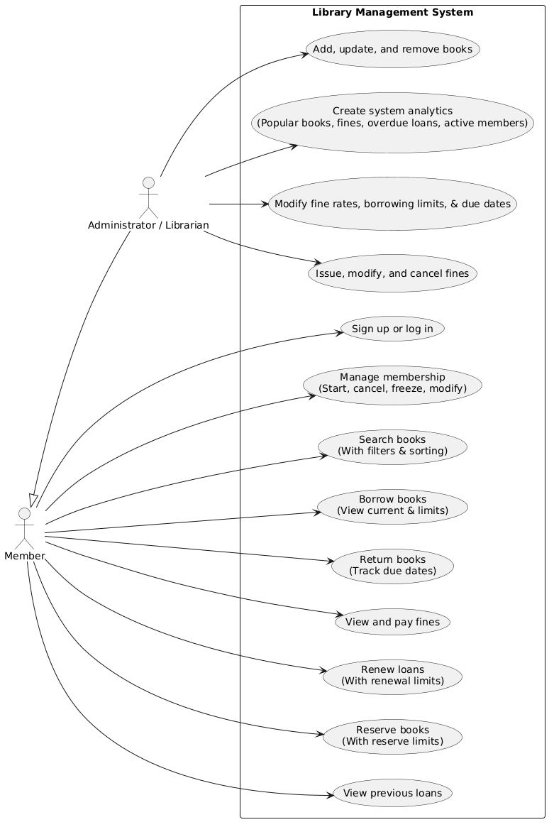

PlantUML
@startuml
left to right direction
actor "Member" as member
actor "Administrator / Librarian" as admin
admin -up-|> member
rectangle "Library Management System" {
usecase "Sign up or log in" as UC1
usecase "Manage membership\n(Start, cancel, freeze, modify)" as UC2
usecase "Search books\n(With filters & sorting)" as UC3
usecase "Borrow books\n(View current & limits)" as UC4
usecase "Return books\n(Track due dates)" as UC5
usecase "View and pay fines" as UC6
usecase "Renew loans\n(With renewal limits)" as UC7
usecase "Reserve books\n(With reserve limits)" as UC8
usecase "View previous loans" as UC9
usecase "Add, update, and remove books" as UC10
usecase "Issue, modify, and cancel fines" as UC11
usecase "Modify fine rates, borrowing limits, & due dates" as UC12
usecase "Create system analytics\n(Popular books, fines, overdue loans, active members)" as UC13
}
member --> UC1
member --> UC2
member --> UC3
member --> UC4
member --> UC5
member --> UC6
member --> UC7
member --> UC8
member --> UC9
admin --> UC10
admin --> UC11
admin --> UC12
admin --> UC13
@endum

Database rules
Users may borrow many Loans, a Loan may be borrowed by one User
A Loan may contain one Book copy, a Book copy may be contained by one Loan
A Loan may issue many Fines, a Fine must be issued by one Loan
A User may make many Reservations, a Reservation must be made by one User
A Reservation must contain one Book, a Book may be contained by many Reservations
A Book copy must correspond to one Book, a Book may correspond to many Book copies
Note:
If a User is deleted, referencing Reservations are deleted
If a Book is deleted, referencing Reservations are deleted
If a Book is deleted, referencing Book copies are deleted
If a Loan is deleted, referencing Fines are deleted
Loans can exist without a User or Book copy for archival purposes.
User can only reserve a Book once

ERD
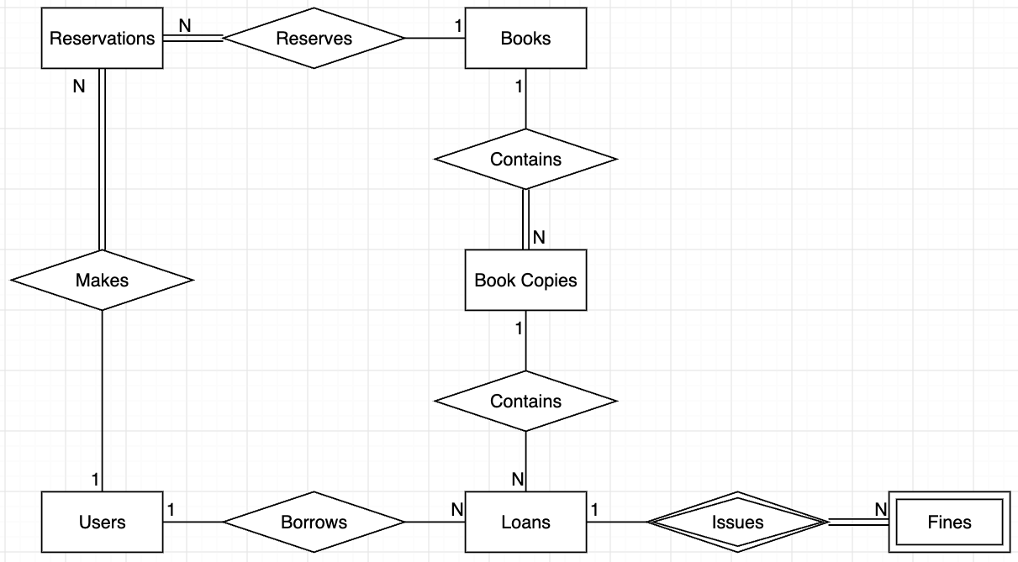

Schema
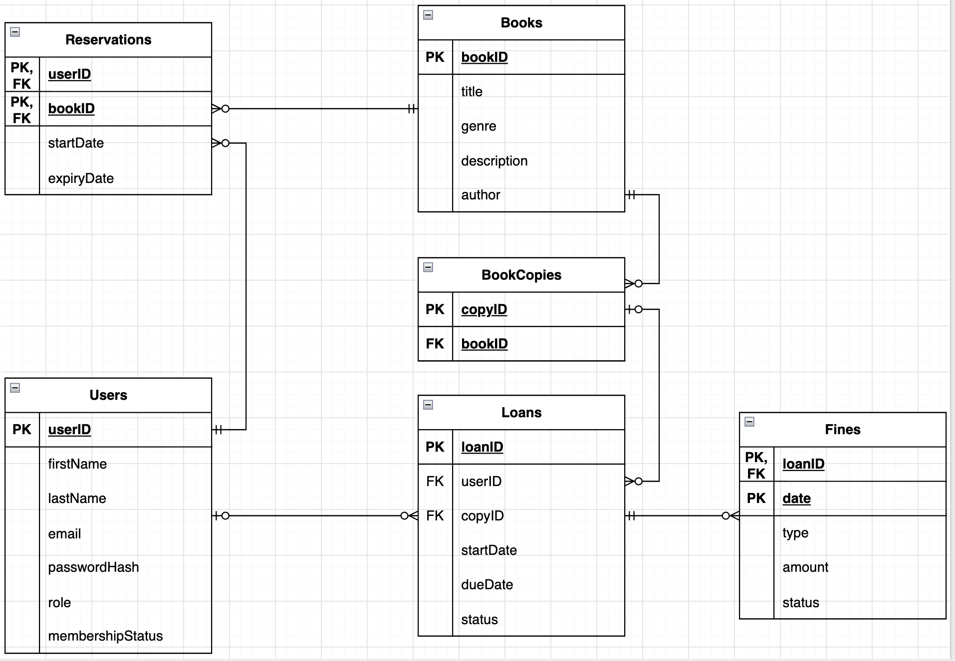

Backend functionality

Users
Function: Add member
Requirements: first name, last name, email, password
Restrictions: admin and member function. Email and password format/restrictions. Email should not be in use. No empty strings for attributes
Result: added member record

Function: Delete member
Requirements: userID, password (if members delete their own account)
Restrictions: admin and member function. No outstanding fines, or active loans. Password hash matches stored password hash
Result: deleted user account. Deleted reservations

Function: Freeze member
Requirements: userID
Restrictions: admin and member function. No active loans. No outstanding fines.
Result: updated user membership status attribute to frozen. Deleted reservations

Function: Change password
Requirements: userID, current password (if members change their own password), new password
Restrictions: admin and member function. New password restrictions. Old password hash matches stored password hash
Result: updated password hash

Function: Change name
Requirements: userID, first name, last name
Restrictions: admin and member function. First name and last name should not be empty strings
Result: updated user attributes

Function: Promote member to admin
Requirements: userID (member), userID (admin), password
Restrictions: admin function. Password hash matches admin stored password hash
Result: updated role attribute

Books
Function: Add a new book
Requirements: title, genre, description, author
Restrictions: Admin function. No empty strings for attributes
Result: New book record

Function: Remove an existing book
Requirements: bookID
Restrictions: Admin function
Result: Deleted book record. Deleted book copies. Deleted reservations. Updated loans to null copyID

Function: Update an existing book
Requirements: bookID, title, genre, description, author
Restrictions: Admin function. No empty string attributes
Result: Updated book attributes

Book copies
Function: Add a new book copy
Requirements: bookID
Restrictions: Admin function
Result: New book copy record

Function: Remove an existing book copy
Requirements: bookID
Restrictions: Admin function
Result: deleted book copy record, Updated loans to null copyID

Loans
Function: Borrow a Loan
Requirements: userID, bookID
Restrictions: active member function. The book should have number of copies not in active loans, higher than the number of reservations for the book. If there are less copies not in active loans than reservations, then the oldest reservation must be for the same user to loan the book. If there are no reservations for the book, then there needs to be at least one book copy not in an active loan
Result: new loan record

Function: Renew an existing loan
Requirements: loanID, dueDate
Restrictions: admin and member function. New due date follows system rules set by library staff (example: no more than 30 weeks since start, Maximum of 10 days at a time). Cannot renew if book copy is reserved
Result: updated due date

Function: Return Loan
Requirements: loanID
Restrictions: admin and member function
Result: updated loan status to returned, updated reservations

Function: Lose loaned book
Requirements: loanID
Restrictions: admin and member function
Result: updated loan status to lost. Deleted reservations if no other book copies exist. Fine record added. Deleted book copy. Updated loans to null copyID

Reservations
Function: Add reservation
Requirements: userID, bookID, startDate (if admin makes reservation for member), expiryDate (if admin makes reservation for member)
Restrictions: admin and member function
Result: added reservation record. If expiry of reservation has past, reservation is deleted. Oldest N reservations updates expiry attribute if attribute is set to null and N book copies are not being loaned

Function: Delete reservation
Requirements: userID, bookID
Restrictions: admin and member function
Result: deleted reservation record. If expiry of reservation has past, reservation is deleted. Oldest N reservations updates expiry attribute if attribute is set to null and N book copies are not being loaned

Fines
Function: Issue fine
Requirements: loanID, type, amount, status
Restrictions: admin function
Result: added fine record

Function: Pay fine
Requirements: loanID, paymentToken
Restrictions: member and admin function. Payment provider approves the transaction. Fine is outstanding
Result: updated fine status attribute

Function: Cancel fine
Requirements: loanID
Restrictions: admin function
Result: updates fine status attribute

Note
All functions apart from Add member requires validation such as a session ID. Session IDs are generated and returned by the server given valid log in credentials.

Function: Log in
Requirements: email, password
Restrictions: members and admin function. Valid log in credentials
Result: update session code if expired and return session code to user

