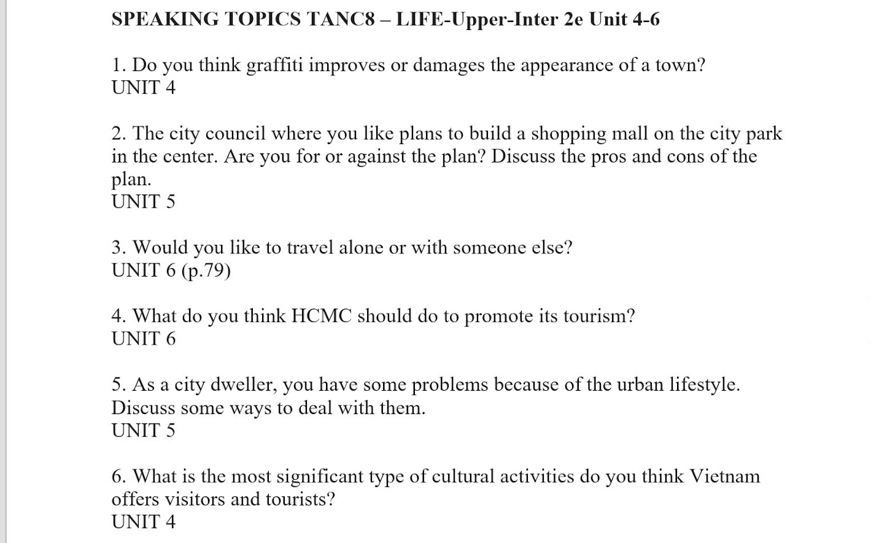

1

I think it will depend on an individual's perspective. Someone will consider it as art and believe it improves the appearance of the city. But from my perspective, I consider it a crime. Because, it damage and decrease the value of the properties. It also cause and increase the concern about safty for the people who live there

2

I will discuss a little bit about the pros and cons of the plan. To commence, the prominent advantage is it potential to stimulate the local economy and increase the job opportunity for the resident. But on the flip side, there are concern about the loss of green space and recreation area, this could impact the overall quality of life for residents.for me, I against the plan, because if the central park is gone, not only the green is lost, the animal,the quality of air is decrease too.

3.

I would like to travel with my best friend, because it will be much more fun and enjoyable. Traveling with another people would certainly be safe and we can be able to rely and support to eachother. Another reason I like to travel with my friend is that it will be a good way trong make our friendship stronger and we can sharing excitement and feeling together during the trip

4.

to promote the tourism, I think VietNam should inprove the quality of tourist service, including hospitality, guided tour and information center. Providing multilingual support and clear signage can enhance the overall tourist exprerience.

5.

To deal with problem of urban lifestyle,if possible you shold negotiate flexible work hours to avoid peak traffic times. If the place where you work is too noisy, consider to carry an earbug with noise canceling feature.additionally, to reduce stress is that you incoperate with mindfullness or meditation of your daily routine and take short break during work hour to recharge.

6.

I would offer visitor and tourist to watch water puppetry. It is a unique and traditional form of Vietnamese folk art. Performance typically take place on water with puppets controlled by puppeteer behind screen. The show describe sence from rural life, legend, and historical stories.