**SETTING WEBSITE**

1. Setting Database

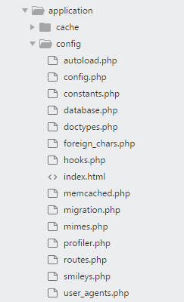

Note : Buka Folder application/config/database.php

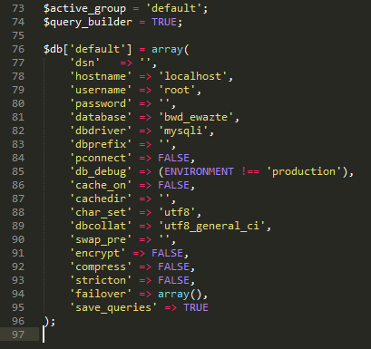

1. Setting base_url



Note : Buka File Application/config/config.php



Note : Ganti base_url dengan url website anda