A README file for web development

Full Name: Konradas Siaulys

Student Number: 16441884

https://xafierz.github.io/web-development/

Assignment 1: Web Development

Assignment is worth 50% of the overall mark for CSY1018

You must work on this assignment individually. **This is not a group assignment.**

Be sure to put your name and student number as a comment at the top of all code and files.

The assignment must be submitted in a single zipped archive containing the following subfolders:

* + csy1018-assign1/ All html files (.html)
  + csy1018-assign1/images All website image files (.gif .jpg)
  + csy1018-assign1/css All css files (.css)
  + csy1018-assign1/README.md or README.txt All Storyboards or navigation diagrams to be included in this file along with a description of the development of the site.

Web development report

I started off by creating my CV page because I’ve believed that this was where most of my structure will have to go. Because I am a novice coder I had no idea how to do any fancy positioning. The problem that I faced when I first started off was the CSS coding, this was a completely new area for me so I had to use websites like w3schools and google to guide me and explain to me what had to be done and how everything works. The hardest bit and challenge was for me this:

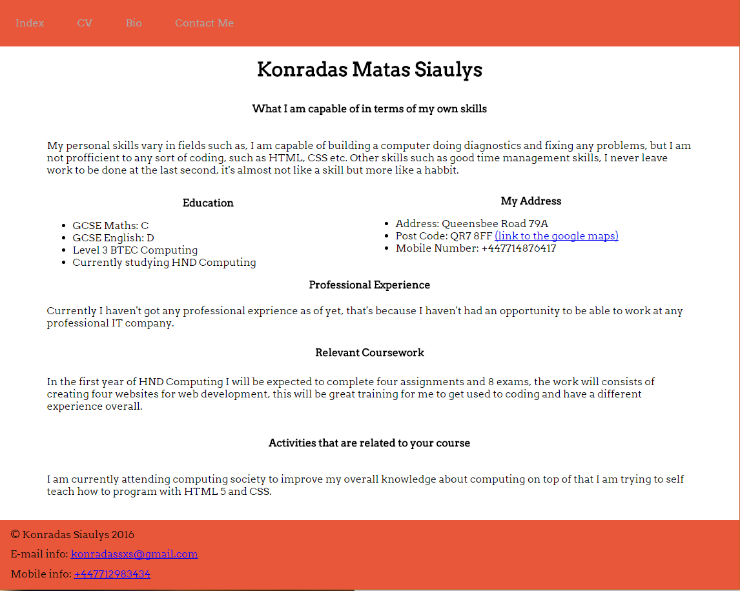

Specifically, the bits for “Education” and “My Address”.

The second page that I created was my bio, this was a lot easier since the only things that I had to do were copy my navigation bar and footer then add extra bits to my CSS to make sure that everything is perfectly aligned and finalize the page. The finalized page looked like this:

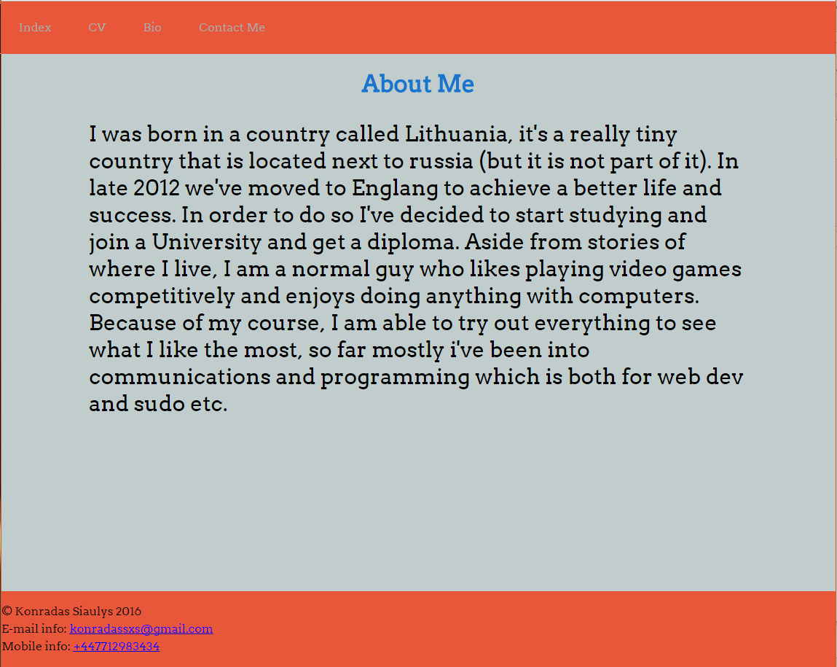

This contains simple information about me, where I’m from and what do I want to do with my future. I’ve spent most of my hours working on my CV page which would have taken me not as much time if I wouldn’t have needed to specifically research information about coding that is relevant to that page. I’ve spent over 20 hours on this project during these 3 months. Most of the hours were used in one or two weeks and the rest were split between the rest. For my third page which was the static form I was having some issues with coding, the challenge was that it was really hard to try to understand how it all works. Other issues that I had were with the footer and navigation bar which they all took me forever to understand how to code them in the CSS section and trying to understand, padding, margin etc. For my index page the challenge for me was that I had to learn what each display code meant in CSS, for example static, absolute etc. Then I had to play around with different sizing coordination and what would happen if I make the page smaller would it shrink or would it just slide to a place where I can’t see it anymore and stuff like that. Most of the challenges were overcame by doing a lot of research which is where most of my hours on this project went to. Unfortunately, I didn’t use the flex box as I already did most of my modelling with other codes so I didn’t have time to research that too. I didn’t cooperate with anyone apart from the internet itself.