# Lab 2 – Star Schema

# Overview

*TPC* is ready to implement its first data mart. In this lab, you will analyze the user requirements for thisdata mart, design it using dimensional modeling techniques, and implement the schema design in your database.

# After completing this lab exercise, you should be able to:

* Translate user information requirements into a design for a data mart.
* Identify the data needs and potential data sources for a data mart.
* Implement the design for a data mart in a database schema.

# To do this lab you will need the following:

1. Your copies of the *TPC* case study, business rules, and ERD.
2. Access to a computer running MySQL and MySQL Workbench.

# Deliverables

Submit the following to MyCourses as a single .zip file with the following name – *YourLastName_Lab2_211*.zip:

1. Answers to the questions in this lab (MS Word).
2. An ER diagram showing your Star Schema, developed in MySQL Workbench and pasted into a MS Word or .pdf document.
3. A screenshot of your tables from MySQL Workbench.
4. Your MySQL Workbench model *YourLastName_211*.mwb file
5. A *YourLastName_211*.sql file that contains the dumping your database

# Business Scenario

*TPC* management has identified financial control and analysis as their top current issue. After talking with the users in the *TPC* central office in Stratford who are involved with financial control, you find out the following:

* Although each of the three divisions is responsible for financial control (increasing sales and decreasing costs), the Financial Director in Stratford is primarily responsible for overall company performance.
* The three divisions will provide data to the data warehouse in different forms. You will have access to OLTP database for TPC-E. This will provide you with sales data for TPC-E. Since you have access to the developers, they can help you with the data in the OLTP system.
* TPC-W in similar in operation to TPC-E and TPC-W will provide a feed of data for you to use. The data will be similar to that which you have access to for TPC-E. An initial feed will be provided from TPC-W and a monthly feed will be provided with updates each month.
* The data from PEC will be different. There will be a customer and a product feed, but the cost will have to be calculated from manufacturing cost data that will be provided. Formulas for calculation will be provided later.
* Since sales can be made from TPC-E and TPC-W to PEC and from PEC to TPC-E and TPC-W, there will need to be allowances when sales and costs are calculated at the total company level. Sales from one unit to another, although considered as sales for the first unit, are not considered sales for the total company (You can’t count sales to yourself). You will need to identify these customer records.
* There may be overlap in customers among the three company units.
* The company financial performance is measured on an annual, quarterly, monthly and weekly basis. Quarters are based on the normal annual quarters for comparison against other companies. (e.g Quarter 1 is January, February and March …). The company’s fiscal year (financial reporting and tax year), however, goes from May 1 through April 30. The fiscal quarters conform to the fiscal year (e.g., Fiscal quarter 1 is May, June and July …). As an example, fiscal 2011 will extend from May 1, 2011 through April 30, 2012.
* Invoice numbers are not unique across the three divisions, so it will be necessary to keep track of the division responsible for the sale.
* PEC sometimes requires special shipping for the products they manufacture. The options are “Train”, “Truck”, “Air”, “N/A” (not available or applicable). Sales that have no special requirements are coded as 0 on the invoice. The other divisions do not provide this information.
* PEC also provides data on the sales feed about the ordering method. The options are “Internet”, “phone”, “email” or “mail”. The values are stored as text. This information is not provided by the other divisions.
* Since PEC manufactures equipment, in addition to the sale date, there is also an order date. The time between order and sale can be used to measure the performance of the organization’s manufacturing process. The other divisions do not provide this information since they normally ship from stock.
* Payment method is also provided by PEC on the sales feed. The three valid methods are “COD”, “charge” or “cash”. Again, this is stored as text. It is not provided by the other divisions.
* After the initial load feeds, there will be similar feeds for monthly updates.

The company would like a data mart that would allow them to investigate their financial performance at the gross profit (margin) level historically so as to more effectively manage financial performance. They are interested in having a flexible system that will ultimately allow them to optimize sales (to maximize sales) while keeping costs down. In addition, they want to be able to better manage the relationships with their suppliers. Some of the initial queries and reports they would like are:

* A report that shows the sales, and costs associated with each customer or customer type on an annual, quarterly, monthly or weekly basis.
* A similar report showing top customers.
* A similar report as above at the product level / product type/ business unit.
* The average time in days needed to fulfill an order from PEC.
* The number of orders that are not shipped within 10 days of order from PEC.
* The average number of products and sales per invoice (keep in mind that invoice number is not unique across divisions).
* What are the average number / maximum number of different shipping methods on each invoice?
* The average cost of shipping for a particular product by different methods.
* The percentage of invoices that are COD.
* The most frequent method of ordering a product from PEC.
* What is the average number of products supplied by each supplier?
* Show the total cost of products for each supplier.
* Show sales from one division to another.
* Comparisons should be able to be done from year-to-year, quarter-to-quarter, month-to-month, same month or quarter compared to last year, … . This should be able to be done on a calendar year basis or a fiscal year basis.
* Sales by type of customer, by state, by product type, by business unit.
* The sales by supplier state to customer state. This would be useful to see if suppliers should ship directly to customers.
* All reports should be able to report sales, costs and gross profit (sales minus costs).

# Part #1. Requirements Gathering – Fill Out an Information Package

NOTE: Record your answers to the questions below in a separate MS Word or .pdf document that will be submitted for grading.

## Step #1-1: Identify the Process

Remember the focus of a data mart is *one* key business process that is important to company success.

*Question*: Which business process will be the focus of this data mart development?

**Financial Control and Analysis**

*Define*: Write a statement that defines the scope – i.e. universe of discourse – of this data mart.

**This data mart will allow us to effectively manage and analyse the financial performance of the company at a gross margin level.**

*Question*: Assuming that the *TPC-E* ERD and other data sources cover various business activities and data systems within the company, what are the source data system(s) that are relevant to this development? Fill out **Table 1** with the details.

*Table 1*. Business Activities & Relevant ERD Tables

|  |  |
| --- | --- |
| **Business Activity** | **Relevant ERD Table(s) or other data source(s)** |
| Manufacturing | Cost of manufacturing |
| Sales | Contains information about Customer, Product and invoice |
|  |  |
|  |  |
|  |  |

## Step #1-2: Choose the Grain

*Question*: What grain options do you see in the scenario?

Order Date, Sales Date, Calender Date, Fiscal Date, Shipping Date

*Question*: What level of detail do you propose for this data mart? Why?

Product, as it will tell us about the cost i.e total sales of a given product. This will allow us to calculate how well the sales are and how they can increase it. Hence, Product should be the level of detail for this data mart.

## Step #1-3: Identify the Dimensions

*Question*: What business dimensions are relevant to the scenario?

Customer, Product, Shipping, Supplier, BusinessUnit, SalesDate, OrderDate, FiscalDate, Payment.

*Question*: Will you have any degenerate dimensions in your model? Explain.

Invoiceno. Is required to identify information about the product and customer. This value is kept in the fact table since they can be utilized to access information from both of these tables. Hence, invoiceno. will be a degenerate dimension.

*Question*: Will you have any role-playing dimensions in your model? Explain.

Sales_Date and Order

These two dimensions will be utilized in the model as role playing dimensions. They contain necessary information about when the sale was made and the order was placed(date, day, week, month, quarter, year).

*Question*: Will you have any junk dimensions in your model? Explain.

Shipping options, Payment method, Ordering method have the least cardinalities and will be taken as the junk dimension in this model.

## Step #1-4: Identify the Facts

*Question*: What are the key performance metrics needed by the users?

Total sales, Gross Profit, Manufacturing cost, Fullfill day, Ship day

*Question*: What *type* of fact table schema will this be? (Refer to the Week #4 lecture discussion of schema types.) Explain your reasoning.

Fill in **Table 2** with the information about the facts that are relevant to this process. Include in your description the reason *why* a given fact is included (i.e. for what will it be used?).

*Table 2*. Data Mart Fact Group Details

|  |  |  |
| --- | --- | --- |
| Fact Group: Financial Control and Analysis | | |
| **Fact Name** | **Fact Description** | **Default Aggregation Rule** |
| **Total** | **Total sales that were made** | **Sum** |
| **ManfCost** | **Total manufacturing cost** | **Sum** |
| **Invoiceno.** | **Contains the invoice number** | **Unique** |
| **GrossProfit** | **Gross profit made** | **Sum** |
| **Fullfilldays** | **Number of days to fullfill order** | **sum** |
| **Shipdays** | **Number of days taken to ship the order** | **sum** |

## Step #1-5: Complete the Process Information Package

Fill in the Information Package chart in **Appendix A** for this process.

*Question*: Did you identify any hierarchies within the dimensions? If so, list them here.

Customer : Customer_Country, Customer_State, Customer_City, Customer_Zip, Customer_Street_Address

Supplier : Supplier_Country, Supplier_State, Supplier_City, Supplier_Zip, Supplier_Street_Address

Shipping, Sales : Year, Quarter, Month, Week, Day, Date

Draw a dimensional table detail diagram (refer to Week #4/5 Practice Exercise #3) for your dimension(s). Put the attribute for the lowest grain level at the bottom. Surround it with the other time items (attributes) and show relationships with arrows. Clearly delineate any hierarchies.

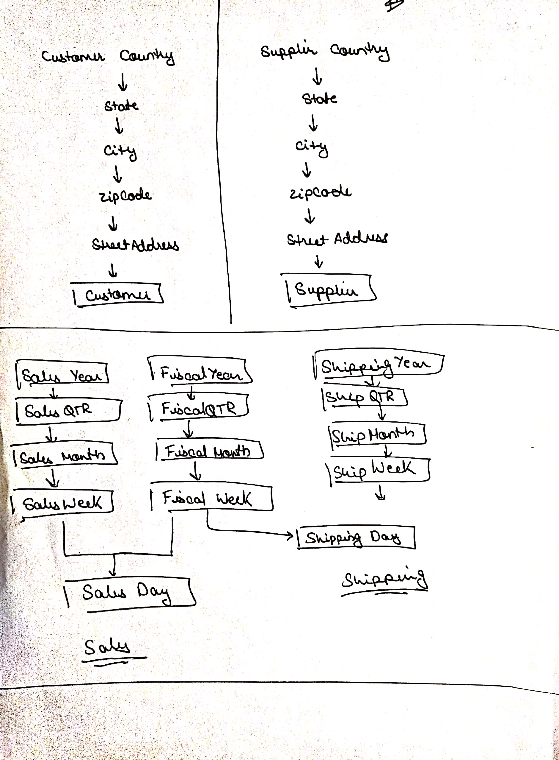

# Part #2. Dimensional Modeling

## Step #2-1: Design Your STAR Schema

Using the information that you have gathered, design a STAR schema for this process. Use MySQL Workbench to formally draw your model. Define tables, attributes, attribute data types, and relationships (with cardinality and participation). Save (paste) your STAR schema in an MS Word or .pdf document and save it to the MyCourse dropbox.

## Step #2-2: Implement the STAR Schema

Create a MySQL database called YourLastName_FinancialDM that will contain your data mart. This will be similar to what you did in Lab #1 using MySQL Workbench.

Implement your STAR schema in your YourLastName_FinancialDM data mart. You should save your SQL generated from MySQL Workbench.

You may define your constraints (PK, FK, etc.) and indexes in your model now but you can wait to implement them in your database until after you’ve loaded the data.

Question: Why would you want to wait?

To avoid taking longer time to load the data, we wait before defining the foreign keys. Once the data is loaded, there is a chance of duplicate data being created which will cause the data to become redundant. Hence, we should wait.

Fill in **Table 3** for the tables that you defined.

*Table 3:* Data Mart Tables

|  |  |
| --- | --- |
| **Table Name** | **Fact or Dimension?** |
| Customer | Dimension |
| Shipping | Dimension |
| Sales_Fact | Fact |
| Product | Dimension |
| Order | Dimension |
| Sales_Date | Dimension |
| Options | Dimension |
| Supplier | Dimension |

**Appendix A: Information Package**

Process Name: __________________________________________________

|  |  |  |  |  |  |  |  |
| --- | --- | --- | --- | --- | --- | --- | --- |
|  |  |  |  |  |  |  |  |
|  |  |  |  |  |  |  |  |
|  |  |  |  |  |  |  |  |
|  |  |  |  |  |  |  |  |
|  |  |  |  |  |  |  |  |
|  |  |  |  |  |  |  |  |
|  |  |  |  |  |  |  |  |
|  |  |  |  |  |  |  |  |
|  |  |  |  |  |  |  |  |
|  |  |  |  |  |  |  |  |
|  |  |  |  |  |  |  |  |
| **Measured Facts:** ___________________________________________________________________________________________________ | | | | | | | |

ISTE-DW Lab #2 Grade Sheet Name: Abhinav Srinivasan

|  |  |  |  |  |
| --- | --- | --- | --- | --- |
| Part/Step | Q# | Max Pts. | Pts. Earned | Comments |
| 1-1 | 1 | 5 |  |  |
|  | 2 | 5 |  |  |
|  | Table 1 | 10 |  |  |
| 1-2 | 1 | 5 |  |  |
|  | 2 | 5 |  |  |
| 1-3 | 1 | 5 |  |  |
|  | 2 | 5 |  |  |
|  | 3 | 5 |  |  |
|  | 4 | 5 |  |  |
| 1-4 | 1 | 5 |  |  |
|  | 2 | 5 |  |  |
|  | Table 2 | 10 |  |  |
| 1-5 | 1 | 5 |  |  |
|  | 2 | 5 |  |  |
| 2-1 | 1 | 15 |  |  |
|  | 2 | 5 |  |  |
|  | 3 | 5 |  |  |
| 2-2 | 1 | 15 |  |  |
|  | 2 | 10 |  |  |
|  | 3 | 5 |  |  |
|  | Table 3 | 5 |  |  |
| Appendix | Info Package | 10 |  |  |
|  | **Total** | 150 |  |  |