National University of Computer and Emerging Sciences


Laboratory Manuals
for
Data Structures Lab
(CL-2001)

Course Instructor | Mr. Waqas Rana
Lab Instructor | Ms. Fatima Ali
Lab TA | Mr. Abdur Rehman
Section | BSE-3B
Semester | Fall 2026

Department of Computer Science
FAST-NU, Lahore, Pakistan

Lab Manual 04

Objectives
- Implement a Stack ADT using an array and a singly linked list.
- Perform basic stack operations such as push, pop, peek, and isEmpty.
- Compare array-based and linked-list-based stack implementations.
- Apply stacks to solve real-world problems such as undo and navigation.

Stacks
Background
A Stack is a linear data structure that follows the LIFO (Last In, First Out) principle. This means the element added last is removed first. Elements are inserted and removed from only one end of the stack, called the top.
For example, a stack of plates works like a stack: the last plate placed on top is the first plate taken out. Common examples of stacks in software include undo operations, browser navigation, function calls, and expression evaluation.
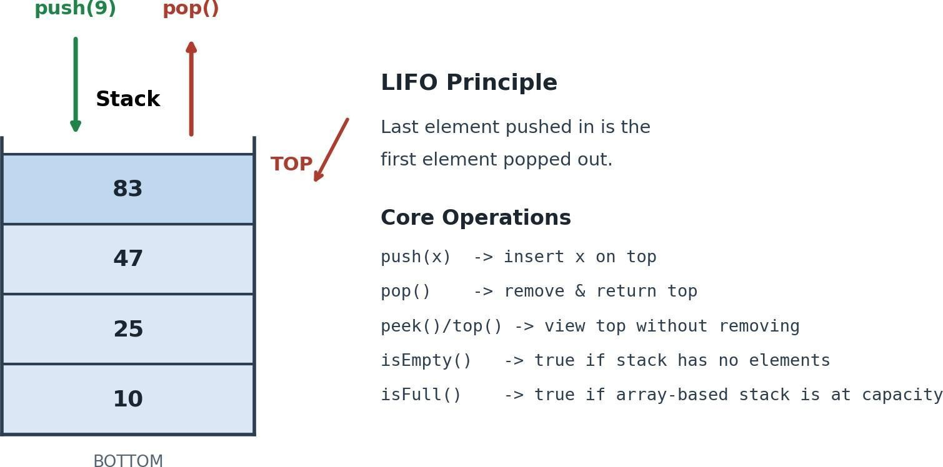

A Stack can be implemented using either an array or a linked list. An array provides a fixed-size implementation while a linked list allows the Stack to grow dynamically as needed.

Part A: Array-Based Stack (10)

Single-Lane Parking System (Stack)

Scenario
A small parking area has only one narrow lane, where cars are parked one behind another. There is only one entrance and exit, so cars cannot move around each other.
- When a car enters, it is parked at the end of the lane (behind the last car).
- When a car needs to leave, the most recently parked car must leave first as it's blocking everyone behind it.
This is a real-world example of the LIFO (Last In, First Out) principle, which is exactly how a Stack behaves. You will implement this system twice, using two different underlying data structures, to see that the same stack behavior can be built in more than one way.
Implement the parking system using a ParkingStack class backed by a dynamically allocated array.

Requirements
- Ask the user to enter the parking capacity at runtime, and allocate the array dynamically to that size. (01)
- Store each car number as a string (e.g. "LEA-1001").
- Maintain a top variable/index that always points to the most recently parked car.
- Implement the following operations: (06)
  - push() – park a new car at the top of the stack.
  - pop() – remove the most recently parked car.
  - peek() – show the car currently at the top without removing it.
  - isEmpty() – check whether the lane has any cars.
  - isFull() – check whether the parking capacity has been reached.
  - display() – show all parked cars from top to bottom without modifying the stack.
- Display a clear message when the user attempts to: (01)
  - Park a car when the lot is full → Stack Overflow.
  - Remove a car when the lot is empty → Stack Underflow.
- Build a menu so the user can repeatedly choose an operation without restarting the program (02)

Part B: [std::stack] Problem Set (20)
In Part A you built a stack completely from scratch (array-backed, your own push/pop/peek). In this part you get to use the built-in std::stack from <stack>.

Task:01 (2)
In this problem, you have to implement the boolean isBalanced(String exp) method, which will take a string containing only curly {}, square [], and round () parentheses. The function will tell us whether all the parentheses in the string are balanced or not. For all the parentheses to be balanced, every opening parenthesis must have a closing one. The order in which they appear, also matters. For example, {[]} is balanced, but {[}]is not.
Sample Input#
exp = "{[({})]}"
Sample Output# True

Task: 02 Postfix Expression Evaluator (3)
In postfix notation, operators come after their operands: 6 3 8 * + 4 - means 6 + (3 * 8) - 4.
Input: single-digit numbers and operators (+ - * /), no spaces, no multi-digit numbers.
Output: the integer result.
"921*-8-4+" // 9 - (2*1) - 8 + 4
Output: 3
(2*1=2 → 9-2=7 → 7-8=-1 → -1+4=3)

Task 03: MinStack (5)

In this problem, you have to implement a new kind of stack called MinStack, which can get the minimum value in O(1) time. An illustration is also provided for your understanding.
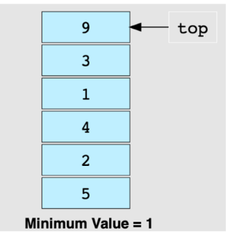

Output:
It returns the minimum number in O(1) time

Task 04: Largest Rectangle in Histogram (10)
Given an array arr[] representing a histogram, where each element denotes the height of a bar and every bar has a uniform width of 1 unit, find the largest rectangular area that can be formed within the histogram. The rectangle must be formed using contiguous bars.

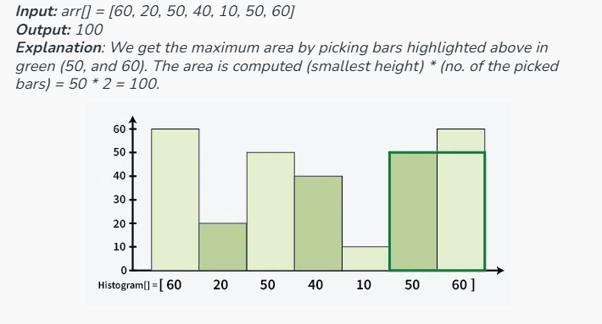

Part C: Linked-List-Based Stack (Take Home) (10)

Scenario
Every time you visit a web page, it's added on top of your history. When you hit the Back button, you return to whichever page you visited right before the current one , the current page is discarded from the "forward" history, again LIFO.
Requirements
Implement a BrowserHistory class backed by a singly linked list.
- Define a Node:
- Maintain a top pointer to the node representing the current page (instead of an array index).
- Implement:
- visit(url): dynamically create a new node for url and push it on top of the history (you just navigated to a new page).
- goBack(): pop the current page off the history and delete its node; the page now on top becomes the current page. Print which page you landed on.
- currentPage() – peek at the page on top without changing anything.
- isEmpty() – true if no pages have been visited yet.
- historyCount() – how many pages are currently in the back-history.
- showHistory() – print all visited pages from most recent to oldest, without modifying the list.
- Show a clear message on:
- goBack() with no history left → Stack Underflow ("No previous page to go back to.").
- There is no overflow case here — that's the point. Explain in one sentence, in a comment above your class, why isFull() doesn't make sense for this version the way it did for the parking lot.
- Wrap everything in a menu

Submission Guidelines
- Submit the following files strictly following the naming convention: l261234.cpp
- l261234.docx (containing screenshots of console output copy-pasted code)
Plagiarism, copying from fellow students, and submitting AI-generated work as your own are strictly prohibited.

