ClassBuilder User Manual
Jimmy Venema
July 2026
Table of Contents

1 Introduction

1.1 What ClassBuilder is
ClassBuilder is a model-driven C++ code generator. You design an object-oriented data model — classes, members, methods, relations, inheritance — in a graphical environment, and ClassBuilder writes the corresponding .h and .cpp source files for you. The generated code is complete, compilable C++: class declarations, constructors and destructors, relation maintenance code, iterators, optional serialization, and optional undo/redo support.
The emphasis is on design first, correct by construction. The mechanical parts of an object model — the parts that are tedious to write and easy to get subtly wrong — are generated from a single description:
- Relations between objects are implemented as intrusive linked lists: fast, allocation-free containers whose maintenance code (insert, remove, cascade delete, iterator bookkeeping) is generated and hidden behind a handful of macros, so the source you actually read stays free of plumbing.
- Ownership is a property of a relation. If every class is reachable from a top class through owned relations, destroying the top object frees the entire object graph — no leaks by design.
- Iterators are self-maintaining: objects can be added or deleted — including the element you are standing on — while you iterate, without invalidating the loop.
- Serialization (save/load of the whole object graph, with schema versioning) and a complete undo/redo framework can be generated on top of the same model.
ClassBuilder is a round-trip code generator, not a one-off wizard: your own logic lives in clearly marked, designated regions inside the generated files (user blocks, method bodies, note comments), and Read Source parses hand edits made there back into the model. Regeneration rewrites everything around those regions — never their content. You can develop in your IDE for days, read the changes back, regenerate, and nothing of yours is lost; the model and the source cannot drift apart.
Historical note — document generation. Earlier (Windows-only) versions could also generate documentation from the model — with the same round-trip idea — into RTF. That feature was bound to Windows and RTF is no longer a common interchange format, so it has been dropped for the moment. It may return in a different form: the building blocks (vector SVG export of every diagram, and the command interface that lets scripts and AI systems walk the entire model) are already in place.
ClassBuilder is self-hosted: the sources of ClassBuilder are generated by ClassBuilder, from a model that ships with the program. Every mechanism described in this manual is exercised daily by the tool itself.
ClassBuilder is a cross-platform tool: the same application runs on Windows, macOS and Linux (it is built on Qt), and a .cbz model file is byte-identical across platforms — design on one machine, continue on another. The generated code and the runtime headers are portable C++ that compiles with MSVC, Clang and GCC alike. Keyboard shortcuts are written as Ctrl+... in this manual; on macOS read Cmd (⌘) wherever Ctrl is named — the mapping is automatic.

1.2 The pieces
Piece | What it is
ClassBuilder.exe | The GUI application (Qt-based; Windows, macOS and Linux).
The model file (.cbz) | Your design, stored as a Zstandard-compressed binary archive.
Generated sources | One .h + one .cpp per class, plus a master include file.
Runtime headers | A small library of CB_*.h headers (plus value types and the serialization runtime) that generated code compiles against.
Command interface | A JSON-over-TCP API through which scripts — or AI systems — can read and modify the live model.

1.3 About this manual
The manual has three parts. Getting started (chapters 2–4): concepts and vocabulary, project setup, and a hands-on quick start that builds a small model, generates code, compiles and runs it — after chapter 4 you can start working. Reference (chapters 5–10): the application shell, the tree, the two diagram views, every dialog, and the code editor — organized so you can look up “what are the toolbar buttons / menu items / context-menu entries / mouse and key gestures in this view”. In depth (chapters 11–16): code generation, the intrusive-list runtime, serialization, undo/redo, the replace constructor, and the command interface, followed by best practices and the appendix.
The examples use the Matrix model — a matrix of cells owned simultaneously by their row and their column — which is small enough to read in one sitting yet touches almost every feature.

1.4 Notation: keyboard shortcuts per platform
This manual writes every shortcut in one notation only — the Windows/Linux form (Ctrl+S, Ctrl+Shift+C, F3, Alt+drag). If you work on macOS, translate with this table; it is not repeated elsewhere in the document:
This manual writes | Windows / Linux | macOS
Ctrl+key (e.g. Ctrl+S) | Ctrl+key | ⌘+key
Ctrl+Shift+key | Ctrl+Shift+key | ⌘⇧+key
F3 (find next) | F3 | ⌘G
Alt+drag | Alt+drag | ⌥+drag
Del | Del | ⌫
Two things make this safe to rely on: ClassBuilder’s menus and tooltips always display the binding that is active on your platform (they are authoritative when in doubt), and mouse gestures (click, drag, wheel, middle-drag) are identical everywhere.
Figures. Screenshots in this manual show ClassBuilder on Windows 11. Diagram figures are SVG exports produced by ClassBuilder itself (via export_diagram_svg, chapter 16). Where a figure is not yet captured, a boxed [FIGURE] note describes exactly what to capture and the intended caption.

2 Concepts and terminology

2.1 The model
A model (document) is the unit you open, edit and save — one .cbz file. It contains:
- Classes — the classes ClassBuilder will generate code for.
- Extern classes — classes that exist outside the model (CbObject, CbArchive, library types, your own hand-written classes). They can be inherited from and referenced, but no code is generated for them.
- Types — non-class types usable for members/arguments (int, void, plus any you add: CString, enums, typedefs with their declaration text).
- Relations — directed, named links between two classes (chapter 12).
- Inheritance edges, with virtual/access modifiers.
- Groups — folders (ClassGroups inside the model or inside MetaGroups) to organize large models; purely organizational.
- Class diagrams and sequence diagrams — graphical views onto the model.
- Actors — external parties that appear on sequence diagrams.
- Project settings — output naming, prefixes, indentation, comment headers, serialize/undo options, phase support.
Everything lives in one tree (chapter 6); diagrams are views of the same underlying objects — a class renamed in a dialog changes everywhere at once.

2.2 Class features
- Members — data members, with type (+ *, &, [], const, mutable, bit-field…), access, static flag, initialization value, optional generated getter/setter, a serialize flag and a version (chapter 13).
- Methods — with return type, arguments (each with type/default), access, virtual / static / const / pure (= 0) / inline / = delete, calling convention, and a body that you write and that round-trips between the model and the source file.
- Constructors / destructor — special methods. Constructor argument lists are largely derived: for every relation the class participates in as a child, the constructor takes the owner pointer(s); the generated ConstructorInclude(...) call splices the new object into those relations.
- Notes — free documentation text on nearly every element; emitted as comments above the declaration.

2.3 Phases
With Phase Support enabled (Project Settings), every element carries a lifecycle phase — Analysis, Design, Implementation, Test, Complete — shown as a second icon in the tree and usable as a tree filter. Purely organizational, no effect on generated code.

2.4 Generated vs. user code
Generated files are divided into regions (chapter 11). Only three kinds of places are yours to edit on disk:
- //@START_USERn ... //@END_USERn blocks (extra includes, declarations, helper code),
- method bodies between {//@CODE_nnnn and }//@CODE_nnnn,
- note comments /*@NOTE_nnnn ... */.
Everything else is rewritten on the next Write Source. Read Source parses your on-disk edits in those regions back into the model.

3 Installation and project files

3.1 The application
ClassBuilder.exe is a single executable (Qt linked statically on Windows). Installing is copying it; associate .cbz files with it for double-click opening. On start-up it also opens the command-interface TCP port (chapter 16).

3.2 What generated code needs — the runtime headers
Generated code #includes a small, header-only runtime. Ship these directories with your project (or point your include path at them):
Directory | Contents | Needed
include/ | CB_Multi.h, CB_MultiOwned.h, CB_Single.h, CB_SingleOwned.h, tree/static/critical variants, CB_IteratorMulti.h, CB_CriticalSection.h, … | always
value/ | CbString.h, CbTime.h, CbColor.h, CbGeometry.h — small value types | when used by your model
serialize/ | CbSerialize.{h,cpp} (CbObject/CbArchive runtime), CbZstdStream.{h,cpp} + the zstd library | only with Serialize on
The generated master include (e.g. MatrixInclude.h) pulls in exactly the CB_* headers the model’s relations need, in the right order, plus all class headers — twice: once for declarations, once (under CB_INLINES) for inline bodies.

3.3 StdAfx.h — the one file you write
With the StdAfx.h code-generation option on (the default), every generated .cpp begins with #include "StdAfx.h". That file is yours, written once per project; it maps the model’s type names onto real headers and includes the master include. The quick start’s version:
// StdAfx.h -- master include for the Matrix sample project.
#ifndef _STDAFX_H
#define _STDAFX_H
#include <assert.h>
#include "CbString.h" // ClassBuilder value-type string
typedef CbString CString; // the model's 'CString' type maps onto CbString
#include "CbSerialize.h" // CbObject / CbArchive / CB_*_SERIAL macros
#include "MatrixInclude.h" // generated master include
#endif
This illustrates a general point: types in the model are just names. The model says a member has type CString; your project decides what that name means.

3.4 Output locations
Each class stores its target file names (.h / .cpp, class dialog); paths are relative to the model file’s directory. Write Source (File menu, toolbar, or the write_source command) regenerates them; it also saves the model, so model and sources stay in step.

4 Quick start — the Matrix model
This chapter builds a complete model, generates the code, compiles it with a small main.cpp, and runs it. Everything shown — generated code, console output, diagrams — is real output produced while writing this manual.
The design. A Matrix owns Rows and Columns; every Cell is owned twice — it sits in its Row’s list and its Column’s list. Deleting a Row must delete its Cells and those Cells must silently vanish from their Columns too. This “one object in several owned containers” pattern is painful with standard containers and is exactly where ClassBuilder shines.
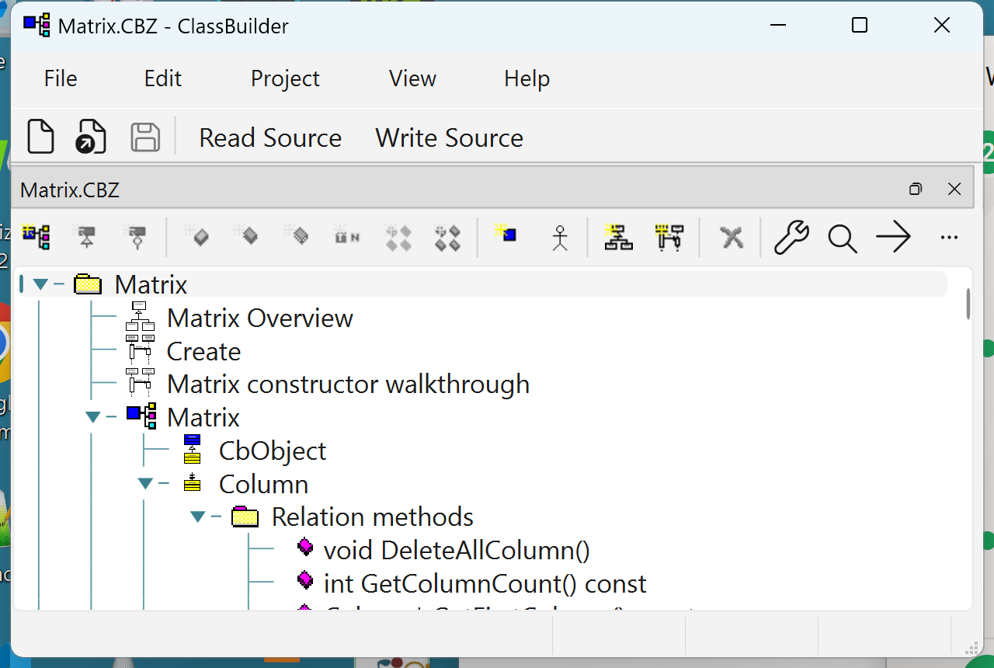
The ClassBuilder shell with the Matrix model open: menu bar, toolbar, and the model tree (diagrams, classes, members, methods, relation methods).

4.1 Step 1 — create the model
File ▸ New... opens the new-model wizard.
[FIGURE] The New Model wizard: model name “Matrix”, master include file “Matrix.h”, the Serialize checkbox ticked and Document class name “Matrix”. Caption: “Creating a serialize-enabled model. The Serialize choice is one-off — it cannot be changed later.”
Choose Serialize support and document class Matrix (chapter 13 explains what is scaffolded: an extern CbObject, the document class Matrix, the polymorphic root MatrixObject, and the relation between them). Two rules to know now:
- Serialize is a one-time choice per model — pick it if in doubt; undo/redo (also enable-once) requires it.
- Every serialize-enabled class single-inherits from the document-object root, directly or transitively; the GUI enforces this.

4.2 Step 2 — add the classes
In the tree, right-click the model node ▸ Add ▸ Class (or Ctrl+Shift+C), and create Row, Column, Cell — each with Serialize on, which auto-inherits them from MatrixObject.
[FIGURE] The Class dialog for “Row”: Class Name, Source/Include File fields, the Properties group (Replace / Dll Export / Serialize / Struct / Relation Macros Last), Member Prefix, Note. Caption: “The Class dialog. With Serialize ticked, the class inherits the model’s document-object root automatically.”

4.3 Step 3 — add members
Right-click Row ▸ Add ▸ Member (Ctrl+Shift+B): type int, name id — bare name, no underscore: the class’s member prefix (default _) is added at generation time, so the emitted member is _id. Set access private and Get method Public: a GetId() getter is generated (and stays in sync if you retype the member). Repeat for Column (id, same settings) and Cell (value of type CString, public, no getter).
[FIGURE] The Member dialog for Row.id: Type combo, Name, the type-property checkboxes (Const/Reference/Pointer/Array/Bit Field…), Access radio group, Get/Set method groups, Initial Value, Serialize checkbox, Note. Caption: “The Member dialog. Getter/setter generation and the serialize flag are per-member choices.”

4.4 Step 4 — add the relations
Right-click Matrix ▸ Add ▸ Relation (Ctrl+Shift+R) and create, all of kind Multi with Aggregation (owned) checked:
From | To | Meaning
Matrix | Row | the matrix owns its rows
Matrix | Column | the matrix owns its columns
Row | Cell | a row owns its cells
Column | Cell | a column owns the same cells
That double ownership of Cell is deliberate — the runtime supports one object in any number of intrusive lists (chapter 12).
[FIGURE] The Relation dialog for Row→Cell: From/To class combos and role names, Association Type radio group (Single / Multi / Static Multi), Association Properties (Aggregation / Critical / Filter), Implementation group (Standard / Value Tree / AVL Tree, Unique). Caption: “A relation: kind, ownership, thread-safety, and container implementation are all declared here — the code is generated.”

4.5 Step 5 — constructors, with real code in the bodies
Right-click each class ▸ Add ▸ Constructor (Ctrl+Shift+U). ClassBuilder derives the argument list: Row’s constructor automatically takes (Matrix* pMatrix) — the owner — plus whatever you add (here: int id). The generated body begins with ConstructorInclude(pMatrix), which splices the new Row into the matrix’s list; below the // Put in your own code marker the body is yours.
Give Row this body (the code editor auto-indents C++). It walks the matrix’s Columns and creates one Cell per column — using a generated iterator:
Matrix::ColumnIterator iColumn(pMatrix);
while (++iColumn)
{
(void)new Cell(this, iColumn, "");
}
Column’s constructor mirrors it (one Cell per existing Row) — the symmetry means Rows and Columns can be added in any order later and the cell grid stays complete. Cell’s constructor just takes its two owners plus the value; its ConstructorInclude(pRow, pColumn) splices it into both lists. Matrix(int rows, int columns) creates the grid:
_version = 2; // model version written into every save (chapter 13)
for (int c = 0; c < columns; c++)
{
(void)new Column(this, c);
}
for (int r = 0; r < rows; r++)
{
(void)new Row(this, r);
}
Note what is absent: no container declarations, no push_back, no bookkeeping. Creating an object with its owner as argument is the insertion.

4.6 Step 6 — a find method
Right-click the Matrix→Row relation ▸ add a Find Method on member id. The generated FindRow(int id) iterates the relation and compares — and if the relation used a tree implementation, the same dialog generates the fast tree lookup instead (chapter 12.7):
Row* Matrix::FindRow(int id)
{//@CODE_3308
RowIterator iRow(this);
while (++iRow)
{
if (id == iRow->GetId())
{
return iRow;
}
}
return 0;
}//@CODE_3308

4.7 Step 7 — a class diagram
Right-click the model node ▸ Add ▸ Class Diagram, name it Matrix Overview, and add the four classes (Select Classes... from the diagram’s context menu, or drag them from the tree). Optimize Placement lays them out.
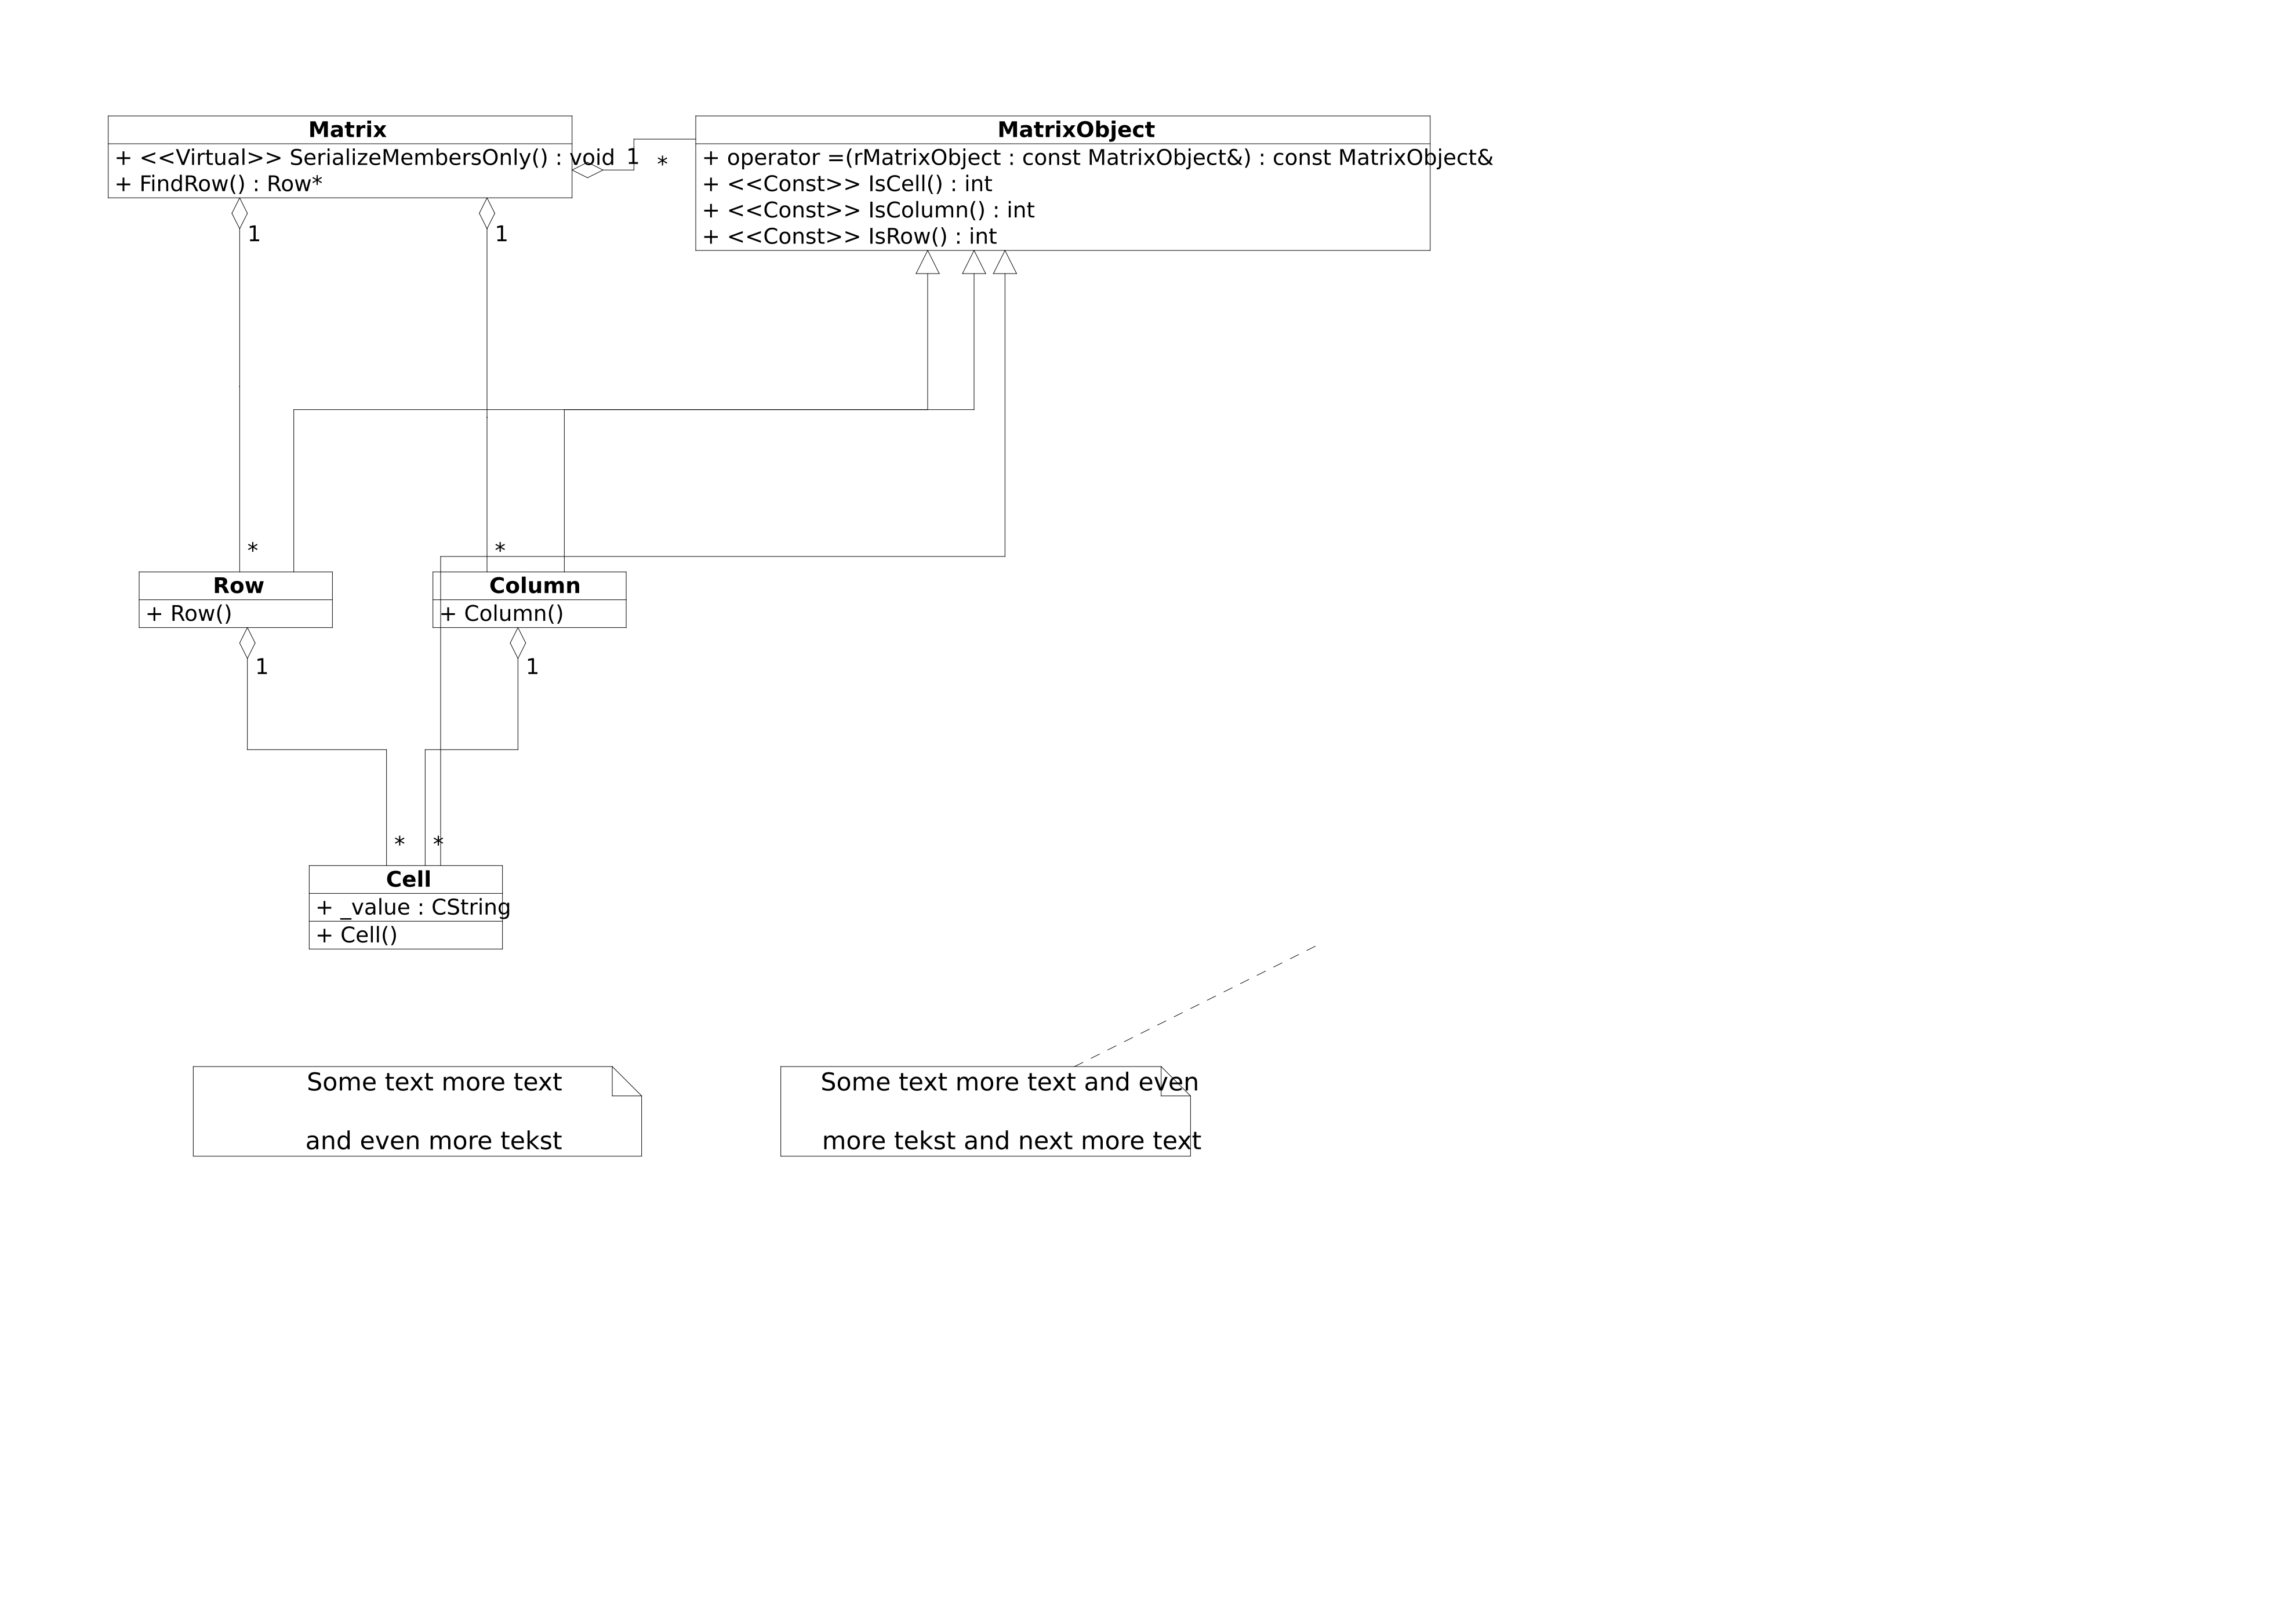
The Matrix Overview class diagram as exported by ClassBuilder (Export SVG). Diamonds mark owned (aggregation) relations; 1/* are the multiplicities.
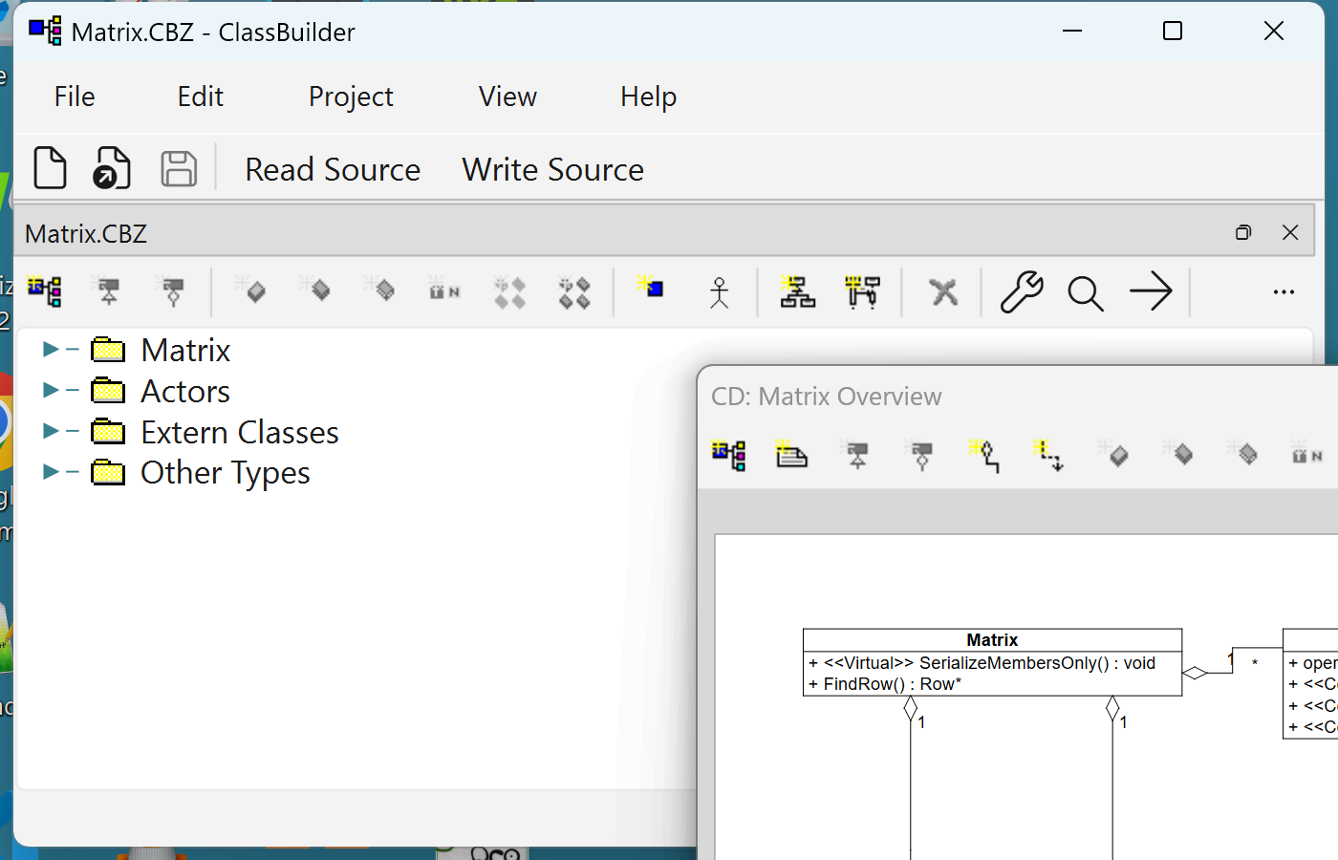
A class-diagram view opens as a dockable window over the shell — dock it, tab it, or float it.

4.8 Step 8 — generate the source
File ▸ Save Source... (toolbar: Write Source). One .h + one .cpp per class appear next to the model, plus MatrixInclude.h. This is the actual generated Cell.h (abridged header comment):
#ifndef _CELL_H
#define _CELL_H
//@START_USER1
//@END_USER1
class Cell
: public MatrixObject
{
CB_DECLARE_SERIAL(Cell)
RELATION_MULTI_OWNED_PASSIVE(Row, Row, Cell, Cell)
RELATION_MULTI_OWNED_PASSIVE(Column, Column, Cell, Cell)
//@START_USER2
//@END_USER2
// Members
private:
protected:
public:
CString _value;
// Methods
private:
void ConstructorInclude(Row* pRow, Column* pColumn);
void DestructorInclude();
void SerializeConstructorInclude();
protected:
Cell();
virtual void Serialize(CbArchive& archive);
virtual void SerializeRelations(CbArchive& archive,
MatrixObject* pointerArray[]);
public:
Cell(Row* pRow, Column* pColumn, CString value);
virtual ~Cell();
};
#endif
The two RELATION_MULTI_OWNED_PASSIVE macros are Cell’s memberships in its Row’s and Column’s lists — the link pointers (_refRow/_prevRow/_nextRow, _refColumn/_prevColumn/_nextColumn) become members of the Cell itself. The .cpp contains the constructors/destructor with your bodies, and a protected block (//{{AFX DO NOT EDIT ...) with the generated relation and serialize machinery.

4.9 Step 9 — compile and run
A minimal driver (main.cpp) exercises the model — construction, iteration from both sides, find, cascade delete, deletion during iteration, and a save/load round-trip:
Matrix* pMatrix = new Matrix(3, 4);
// fill values by iterating rows -> cells
Matrix::RowIterator iRow(pMatrix);
while (++iRow)
{
int c = 0;
Row::CellIterator iCell(iRow);
while (++iCell)
{
char buf[32];
sprintf(buf, "r%dc%d", iRow->GetId(), c++);
iCell->_value = buf;
}
}
// the same cells, reached through a Column's list
Matrix::ColumnIterator iColumn(pMatrix);
while (++iColumn) { /* ... print iColumn's cells ... */ }
Row* pRow = pMatrix->FindRow(1);
delete pRow; // cascade: row's cells leave the columns too
// save -> destroy -> reload (Zstd-compressed archive, chapter 13)
{
std::ofstream raw("matrix.cbz", std::ios::binary);
CbZstdOutBuf zbuf(raw);
std::ostream zos(&zbuf);
CbArchive ar(zos);
pMatrix->Serialize(ar);
}
delete pMatrix;
Matrix* pLoaded = new Matrix(); // serialize ctor: empty shell
{
std::ifstream raw("matrix.cbz", std::ios::binary);
CbZstdInBuf zbuf(raw);
std::istream zis(&zbuf);
CbArchive ar(zis);
pLoaded->Serialize(ar);
}
Compiled with the generated files + runtime headers (here with GCC; MSVC works identically):
g++ -std=c++17 -I. -Iinclude -Ivalue -Iserialize \
main.cpp Matrix.cpp MatrixObject.cpp Row.cpp Column.cpp Cell.cpp \
serialize/CbSerialize.cpp serialize/CbZstdStream.cpp -lzstd -o matrixdemo
The actual run:
created: 3 rows x 4 columns
column 0: r0c0(row 0) r1c0(row 1) r2c0(row 2)
column 1: r0c1(row 0) r1c1(row 1) r2c1(row 2)
column 2: r0c2(row 0) r1c2(row 1) r2c2(row 2)
column 3: r0c3(row 0) r1c3(row 1) r2c3(row 2)
FindRow(1) -> row 1 with 4 cells
first column has 3 cells before the delete
first column has 2 cells after deleting row 1
after mid-iteration delete: 1 rows left
reloaded: 1 rows x 4 columns, first cell 'r2c0'
done -- every object freed by cascade, no leaks by design
Read those middle lines again: deleting one Row made its cells disappear from every Column — no code was written for that. A row was deleted while iterating the rows — the loop just continued. The whole surviving structure round-tripped through a compressed binary file. That is the value proposition of ClassBuilder in eleven lines of console output.

4.10 Step 10 — the round trip
Edit a generated body on disk (inside its //@CODE markers), switch back to ClassBuilder, and use File ▸ Read Source... (Read Modifications): the model absorbs your edit. If ClassBuilder itself has the file’s model open when the source changes, it offers the read-back automatically — accept it, or your next Write Source will overwrite the edit. Model ↔ source is a two-way street.

5 Reference: the application shell

5.1 Menus
Menu | Items
File | New… (Ctrl+N) · Open… (Ctrl+O) · Close Model (Ctrl+W) · Save (Ctrl+S) · Save As… · Save Source… · Read Source… · Delete Source · Exit
Edit | Undo (Ctrl+Z) · Redo (Ctrl+Y)
Project | Settings… · Add Serialize… · Refresh Object IDs
View | New Window · Zoom In (Ctrl++) · Zoom Out (Ctrl+-) · Zoom Full
Help | About ClassBuilder…
Save Source / Read Source are the code-generation round trip (chapter 11). New Window opens a second full tree of the active model. The zoom items act on the active diagram view.

5.2 The main toolbar
Button | Icon | Enabled when
New | new-document glyph | always
Open | open-folder glyph | always
Save | diskette glyph | a model is open and modified
Read Source | text button | the model has been saved to a path
Write Source | text button | the model has been saved to a path
Undo/Redo are deliberately not on the main bar: with several models open they would be ambiguous. They live on each view’s own toolbar (tree and diagrams), and always act on that view’s model.
[FIGURE: Main toolbar] — cropped strip of the main window toolbar (New / Open / Save / Read Source / Write Source).

5.3 Docking
Every view — model trees, class diagrams, sequence diagrams, scoped sub-window trees — lives in the same docking system:
- Views of one model tab together by default; the tab is the drag handle.
- Drag a tab off its row to float the view as its own window; drag it back to re-dock (drop indicators show split vs. tab targets).
- Any pane can be split horizontally/vertically by dropping a view on a pane edge.
- Closing a model’s tab closes the model (with a save prompt when modified).

5.4 Platforms and keys
One binary behavior set on Windows, macOS and Linux, with these platform notes:
- Shortcuts: this manual uses Windows/Linux notation only — the translation table lives in chapter 1 (Notation). Menus and tooltips always display the binding active on your platform.
- AltGr rule: accelerators avoid Ctrl+Alt combinations because on European layouts they collide with AltGr characters — the Add accelerators are all Ctrl+Shift+....
- macOS specifics: ClassBuilder uses Qt’s file dialogs (not the native panels), dock tabs are left-aligned, and the tree adds a hover highlight and adjusts branch-triangle colors on selection — cosmetic parity fixes only; features are identical.
- The status bar shows Width/Height/X/Y of the shape under the cursor in diagram views.

6 Reference: the main tree view
The tree is the master view of a model: every element, in its structure. Multiple models open side by side as tabs; trees and diagram views dock, tab, split and float freely.

6.1 What the tree shows
The model node at top (with class diagrams, sequence diagrams and top-level classes under it), the Actors, Extern Classes and Other Types nodes, groups, and under every class: inheritances, members, methods (with full signatures), constructors/destructor, arguments, relations, and the generated Relation methods in their own folder — visible but owned by the generator. Every node type has its own icon; with Phase Support on, a phase glyph joins it.

6.2 The tree toolbar
Button order, with each button’s accelerator (all Ctrl+Shift+... on purpose: Ctrl+Alt combinations collide with AltGr on European keyboard layouts). A button is enabled exactly when the action is legal on the current selection — the same gate the context menu uses.
Button | Key | Icon glyph
Add Class | Ctrl+Shift+C | class box
Add Inheritance | Ctrl+Shift+I | inheritance triangle
Add Relation | Ctrl+Shift+R | relation line
Add Member | Ctrl+Shift+B | member diamond
Add Method | Ctrl+Shift+M | method diamond
Add Constructor | Ctrl+Shift+U | constructor diamond
Add Argument | Ctrl+Shift+A | argument
Add Virtual Methods | Ctrl+Shift+V | paired diamonds
Add IsClass Methods | Ctrl+Shift+S | paired diamonds (Is)
Add Type | Ctrl+Shift+Y | type block
Add Actor | Ctrl+Shift+T | stick figure
Add Class Diagram | — | class-diagram thumbnail
Add Sequence Diagram | — | sequence-diagram thumbnail
Delete | Del | cross
Filters… | — | wrench
Find… / Next | Ctrl+F / F3 | magnifier / arrow
Undo / Redo | Ctrl+Z / Ctrl+Y | arrows (per-view, act on this model)
Three additions have accelerators but no button: Group Ctrl+Shift+G, Meta Group Ctrl+Shift+P, External Class Ctrl+Shift+E (X was unavailable — it is an OS hotkey).
[FIGURE: Tree toolbar] — cropped strip of the tree toolbar, wide enough to label each button in the caption.
The element icons themselves (class, member, method, relation…) encode access as color variants (public/protected/private) and state (inline, empty-body); they are the same icons used in the diagrams, drawn from SVG with the legacy .ico set as fallback.

6.3 The context menu
Right-click any node (an unselected node is selected first). The full menu, top to bottom — items appear/enable per node type:
- Open — the double-click action: attribute dialog, the code editor for methods with bodies, the view for diagram nodes.
- Edit Attributes — the element’s dialog (chapter 9).
- Edit User Sections / Edit Section ▸ — a class’s six free-code sections, or jump straight to one (Before/Inside/After class definition .h, Before/After master include, After generated code .cpp).
- Edit Exception Specification — per-method exception clause.
- Edit Context / Assign Context — define contexts on the model node, assign them on classes/methods (chapter 9, Context).
- Copy / Paste (Ctrl+C / Ctrl+V) — subtree copy, also across models: copy a class in one model, paste into another.
- Sort on Name / Sort on Phase — reorder children.
- Add ▸ — everything addable here: Class Diagram, Sequence Diagram, Group, Class, External Class, Inheritance, Relation, Member, Method, Constructor, Argument, Meta Group, Actor, Virtual Methods, IsClass Methods, Type — plus Deleted Copy Ctor + operator= on a class (adds both as = delete in one click).
- Phase ▸ — Analysis / Design / Implementation / Test / Complete.
- Base Classes / Derived Classes — read-only inheritance-hierarchy browsers.
- New Sub Window — a second, scoped tree rooted at this node, as its own dockable view.
- Delete Multiple… — bulk delete (below).
[FIGURE: Tree context menu] — the context menu open on a class node, with the Add submenu expanded.

6.4 Filters
Filters… opens the access/phase filter panel: check which access levels (public/protected/private, per element kind) and which phases are visible. Filtered nodes disappear from the tree and the diagrams — useful to show a design-level view of an implementation-heavy model.
[FIGURE] The Filters dialog with the phase checkboxes (Analysis…Complete) and per-kind access checkboxes. Caption: “Tree filters: what you hide here is hidden in every view.”

6.5 Delete Multiple
Delete Multiple... shows a checkbox tree scoped to the clicked node, with type filters and Select All — tick everything to remove and delete it as one undo step. The fastest way to clean up an imported or experimental model.
[FIGURE] The Delete Multiple dialog over a class subtree with several members and methods checked. Caption: “Bulk delete: one dialog, one undo step.”

6.6 Drag, and copy-drag
Dragging in the tree is move-or-copy:
- Plain drag = move: the node re-parents under the drop target (the model validates which parents are legal per element type; illegal targets simply don’t highlight). The dragged row lifts out of the tree while dragging.
- Ctrl+drag = copy: the ghost cursor gains a green + badge and the original stays put — this is how you clone a member/method subtree onto another class quickly.
- Valid drop targets highlight with a tinted row and an accent bar at the left edge.
Everyday examples: drag an argument onto a method to add it there (Ctrl+drag to copy it from another method — the fast way to replicate a signature); drop a type node — a Class, Extern Class or Other Type — onto a method to add a new argument of that type; the same move/copy works for members and methods between classes, and for classes between groups.
Tree → diagram (hold Ctrl and drag over an open diagram view):
- onto a class diagram: a class node drops as a new class shape at the cursor (a ghost of the shape previews while hovering);
- onto a sequence diagram: a class or actor drops as a new lifeline.

7 Reference: class diagrams
A class diagram shows selected classes as UML boxes with their inheritances, relations and dependencies. A model can have any number of diagrams; each shows a chosen subset of classes and features — small focused diagrams beat one wall-sized one.
[FIGURE] A class-diagram view with one class selected (translucent selection box and resize handles visible), a relation and an inheritance between classes, and the CD toolbar along the top. Caption: “The class-diagram view. Selected shapes get a translucent accent box; the last-selected shape is the align anchor.”

7.1 Reading the diagram
- Class box: name, then members / methods (which access levels appear is a per-diagram setting; which individual features appear is per-shape via Select Members & Methods...).
- Inheritance: triangle-headed arrow to the base.
- Relation: line with a diamond on the owner side when owned (aggregation); multiplicities 1/* at the ends; the role names optionally shown (Show Relation Names).
- Dependency: dashed arrow with a name and a stereotype (<<uses>>-style) — a modeled “uses” link that affects only includes/forward declarations in the generated code, not object structure.
- Relation (Diagram Only): looks like a relation but exists only in the drawing — nothing is added to the model and nothing is generated. Use it for documentation-only connections.
- Notes: free-text boxes, attachable by connection points to other shapes.

7.2 Selection
- Click selects the shape under the cursor (clicking an already-selected shape keeps the selection, so a drag can follow). Clicking empty space clears the selection.
- Ctrl+click toggles a shape in/out of the selection; Shift+click always adds.
- Rubber band: drag from empty space — shapes fully enclosed by the dashed box are selected (with Shift: added to the selection).
- Ctrl+A selects all top-level shapes; Esc clears the selection (or cancels whatever drag/placement is in progress).
- When several things overlap, the hit-test prefers the small things first: connection text labels, then note connection points, then connection segment handles, then resize handles, then shape bodies.
- Selected shapes are outlined (and lightly filled) in the accent color. The last-selected class/note carries a darker frame: it is the anchor that Align works against.
- A right-click on an unselected shape selects it first, then opens the context menu.

7.3 Moving and resizing
- Move: drag any selected shape — a multi-selection moves as a block (dashed ghost outlines preview the landing spots). Connections between two moved shapes translate along; connections to unmoved shapes re-route.
- Resize: classes and notes have left/right edge handles (cursor becomes a horizontal double arrow). Width is clamped to a minimum; height is derived from content. Manually resizing a class turns its Auto Width off (re-enable via the context menu).

7.4 Editing connection routing
Connections are orthogonal poly-lines that you can reshape — select the connection first:
- Middle segments slide perpendicular to their direction (a vertical segment moves left/right — horizontal double-arrow cursor; a horizontal one moves up/down). Movement snaps to the grid and is clamped so the routing stays legal; a dashed ghost previews the result.
- End points slide along the class perimeter (four-arrow cursor). The whole path re-routes live: the preview shows the complete re-routed connection — arrowheads, diamonds and all — as a dashed ghost.
- Move all — Alt: hold Alt while dropping and every sibling connection that shares the same routing moves together. This is how you move the shared trunk of all inheritance lines of a base class in one gesture: drag any one of them with Alt, and every collinear sibling follows. The same applies to Alt on a shared start point.
- Text labels (relation role names and multiplicities, dependency name/stereotype) are draggable on a selected connection (four-arrow cursor, snaps to the grid). Once moved, a label stays where you put it.

7.5 Members and methods inside the box
- A member/method row is individually selectable; double-click opens its dialog.
- Reorder by drag: press on an already-selected row and drag vertically — a horizontal insertion line shows the landing slot. Members reorder among members, methods among methods. The new order is model order: it changes the declaration order in the generated file.
- Arrow keys walk the rows of a class (header ↔ members ↔ methods).

7.6 Notes and their connection points
Notes attach to other shapes with connection lines whose points are positional (“semi-attached”): a point that lies inside a shape’s rectangle travels with that shape when it moves — nothing is hard-wired, so you can park a point anywhere.
- Drag a note’s corner point outward to spawn a new point (the attach-line grows a joint); drag a point back inside the note to delete it.
- While dragging, a dashed line plus a small square marker previews the geometry.

7.7 Creating elements on the canvas
- Key + drag (the fastest way): hold a key, then drag from one class to another — the cursor becomes a crosshair, a dashed line follows the drag, and the target class highlights:
  - R — Relation (dialog opens on drop; Cancel creates nothing)
  - I — Inheritance (drag from derived to base)
  - D — Dependency
  - O — Relation (Diagram Only)
  - One gesture per key press; Esc cancels mid-drag.
- Placement modes: Add ▸ Class (Ctrl+Shift+C) or Add ▸ Note (Ctrl+Shift+N) arm a crosshair with a footprint ghost; click to place (the class/note dialog opens), right-click or Esc to cancel.
- From the selection: select the from class, Shift+click the to class, then use Add ▸ Relation / Add ▸ Inheritance — the dialog opens pre-filled with the pair in selection order.
- Add ▸ also creates members/methods/constructors/arguments directly on the selected class or method — same dialogs as the tree.
- Deleting a shape asks whether to remove it from the diagram or from the model.

7.8 Align
Select two or more classes/notes and align them to the anchor (the last-selected shape, marked with the darker frame): Left / Center / Right (horizontal) and Top / Middle / Bottom (vertical) — from the context menu’s Align ▸ submenu or the toolbar’s align dropdown. Optimize Placement (≥ 2 classes) auto-lays-out the whole diagram instead.

7.9 Hiding, per-shape toggles, colors
- Hide removes selected connections from view (per diagram); Show Hidden brings them back via a picker.
- Per-class toggles: Auto Width, Show Method Arguments. Per-relation: Show Relation Names.
- Change Line Color… / Change Text Color… recolor the selected shapes.
- Color Templates ▸ sets the document-wide default colors — class line/text, member text, method text, relation line/critical-relation line/text, inherit line, diagram-only line/text, dependency line/text, note line/text. Each opens a color picker seeded with the current value; the change applies to every diagram of the model (and is undoable).

7.10 Zoom and pan
Input | Effect
Ctrl+wheel (or trackpad pinch) | zoom in/out, anchored at the cursor
Ctrl+= / Ctrl+- / toolbar | zoom one step in/out
Toolbar Fit / double-click empty space | reset to fit-to-window
wheel / trackpad scroll | pan
middle-mouse drag | pan (closed-hand cursor)
scrollbars | pan
Zoom ranges from 0.1× to 32×; the status bar’s X/Y fields track the model coordinates under the cursor.

7.11 The CD toolbar
In order: Add Class, Add Note (both arm placement) · Add Inheritance, Add Relation, Add Relation (Diagram Only), Add Dependency (enabled per selection) · Add Member / Method / Constructor / Argument / Virtual Methods / IsClass Methods (enabled when a single suitable target is selected) · Align dropdown (≥ 2 alignable) · Delete (any selection) · Undo / Redo · Zoom In / Zoom Out / Fit · Export SVG.
[FIGURE: Class-diagram toolbar] — cropped strip of the CD toolbar in the order above.

7.12 The CD context menu
Open · Edit Attributes · Delete · Add ▸ (all of the above) · Edit User Sections... · Edit Exception Specification... · Edit/Assign Context... · Change Line/Text Color... · Color Templates ▸ · Auto Width · Show Method Arguments · Show Relation Names · Hide / Show Hidden · Select Classes... · Select Members & Methods... · Optimize Placement · Align ▸ · Reorder Members & Methods... · Inherits From... / Inherited By....
[FIGURE: Class-diagram context menu] — the context menu open on a selected class shape, with the Add submenu expanded.

7.13 Canvas keys
Key | Action
R / I / D / O + drag | create relation / inheritance / dependency / diagram-only
Ctrl+Shift+C/N | arm Add Class / Add Note placement
Ctrl+Shift+I/R/O/D/B/M/U/A/V/S | the Add actions (as on the tree)
↑ / ↓ | walk the rows of the selected class
Del | delete selection
Esc | cancel placement/drag/rubber-band, else clear selection
Ctrl+A | select all

8 Reference: sequence diagrams
Sequence diagrams show interactions: which object calls what, in which order. Lifelines (classes or actors) run vertically; activations (the narrow boxes) are nested calls; messages (signals) are the arrows between them. Activations can be bound to a real method of the model — the diagram then knows the signature, and Open on the activation jumps straight into the method’s code editor.
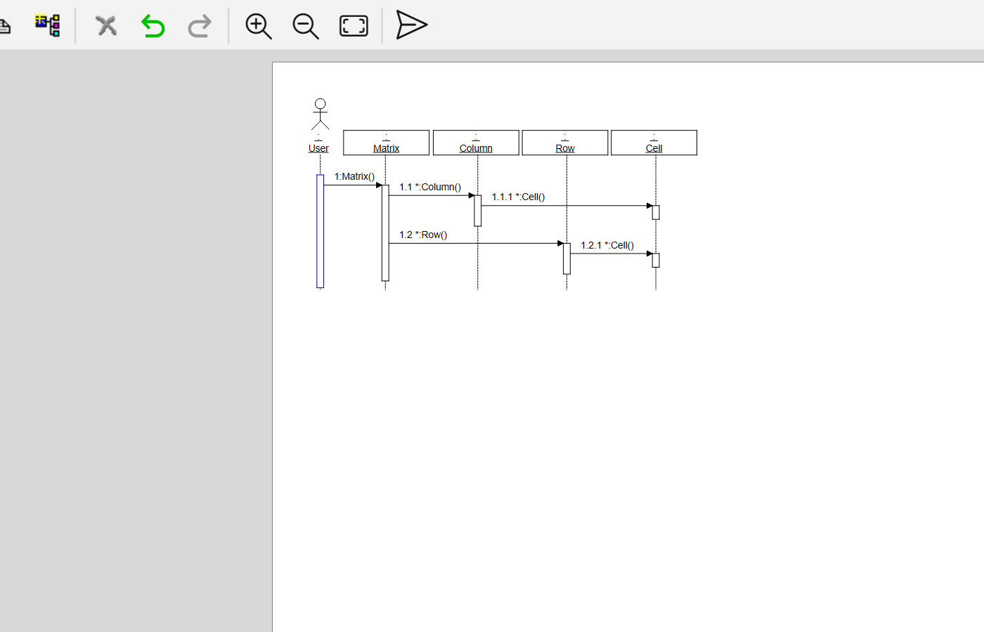
A sequence-diagram view in the shell — its own toolbar (delete, undo/redo, zoom, export SVG) at the top; diagram views dock, tab and float exactly like the trees.
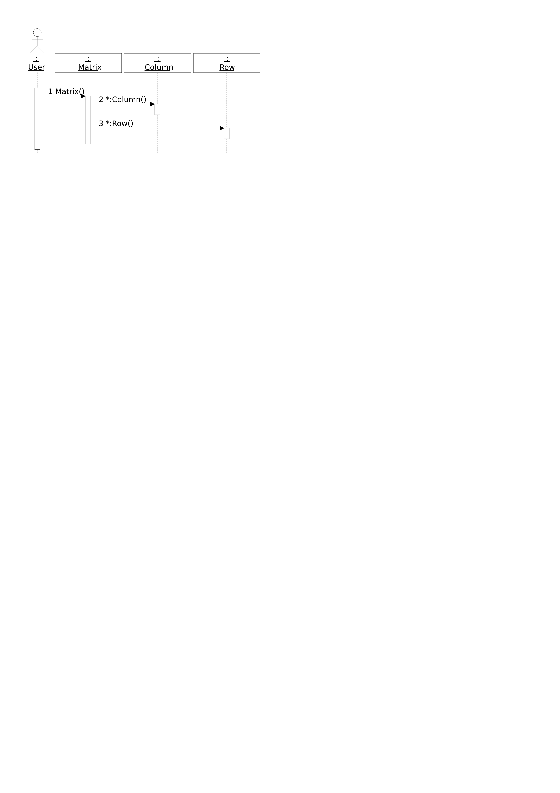
The “Creating a Matrix” sequence diagram (SVG export, generated with add_call_trace): a User triggers Matrix(rows, columns), which constructs the Columns and Rows.

8.1 Building one
- Add ▸ Sequence Diagram on the model/class/group node; the dialog sets numbering style (1, 1.1.1, a, …), whether message labels show argument types/names/scope, caption, scale.
- Add lifelines: Add ▸ Lifeline (Ctrl+Shift+L) then click on the lifeline row, Ctrl+drag classes/actors in from the tree, or Add ▸ Class to create a class and its lifeline in one go.
- Create messages by dragging: press on a sender activation and drag onto a target — another activation, or a lifeline body (which creates the receiving activation). A dashed preview line follows the drag and the cursor becomes a pointing hand over a valid target; on drop the message dialog opens to bind a method (Cancel creates nothing). Creation/destruction flags mark constructor/destructor semantics. Self-calls and cycles are refused.
- Notes: free boxes with attach-lines — see below.

8.2 What moves, and how
What | Gesture | Notes
Receiving activation | drag the message arrow up/down | vertical only; clamped to its container; dashed ghost
Sending activation | Alt + drag the arrow | same drag, other end
Activation among siblings | Ctrl+↑ / Ctrl+↓ (or context menu Move Up/Down) | reorders the call sequence
Lifeline | drag its head left/right, or Ctrl+← / Ctrl+→ | horizontal only; siblings shift aside
Signal texts (name, guard label, return) | drag, on a selected signal | free 2-D offset, grid-snapped
Note | drag body / left-right edge handles | move / resize
Note attach-line points | drag the point | see below
Notes and their points. Like class-diagram notes, attach-line endpoints are semi-attached: purely positional, so a point lying on a lifeline or signal travels with it. Dragging a corner point outward spawns a new joint; dragging a point back into the note deletes it. On release, a point near a signal arrow snaps vertically onto it — the line then tracks that signal.

8.3 Keeping it readable
Three context-menu layout commands (each one undo step):
- Optimize Placement — reorders lifelines to minimize crossings, packs horizontally, resets offsets.
- Space Lifelines — even horizontal spacing, order preserved.
- Reset Activation Offsets — clears manual vertical tweaks.
Collapse Activations to Note replaces a selected group of nested activations with a summarizing note — good for hiding boilerplate sub-calls.

8.4 Toolbar, colors, zoom
- Toolbar: Add Lifeline, Add Note, Add Class (placement/dialog) · Delete · Undo / Redo · Zoom In / Out / Fit · Export SVG.
[FIGURE: Sequence-diagram toolbar] — cropped strip of the SD toolbar. [FIGURE: Sequence-diagram context menu] — the context menu open on an activation, with the Add submenu expanded. - Colors: per-shape Change Line/Text Color..., plus the document-wide Color Templates ▸ for the sequence-diagram defaults (lifeline, activation, signal and note line/text colors) — same mechanism as in class diagrams. - Zoom & pan: identical to class diagrams (Ctrl+wheel anchored at the cursor, Ctrl+=/Ctrl+-, Fit via toolbar or double-click on empty space, pan with plain scroll / middle-drag / scrollbars, pinch on trackpads).

8.5 Canvas keys
Key | Action
Ctrl+Shift+L / Ctrl+Shift+N | arm Add Lifeline / Add Note placement
Ctrl+Shift+C | Add Class (dialog; lifeline auto-placed)
Ctrl+↑ Ctrl+↓ | move activation up/down among siblings
Ctrl+← Ctrl+→ | move lifeline left/right
← → / ↑ ↓ | navigate between related shapes / along a lifeline
Enter | open the selected shape (as double-click)
Del / Esc / Ctrl+A | delete / cancel-or-clear / select all
A power feature for documentation: call traces. Via the command interface (add_call_trace, chapter 16), ClassBuilder scans a method body, resolves the calls against the model, and generates a whole sequence diagram of the call tree automatically — the figure below was made that way from Matrix::Matrix(int, int).
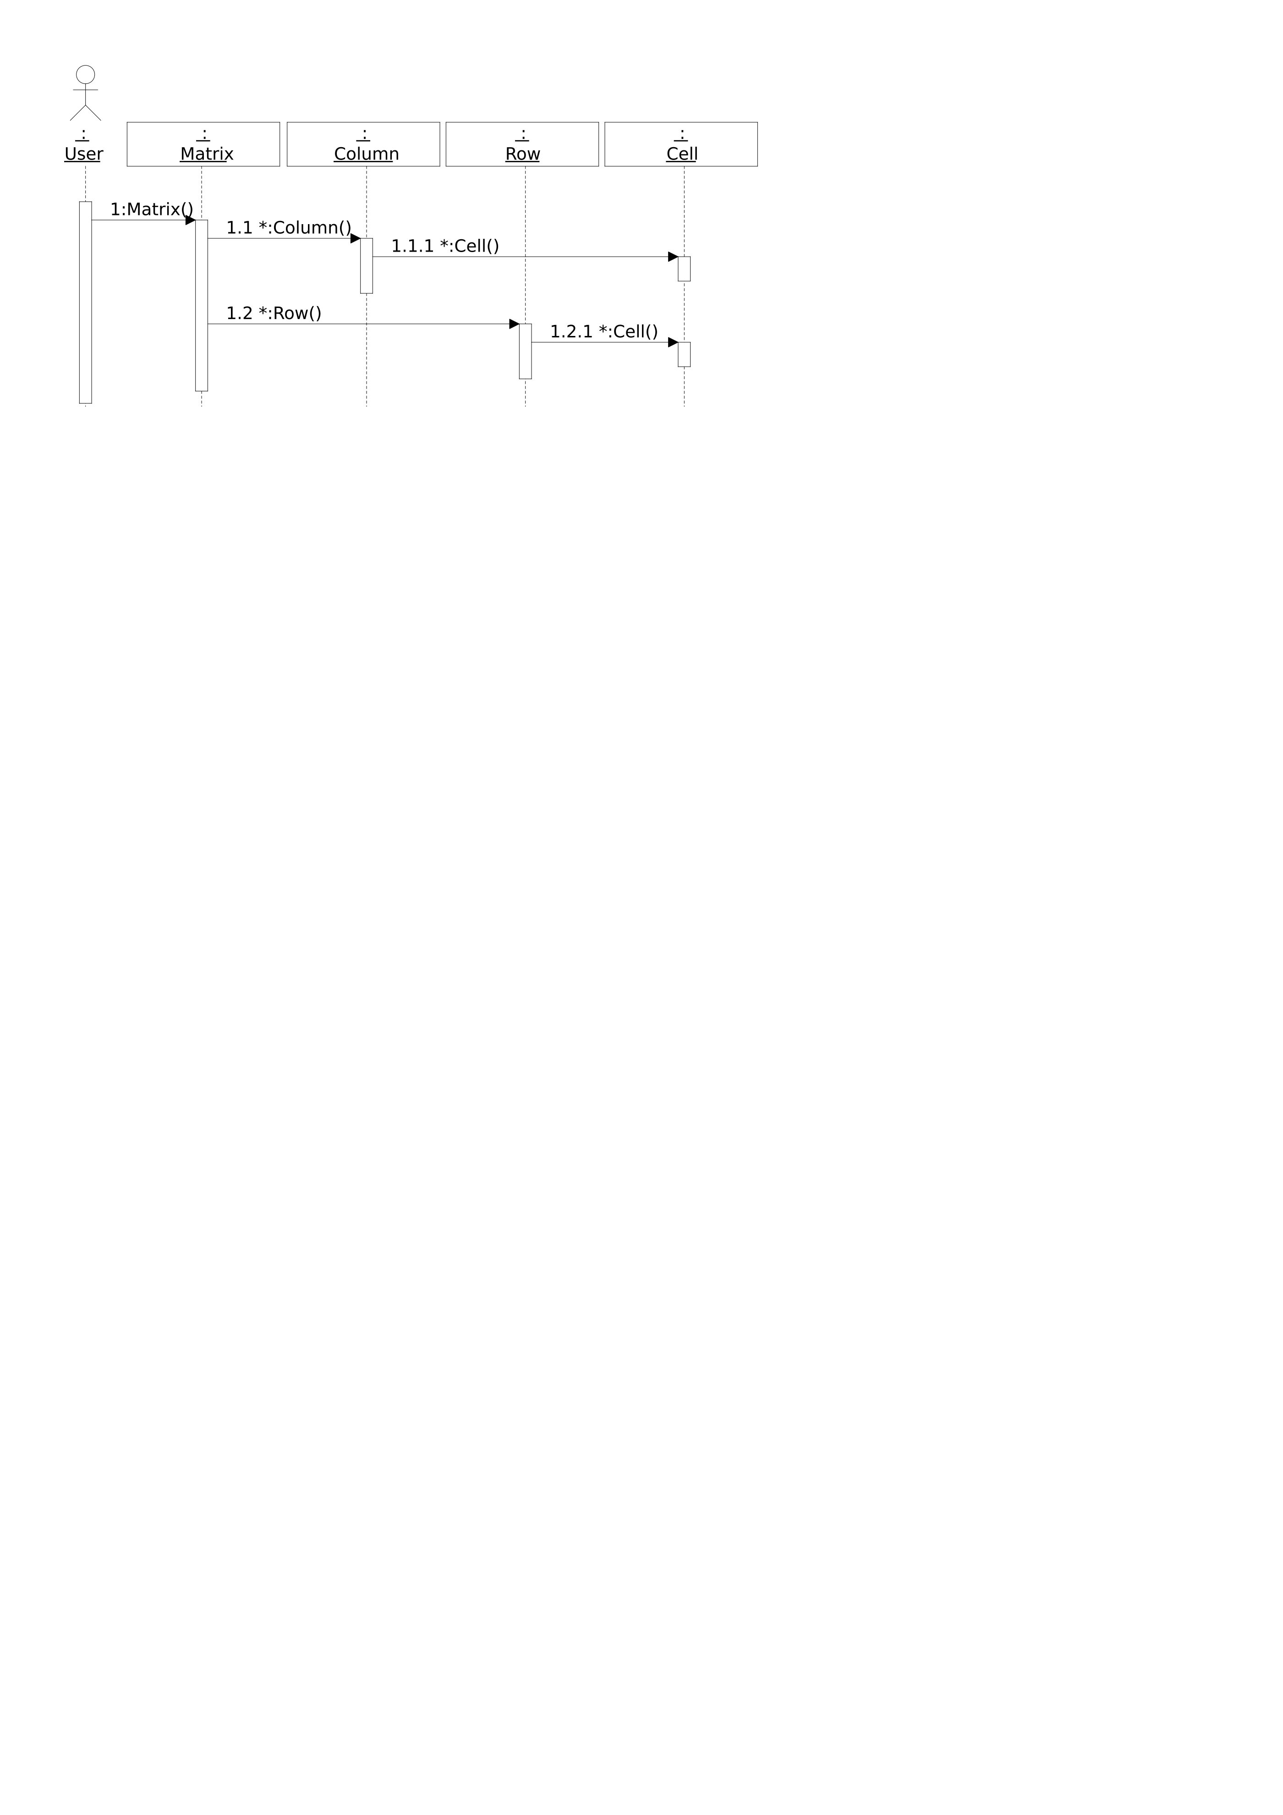
A pipe-generated call trace of the Matrix constructor (“Matrix constructor walkthrough”).

9 Reference: dialogs
Every dialog, what it edits, and the fields that need explanation. (All dialogs end with OK/Cancel; changes are undoable model edits.)
Screenshot convention. Every section below starts with a marker of the form [FIGURE: Title dialog], where Title is the exact text in the dialog’s title bar — capture that dialog (preferably filled with Matrix-model content) and insert the screenshot at the marker.
[FIGURE: Class dialog] — the dialog titled “Class”.
[FIGURE] One screenshot per dialog in this chapter, captured on Windows at 100% scale with realistic content from the Matrix model. Captions are given per dialog below.

9.1 Class
Name; Source File / Include File (output paths); Template (+ declaration template<class T> and reference <T>); properties: Replace (generate the replace constructor — chapter 15), Dll Export, Serialize (chapter 13; locking rules below), Struct (emit struct), Relation Macros Last (move the relation macro block to the end of the class declaration); Member Prefix (per-class override of the model default); Note.
Serialize locking: the checkbox disables when switching would break the model — most importantly, a class with a Serialize-on subclass cannot turn Serialize off.

9.2 External Class
[FIGURE: Extern Class dialog] — the dialog titled “Extern Class”.
Name, template declaration/reference, Struct, Suppress forward declaration (for types that must not be forward-declared, e.g. typedefs), member prefix (used when generated code calls its getters/setters).

9.3 Member
[FIGURE: Member dialog] — the dialog titled “Member”.
Type (searchable combo of all model types) + name (bare, no prefix); template reference for templated types; type shape: Const, Mutable, Reference, Pointer, Pointer/Pointer, Const Pointer, Array [size], Bit Field [bits]; Serialize (include in the generated Serialize body — with the member’s version, chapter 13); Delete (emit = delete); access + Static; Get method / Set method (see below); Initial Value (becomes the constructor-initializer expression); Note.
Generated getters and setters. Choosing an access level (instead of None) generates GetX() (inline, const, returns the member) and/or SetX(value) with that access; the static flag follows the member, and both stay in sync when the member is renamed or retyped. One important special case: if the member is the key of a tree-implemented relation (Value Tree / Unique Value Tree / AVL Tree), the generated setter also repositions the object inside the tree — changing a key must never be a plain assignment. See chapter 12.7 for the generated code.

9.4 Method
[FIGURE: Method dialog] — the dialog titled “Method”.
Return type + shape; name (combo remembers names used elsewhere — pick Serialize and the tool knows the convention); access + Static; Virtual, Pure (= 0), Declare / Implement (whether to emit the declaration and/or an implementation body — declare-only for hand-implemented specials), Inline, Const, = delete, Dll Export, Calling Convention (__cdecl, __stdcall, … or free text); Note (emitted as the @NOTE comment above the method).
Renaming a method does not stop at the declaration: ClassBuilder scans all stored method bodies for occurrences of the old name and opens the occurrences dialog — every hit listed with its class/method location; select which to rename, and view any hit’s code directly from the dialog before deciding. This makes model-wide renames safe without a text editor.
[FIGURE: Replace dialog] — the occurrences dialog (titled “Replace”) after renaming a method that is called in several bodies: the hit list with checkboxes (Select All / Unselect All) and the code preview. Caption: “Renaming a method offers to update every call site stored in the model — with code preview per hit.”

9.5 Constructor / Destructor
[FIGURE: Constructor dialog] — the dialog titled “Constructor”. [FIGURE: Destructor dialog] — the dialog titled “Destructor”.
Constructor: access, Inline / Explicit / Declare / Implement / = delete / Dll Export, calling convention — plus the derived-arguments behaviour of chapter 4.5. Destructor: the same minus Explicit, plus Virtual / Pure.
The constructor’s derived argument list and initializer list re-derive automatically when the class structure changes — adding/removing a member or changing a base updates the constructor’s arguments and its _x(value) initializer entries (from each member’s Initial Value). If you edit an initializer by hand in the constructor dialog, your text wins until the next structural change re-derives that entry.

9.6 Exception Specification
[FIGURE: Exception Specification dialog] — the dialog titled “Exception Specification”.
Per method (context menu ▸ Edit Exception Specification): a master checkbox “Method has an exception specification (throw clause)”, and a two-list builder — pick types from the model (with the usual type-shape modifiers: const, reference, pointer, const pointer, pointer-pointer, array size, template reference) and Add/Remove them to compose the emitted throw(...) clause.

9.7 Argument
[FIGURE: Argument dialog] — the dialog titled “Argument”.
Type + shape (const/ref/pointer/array), name, Default Value, note. Reorder arguments by drag in the tree.

9.8 Inheritance
[FIGURE: Inherit dialog] — the dialog titled “Inherit”.
Base class combo (Classes + Extern Classes), access (public/protected/private), Virtual inheritance, template reference (inherit Base<int>), note.
The Base Classes / Derived Classes context-menu items open read-only browser dialogs showing the inheritance hierarchy up- or downward from the clicked class.
[FIGURE: Base Classes dialog] — the “Base Classes of class …” browser.

9.9 Relation
[FIGURE: Relation dialog] — the dialog titled “Relation”.
Chapter 12 is the background; the dialog fields:
- From / To: the two classes and the two role names (the names appear in all generated identifiers: GetFirstCell, AddCellLast, CellIterator, …).
- Association Type: Single (one pointer), Multi (a list), Static Multi (one shared container across all instances of the from-class).
- Association Properties: Aggregation (owned: cascade delete), Critical (thread-safe: every operation locks — chapter 12.8), Filter (iterators get a predicate variant).
- Implementation (Multi only): Standard (doubly-linked intrusive list), Value Tree (bit-indexed tree on an integer-like member — fastest find, unordered; Unique selects the unique-key variant when duplicates are impossible), AVL Tree (balanced, ordered iteration; the key type must support <, <=, >, >=, == — ints and CbString qualify). Member: the key member for the tree variants — its generated setter becomes tree-aware (chapter 12.7).

9.10 Find Method (on a relation)
[FIGURE: Find Method dialog] — the find-method creation dialog, opened from a multi relation.
Created on a multi relation (context menu of the relation node). The dialog offers a tree of everything reachable from the iterated object — its members, and members reached by navigating further relations — from which you pick the value(s) to compare; each pick becomes an argument of the generated method. The name defaults to Find<ToName> (editable), plus options for reverse iteration and a continue-after argument (find the next match, for iterating all matches). On a list relation the body is the compare loop of chapter 4.6; on a value-tree/AVL relation whose key matches the argument, the fast tree lookup is generated instead — callers are identical either way.

9.11 Dependency
[FIGURE: Dependency dialog] — the dialog titled “Dependency”.
Client Class (the user) and Supplier Class (the used), the Stereotype text drawn between << >> guillemets on the dashed arrow, and a Name. A dependency is modeled — it affects the include/forward-declaration emission for the client — but adds no members or relation code.

9.12 Relation (Diagram Only)
[FIGURE: Relation ClassDiagram Only dialog] — the dialog titled “Relation ClassDiagram Only”.
The drawing-only counterpart of the Relation dialog: both ends get a Class, a Name and a free Multiplicity text; the kind radio buttons (Single / Multi / Static Multi) and Association / Aggregation / Composition choose the UML notation drawn. Nothing enters the model and nothing is generated — pure documentation, and notation-wise richer than modeled relations (e.g. Composition).

9.13 Type
[FIGURE: Type dialog] — the dialog titled “Type”.
Name, serialize mapping (None or Int — how the unknown type is streamed), and the Declaration text block: the actual typedef/enum/struct C++ text that gets emitted into the master include.

9.14 Group / Meta Group
[FIGURE: Group dialog] — the dialog titled “Group”.
Name + note. (MemberAndMethodGroups — in-class folders — are created from the class context menu.)

9.15 Context — define and assign
[FIGURE: Edit Context dialog] — the context-declaration editor, opened on the model node.
A context is a named preprocessor wrapper: generated code for the elements assigned to it is emitted inside #ifdef/#endif blocks, so whole classes or individual methods can be compiled in or out of a build. Two dialogs:
- Edit Context (on the model node) manages the context declarations: each has a name, the #define line to emit into the master include (with an enable/disable flag — the master include’s “Context define declarations” section), and the exact start/end wrapper text used around declarations (.h) and implementations (.cpp).
- Assign Context (on a class or method) assigns declarations to that element: the left list shows contexts already assigned, the right list the available declarations; Add and Remove move between them.
Typical use: feature flags (FEATURE_X), platform sections, or debug-only helpers — modeled once, consistently emitted, instead of hand-maintained #ifdefs scattered through user regions.
[FIGURE: Assign Context dialog] — on a class: assigned list left, available declarations right, Add/Remove between. Caption: “Contexts wrap the generated code of assigned elements in #ifdef blocks.”

9.16 Actor
[FIGURE: Actor dialog] — the dialog titled “Actor”.
Name + note; actors appear under Actors and go on sequence diagrams as stick figures.

9.17 Class Diagram
[FIGURE: Class Diagram dialog] — the diagram-properties dialog titled “Class Diagram”.
Name, page size/orientation/scale, multi-page layout (1–16 pages), caption, note — and the auto-add matrix: which member/method access levels are automatically shown when a class is placed on this diagram (private/protected/public members and methods, plus Get/Set methods).

9.18 Sequence Diagram
[FIGURE: SequenceDiagram dialog] — the diagram-properties dialog titled “SequenceDiagram”.
Name, page setup as above; Message Numbering (None, 1, a, A, 1.1.1, a.a.a, A.A.A); Message Name options (argument types, argument names, scope). Per-message overrides exist on each signal’s own dialog.

9.19 Select Classes
[FIGURE: Select Classes dialog] — opened from a class diagram’s context menu.
A checkbox list of every class in the model: tick to place a class on this diagram, untick to remove its shape. The bulk way to (re)compose a diagram — newly ticked classes are placed on free grid positions (run Optimize Placement afterwards).

9.20 Class Shape
[FIGURE: Class Shape dialog] — the dialog titled “Class Shape”, opened with Open on a class shape.
The per-shape feature picker: two checkbox lists — the class’s members and methods — each with Select All / Unselect All; ticked items are shown on this shape. The same class can show different features on different diagrams.

9.21 Select Members & Methods
[FIGURE: Select Members & Methods dialog] — opened from a class shape or the diagram context menu.
Controls which individual members and methods are visible on a class shape (within what the diagram’s access-level flags allow). Checkbox lists per section, with Select All / Unselect All. Diagram-wide or per-class, depending on where it was opened.

9.22 Reorder Members & Methods
[FIGURE: Reorder Members & Methods dialog] — opened from the class-diagram context menu.
Reorders a class’s members and methods by drag in a list — the same operation as row-dragging inside the class shape (chapter 7), convenient for long lists. The order is model order: it changes declaration order in the generated file.

9.23 Signal (message)
[FIGURE: Signal dialog] — the message-specification dialog.
Name (the displayed call), label/guard ([...] — the * clause conventionally means “called in a loop”), return text + show-return-arrow, async flag, per-message argument/scope display, note.

9.24 LifeLine / Note dialogs
[FIGURE: LifeLine dialog] — the lifeline-specification dialog. [FIGURE: Note dialog] — the note-text dialog (either diagram kind).
LifeLine: the represented class/actor, auto-width. Note (both diagram kinds): text, font height, and “force to all” (apply the size everywhere).

9.25 Project Settings and the DataModel dialog
Two related dialogs share this ground: Edit Attributes on the model node opens the “DataModel” dialog (the model’s structural properties), while Project ▸ Settings… opens “Project Settings” (working preferences: the Undo stack depth, Additional Allowed identifier characters, Comment Initial Code, and the Method Name / Similar Lines lists). The fields below are described together.
[FIGURE: DataModel dialog] — Edit Attributes on the model node, titled “DataModel”. [FIGURE: Project Settings dialog] — Project ▸ Settings…
Model name; Master Include File; Namespace (wrap all generated code); Document Class Name; Phase Support; Show DLL Export; Indent size; Version (the model schema version — chapter 13) with the Compact Version button (renumbers to the smallest equivalent scheme); prefixes (Class name prefix, default Member prefix); comment-header templates for .h/.cpp (with placeholders for file name, date, author, purpose — the @INSERT_MODIFICATIONS marker keeps a per-file change log); Code Generation: StdAfx.h include on/off, Serialize, Undo/Redo (chapter 14; enable-once), Modifiers at Implementation, Implement Template class in Header file, line endings (CRLF/LF); Undo stack depth — default 10 steps, raise it here if you want deeper undo history; Additional Allowed identifier characters; Comment Initial Code (the TODO line seeded into new method bodies); Method Name List / Similar Lines List (name suggestions and the similar-lines tool’s pattern list).

9.26 Add Serialization to project
[FIGURE: Add Serialization to project dialog] — Project ▸ Add Serialize…
Adds the full serialization scaffolding to an existing model that was created without it: you supply the Document Class Name, and the wizard creates the CbObject extern, the document class, the document-object root, their relation, and the SerializeMembersOnly machinery (chapter 13.1). One-way — once a model has Serialize, it keeps it.

9.27 Find
[FIGURE: Find dialog] — the dialog titled “Find”.
Ctrl+F: search text, match case / whole name, and which element kinds to search (Types / Arguments / Methods / Members). F3 repeats.

9.28 Read Source
[FIGURE: Read source files dialog] — the dialog titled “Read source files”.
Non-modal progress dialog for source read-back: log pane, progress bar, Read Modifications (changed files only) vs Read All.

9.29 Save Source
[FIGURE: Save source files dialog] — the dialog titled “Save source files”.
The generation twin of Read Source: Save Modifications (only classes changed since the last write) vs Save All, a log pane — and the Author & Note field, whose text is stamped into each rewritten file’s Modifications change log (the @INSERT_MODIFICATIONS block in the header comment). That is where the author initials next to each change line in generated headers come from.

9.30 Virtual Methods / IsClass Methods
[FIGURE: Virtual Methods dialog] — the override picker. [FIGURE: IsClass Methods dialog] — the type-predicate generator.
Two generators: Virtual Methods lists every virtual of the base classes so you can add overrides with matching signatures in one click. IsClass Methods adds IsRow()-style type predicates to a base class for each selected subclass (implemented via dynamic_cast, returning a boolean truth value).

9.31 User Sections / Code dialogs
[FIGURE: Method code editor] — the method-body editor on a Matrix constructor body. [FIGURE: User Sections editor] — one of the six per-class user sections.
The six per-class user sections and the method-body editor both embed the code editor — see the next chapter. The body editor edits exactly the text between the @CODE markers; the user-section editor pins the //@START_USER///@END_USER marker bands above and below your text.

9.32 Code-editing helper wizards
Launched from the code editor (method/constructor code dialogs), these insert correct code instead of making you type it:
- Iterator Wizard — pick a variable reachable in the current scope (a tree of candidates is offered, derived from the arguments, members and the code so far), then one of its class’s relations, optionally a filter predicate — and the correctly-typed iterator loop (X::YIterator i(...); while (++i) { }) is inserted at the caret, indentation matched.
- Type Variable Wizard — declare a local variable: pick the type (with const/reference/array/pointer modifiers) and name; the declaration is inserted.
- Variable→Method() Wizard — pick a reachable variable, then one of the methods of its class; the call expression is inserted through that variable.
- Similar Lines — works against the Similar Lines List patterns from Project Settings: shows where bodies contain matching recurring lines, for reviewing/harmonizing repeated hand-written idioms.
- Wrap Member Methods — for a member whose type is a class: pick methods of that class and forwarding wrappers are generated on the containing class (the classic “expose the embedded object’s interface” chore, generated).
[FIGURE: Iterator Wizard dialog] — the iterator-insertion wizard, opened from the code editor. [FIGURE: Type Variable Wizard dialog] — the local-variable declaration wizard. [FIGURE: Variable->Method() Wizard dialog] — the call-insertion wizard. [FIGURE: Similar Lines dialog] — the similar-lines browser. [FIGURE: Wrap Member Methods dialog] — the member-method wrapper picker.

10 Reference: the code editor
Method bodies, constructor/destructor bodies and the user sections are edited in ClassBuilder’s built-in code editor (a fixed-pitch C++ editor; Consolas 11 pt on Windows).

10.1 Editing behavior
- Enter inserts a newline with a predicted indent: after a line ending in { it indents one level deeper; after } it returns to the closing brace’s level; after ; it keeps the statement level; after : (labels, initializer lists) it indents one level.
- Typing } on an otherwise-blank line re-indents that line to the matching level.
- Tab indents — with a selection, all selected lines shift one indent level; without, spaces are inserted to the next indent stop. Shift+Tab un-indents. Indentation is spaces (the width follows the model’s Indent size setting, default 4).
- No line wrapping; long lines scroll.

10.2 Code insertion
Generated helpers can insert code for you rather than making you type it:
- New method bodies are seeded with the Comment Initial Code line from Project Settings (e.g. a // TODO: marker naming the method).
- Wizard actions (getter/setter creation, Virtual Methods, IsClass Methods, the serialize scaffolding) insert complete, correctly-indented bodies; inserted multi-line snippets inherit the indentation at the caret.
- Constructor/destructor templates arrive with the ConstructorInclude(...)/DestructorInclude() call and the // Put in your own code marker already in place — write below the marker (chapter 11.4 for the destructor-order exception).

10.3 Where it appears
Dialog | Edits
Method / Constructor code | the {//@CODE_nnnn ... } body
User Sections (six per class) | the //@START_USERn regions of .h / .cpp
Exception specification | the method’s exception clause
Note editors | plain text (no C++ features)

11 Code generation in depth

11.1 Files produced
Per class: one .h and one .cpp (paths from the class dialog). Per model: the master include (<Model>Include.h) containing version defines, forward declarations for every class, the CB_* runtime includes the model’s relations require, and the double inclusion of all class headers (declarations first, then inline bodies under CB_INLINES).

11.2 Anatomy of a generated file
/**************************************************************************\
* File / Creation date / Author / Purpose *
* Modifications: @INSERT_MODIFICATIONS(* ) <- running change log *
\**************************************************************************/
//@START_USER1 ... //@END_USER1 <- your includes / early declarations
#include "StdAfx.h" (.cpp only)
//@START_USER2 ... //@END_USER2 <- your declarations, friends, helpers
class declaration | static members
constructors / destructor / methods <- bodies inside {//@CODE_nnnn ... }
//{{AFX DO NOT EDIT CODE BELOW THIS LINE !!!
ConstructorInclude / DestructorInclude / Serialize* implementations
METHODS_* relation-code macros, CB_IMPLEMENT_SERIAL
//}}AFX DO NOT EDIT CODE ABOVE THIS LINE !!!
//@START_USER3 ... <- trailing user code (h: inline section)
The markers, precisely:
Marker | Meaning
//@START_USERn / //@END_USERn | Free user region (1: top, 2: after includes/inside class, 3: tail/inline section). Round-tripped verbatim.
{//@CODE_nnnn ... }//@CODE_nnnn | A method body. nnnn is the method’s permanent id (also used by the command interface). Round-tripped.
/*@NOTE_nnnn ... */ | The note comment above a method. Round-tripped.
//@INIT_nnnn | Marks a constructor’s initializer list (generated from member Initial Values).
//{{AFX ... //}}AFX | Generator-owned block. Never edit.
// Put in your own code | Inside ctor/dtor bodies: the boundary below which your code goes.
Everything outside the round-tripped regions is regenerated — hand edits there are lost on the next Write Source. In particular: never patch Serialize bodies, relation macros, class declarations or member lists on disk; change the model instead.

11.3 The six user sections
Per class (context menu ▸ Edit User Sections): Before / Inside / After class definition (.h) and Before master include / After master include / After generated code (.cpp). “Inside class definition” is the place for hand-written members or friend declarations that should live in the class but not in the model.

11.4 ConstructorInclude / DestructorInclude
Every class gets these two generated private methods:
- ConstructorInclude(owners...) — initializes all relation link members and splices the object into its owners’ lists. Must be the first call in every constructor.
- DestructorInclude() — deletes all owned children (cascade) and unlinks the object from every list it is in. Called first in the destructor.
Because DestructorInclude() runs first, destructor user code that still needs the owned children must move above it — a deliberate exception to “user code below the marker” (the generator preserves your body; you own the order inside it).

11.5 Read Source — the round trip
Read Source runs a real C++-aware parser (flex/bison based) over the generated files and folds back: user regions, method bodies (by @CODE id), and notes. Read Modifications processes only files newer than the last write; Read All re-reads everything. The parser skips the //{{AFX blocks entirely.
Practical consequences:
- You can develop in your IDE (edit bodies, debug, refactor inside bodies) and periodically read back.
- Renames/refactors that touch declarations belong in the model, not on disk.
- Line endings: bodies are stored with CRLF; keep generated files CRLF (the model’s line-ending setting controls emissions).

12 Relations and the intrusive runtime
This chapter is the heart of ClassBuilder. It explains what the relation macros generate, why intrusive linked lists were chosen, and what guarantees you get.

12.1 What “intrusive” means
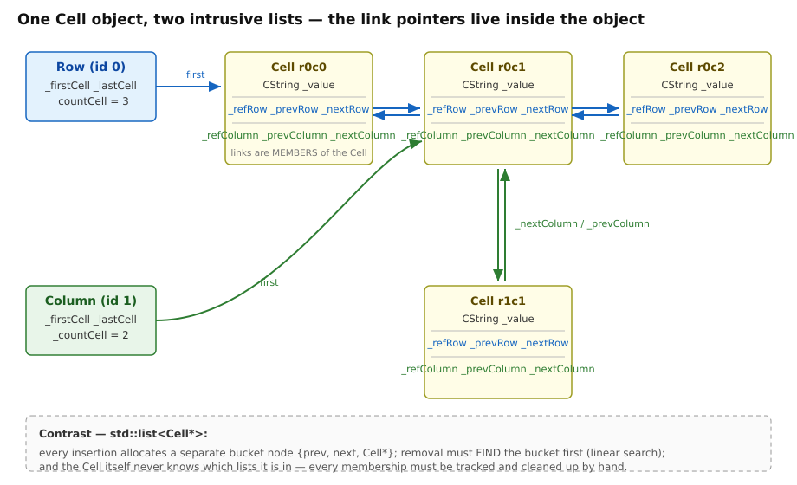
One Cell in two lists: all link pointers are members of the Cell itself.
A conventional std::list<Cell*> allocates a bucket per element {prev, next, payload*}. An intrusive list stores those pointers inside the element: declaring the Row→Cell relation gives Row the members _firstCell/_lastCell/_countCell and gives Cell the members _refRow/_prevRow/_nextRow. Membership in a second list (Column→Cell) adds a second, independently-named pointer set (_refColumn/_prevColumn/_nextColumn). One object, N lists, zero ambiguity.
Allocation economics. Every std::list insertion is a heap allocation; heap allocations are among the most expensive primitive operations in C++. The intrusive list allocates nothing — the links are already inside the object you just created. Against a pointer-bucket list you halve the allocations; and the object-by-value alternative (std::list<Cell>) is even worse off, as the next section shows.
Locality/lifetime. The element knows all its memberships, so the destructor can unlink it from everything without searching any container — O(1) per membership, symmetric between Row and Column. Deleting a Row in the Matrix example costs exactly (cells in the row) unlink operations; a std::list design would have to search every Column’s list for each cell to remove it — O(rows×columns) where the intrusive design is O(columns).
Why not simply store objects by value in the container? Then the container is the object’s home: std::list<Cell> inside Row means Cells physically live in the Row. When the model later evolves — a Column class is added that also needs to hold the cells — there is nowhere to go: the Cells are already inside the Rows. The implementation has to be redesigned. This is the general scalability failure of container-centric design: the relation owns the class instead of the class having relations. In ClassBuilder a new relation on an existing class is one dialog and a regeneration; existing relations, code and files are untouched.

12.2 Declaring relations: the macro surface
For an owned multi relation Row→Cell, the generated headers contain single-line macros:
class Row { RELATION_MULTI_OWNED_ACTIVE (Row, Row, Cell, Cell) ... }; // owner side
class Cell { RELATION_MULTI_OWNED_PASSIVE(Row, Row, Cell, Cell) ... }; // member side
and the .cpps add METHODS_MULTI_OWNED_ACTIVE(...) (the method bodies) plus INIT_.../EXIT_... lines inside ConstructorInclude/DestructorInclude. That is all the generated source shows — the machinery lives in include/CB_*.h, and your code reads like design, not bookkeeping. The macro families:
Family | Variants
kind | SINGLE (one pointer) / MULTI (list) / STATICMULTI (one shared container for the whole class)
ownership | plain (reference only) / OWNED (aggregation: cascade delete)
side | ACTIVE (the from/owner side) / PASSIVE (the to/member side)
implementation | list (default) / VALUETREE / UNIQUEVALUETREE / AVLTREE
thread safety | plain / CRITICAL (chapter 12.8)
iterator | with filter support / NOFILTER

12.3 The generated API of a multi relation
For Row→Cell (names come from the relation’s role names):
// navigation // mutation
Cell* GetFirstCell() const; void AddCellFirst(Cell*); void AddCellLast(Cell*);
Cell* GetLastCell() const; void AddCellBefore(Cell*, Cell* pos);
Cell* GetNextCell(Cell* pos) const; void AddCellAfter (Cell*, Cell* pos);
Cell* GetPrevCell(Cell* pos) const; void RemoveCell(Cell*); // unlink (non-owned use)
int GetCellCount() const; void DeleteAllCell(); // owned: delete children
void ReplaceCell(Cell* old, Cell* nw);
// ordering void MoveCellFirst/Last/Before/After(...);
void SortCell(int (*cmp)(Cell*, Cell*)); // and MergeSortCell
// per-relation iterator class
Row::CellIterator it(pRow); while (++it) { it->...; }
On the passive side, Cell gets GetRow() — the back-pointer. All of these appear in the tree under Relation methods, so their exact signatures are always visible.

12.4 Lifetime semantics — the formal ground rules
Relations constrain object lifetimes, and the generated constructors/destructors are where those constraints are enforced. Writing L_{A} for the lifetime of an object and L_{R} for the lifetime of a relation between two objects:
- Association (non-owned): L_{R} ⊂ L_{A} ∩ L_{B} — the relation can only exist while both objects do. So when either object dies, the association must die with it: the destructor unlinks.
- Aggregation (owned): L_{R} = L_{B}, hence L_{B} ⊂ L_{A} — a member object cannot exist outside the relation. Creation splices it in (ConstructorInclude), and when the owner dies the members die (cascade).
- Shared aggregate (two owners, like the Matrix’s Cells): L_{C} ⊂ L_{A} ∩ L_{B} — the member exists only while all its owners do; whichever owner dies first takes it along, and it unlinks from the survivor.
The point of enforcing this in constructors and destructors — rather than in “manager” code — is that an in-core data structure that violates its own specification can then never exist: the pre- and postcondition of every public method is the fulfilled model. That is what “correct by construction” means concretely.
One transformation is worth knowing: ClassBuilder deliberately has no direct many-to-many relation. Model it as a small link class owned from both sides — A ◇— AB —◇ B — which has the same lifetime semantics (L_{AB} ⊂ L_{A} ∩ L_{B}) and gives the pair a natural home for attributes of the association itself. The Matrix example is exactly this shape: Cell is the link class between Row and Column.

12.5 Ownership and cascade delete
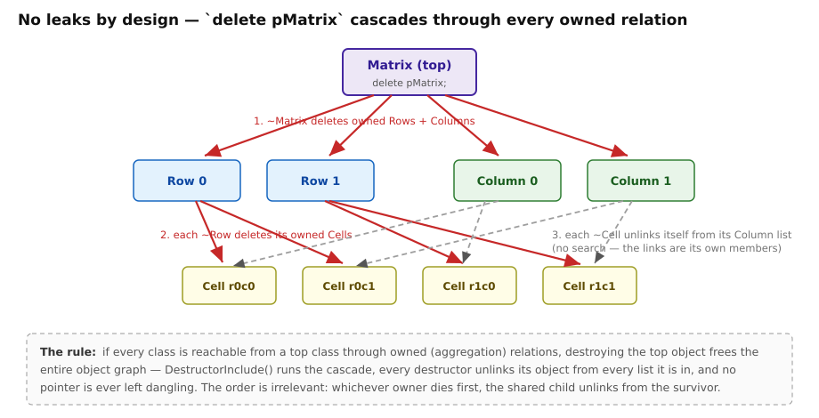
delete pMatrix — the cascade frees the entire graph.
Owned relations delete their members: ~Row (via DestructorInclude) deletes its cells (while (Cell* c = GetLastCell()) delete c;), and each ~Cell unlinks itself from both its Row and its Column. Order never matters — whichever owner cascades first, the shared child unlinks from the survivor, and the second cascade simply finds a shorter list.
The no-leak rule: make every class reachable from one top class through owned relations, and delete top provably frees everything, with no dangling pointer left anywhere — the links are members, and destructors clear them. In the demo run of chapter 4 this is the last line: every object freed by cascade.

12.6 Iterators that survive modification
Generated iterators register themselves (per relation, in a small global registry) for their lifetime. Every Remove/delete notifies live iterators: an iterator standing on the removed element silently re-anchors to its neighbour, so ++ continues correctly. This is why the chapter-4 demo could delete the current Row inside the row loop.
The classic use case: a netlist optimizer walks all instances looking for an inverter driving an inverter, replaces each such pair with a wire — deleting two instances per hit from the very relation being iterated. With ClassBuilder iterators that is just the natural loop; no deferred-delete lists, no “collect then erase” second pass, no invalidation crashes.
Iterator flavour notes:
- while (++it) is the idiom; the iterator converts to the element pointer (Cell* p = it; / it->Member()).
- Relations with Filter checked add a predicate constructor: Row::CellIterator it(pRow, &Cell::IsMarked); iterates matching cells only.
- Iteration is bidirectional (--it from the end).
One rule of hand-written code around iterators: if you call a setter on the iterated object inside the loop and then still need the raw pointer, capture it first (Cell* p = it.Get();). Setters may trigger model-side reordering (e.g. in sorted tree relations); the captured pointer stays valid, the iterator re-anchors.

12.7 Single, static-multi
- Single: a 1:1 slot — GetCell()/AddCell()/RemoveCell()/ReplaceCell(), owned or not. Cheaper than a list of one.
- Static Multi: one container shared by all instances of the from-class (class-level registry). Not available for template or serialize classes.

12.8 Tree implementations and find methods
A multi relation’s implementation can be switched (dialog or set_relation_implementation) with zero source-level API change — the accessors and iterators keep their names:
- Value Tree — bit-pattern-indexed tree keyed on an integer member: near-hash-table find speed, no ordering, no rebalancing. It exists in two versions: the plain Value Tree allows several objects with the same key value; the Unique Value Tree is the leaner variant for keys that are guaranteed unique (typically IDs) — the model then knows duplicates are impossible.
- AVL Tree — balanced search tree: ordered iteration + O(log n) find.
What a key type must provide. A Value Tree (either version) indexes on the key’s bit pattern: the member must be an integer-like type (convertible to an integer; no other operators needed). An AVL Tree keeps its elements ordered by comparing keys: the member’s type must support the comparison operators <, <=, >, >=, == — plain integers qualify, and so does any class implementing them (CbString does, which is how string-keyed AVL relations work).
The key member’s setter is special. An object’s position in the tree is its key, so changing the key by plain assignment would corrupt the tree. The generated setter therefore takes the object out, changes the key, and re-inserts it at the right position — this is real generated code from ClassBuilder’s own model, where every Property sits in its owner’s AVL tree keyed on _name:
void Property::SetName(const CbString& rName)
{//@CODE_36069
if (_name != rName)
{
DataModelDocObject* refDataModelDocObject = _refDataModelDocObject;
refDataModelDocObject->RemoveProperty(this);
_name = rName;
refDataModelDocObject->AddProperty(this);
}
}//@CODE_36069
The corollary for hand-written code: always change a key through its setter — never assign the member directly (from inside the class, for example), or the tree will no longer find the object.
Find methods (chapter 4.6) are generated lookups on a relation: choose the member(s)/paths to compare and get FindCell(...) — implemented as a loop on a list relation, or as the native tree search when the argument matches the tree key. Design workflow: start with lists; when profiling says a find is hot, flip the relation to a tree — the find method regenerates to the fast path, callers unchanged.

12.9 Critical relations (threads)
Checking Critical on a relation wraps every operation of that relation in a per-relation recursive mutex (CB_CriticalSection.h), and iterators take the lock while re-anchoring. Use it when another thread mutates a relation you iterate. It serializes relation maintenance only — your own data races remain your own; keep cross-thread mutation points few and explicit.

12.10 Writing loops the generated way
Two idioms to copy from generated code rather than invent:
// cascade-style consume loop: RE-QUERY each pass, never cache first/last
while (Cell* c = pRow->GetLastCell())
delete c;
// iteration with deletion of the current element: iterators handle it
Row::CellIterator it(pRow);
while (++it)
if (Condition(it))
delete (Cell*)it;
Never snapshot GetFirst()/GetLast() before a loop that deletes — the list is live and your snapshot is not.

13 Serialization

13.1 What you get
With Serialize on, the model gains a document class (e.g. Matrix) and a document-object root (MatrixObject); every serialize-enabled class inherits the root and gets three generated methods — Serialize (members), SerializeRelations (links), and a private serialize constructor — plus CB_DECLARE_SERIAL / CB_IMPLEMENT_SERIAL registration. One call streams the entire object graph:
pMatrix->Serialize(archive); // store or load, decided by the archive
Under the hood the document’s Serialize runs SERIALIZE_ALL_OBJECTS: store writes the object count, then every object polymorphically (class tag + members), then every object’s relations as index references; load reads the count, factory-creates each object from its class tag (CB_IMPLEMENT_SERIAL registers the factory), then re-links all relations through a pointer table. Shared pointers, back-pointers, multi-ownership — the graph reloads exactly.

13.2 CbArchive and the wire format
CbArchive (in serialize/CbSerialize.{h,cpp}, MFC-free) streams over any std::istream/ostream. Primitives, CbString, CbPoint/CbRect/CbSize, CbTime and CbObject* have <</>> operators; IsStoring()/IsLoading() pick the direction. Class tags are written as the class-name string on first encounter, then as a 2-byte index — compact and self-describing. A corrupted or schema-mismatched stream throws CB_ARCHIVE_BAD_STREAM rather than crashing.

13.3 CBZ: compression on the fly
.cbz files are a Zstandard frame around the raw archive bytes — not an archive-then-compress step, but transparent stream compression: CbZstdOutBuf/CbZstdInBuf are std::streambuf wrappers that compress on write and decompress on read, so CbArchive never knows compression exists:
std::ofstream raw(path, std::ios::binary);
{
CbZstdOutBuf zbuf(raw); // compresses as bytes stream through
std::ostream zos(&zbuf);
CbArchive ar(zos);
doc.Serialize(ar);
} // zbuf destructor finalizes the frame
Real-world ratio on model files is roughly 8–9×; the quick start’s whole matrix saved in 114 bytes. Your applications get the same for free — link zstd and use the two wrappers.

13.4 Versioning: evolving the model without breaking old files
The scheme is write everything, gate the reads:
- The document has an int _version member, stored first. Set it (constructor initialization) to the model’s current schema version; bump it when the schema grows. On load it is read back and published to every class (_objectVersion).
- Every member carries a version (member dialog). Store side writes members unconditionally; load side wraps them in if (memberVersion <= _objectVersion).
Adding a field to a shipped schema, correctly:
- Add the member; set its version to (current document version + 1).
- Bump the document version (the _version initialization) to the same number.
- Regenerate.
Old files (smaller stored _version) skip the new field’s read and keep the member’s initial value; new files read it. The failure mode to respect: if the new member’s version gate is wrong (e.g. left at a value old files already satisfy), load consumes bytes that were never written — the stream misaligns and the next object’s class tag is garbage → CB_ARCHIVE_BAD_STREAM. If an old file must gain a field retroactively, load it with the older binary, save (now written with the field), then upgrade.
The Compact Version button (Project Settings) renumbers a long version history down to the minimal equivalent scheme (max used + 1) — cosmetic, but keeps gates readable. Only compact when files older than the compacted scheme no longer need to load.

13.5 Rules and properties
- Single inheritance for serialize classes (GUI-enforced): the generated Serialize chains base-class Serialize calls; a diamond would double-stream members.
- Per-member opt-out: transient members simply untick Serialize.
- Object-pointer members (not just relations) stream as graph references too.
- SerializeMembersOnly on the document: streams only the document’s own scalar settings — the graph is skipped via an internal flag. This is the cheap snapshot the undo system uses for document-level changes, and it stays in lockstep with Serialize automatically.
- Unknown types: an OtherType maps to None or Int for streaming (type dialog).

13.6 Starting a new serialize model — current scaffolding checklist
The new-model scaffolding predates recent runtime changes; until it is refreshed, bring a fresh serialize model in line once (two minutes, or script it — chapter 16):
- Add extern class CbArchive; change the archive argument of every generated Serialize/SerializeRelations (and the document’s SerializeMembersOnly) from CbObject& to CbArchive&.
- The auto-created inheritances of serialize classes are marked virtual; recreate them non-virtual (serialize off → add inherit → serialize on). Virtual bases break the generated relation-load casts.
- Add the document’s int version member (serialize on) and initialize it — the generated document Serialize expects it.
Models that already build (like ClassBuilder’s own) are unaffected.

14 The generated Undo/Redo framework

14.1 What it is
With Undo/Redo enabled (Project Settings; requires Serialize; enable-once), ClassBuilder generates a complete, application-level undo system for your generated model — the same machinery ClassBuilder itself uses for its own Edit ▸ Undo/Redo.

14.2 How it works
The framework leans on serialization for state capture:
- UndoNew — recorded when an object is created; undo = delete it.
- UndoDelete — recorded before an object dies; the object’s state is kept; undo = resurrect and re-link.
- UndoChange — recorded by calling SaveState() on an object before changing it; the object is snapshotted through CbArchive into an in-memory stream (a std::stringstream), relations included via reference bookkeeping; undo streams it back.
- UndoChangeDoc — document-level settings snapshot via SerializeMembersOnly (cheap: no graph clone).
Records accumulate on an undo stack; MarkLastUndo() closes the current user-visible step (one Ctrl+Z’s worth). A second marker level (MarkLastUndo(2)) creates sub-batches inside a step — used for compound operations that need internal ordering (e.g. multi-swap reorders) while still undoing as one step. The stack depth is the Project-Settings Undo stack value; redo is symmetric.
Usage pattern in application code:
pCell->SaveState(); // snapshot before the change
pCell->_value = "new"; // mutate
pDoc->MarkLastUndo(); // close the user-visible step
SaveState deduplicates: an object already captured in the open step is not snapshotted again.

14.3 The undo/replace entanglement
Undo restore works by replacement: the stored copy is deserialized and takes the live object’s place, with every reference redirected (ReplaceReference sweeps live objects and the parked entries on the undo/redo stacks). That is the replace-constructor mechanism of chapter 15 — the framework is its heaviest user.
Consequence: combining generated undo/redo with your own replace-constructor usage is delicate. A user-level replace must also fix up undo-stack entries that still point at the replaced object (reuse the old object’s undo record and redirect it — ChangeDataModelDocObject in ClassBuilder’s own model shows the pattern). If you use both features on the same classes, study that pattern first; getting it wrong leaves stale pointers parked on the undo stack — crashes that appear only after later undos.

15 The replace constructor

15.1 The idea
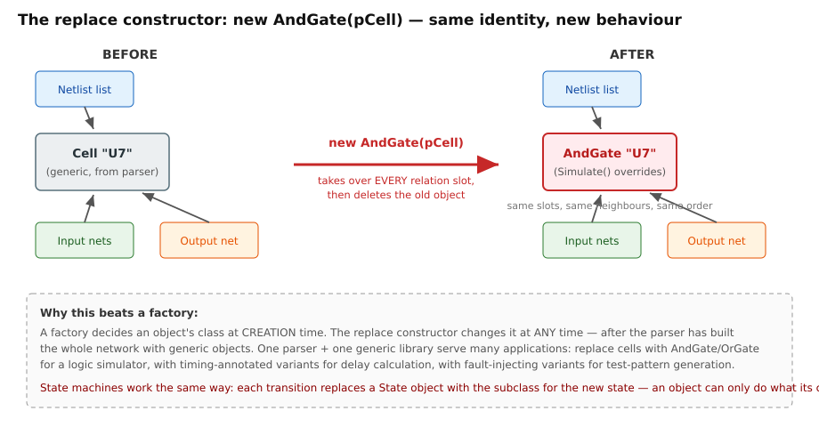
Replace: the new object takes over every relation slot of the old one.
Checking Replace on a class generates a special constructor taking a pointer to an existing object:
AndGate* pGate = new AndGate(pCell); // pCell: the generic object being replaced
Semantics: the new object copies the old one’s members, takes the old object’s exact place in every relation it participates in — same lists, same neighbours, same back-pointers, same owners — and then the old object is deleted. To the rest of the object graph nothing happened; the object simply became a different class.

15.2 Why it is more powerful than a factory
A factory chooses a class at creation time — you must already know, at parse time, what each object will be. The replace constructor postpones that decision to any later moment, after the object is fully wired into the graph.
The original motivation is the generic-library problem: a reusable library ships with readers/parsers that build data structures out of its own classes — they cannot know about the classes an application derives from them. With replace constructors in the library, the application first lets the generic reader build the whole structure, then promotes the generic objects to its own derived classes — a derived-class constructor that forwards to the base’s replace constructor is called a promotion constructor:
Ax::Ax(A* pOld, int value)
: A(pOld) // base replace ctor: take over pOld's place, dispose of pOld
{
_value = value; // then initialize what the derived class adds
}
That enables one generic front end to serve many applications:
The logic-network family. A netlist parser builds a generic network: Cell objects with input/output net relations, named “AND2”, “OR4”, whatever the library says. The parser knows nothing about applications — it creates only Cells. Then:
- a logic simulator walks the network once and replaces each Cell with AndGate, OrGate, … — subclasses whose Simulate() does the logic;
- a timing analyzer replaces the same generic cells with delay-annotated variants for propagation calculations;
- a fault simulator / test-pattern generator replaces them with fault-injecting variants.
One parser, one generic library, three applications — each specializes the same loaded network for its own task. Every replaced object keeps its position in every net list, so the network never needs re-wiring.
State machines. Model a base State with one subclass per state, each implementing only the transitions that state allows. A transition is then literally:
(void)new StateRunning(pStateIdle); // the object changes state class
The object’s relations (owner machine, queues, watchers) carry over untouched; illegal transitions don’t compile or don’t exist as methods. The object’s class is the state — the type system enforces the state chart.

15.3 Mechanics and constraints
- Generated body: base-class replace chain, ReplaceConstructorInclude(pOld) (relation slot takeover), member-by-member copy, then delete pOld — with a user-code region for what you want to add.
- Replacement is between classes sharing the relation-carrying base (typically siblings under the same root, e.g. MatrixObject); the relation macros transfer per-relation link sets, which both classes must have.
- Owned pointers that move to the new object are nulled on the old one before deletion (no double-free).
- Undo/redo interplay: see chapter 14.3 — the undo framework itself replaces objects on restore; mixing both requires redirecting parked undo entries, as ClassBuilder’s own model does.

16 The command interface

16.1 What it is
Every running ClassBuilder is also a server: a JSON-over-TCP command interface listening on 127.0.0.1:51777 (loopback only; override with the CB_CMD_PORT environment variable — a dev instance on 51778 runs happily beside the stable one). One JSON request per line, one JSON reply per line:
request: {"cmd":"<name>","params":{...}}
reply: {"ok":true,"result":{...}} or {"ok":false,"error":"<message>"}
Commands execute on the GUI thread against the live model — every mutation follows the same code path as the corresponding GUI action, including undo recording and view refresh. You watch the model change while a script drives it.
This is a first-class interface, not an afterthought: it is how bulk migrations are done on ClassBuilder’s own model, and it is deliberately friendly to AI systems — an AI agent that can open a TCP socket can inspect and refactor a live model conversationally (list_commands gives it the full vocabulary to discover). Most of this manual’s figures and its whole quick-start model were produced through this interface. The commands have grown on need — when a workflow needs a missing command, adding one is routine (there can be gaps; list_commands on your build is the ground truth). The complete per-command reference with all parameters lives in tools/PIPE_API.md; below is the map plus worked examples.

16.2 Connecting
Any language that can speak TCP works. PowerShell ships in tools/CbCmd.ps1:
. tools/CbCmd.ps1
Connect-Cb # or -Port 51778
(Invoke-Cb 'ping').result # {pong:true, build:"Jul 2 2026 00:13:13"}
Invoke-Cb 'add_type' @{ name = 'CString' }
Disconnect-Cb
Python in five lines:
import socket, json
s = socket.create_connection(("127.0.0.1", 51777))
def cb(cmd, **params):
s.sendall((json.dumps({"cmd": cmd, "params": params}) + "\n").encode())
return json.loads(s.makefile().readline())
print(cb("list_classes"))

16.3 The command families
Family | Commands (abridged)
Lifecycle / meta | ping (returns the build stamp — detects a stale binary), list_commands, new_model_basic, new_model_serialize
Documents | list_documents, select_document (sticky server-side target, decoupled from GUI focus), current_document, close_document
Read | list_classes, get_class (full record), list_members, list_class_methods, find_method[_by_id], find_member, list_relations, get_relation, list_types, list_methods_named, find_methods_using_type (migration audits)
Classes | add_class, delete_class, set_class_name/_serialize/_h_file/_note/_dll_export/_member_prefix, add_inherit, remove_inherit, extern-class family
Members | add_member (type modifiers parsed from the string: Foo*, Foo[8]…), delete_member, set_member_*, set_member_getter/setter
Methods | add_method, add_constructor (auto-derives owner arguments), set_method_body, set_method_* (access/virtual/static/const/pure/name/return_type/note), argument commands incl. move_argument
Relations | add_relation (kind/owned/critical/filter/implementation/member/unique), delete_relation, set_relation_*, set_relation_implementation, add_find_method
Groups | add_meta_group, add_class_group, list_groups, move_class, move_class_group, in-class member/method groups
Class diagrams | add_class_diagram (with classes + auto-place), add_class_to_diagram, show_class_members/methods/features, auto_place_diagram
Sequence diagrams | add_actor, add_sequence_diagram, add_actor_lifeline, add_class_lifeline, add_root_child_activation, add_child_activation, add_signal, signal setters, optimize_placement, space_lifelines, add_call_trace (generate a whole SD from a method’s call tree)
Diagram views | open_diagram (open the GUI view), export_diagram_svg (vector export — this manual’s diagram figures)
Source | write_source (regenerate files + save the model), read_source (fold disk edits back in)

16.4 Worked examples (real requests)
Build a model from nothing (the quick start, scripted — see tools/build_matrix_model.ps1 for the full version):
{"cmd":"new_model_serialize","params":{"name":"Matrix","document_class":"Matrix","h_file":"Matrix.h"}}
{"cmd":"add_class","params":{"name":"Row","serialize":true}}
{"cmd":"add_member","params":{"class":"Row","name":"id","type":"int","access":"private","getter":"public"}}
{"cmd":"add_relation","params":{"from_class":"Row","to_class":"Cell","kind":"multi","owned":true}}
{"cmd":"add_constructor","params":{"class":"Row","access":"public",
"body":" ConstructorInclude(pMatrix);\r\n\r\n // Put in your own code\r\n Matrix::ColumnIterator iColumn(pMatrix);\r\n while (++iColumn)\r\n {\r\n (void)new Cell(this, iColumn, \"\");\r\n }"}}
Inspect and edit:
{"cmd":"get_class","params":{"name":"Cell"}}
→ {"ok":true,"result":{"name":"Cell","serialize":true,"h_file":"Cell.h",
"inherits":[{"name":"MatrixObject","virtual":false}],
"members":[{"name":"_value","type":"CString"}],
"methods":[{"id":313,"name":"Cell","args":[...]}, ...]}}
{"cmd":"set_method_body","params":{"class":"Matrix","id":317,
"body":" ConstructorInclude();\r\n\r\n // Put in your own code\r\n _version = 2;\r\n ..."}}
Generate sources and export a figure:
{"cmd":"write_source","params":{"modified_only":false}}
→ {"ok":true,"result":{"modified_only":false,"warnings":0,"errors":0}}
{"cmd":"export_diagram_svg","params":{"diagram":"Matrix Overview","path":"docs/images/cd.svg"}}
→ {"ok":true,"result":{"diagram":"Matrix Overview","kind":"class_diagram","path":"docs/images/cd.svg"}}

16.5 Conventions and gotchas
- Member names are bare (id, not _id) — the prefix is applied at generation time.
- Method bodies: CRLF line endings (\r\n in JSON) and 4-space indentation including the first line; LF-only bodies collapse to one line. When replacing a constructor/destructor body wholesale, keep the ConstructorInclude(...)/DestructorInclude() call — set_method_body warns when it is missing (add_constructor seeds it for you).
- write_source also saves the model (like the GUI’s Save Source), and flushes every modified class — make sure the model state is what you want on disk before calling. A failed write rolls the model back to the last saved state.
- add_member with an initialization does not retrofit existing constructors’ initializer lists — set the value in a constructor body or recreate the constructor.
- A bare {"ok":false} with no error text usually means a stale older binary still owns the port — ping’s build stamp tells you.

17 Tips, pitfalls, and best practices
Modeling
- One top class owning everything (directly or transitively) buys the no-leak guarantee — design for it from day one.
- Prefer modeled relations over hand-kept std::vector<T*> members: the vector version re-invents (worse) what the generator does, and grows dedup/cleanup bugs one design step later.
- Copying entities: copy values, never relation links — give classes a CopyValuesFrom instead of a full operator= (or = delete the copy operations via the one-click menu item).
- Multi-ownership (one child in N owned lists) is fully supported — the Matrix’s Cells are the pattern.
- Model evolution is cheap; exploit it. Adding a relation/tree/find method later is a regeneration, not a refactor.
Serialization
- Decide Serialize (and Undo/Redo) at model creation — both are enable-once.
- Bump the document version and the new member’s version together; misaligned gates are the classic broken-load (chapter 13.4).
- Keep a copy of the previous binary around while old files still matter.
Hand-written code
- bool over BOOL in new code; Gti-style IsX() predicates over RTTI chains.
- Re-query GetFirst/GetLast in delete loops; never iterate a cached snapshot of a live list.
- Destructor user code that reads owned children goes before DestructorInclude().
- In iterator loops that call setters, capture it.Get() first.
- Only edit inside @START_USER/@CODE/@NOTE regions — everything else is regenerated.
- After hand edits, Read Source before Write Source: read-back first, or the next generation overwrites you (the self-host prompt exists for exactly this).
Workflow
- Save the model before big pipe-driven operations (write_source saves; a failed one rolls back to the last save).
- Use select_document when scripting against one model while editing another.
- Keep generated files out of manual formatting tools; CRLF endings are part of the round-trip contract.
- Use SVG export (GUI button or export_diagram_svg) for documentation — it is the same renderer as the screen, vector-clean at any size.

18 Appendix

18.1 A. Runtime header inventory
Header | Provides
CB_Single.h / CB_SingleOwned.h | 1:1 relation (reference / owned)
CB_Multi.h / CB_MultiOwned.h | 1:N intrusive list (+ serialize macros SERIALIZE_ALL_OBJECTS, WRITE/READ_*)
CB_StaticMulti.h / CB_StaticMultiOwned.h | class-level shared container
CB_ValueTree.h / CB_UniqueValueTree.h / CB_AvlTree.h (+ Owned) | tree-implemented relations
CB_IteratorMulti.h / CB_IteratorStaticMulti.h | the self-maintaining iterators
CB_CriticalSection.h + CB_Critical*.h | mutex + thread-safe relation variants
CbString.h, CbTime.h, CbColor.h, CbGeometry.h | value types (value/)
CbSerialize.h/.cpp | CbObject, CbArchive, CbClassRegistration, CB_*_SERIAL
CbZstdStream.h/.cpp | on-the-fly Zstandard stream compression (.cbz)

18.2 B. Marker quick reference
//@START_USER1..3 / //@END_USER1..3 user regions (round-tripped)
{//@CODE_nnnn ... }//@CODE_nnnn method body (round-tripped)
/*@NOTE_nnnn ... */ method note (round-tripped)
//@INIT_nnnn constructor initializer marker
//{{AFX ... //}}AFX generator-owned block (never edit)
// Put in your own code ctor/dtor: your code goes below
@INSERT_MODIFICATIONS(* ) per-file change log insertion point

18.3 C. Glossary
Term | Meaning
Active / passive side | The owner (from) / member (to) side of a relation
Aggregation | Owned relation: cascade delete of members
CBZ | The model file: Zstd-compressed CbArchive stream
Critical | Thread-safe (locked) relation variant
Document class / document object | The serialize top class / the polymorphic root all serialize classes inherit
Filter iterator | Relation iterator taking a member-predicate
Find method | Generated lookup on a relation (loop or tree-accelerated)
Intrusive list | Container whose links live inside the elements
Phase | Lifecycle tag (Analysis…Complete) on model elements
Replace constructor | Generated ctor that substitutes an object in-place across all relations
User region | The parts of generated files that survive regeneration

