Execute in urho (base directory)
MakeUWP.bat x86 Debug 2017

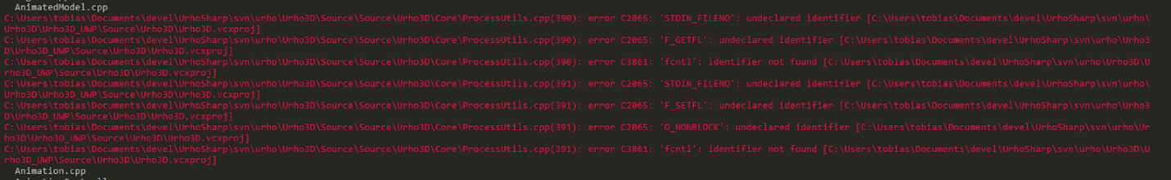

- Comment urho\Urho3D\Source\Urho3D\Source\Urho3D\Core\ProcessUtils.cpp:390:399 . This is done just to compile. Must to be fixed later.

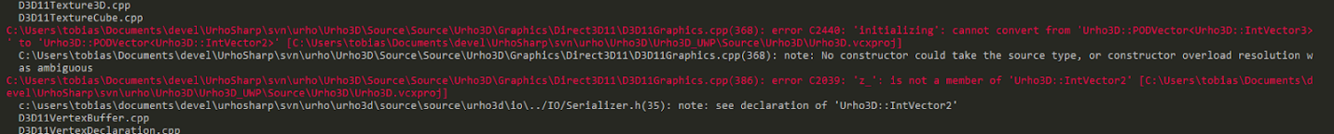

- Change IntVector2 to IntVector3 urho\Urho3D\Source\Urho3D\Source\Urho3D\Graphics\D3D11Graphics.cpp:368
PODVector<IntVector3> resolutions = GetResolutions(monitor);

- Remove extra ) urho\Urho3D\Source\Urho3D\Source\Urho3D\IO\Log.cpp:84

- Add programDir_ urho\Urho3D\Source\Urho3D\Source\Urho3D\IO\FileSystem.h:123
String programDir_;

- Replace urho\Urho3D\Source\Urho3D\Source\Urho3D\IO\FileSystem.cpp:710:711 with

wchar_t exeName[MAX_PATH];
exeName[0] = 0;
wcscpy(exeName, SDL_UWP_GetResourceDir());
return AddTrailingSlash(exeName);

- With current native bindings were lots of errors but regenerating them only one was found

to fixed just commented urho\Bindings\Native\glue.cpp:421:424

After execute this command in urho\Urho3D\Urho3D_UWP directory
msbuild MonoUrho.UWP\MonoUrho.UWP.vcxproj /p:Configuration=Debug /p:Platform=x86
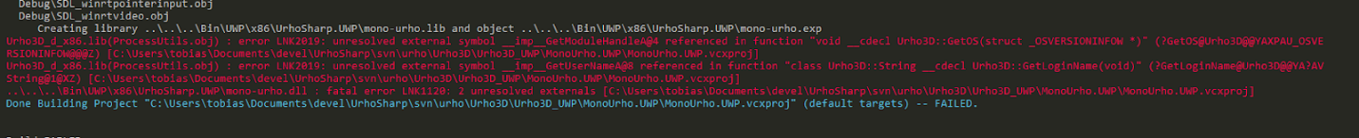

- Added this kernel32.lib;advapi32.lib in MonoUrho.UWP.vcxproj:65

After this binding is generated

Then the nuget package is generated and used to test the FeaturesSamples from Samples repository. When some sample is selected, this exception is launched but this function (SDL_WINRT_InitSdl) wasn't found in urho\Urho3D\Source\Source\ThirdParty\SDL or urho\Urho3D\Urho3D_UWP\MonoUrho.UWP\SdlStub\SDL

